SITE OVERVIEW:
Town | Torquay
Site Name | Former market site Stantor Barton
HELAA Reference no. | 21T136
Approx. yield | 0
Suitable | See below. Not suitable for residential development as a standalone site.
Available | Being promoted for development
Achievable | Uplift in value would be likely to make development viable.
Customer Reference no.
Source of Site (call for sites, Local Plan allocation etc.). | Call for sites
Current use | Agriculture/ no active use
Site descriptions | Field/hardstanding area to the west of Torquay and the east of Hellevoetsluis Way (Torquay Ring Road). This relates to the former “Monday Market” site- the main Stantor Barton area is assessed as 21T136.
Total site area (ha)
Gross site area (ha) | 1.4
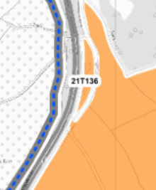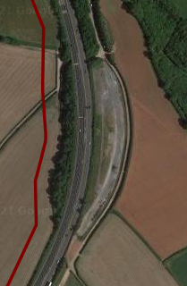

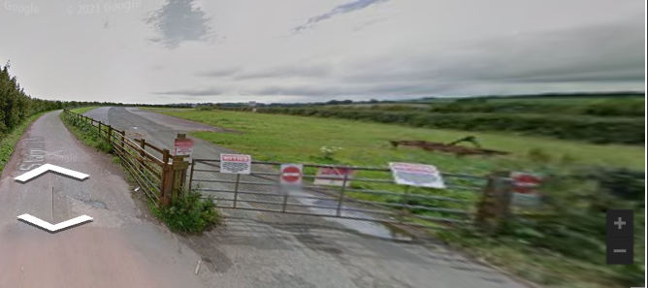

SUITABILITY ASSESSMENT: STAGE A

Strategic potential: | No
Housing? | Not suitable for housing -due to isolated location
Employment? | Possible low density employment
Other Use? | Possible low-density leisure use.  Traveller temporary stopping place(?)
Biodiversity- Within SAC/SSSI | Not likely to be significant- see below
Flood Zone 3b | No
Other NPPF Showstoppers (not policy constraints) | No
Conclusion | Isolated location next to busy main road limits potential for residential development.

SUITABILITY ASSESSMENT: STAGE B
Access | Easy access to main Ring Road e.g. via Gallows Gate or Hellevoetsluis Way. However, access to shops and other facilities is more difficult. Development would be largely car dependent.
Flood risk, water quality and drainage | No
Heritage and Archaeology (including distance from assets). | Would need detailed assessment.
Infrastructure | Distance from the built up area.
Landscape | Rolling farmland 1E Upper Cockington (Highly sensitive: conserve and enhance) and 1FStantor Barton; Highly sensitive: enhance.
Ecology | Cirl Buntings and Greater Horsehoe bat Sustenance Zone. However site is around 50% covered in hardstanding , so biodiversity value likely to be limited.
Safety related constraints | No
Soils (Agricultural Land classification) and contamination | Not in active agricultural use.
Local Plan | C1 Countryside Area
Neighbourhood Plan
Development progress (where relevant) | No
Other | Isolated and prominent location.
HELAA Panel Summary | Supported if wider area comes forward.
Site potential | 0

AVAILABILITY ASSESSMENT
Not suitable for residential development due to isolated and prominent location next to busy main road. May be suitable for low impact employment or similar use.
The next 5 years
A 6-10 year period
An 11-15 year period
Later than 15 years

