SITE OVERVIEW: Amber sites – significant constraints
Town | Torquay
Site Name | Lower Union Lane office Block
Site Description | Lower Union Lane Office Block Fleet House Telephone Exchange  1960s-70s office block containing telecommunications equipment
Total site area (ha) | 0.23
Map (if needed)
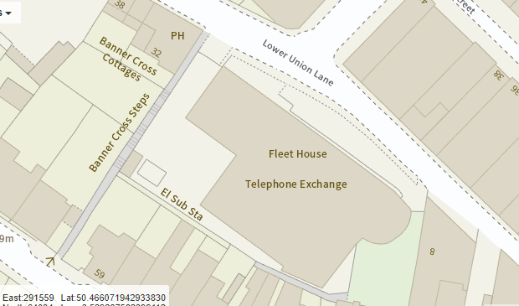

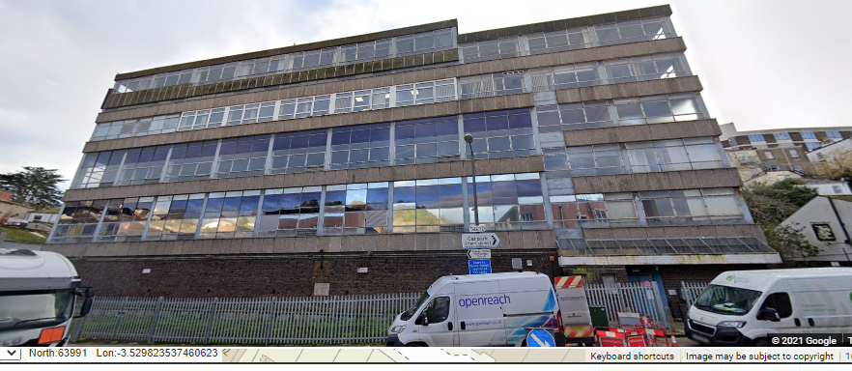

HELAA Reference no. | 21T123 formerly 13221
Approx. yield | Up to 100 apartments
Suitable: Previous assessment of suitability | Could be converted under PD but would be poor living environment and retain ugly building.  Adjoining Abbey Road CA. Scope for a taller building if better designed than the current non-descript 1960s office.  Flooding issues.
Any Change in circumstances to consider suitable? | Torbay Local Plan TC2/TNPH27  Part of wider regeneration of Lower Union Lane, but could be redeveloped as a standalone building
Available? | No – telecommunication equipment in the building
Achievable
Customer Reference no.
Current use | Underused Telecommuncation building, but contains telecoms equipment.
Assess in 2021 HELAA? | Yes- but availability is an issue

AVAILABILITY ASSESSMENT
Reasonable prospect of delivery (timescale):
Suitable brownield site. Understood to contain telecommunications equipment so not available in the short term
The next 5 years
A 6-10 year period
An 11-15 year period
Later than 15 years | 70

