SITE OVERVIEW: Amber sites – significant constraints
Town | Torquay
Site Name | Former Living Coasts, Beacon Hill
Map (if needed)
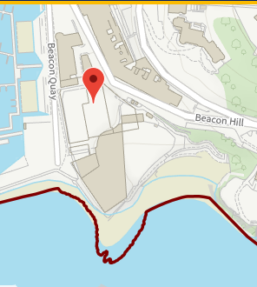
Allocation or HELAA Reference no. | 21T119
Approx. yield | 20
Suitable: How the principle of development is established | Main issues are likely to be principle of mixed use development including some residential. Detailed amenity, Conservation Area and marine impacts need to be considered. A landmark design would be necessary.  Given the waterfront location a mixed use development incorporating.
Available: Any change in circumstances since principle established | Yes- site has been marketted
Achievable | High value location, subject to viable mix of uses.
Customer Reference no.
Current use | Vacant zoological aviary.
Site description | Vacant Living Coasts zoo on site of former Coral Island located on a headland on Beacon Quay.
Total site area (ha) | 0.24ha (excluding car park)
HELAA Panel Summary | Premier site that would be incredible for apartments.  TDA expressed desired for retention as an employment/tourist attraction site – something more special for Torbay than solely resi.  Some consensus that mixed use may be ideal.  Deliverability may be a challenge.

AVAILABILITY ASSESSMENT
Reasonable prospect of delivery (timescale): Suitable, high value site, subject to principle of residential use being agreed.
The next 5 years
A 6-10 year period | 20
An 11-15 year period
Later than 15 years

