SITE OVERVIEW: Amber sites – significant constraints
Town | Torquay
Site Name | Rear of Farmhouse Tavern ,now Old engine House, Newton Road
Allocation or HELAA Reference no. | 21T118 former R363
Approx. yield | 50
Suitable: How the principle of development is established | Yes ; within built up area. Close to hospital and proposed new railway station.
Available: Any change in circumstances since principle established | Not clear – has not recently been promoted. Not included in 2013 SHLAA as no recent promotion. Currently in use as pub car park.
Achievable | Likely to be achievable as key worker accommodation.
Customer Reference no.
Current use | Car park rear of pub. The site directly adjoins hospital car park with combined area of about 0.3ha.
Site description | Land rear of Farmhouse Tavern, backing onto Torbay Hospital.
Total site area (ha) | 0.14ha 0.3ha with hospital car park
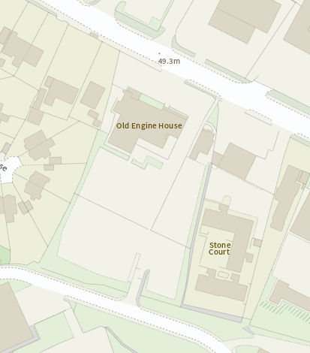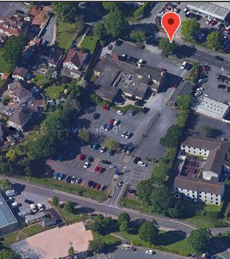

AVAILABILITY ASSESSMENT
Reasonable prospect of delivery (timescale):
Highly sustainable site close to hospital, District Centre and proposed train station. Ideally situated for key worker apartments.
Confirmation of availability needed from owners-lack of promotion prevents the site being viewed as more deliverable.
Next 5 years
A 6-10 year period
An 11-15 year period | 50
Later than 15 years

