SITE OVERVIEW: Amber sites – significant constraints
Town | Torquay
Site Name | Port Talland Farm Maidencombe
Map (if needed)
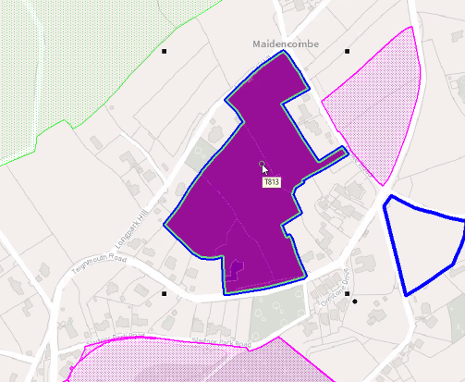

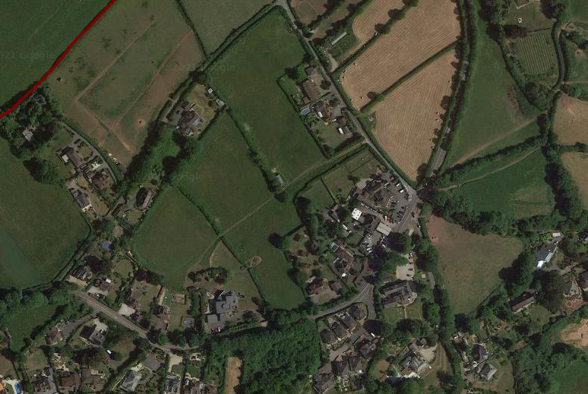

Allocation or HELAA Reference no. | 21T111
Approx. yield | 30
Suitable: How the principle of development is established | Torbay Local Plan- Countryside Area (C1)  Landscape Character Assessment 1A Rolling Farmland – Highly sensitive  Part of wider County Wildlife Site.
Available: Any change in circumstances since principle established | Torquay Neighbourhood Plan – outside Village Envelope  Promoted to previous SHLAA/UCS.  Archaeology: Proximity to prehistoric or Romano-British settlement. Medieval field pattern. Requires programme of archaeological mitigation.
Achievable | If designated would be attractive to housebuilders.
Customer Reference no.
Current use | Low density residential
Site description | Land at Port Talland Farm, w side of Teignmouth Road, Maidencombe
Total site area (ha) | 3.65ha

AVAILABILITY ASSESSMENT
Reasonable prospect of delivery (timescale):

Confirmation of availability needed from owners, if considered suitable. But may be considered unsuitable due to landscape impact and relative remoteness. .
The next 5 years
A 6-10 year period
An 11-15 year period | 30
Later than 15 years

