SITE OVERVIEW: Amber sites – significant constraints
Town | Torquay
Site Name | S of Step Hill , Maidencombe Cross
Site Description | Land south of Steep Hill and south east of Teignmouth Road, Maidencombe Cross
Total site area (ha) | 0.86
Map (if needed)
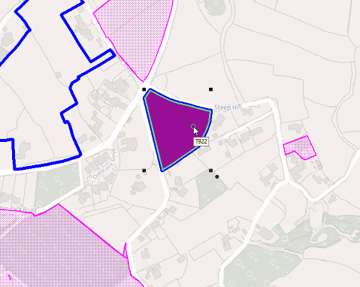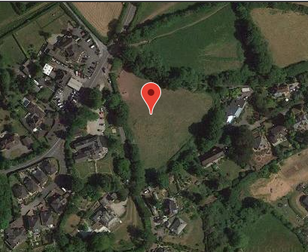

HELAA Reference no. | 21T110  SHLAA ref: T922
Approx. yield | 20
Suitable: Previous assessment of suitability | Rejected. Countryside Area, Undeveloped Coast, County Wildlife Site, Topography. LCA(2010)- LCA 8.A Highly sensitive
Any Change in circumstances to consider suitable? | Torquay Neighbourhood Plan - Outside of , but adjoining, village envelope.  Archaeology: Proximity to prehistoric or Romano-British settlement. Requires programme of archaeological mitigation.
Available? | Council owned land
Achievable | Yes
Customer Reference no.
Current use | Field – agriculture(?)
Assess in 2021 HELAA?

AVAILABILITY ASSESSMENT
Reasonable prospect of delivery (timescale):

Could achieve circa 20 units – but may be considered unacceptable.
The next 5 years
A 6-10 year period
An 11-15 year period
Later than 15 years

