SITE OVERVIEW: Amber sites – significant constraints
Town | Torquay
Site Name | Magistrates Court
HELAA Reference no.
Approx. yield | DPH / 0 ha employment N.B Starting assumption is for 25% of strategic sites to be employment.
Suitable | Yes
Available | Yes
Achievable | Yes (stalled?)
Customer Reference no. | Leave Blank for now
Source of Site (call for sites, Local Plan allocation etc.). | Knowledge sites
Current use | Lawful previous use as magistrates’ court now dis-used and vacant
Site descriptions | Old magistrates court on NW side of Union Street close to one way system with Torre and Trematon Avenue junction. Adjacent to St Mary Magdalene’s Church and Castle Chambers (Grade 2 listed buildings)
Total site area (ha) | 1060sqm
Gross site area (ha) | <1000sqm
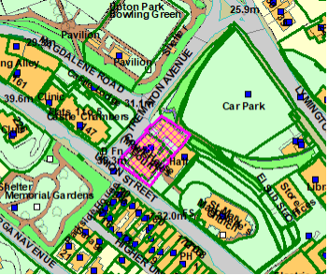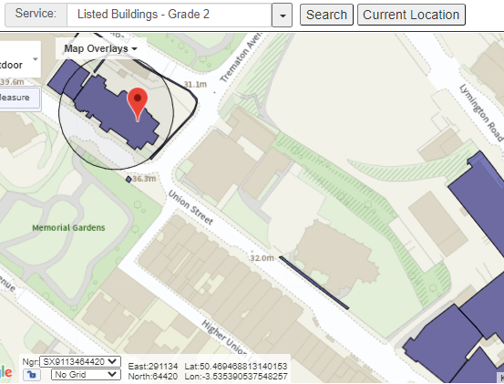
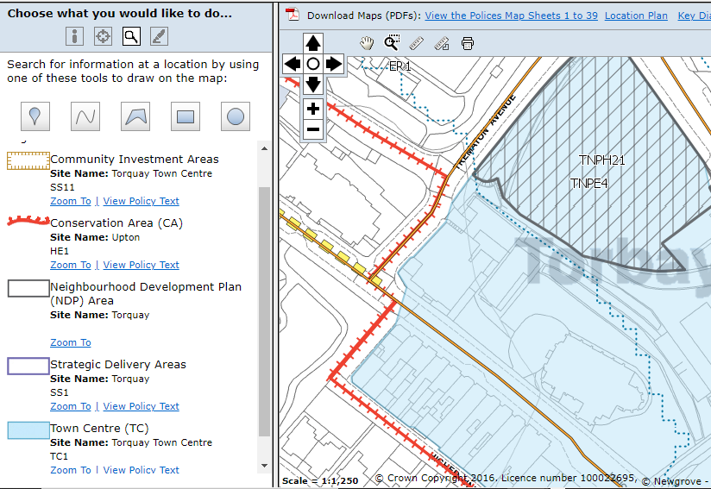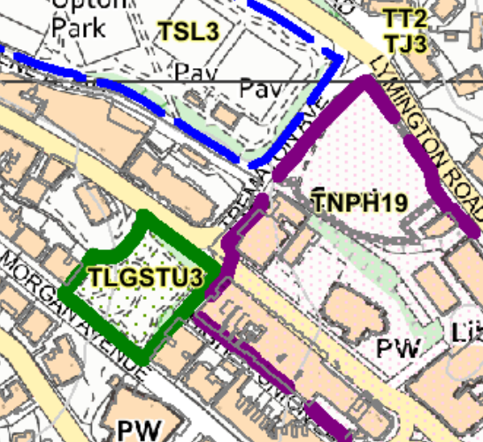
SUITABILITY ASSESSMENT: STAGE A

Strategic potential: | No
Housing? | Yes
Employment? | Office/commercial
Other Use? | residential
Biodiversity- Within SAC/SSSI | No
Flood Zone 3b | No - just outside of Flood zone 3
Other NPPF Showstoppers (not policy constraints) | None
Conclusion | Suitable, available: for sale. Achievable (Stalled)

SUITABILITY ASSESSMENT: STAGE B

Access | Existing access from Trematon Avenue
Flood risk, water quality and drainage | No Surface Water Flooding - SW1
Heritage and Archaeology (including distance from assets). | Conservation Area – Upton  Grade 2 and Grade 2 star buildings adjacent (Chambers, Church and Town Hall)
Infrastructure | Within built up area.
Landscape | No  Memorial Gardens opposite LGS (TU3)
Ecology | No
Safety related constraints | No
Soils (Agricultural Land classification) and contamination | Not agricultural land
Local Plan | CTIA/Town Centre (TC2) Edge of ER1, CA (SS10 and HE)
Neighbourhood Plan | TNP: THPH19 Memorial Gardens opposite LGS (TU3) Policy TE2
Development progress (where relevant) | N/A
Other | Redevelopment residential value. Alternative commercial or community use, possible but unlikely. Parking limited but Town Centre Location adjacent town Hall car park
HELAA Panel Summary
Site potential

AVAILABILITY ASSESSMENT
Reasonable prospect of delivery (timescale):
P/2021/0266 Change of use from former Magistrates Court to 10
residential apartments & associated facilities. INVALID

Pre-Applications:
Reference: Proposal: Decision:
DE/2019/0008 Change of use from courthouse to offices/church day
centre and community activities hall. PER - 30/04/201
Possibility of conversion or sensitive redevelopment for 6 to 10 units.

The next 5 years | 10 units
A 6-10 year period
An 11-15 year period
Later than 15 years

