SITE OVERVIEW: Amber sites – significant constraints
Town Torquay
Site Name Land of Orchard Way , Torquay
HELAA Reference no. | 21T059  TDA T3229  ZP/1888/0012
Customer Reference no. | Leave Blank for now
Source of Site (call for sites, Local Plan allocation etc.). | TDA
Current use | Vacant land with permission for mixed use employment use, including bulky non-food retail
Site descriptions | Scrubland to the north of Orchard Way, part of Torquay Gateway Future Growth Area.
Total site area (ha) | 2.41ha
Gross site area (ha) | 5.91 ha (whole site)
Approx. yield | DPH / 0 ha employment N.B Starting assumption is for 25% of strategic sites to be employment.
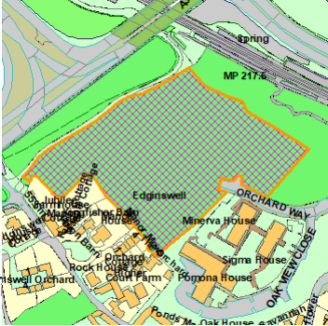
SUITABILITY ASSESSMENT: STAGE A

Strategic potential: 50+ dwellings
Housing?
Employment? | B Class
Other Use? | Class E , B2, B8
Biodiversity- Within SAC/SSSI
Flood Zone 3b | Northern part of the site
Other NPPF Showstoppers (not policy constraints)
Conclusion

SUITABILITY ASSESSMENT: STAGE B

Access | Access off Orchard Way
Flood risk, water quality and drainage | Flooding issues (Zone 3) to the North and East of the site
Heritage and Archaeology (including distance from assets). | No significant heritage constraints.  Archaeology: Potential for medieval settlement archaeology. Requires programme of archaeological mitigation.
Infrastructure | Flooding  The area is designated, and has permission for mainly commercial uses
Landscape | Not countryside area – but promient gateway site
Ecology | LP – OSWI/CWS/SSSI etc. GHB/Cirl Buntings Sustenance Zone/Pinch Points
Safety related constraints | None?  High Voltage Power Line (Edginswell)
Soils (Agricultural Land classification) and contamination | MapInfo/Maps (can do retrospectively
Local Plan | Torquay Gateway Future Growth Area  Adopted Masterplan SPD (2015)- The area is shown as Edginswell Business Park.
Neighbourhood Plan | TH3 Future growth Area Priorities –“affordable housing and community facilities will be given the highest prority”
Development progress (where relevant) | Extensive planning history relating to commercial development:  P/2021/0123  P/2007/1743 Mixed use development comprising business use, car show room, retail warehouse and residential and public house. The development has been implemented and various later permissions relate to elements of the permission e.g P/2016/0955/
Other | See NPPF paragraphs 120 and 121. The LPA could consider allowing some residential use on the land. However, this would result in the loss of employment use in an accessible location. Implementation of the extant permission for bulky retail d
HELAA Panel Summary
Site potential

AVAILABILITY ASSESSMENT

The site promoter(s) has confirmed that the site will be available for development within:
The next 5 years
A 6-10 year period | Could provide approx 50 dwellings but would be contrary to the masterplan and would result in the loss of employment land.
An 11-15 year period
Later than 15 years

