SITE OVERVIEW: Amber sites – significant constraints
Town | Torquay
Site Name | Kingskerswell Fields A And B
HELAA Reference no. | 21T056  T3217
Approx. yield | 10
Suitable | Yes
Available | Unknown
Achievable | Yes
Customer Reference no. | Leave Blank for now
Source of Site (call for sites, Local Plan allocation etc.). | TDA sites.
Current use | Agricultural or open green space
Site descriptions | Fields bound by Kingskerswell Road to the north and housing to the south.
Total site area (ha) | 0.9ha
Gross site area (ha) | 0.7 ha
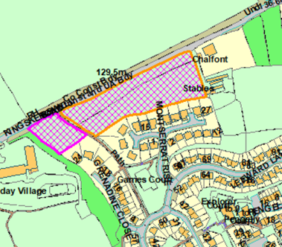
SUITABILITY ASSESSMENT: STAGE A

Strategic potential: | No
Housing? | Yes
Employment? | No.
Other Use? | Tourism (holiday park), G&T, C2.
Biodiversity- Within SAC/SSSI | Cirl Bunting 250 buffer zone for breeding territory. Adjacent to South Hams SAC LCZ.
Flood Zone 3b | No
Other NPPF Showstoppers (not policy constraints) | None.
Conclusion | Suitable if available.

SUITABILITY ASSESSMENT: STAGE B

Access | Kingskerswell Road, C Road, narrow
Flood risk, water quality and drainage | N/A
Heritage and Archaeology (including distance from assets). | N/A
Infrastructure | Drainage, sweage.
Landscape | Greenfield site which falls within Scotts Bridge/Barton Urban Landscape Protection Area.  Policy C5 – Development only permitted where It does not undermine the value of the ULPA as an open or landscaped feature within the  urban area; and It makes a positive contribution to the urban environment and enhances the landscape character of the ULPA.
Ecology | Adjacent to South Hams SAC GHB LCZ.  Cirl Bunting 250m buffer zone for breeding territory falls within part of the site and within consultation zone. Mitigation likely required if loss of suitable habitat.  Greenfield site which falls within a Urban Landscape protection area.
Safety related constraints | N/A
Soils (Agricultural Land classification) and contamination | Need Mapinfo to check
Local Plan | Policy C5 - Development only permitted where It does not undermine the value of the ULPA as an open or landscaped feature within the  urban area; and It makes a positive contribution to the urban environment and enhances the landscape character of the ULPA.  NC1 – Biodiversity and Geodiversity  Policy SS8 – Natural Environement
Neighbourhood Plan | Policy TE4 – Green Corridors  Policy TE5 – Protected species and biodiversity
Development progress (where relevant) | No
Other | Group and individual TPOs along path through centre of site.
HELAA Panel Summary | To be completed later
Site potential | Leave blank until after HELAA Panel

AVAILABILITY ASSESSMENT
Reasonable prospect of delivery (timescale):

The next 5 years
A 6-10 year period | 10
An 11-15 year period
Later than 15 years

