SITE OVERVIEW : Amber sites – significant constraints
Town | Torquay
Site Name | Watcombe Beach Car Park
HELAA Reference no. | 21T055
Approx. yield | 6
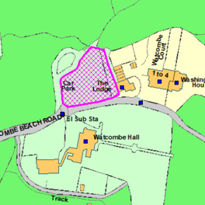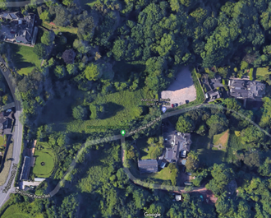
Suitable | Notwithstanding the site’s location at the edge of the settlement boundary within the Countryside Area and Undeveloped Coast, the site is relatively well located with respect to local amenities with a nursery, primary and secondary schools, the Moor Lane Watcombe Neighbourhood Centre, open spaces and recreational facilities, and bus stops on Teignmouth Road all within approximately 10-15mins walk. The site is therefore likely to be suitable subject to a design that conserves or enhances the Conservation Area and has an acceptable landscape impact, however improvements to pedestrian infrastructure would be necessary.
Available | Subject to a review of car parks.
Achievable | Yes, if available.
Customer Reference no.
Source of Site (call for sites, Local Plan allocation etc.). | TDA sites
Current use | Council-owned public car park.
Site descriptions | A Council-owned public car park serving Watcombe Beach. The car park comprises of hardstanding and is bounded by stone boundary walls, hedgerows and trees.
Total site area (ha) | Approx. 0.17ha
Gross site area (ha)

SUITABILITY ASSESSMENT: STAGE A

Strategic potential: | No
Housing? | Yes
Employment? | No
Other Use? | Public car park, other public facilities serving Watcombe Beach
Biodiversity- Within SAC/SSSI | No
Flood Zone 3b | No
Other NPPF Showstoppers (not policy constraints) | None

SUITABILITY ASSESSMENT: STAGE B

Access | Existing site access via Watcombe Beach Road which leads to Teignmouth Road. Much of the 190m stretch of Watcombe Beach Road leading from Teignmouth Road to the site is only wide enough for one car and does not provide a dedicated pedestrian footpath. There may also be a potential need for a pedestrian crossing across Teignmouth Road.
Flood risk, water quality and drainage | Parts of Watcombe Beach Road adjacent to the site boundary are identified on the Environment Agency flood map as an area of surface water flood risk (low risk).
Heritage and Archaeology (including distance from assets). | Located within Watcombe Park Conservation Area.  The Grade II Listed ‘Washington House’ is located around 30m to the east of the site, and the Grade II Listed ‘Lantern House and Watcombe Lodge’ is located around 130m to the northwest of the site.  Historic Environment Record Monument (Clay pits, Watcombe potteries) located immediately to the west of the site.
Infrastructure
Landscape | Torbay Landscape Character Appraisal: Character Type 8 (Coastal slopes and combes), Area of Local Character 8D (Valley of the rocks), Highly sensitive.
Ecology | South Hams Special Area of Conservation for Greater Horseshoe Bats: Landscape Connectivity Zone.  Consultation Zone for Cirl Buntings.
Safety related constraints | Pedestrian access, particularly with respect to crossing Teignmouth Road.
Soils (Agricultural Land classification) and contamination | Non-agricultural land (Grade 5)
Local Plan | Countryside Area (Policy C1).  Undeveloped Coast (Policy C2).  Watcombe Park Conservation Area (Policy SS10).  The northernmost tip of the site is just inside the Coastal Change Management Area (Policy C3).  Biodiversity and Geodiversity (Policy NC1).
Neighbourhood Plan | The adjacent land to the north is designated as a Local Green Space although the site itself is not.
Development progress (where relevant) | None
Other
HELAA Panel Summary
Site potential

AVAILABILITY ASSESSMENT
Reasonable prospect of delivery (timescale):

The next 5 years
A 6-10 year period | 6
An 11-15 year period
Later than 15 years

