SITE OVERVIEW: Amber sites – significant constraints
Town | Torquay
Site Name | TNPH12 Torre Station
Allocation or HELAA Reference no. | 21T053 (21T061is windfall to south)  Housing proposal TNPH12  TNPH11
Approx. yield | 9 dwellings
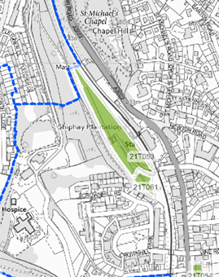
Suitable: How the principle of development is established | Yes - Allocated site
Available: Any change in circumstances since principle established | In use as self storage buisiness – successful business may be why site has not come forward
Achievable | Achievable subject to availability.
Customer Reference no. | Leave Blank for now
Current use | Self-storage
Site description | Land located to the west of Torre Station and the railway line
Total site area (ha) | 1

AVAILABILITY ASSESSMENT
Reasonable prospect of delivery (timescale):

Confirmation of availability needed from owners.
The next 5 years
A 6-10 year period
An 11-15 year period | 9 (not available?)
Later than 15 years

