SITE OVERVIEW : Amber sites – significant constraints
Town | Torquay
Site Name | Argos ‘Block’, Union Street
HELAA Reference no. | 21T052
Approx. yield | 40
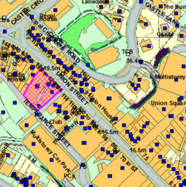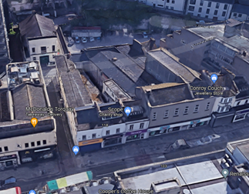
Suitable | Yes, highly sustainable town centre brownfield site that is suitable for residential development on the floors above the ground floor commercial units. The ground floor units themselves could potentially be suitable for conversion to residential however this would need to be considered in terms of a more comprehensive retail study and review of town centre area designations. Suitability is subject to the findings of an updated Strategic Flood Risk Assessment.
Available | Some of the ground floor commercial units which front onto Union Street are occupied and are therefore currently unavailable. The usage and availability of the underutilised spaces on the floors above would need to be checked.
Achievable | Apartments in town centre areas (without sea views and outside of desirable areas such as Conservation Areas) are reported by the development industry to have limited viability in the current market. The site is therefore only likely to be achievable in the longer term (longer than 15 years) should viability improve.
Customer Reference no.
Source of Site (call for sites, Local Plan allocation etc.). | Post Panel Addition
Current use | The ground floor units fronting onto Union Street comprise of retail, offices (Job Centre) and a vacant unit. The premises to the rear, currently vacant, comprise of a former pub (White Hart Inn, which has had its premises license revoked) with manager’s accommodation on the floors above.
Site descriptions | A block of buildings in Torquay’s town centre, located between Union Street and Temperance Street. The block comprises of ground floor retail/commercial units fronting onto Union Street with underutilised space within the first and second floors above, and a vacant pub premises to the rear with manager’s accommodation above.
Total site area (ha) | Approx. 0.13ha
Gross site area (ha)

SUITABILITY ASSESSMENT: STAGE A

Strategic potential: | No
Housing? | Yes
Employment? | Yes – the floors above could be used for offices.
Other Use? | Social housing, older persons’ housing.
Biodiversity- Within SAC/SSSI | No
Flood Zone 3b | Flood Zone 3
Other NPPF Showstoppers (not policy constraints) | None

SUITABILITY ASSESSMENT: STAGE B

Access | Existing site access via Union Street and Temperance Street. Good access to public transport, and walking and cycling infrastructure.
Flood risk, water quality and drainage | The site is located within Flood Zone 3 in terms of the Environment Agency flood map, and within a Flood Risk Area in terms of the Torbay Local Plan. Subject to Strategic Flood Risk Assessment.
Heritage and Archaeology (including distance from assets). | The site forms part of the setting of Tormohun, Abbey Road, and Upton Conservation Areas. Nearby listed buildings include the Grade II Listed Town Hall (80m to the northwest), the Grade II Listed 2 Tor Hill Road (65m to the northwest), and the Grade II* Listed St Mary Magdelene’s Church (150m to the northwest).
Infrastructure | Town centre site with existing infrastructure connections.
Landscape | No significant constraints.
Ecology | The site is located within the Greater Crested Newt Consultation Zone, however it is a brownfield site and therefore this is unlikely to be relevant. Conversion/redevelopment of redundant space would need to be subject to a Bat and Breeding Bird Survey.
Safety related constraints | Any scheme should be designed to reduce the potential for crime.
Soils (Agricultural Land classification) and contamination
Local Plan | Torquay Town Centre (Policy TC1)  Community Investment Area (Policy SS11)  Flood Risk (Policy ER1)  If applicable, conversion of ground floor retail units to residential would need to be considered in terms of Policies TC1 (Town Centre) and TC4 (Change of retail use).
Neighbourhood Plan | Not subject to any specific designations in terms of the Torquay Neighbourhood Plan.
Development progress (where relevant) | A pre-app (DE/2021/0123) has recently been submitted for conversion of the former White Hart Inn into an apartment. A written response has yet to be provided at the time of writing.
Other
HELAA Panel Summary
Site potential

AVAILABILITY ASSESSMENT
Reasonable prospect of delivery (timescale):

The next 5 years
A 6-10 year period
An 11-15 year period
Later than 15 years | 40

