SITE OVERVIEW: Amber sites – significant constraints
Town | Torquay
Site Name | North of Nuthatch Drive
Allocation or HELAA Reference no. | 21T018  TNPH3  T749
Approx. yield | 100
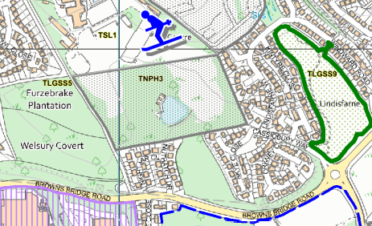
Suitable: How the principle of development is established | Allocated site  Archaeology: Medieval field system identified on LiDAR. May need programme of archaeological mitigation.
Available: Any change in circumstances since principle established | Appears to be available
Achievable | Yes- subject to availability
Customer Reference no.
Current use | Land associated with holiday park
Site description | Land north of Nuthatch Drive and to the east of Furzebank Plantation, Scotts Bridge, Torquay.
Total site area (ha)

AVAILABILITY ASSESSMENT
Reasonable prospect of delivery (timescale):

Confirmation of availability needed from owners.
The next 5 years
A 6-10 year period | 100
An 11-15 year period
Later than 15 years

