SITE OVERVIEW: Amber sites – significant constraints
Town | Torquay
Site Name | Holiday Park, Kingskerswell Road, Torquay western part of site 21T016
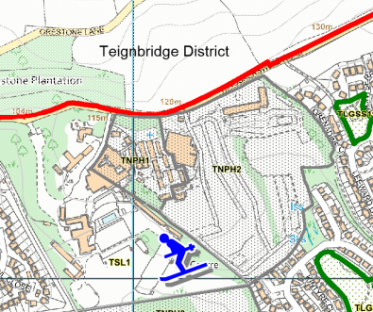
Allocation or HELAA Reference no. | 21T016  Housing proposal TNPH1
Approx. yield | 45 dwellings
Suitable: How the principle of development is established | Yes - Allocated site
Available: Any change in circumstances since principle established | Currently in use as holiday park. Owner confirmation needed
Achievable | Achievable subject to availability.
Customer Reference no. | Leave Blank for now
Current use | Holiday Park
Site description | Holiday Park, Kingskerswell Road, north of Scotts Bridge/Barton residential area.
Total site area (ha)

AVAILABILITY ASSESSMENT
Reasonable prospect of delivery (timescale):

Confirmation of availability needed from owners.
The next 5 years
A 6-10 year period
An 11-15 year period | 45
Later than 15 years

