SITE OVERVIEW: Amber site – significant constraints
Town | Torquay
Site Name | Hollicombe Gas Works, Torbay Road
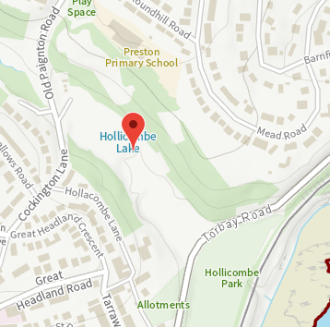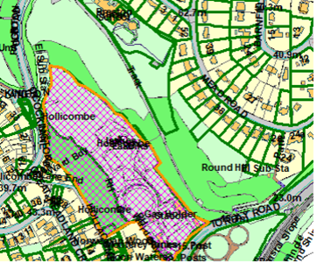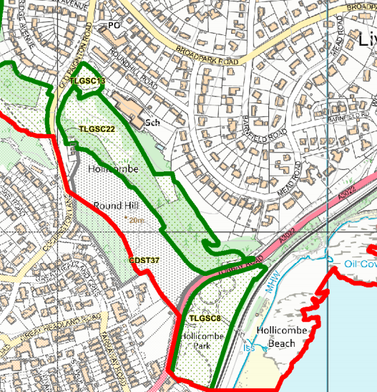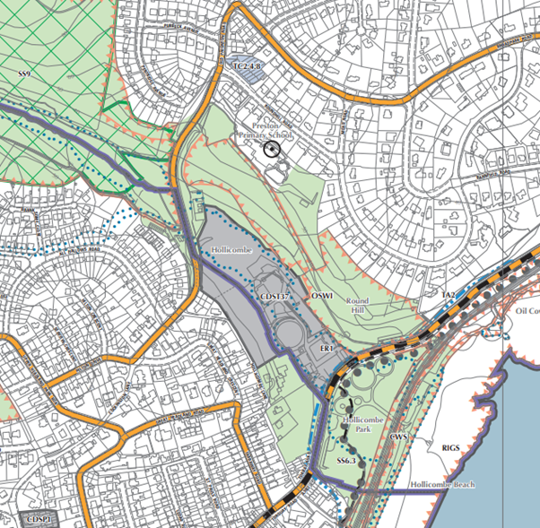
Allocation or HELAA Reference no. | 21T015  Allocated site CDST37  H1.010
Approx. yield | 185
Suitable: How the principle of development is established | P/2008/0114 Construction of 185 residential apartments with associated vehicular and pedestrian access, parking, infrastructure and landscaping works.  P/2015/0999 | Certificate of lawfulness for a section of a vehicular access road built in accordance with planning permission P/2008/0114. | Hollicombe Gas Works Torbay Road Torquay  Archaeology: Former gas works and marsh. Potential for industrial archaeology and palaeoenvironmental evidence. Requires programme of archaeological mitigation.
Available: Any change in circumstances since principle established | Available – owned by a housebuilder  The site was always subject to significant flooding (Zone 3 in the middle of the site). Strategic Flood Risk Assessment will need to determine whether this has become worse since the site was allocated for development. But note that there is a lawfully commenced scheme.
Achievable | No – Despite significant decontamination works the housebuilder owning the site indicates that there is a signicant viability shortfall with the existing 185 flat approval. Site was allocated in the Torbay Local Plan 1995-2011 (adopted 2004) but has not been developed.
Customer Reference no.
Current use | Vacant and boarded up land
Site description | Former gas works site at Hollicombe between Torquay and Paignton.
Total site area (ha)

AVAILABILITY ASSESSMENT
Reasonable prospect of delivery (timescale):

Viability issues with flatted scheme.
The next 5 years
A 6-10 year period | 185
An 11-15 year period
Later than 15 years

