SITE OVERVIEW: Amber sites – significant constraints
Town Torquay
Site Hampton Avenue (car park)
HELAA Reference no. | 21T009
Customer Reference no.
Source of Site (call for sites, Local Plan allocation etc.). | 2013 “Below the Line site” from the previous Local Plan
Current use | Car park
Site descriptions | Part of car park off Hampton Avenue, east of St marychurch Road and adjacent to model village, St Marychurch.
Total site area (ha)
Gross site area (ha) | 0.2 – part of site only
Approx. yield | 10
Map
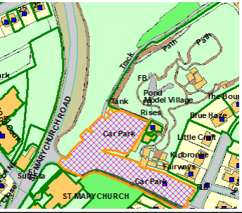

SUITABILITY ASSESSMENT: STAGE A

Strategic potential: 50+ dwellings - no
Housing?
Employment?
Other Use?
Biodiversity- Within SAC/SSSI | No
Flood Zone 3b | No
Other NPPF Showstoppers (not policy constraints)
Conclusion

SUITABILITY ASSESSMENT: STAGE B

Access | Across car park or from St Marychurch Road (not ideal)  Need to retain parking?
Flood risk, water quality and drainage | No (flood zone 2)
Heritage and Archaeology (including distance from assets). | Adjacent (within 15m) of St Marychurch CA
Infrastructure | Urban site
Landscape | Urban site
Ecology | TPO on site
Safety related constraints | Relationship to car park
Soils (Agricultural Land classification) and contamination | No
Local Plan
Neighbourhood Plan
Development progress (where relevant) | None
Other
HELAA Panel Summary
Site potential | Access issues due to car park. Only part of CP for devt. Terraced houses circa 10.

AVAILABILITY ASSESSMENT

The site promoter(s) has confirmed that the site will be available for development within:
The next 5 years
A 6-10 year period | 10
An 11-15 year period
Later than 15 years

