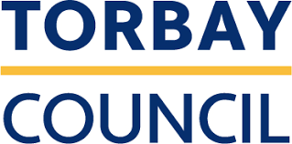

Torbay Suicide Prevention Community Pot

Application form 2021/22.

What is Torbay Suicide Prevention Community Pot?
This funding scheme is available to community organisations across Torbay interested in working on suicide prevention.

Applications can be between £500 and £2000.

Who can apply?
Not for profit, voluntary or community groups, registered charities or social enterprises that are providing services or activities for the benefit of people and communities in Torbay.

What sort of schemes will be funded?
Schemes will need to fit loosely into:
- Peer support
- Online support
- Safe places

Peer support:
For these projects money would be used for peer support activities around mental health and suicide prevention. This might be used to run peer support meetings or other peer support activities.

Online support:
For these projects’ money would be used to support online provision of services, or other online support designed to improve mental health and reduce suicides. This might be used to run an online support group or to fund a community support website.

Safe places:
For these projects money would be used to support activities around creating mental health ‘safe places’. This might be used to help run training for Torbay hospitality staff or taxi drivers

We especially welcome applications to support projects which are already running or established. Applications are not restricted to the example ideas set out above, we are interested in any ideas that fall within the three priority areas outlined

Any funding awarded through this scheme must be spent by 31st March 2022.
For questions about this please contact robincausley@torbaycdt.org.uk

What costs can be applied for?
Expenditure related directly to the project you are requesting a grant for only, including: training, volunteer expenses, publicity, travel, administration, room hire, utilities, telephone and internet, materials and equipment.

Salary costs are not eligible.

How do I apply?
To apply, complete the application form on the next page, and email it to robincausley@torbaycdt.org.uk
The deadline for applications is 1st November 2021. 5 PM.
Decisions will be sent out week commencing 15th November.

Applications can be in different formats, e.g. pictures, video, audio.

If you want help with your application or have questions about this form please contact: robincausley@torbaycdt.org.uk

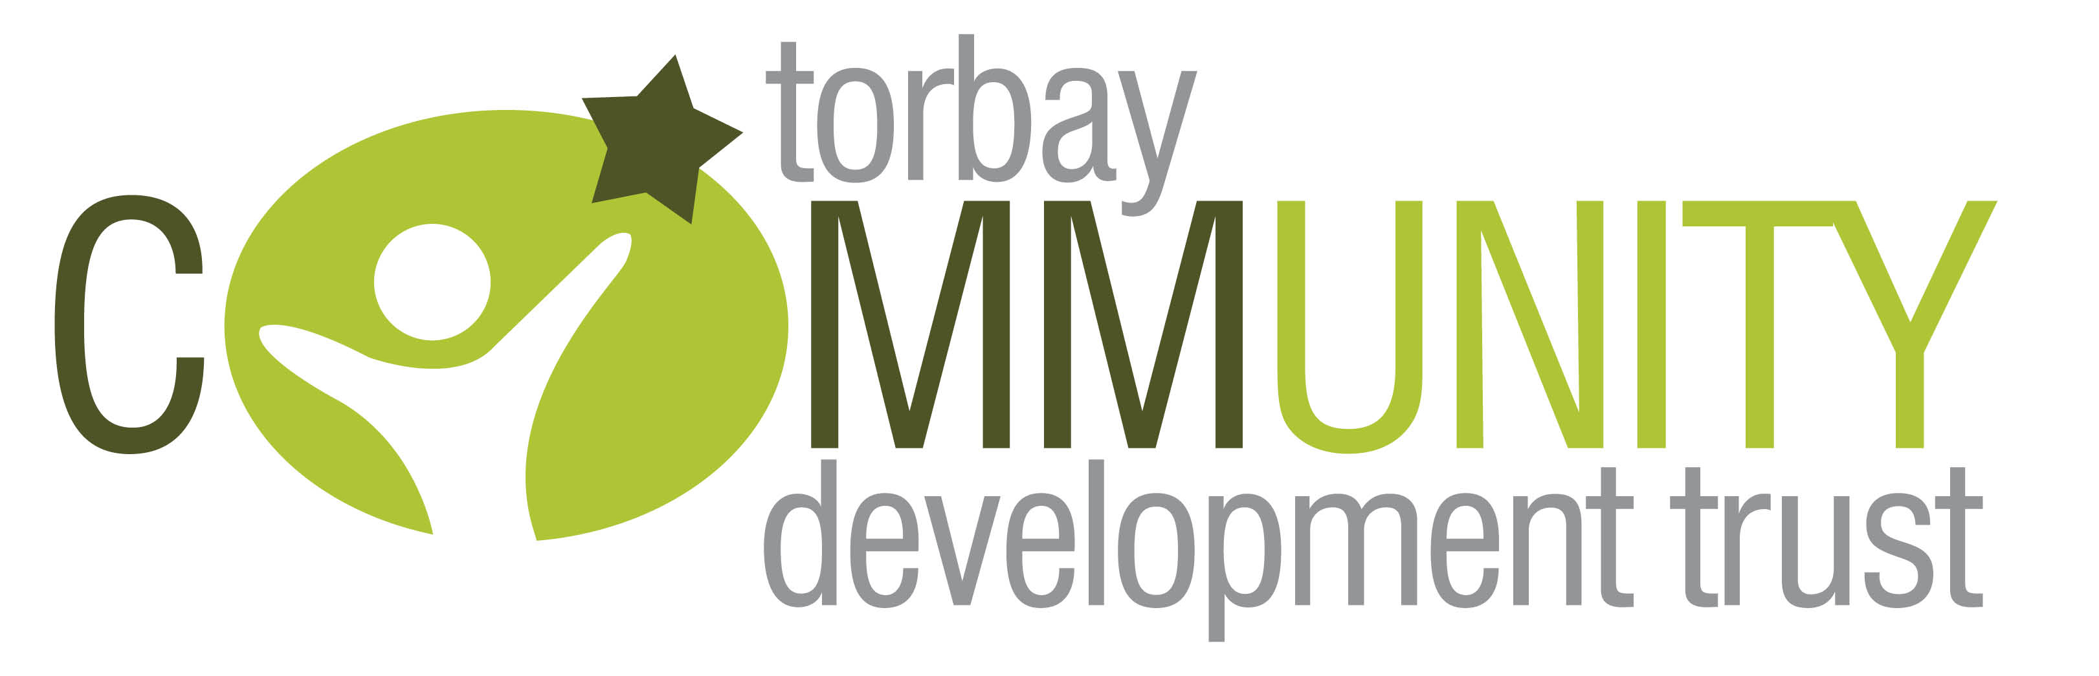

Torbay Suicide Prevention Community Pot: Application Form
Name of group or organisation applying:
Telephone number of main contact:
Email:
Website address:
Address (including postcode):
Which focus area/s (peer support, online support or safe places) does your proposal fall into, briefly explain:

Please briefly tell us about your proposed scheme:
Send your description in any format (pictures, video, audio) you prefer

How will your scheme help to improve mental health and suicide prevention activities in your community?

Numbers expected to benefit from this project:
In the six months after you receive funding, how many people do you expect to benefit from this project? (please give numbers):
- Volunteers

- Participants

- Other (please specify)

Which area of Torbay will the project benefit?
(please tick all that apply)
- Torquay

- Paignton

- Brixham

What is the total cost of your scheme?

£…
How much money do you need from the Torbay Suicide Prevention Community Pot?

£…
What will you spend this money on?

If you are receiving any other funds for this activity please give details:

How will you measure if your scheme is a success?

Please email your completed form to: robincausley@torbaycdt.org.uk

What happens next?
Your proposal will be reviewed by a grants panel. Panels meet regularly and you will be contacted after the next panel meeting to let you know whether your scheme will receive funding.

Someone may contact you for further details about your scheme in the meantime. If you would like to present your scheme to the panel, in person or with others, please let us know.

If you are successful in getting funding for your scheme, we will ask you for reporting in March 20 2022.

