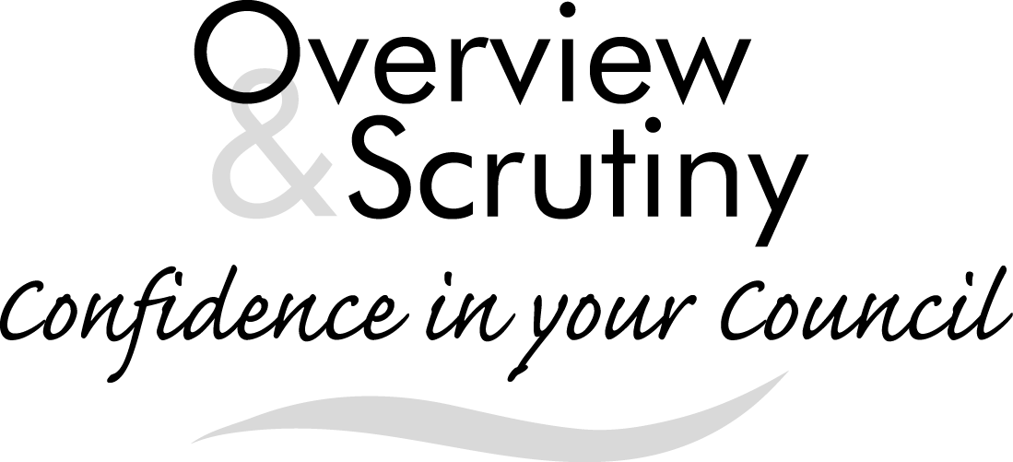
Annual Report 2019/2020

Foreword
This year has been a busy year for the Overview and Scrutiny Board, as can be seen from this report. We have taken a leading role in the Leader and Cabinet’s Budget, the first for the partnership. I am pleased to say our Cabinet colleagues listened to our recommendations and, in part, took them into account. In addition to the budget the Board has investigated a number of issues and I believe has made a difference in some of the key decisions made by the Cabinet.
I would like to thank all the officers at the Town Hall for their help and assistance during our busy year. I would also like to thank all members of the Board who have played their part in our discussions and recommendations.
Councillor Lee Howgate
Overview and Scrutiny Co-ordinator
Introduction
Overview and scrutiny…
- is one of the ways the Council improves services and the quality of people’s lives in Torbay
- acts as the Council’s “watchdog” and challenges decisions taken by the Mayor and looks at decisions in more detail
- reviews existing policies and issues of concern
- is a constructive and independent way of looking at an issue, highlighting areas that work well and suggesting where improvements can be made.
Torbay Council has agreed that overview and scrutiny should operate in accordance with following principles:
- Focusing on the issues which matter:

- Policy Development is of equal importance to “holding to account”

- The Forward Plan is the key tool for managing the decision making process

- The relationship between overview and scrutiny and the executive should seek to complement one another

- All Councillors should have the opportunity to help shape policy decisions at an early stage
This report gives details of the work which has been undertaken by the Overview and Scrutiny Board over the course of 2019/2020.
The operation of overview and scrutiny
The Council appointed Councillor Howgate as the Overview and Scrutiny Co-ordinator in May 2019. He is supported by Councillors Bye, Mandy Darling, Doggett and Foster as Overview and Scrutiny Lead Members.
The membership of the Overview and Scrutiny Board over the course of the year has comprised Councillors Barrand, Brown, Bye, Darling (M), Doggett, Foster, Kennedy and Loxton.
Focusing on the issues which matter
The Overview and Scrutiny Board has continued to undertake its health scrutiny duty and has maintained an oversight of health services in Torbay and clinical services across the peninsula through cross authority briefings.
The Board has continued to receive regular reports on the Council’s revenue and capital budgets. It has closely monitored the performance of Children’s Services both in terms of outcomes for children and the costs of the service.
The Board also responded to the ‘Safer Together – Devon and Somerset Fire and Rescue Service Consultation’, a call for evidence was launched and a number of stakeholders made representation to the Board enabling the Board to provide a comprehensive response to the proposals which the Leader of the Council was recommended to approve as the Council’s formal response.
Equal importance placed on policy development
The Board provided feedback during the development of a number of policies over the course of the year, including the One Torbay Working for all Torbay Draft Corporate Plan, the draft Housing Strategy and were consulted on the Torre Abbey Restoration Project - Phase 3 National Heritage Lottery Fund Bid.
Complementing the work of the executive
The Overview and Scrutiny Board continue to seek to complement the work of the Cabinet, with regular strategic meetings held between the Overview and Scrutiny Co-ordinator, Overview and Scrutiny Vice-Chairman and the Leader of the Council. The Overview and Scrutiny Board held a series of meetings to discuss the Cabinet’s proposals for the budget for 2020/2021.
Call-ins
The call-in process is one of the mechanisms which can be used to hold the Cabinet to account.
The purpose of call-in is to examine the decisions reached by the Cabinet (or other decision makers) and the reasoning behind those decisions. The process enables further public debate to be held on the subject. The Overview and Scrutiny Board can then consider whether the decision was appropriate and make recommendations accordingly.
Over the course of the year, the Overview and Scrutiny Board have considered three call-ins.
Current and Future Work Programme
The Overview and Scrutiny work programme should be flexible in order to address any issues that arise throughout the Municipal Year. The COVID-19 Pandemic has seen that flexibility pushed to the limit. The pandemic has seen the Boards focus significantly change. A number of task and finish groups have had to be suspended due to key officers leading the Council’s response to the initial outbreak and the subsequent recovery phase. The Board has considered how it can contribute to the recovery phase and in doing so sought further information on the preparedness of the Bay’s primary schools from the Assistant Director of Education and Skills in respect of Reception, Years 1 and 6 returning to school. The Board has also held discussions on the impact and possible opportunities for our economy and sense of place during the easing of lockdown and the recovery of the economy.
The future Work Programme will be agreed by the Overview and Scrutiny Board at its first meeting in the new Municipal Year although it will continue to have the flexibility to react to issues as they arise, recognising that the current pressures placed upon the Council’s staff may continue for sometime.
Contact Details
Overview and Scrutiny scrutiny@torbay.gov.uk
Torbay Council www.torbay.gov.uk/scrutiny
Town Hall
Torquay
TQ1 3DR
01803 207014

