ROAD CASUALTY
REDUCTION REPORT 2017

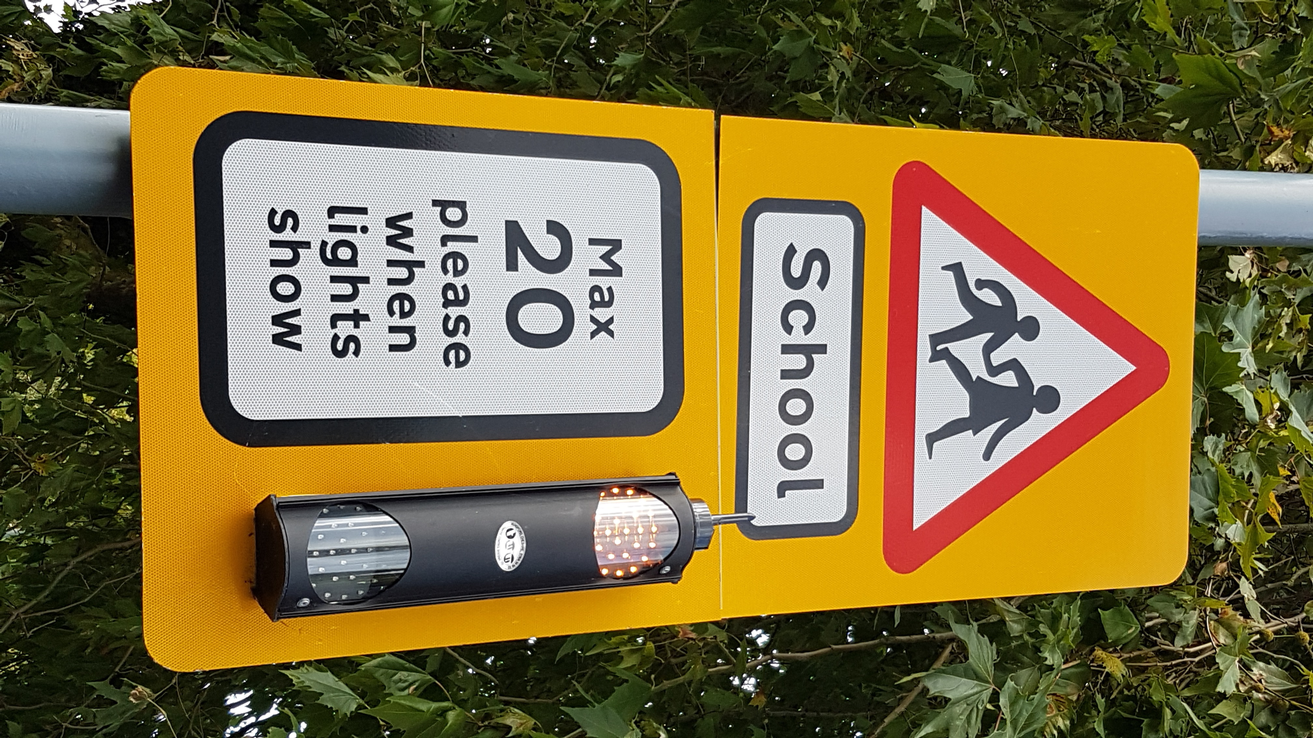

Community & Customer Services

Lower Ground Floor

Town Hall
Torquay
TQ1 3DR

- INTRODUCTION

  - This report highlights the road casualty and collision data for the Torbay area during the calendar year 2017. Torbay Council’s proposals for improving road safety for the next year are identified in the Torbay Council Road Safety Strategy 2017 - 2020, however, this report highlights in more detail the activities for 2017.

2 TORBAY’S TARGETS

2.1 In March 2000 the Government announced new targets for reducing casualties nationally. The targets are the percentage reductions to be achieved by 2010 compared with the average results for the base years, 1994 – 1998. The targets set by the Government were as follows:

- 40% reduction in the number of people killed or seriously injured in road crashes/collisions;

- 50% reduction in the number of children killed or seriously injured;

- 10% reduction in the slight casualty rate, expressed as the number of people slightly injured.

2.2 In 2011 and for the years ahead, it is the intention for the development and implementation of local road safety strategies to enhance road safety delivery by focussing on casualty reduction with objectives and targets to support that aim and programmes planned to achieve that, thus improving casualty reduction.

The development of a local road safety strategy is included within the new Local Transport Plan 3 (2011 – 2026), to ensure greater reductions in road casualties locally by:
- Encouraging better and co-ordinated working between local authorities and their partners;
- Enabling local authorities to consider their future priorities;
- Involving and informing the public.

Road Safety is of paramount importance to both the Council and the residents it serves. Road safety issues are wide ranging and sometimes complex, but the Council has a good record in improving road safety for all transport users. A mixture of on-line education, encouragement, enforcement and engineering alongside evaluation will be used to further improve the safety of all road users. The targeting of young drivers will continue via the ‘Learn 2 Live’ programme.

An evidence based approach to road safety engineering will be used in Torbay to identify and target investment where it is most needed. This will be led by the new Road Safety Strategy 2017-2020, which was approved by members of the Transport Working Party at their meeting on 12th October 2017 and which reflects the reduced staffing levels and resultant loss of the Road Safety Education Service. The new Road Safety Strategy reflects local road safety requirements, taking into account the most up-to-date Government recommendations, guidance, targets and strategy.

Unlike in the period up to 2010, the Department for Transport (DfT) have not set any targets for us to compare our results against.

However the DfT published its Strategic Framework for Road Safety (May 2011) which is designed to help Government, local organisations and citizens to monitor the progress in improving road safety.

The DfT have identified 6 key indicators which relate to road deaths and will measure the key outcomes of the strategy at national level. These are:

- Number of road deaths (and rate per billion vehicle miles)
- Rate of motorcyclist deaths per billion vehicle miles
- Rate of car occupant deaths per billion vehicle miles
- Rate of pedal cyclist deaths per billion vehicle miles
- Rate of pedestrian deaths per billion miles walked
- Number of deaths resulting from collisions involving drivers under 25.

At a local level, such as here in Torbay, the number of road deaths is small and subject to fluctuation. For this reason the DfT propose the following as key indicators:

- Number of killed or seriously injured casualties
- Rate of killed or seriously injured casualties per million people
- Rate of killed or seriously injured casualties per billion vehicle miles

The progress will be reported annually, with details published in ‘Reported Road Casualties Great Britain’.

This will enable local authorities to consider their future priorities, whilst involving and informing the public of what action is taken.

Here in Torbay, we will also to continue to report casualty figures each year as part of the Road Casualty Reduction Report and the figures for the following categories can be found displayed in section 3 of this report.

- Fatal
- Killed and seriously injured
- Killed and seriously injured (0 – 15 years-old)
- Slightly injured
- Slightly injured (0 – 15 years old)

2.3 Over the coming years Torbay, in line with our partners in the Peninsula Road Safety Partnership, will move towards the Vision Zero / Safe Systems approach to road safety with a target of providing a safe transport system, free from death and serious injury.

Safe Systems involves an important shift in approach from trying to prevent all collisions to preventing death and mitigating serious injury in road traffic collisions,
Safe System requires a proactive approach placing road safety in the mainstream of road traffic system planning, design and operation and use. Safe System interventions address common human errors (including seat belt use, alcohol and drug abuse) and human tolerance to injury thresholds and in so doing aims to address the road safety needs of non-motorised as well as motorised road users, younger and older users, male and female users.
Safe System has five pillars of action:
- Safe Road Use;
- Safe vehicles;
- Safe speeds;
- Safe roads and roadsides;
- Post crash response.

This will back up the more normal strategies of Engineering and Enforcement.
The key demonstrably effective strategies are:
- Encouraging use of safer modes and safer routes
- Safety conscious planning and proactive safety engineering design
- Safe separation or safe integration of mixed road use
- Managing speeds to crash protection levels
- Providing crash protective roadsides
- Providing vehicles with collision avoidance and collision injury mitigation and protection
- Deterring dangerous behaviour and ensuring compliance with key safety rules by social marketing and increased highly visible police enforcement and use of camera technologies and by providing proven driver assistance safety technologies in motor vehicles to help drivers keep to speed limits, wear seat belts, and avoid excess alcohol.
- Managing risk via driver standards e.g. graduated driver licensing.
- Fast and efficient emergency medical help, diagnosis and care.

3 CASUALTY AND COLLISION DATA

3.1 A Casualty is a person killed or injured in a reported accident on a public road. Casualties are sub-divided into killed, seriously injured and slightly injured. The graphs below outline the road casualty and collision data for the years 1998 to 2017 compared against the government targets (where applicable).

3.2 Nationally car occupants continue to account for the largest proportion of casualties of all severities. A total of 787 car occupants were killed in 2017, down 4% (or 29 fatalities) from 816 in 2016. Overall car occupant casualties decreased by 8% to 100,082 in 2017 compared to 2016, and was the lowest on record.
3.3 In 2017, nationally there were 144,369 slightly injured casualties in reported road traffic accidents, this figure is as reported to the police and is not comparable to earlier years due to changes in severity reporting.

3.4 Approximately half of English police forces adopted the CRASH (Collision Recording and Sharing) system for recording reported road traffic collisions at the end of 2015 or the first part of 2016, Devon and Cornwall Police switched in December 2015.

It is likely that the recording of injury severity is more accurate for forces using this new reporting system. Nationally this has had a large impact on the number of serious injuries recorded in 2016, compared with 2015. Some of these serious injuries may previously have been classified as slight injuries, which means that the 2016 and 2017 serious injury figures are not comparable to previous years.
CRASH is an injury-based severity reporting systems where the officer records the most severe injury for the casualty and the injuries are then automatically converted to a severity level from ‘slight’ to ‘serious’. Eliminating the uncertainty in determining severity that arises from the officer having to make their own judgement means that the new severity level data observed from these systems using injury based methods are expected to be more accurate than the data from other systems.
Therefore there has been a large increase in the number of serious injuries reported by the police after the introduction of CRASH in 2015/16 (+20%); as around half of police forces in England adopted this system, however the number of serious injuries recorded in 2017 has remained stable when compared to 2016.
Even though Torbay has such low base figures, this still showed an increase in our KSI figures of 15% between 2015 and 2016.

3.5 Fatalities

Fig 1 shows the number of fatalities that have occurred within Torbay

Whilst there has been a 15% increase in fatalities cross the South West, we can report a decrease in the number of fatalities on Torbay roads in 2017, decreasing from 3 in 2016 to 1. The average figures remain at a consistent overall level, since the 1998 to 2010 targets were introduced.

Torbay Council continues to work from very low base figures and continues to have one of the safest road networks within the South West. The authority benchmarks with other highway authorities and the number of road traffic casualties expressed as a percentage of the population is amongst the lowest in the south west.

3.6. Killed and Seriously Injured (KSI’s) (all age groups)

Fig 2 shows the number of people killed or seriously injured within Torbay.

Unfortunately there has been an increase in the numbers of killed and seriously injured casualties, the results for 2017 show there has been an increase of 6% in the number of killed and seriously injured since last year, rising from 45 to 48.

Torbay Council continues to work from very low base figures and significant reductions can be very hard to identify, further details on reviewing collision cluster sites are included in section 5.3.

It should be noted that due to the change in the Police collision recording system (as detailed in 3.4 above) the 2016 and 2017 serious injury figures are not comparable to previous years.

3.7 Killed and seriously injured (0 – 15 age group)

Fig 3 shows the number of 0-15’s killed or seriously injured within Torbay

The results show that the number of killed and seriously injured casualties (0-15 age group) has remained static over the past year, remaining at 2 casualties.

Analysis shows that both of these casualties were cyclists (ages 13 and 14), ongoing ‘Bikeability’ cycle training, now being run by the Culture and Events Service will continue to target this category.

It should be noted that due to the change in the Police collision recording system (as detailed in 3.4 above) the 2016 and 2017 serious injury figures are not comparable to previous years.

3.8 Slight Injuries

Fig 4 shows the slight injuries for all ages and the 0-15’s within Torbay

All ages
The results show slight injury casualties down slightly by 13% to 274 and our figures continue to show a downward trend from the 1988 baseline of 445, with a current reduction of 38%.

Children (0-15 age group)
After last year’s spike in the figures, there has also been a 35% decrease in child slights, with 20 recorded in 2017.

Provisional analysis shows that 25% of these casualties were pedestrians (one of which was two years old), 30% front seat passengers, 25% rear seat passengers (all of whom were aged 6 or younger) and 20% cyclists.

Again, it should be noted that due to the change in the Police collision recording system (as detailed in 3.4 above) the 2016 and 2017 serious injury figures are not comparable to previous years.

4 PLANNED ROAD SAFETY CAMPAIGNS 2018

4.1 Reductions in local government grants from Central Government and the increasing demands on our services has meant that difficult decisions have had to be made and as there is no statutory duty to provide Road Safety officers, the Mayors Budget for 2017/2018 resulted in the loss of posts within Road Safety.

Whilst there will be no Road Safety campaigns or Road Safety education undertaken during 2018, the website (http://www.torbay.gov.uk/roads/road-safety/) will become a pointing service, guiding users to associated Road Safety websites for the latest available information.

5 PLANNED EXPENDITURE OF FUNDING FOR ROAD SAFETY INITIATIVES

5.1 Contained within the Local Transport Plan Implementation Plan (2016/17 – 2020/21) are the details of committed budgets which includes Road Safety initiatives. This information is shown under the heading of Safety / Congestion / Engineering Work.

This budget will allow for a number of small minor road safety engineering schemes each year. Any larger schemes will need to be considered as separate businesses cases as part of the authority’s capital budget setting process.

The expenditure for minor schemes in 2018/19 is expected to be £50,000.

TRAFFIC ACTION ZONE

The Local Transport Plan 3 (2011 – 2016) identified the continued provision of funding from the capital programme for Traffic Action Zones (TAZ), the last of which was in Coombe Pafford and Hele, which was implemented during 2013/2014.

There are currently no plans to consider any further TAZ’s

  - ROAD SAFETY INITIATIVES

With the implementation of various road safety schemes since Torbay became a unitary authority, there are now very few obvious ‘traditional’ collision cluster areas which can be identified. This means that the law of diminishing returns applies to any schemes implemented. However, engineering measures are an important part of the Council’s strategy in reducing collisions. The Council will continue with its Safer Journeys programme and will carry out a review of accidents to identify any linear routes which have a higher than normal collision record. Further details of the engineering measures to be carried out in 2018/19 will be presented to the Transport Working Party in the Road Safety Initiatives Report.

5.4 PENINSULA ROAD SAFETY PARTNERSHIP

Torbay Council continues to work closely with the Police to ensure enforcement is a key activity in road casualty reduction. The Council also works with the Peninsula Road Safety Partnership (formerly known as the Devon and Cornwall Safety Camera Partnership) to use camera enforcement and education to reduce speeds and red light violation.

Once again there will be decreased funding for the operation of Safety Cameras in 2017/18, however the operation and enforcement of the fixed safety camera sites within Torbay will continue.

The authority will continue to work closely with the partnership to ensure that mobile safety camera activity is targeted at those locations where speed related problems continue in an effort to increase the visibility of enforcement.

A new addition for 2018 is the partnerships ‘No Excuses’ team, with operational hubs at Exeter and Bodmin the seven officers are dedicated to targeting offences on the regions roads and to assist and enable fellow roads policing and response officers to do the same. Concentrating on tackling the Fatal Five offences that cause an unacceptable level of deaths and serious injuries on our roads – excessive or inappropriate speed, not wearing a seatbelt, distracted driving such as using a handheld mobile phone, driving under the influence of alcohol or drugs and careless or inconsiderate driving. They will be supported by a researcher to identify significant intelligence trends on road users and areas with specific issues.

