ROAD CASUALTY
REDUCTION REPORT 2016

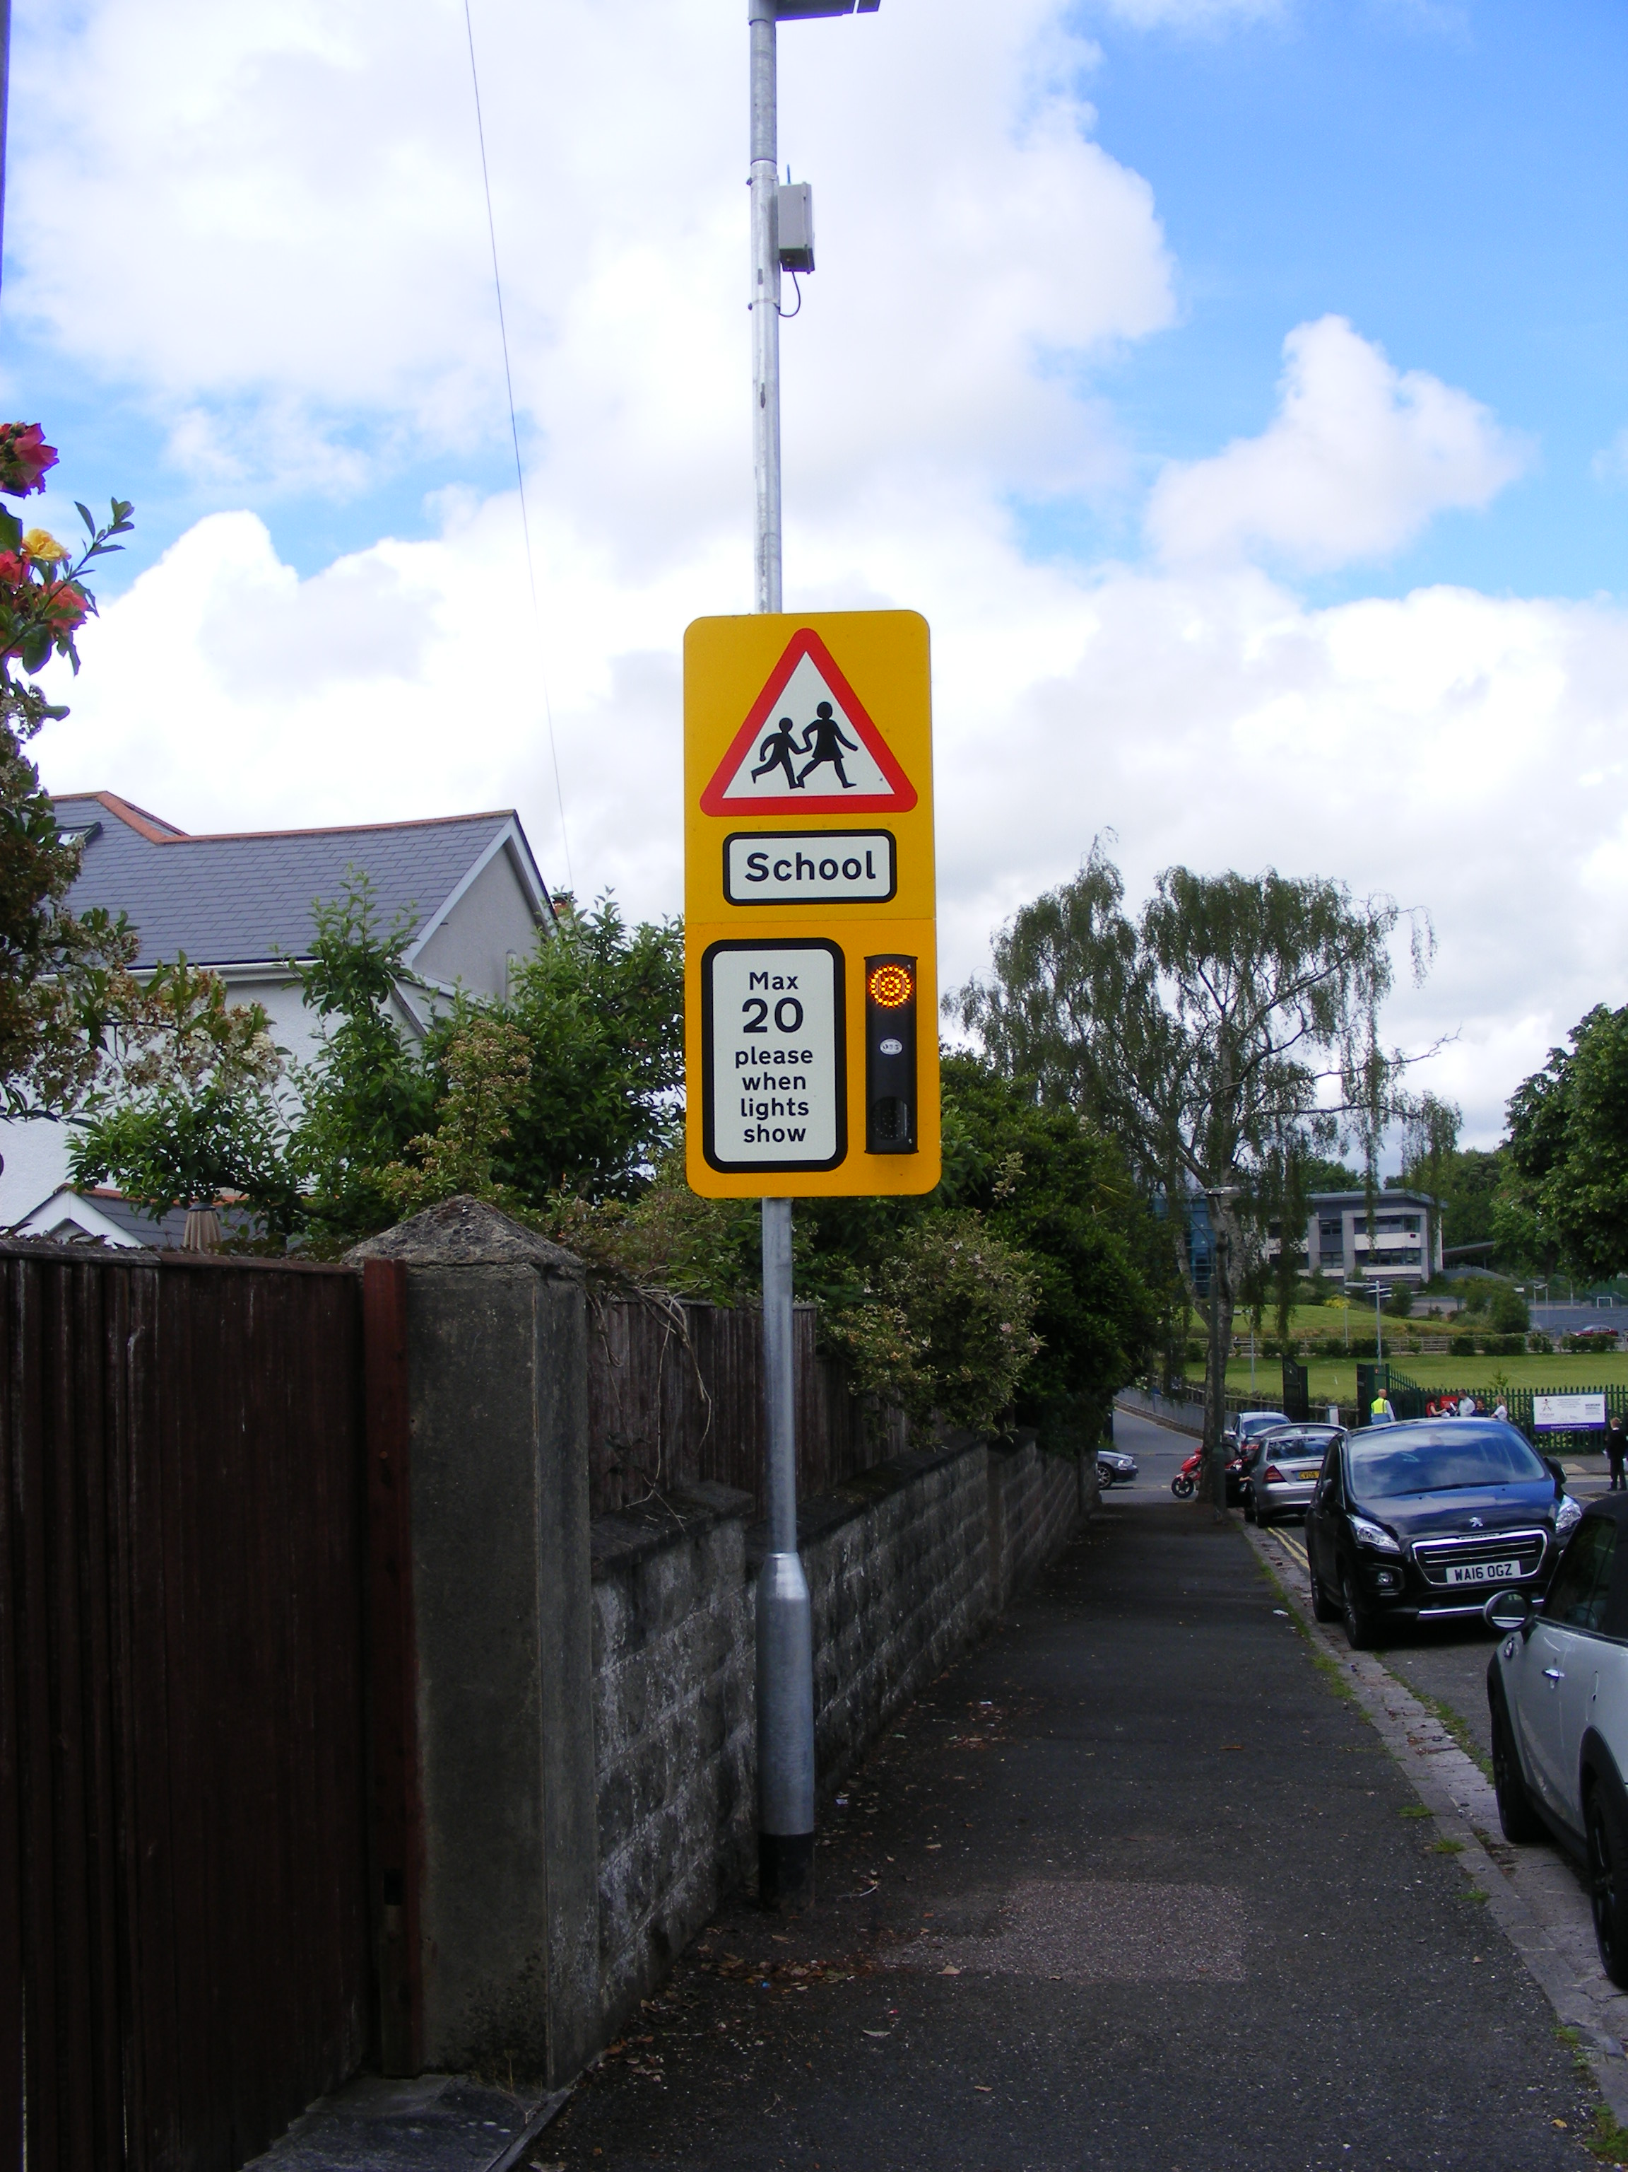

Community & Customer Services

Lower Ground Floor

Town Hall
Torquay
TQ1 3DR

- INTRODUCTION

  - This report highlights the road casualty and collision data for the Torbay area during the calendar year 2016. Torbay Council’s proposals for improving road safety for the next year are identified in the Torbay Council Road Safety Strategy 2012 - 2020, however, this report highlights in more detail the activities for 2016.

2 TORBAY’S TARGETS

2.1 In March 2000 the Government announced new targets for reducing casualties nationally. The targets are the percentage reductions to be achieved by 2010 compared with the average results for the base years, 1994 – 1998. The targets set by the Government were as follows:

- 40% reduction in the number of people killed or seriously injured in road crashes/collisions;

- 50% reduction in the number of children killed or seriously injured;

- 10% reduction in the slight casualty rate, expressed as the number of people slightly injured.

2.2 In 2011 and for the years ahead, it is the intention for the development and implementation of local road safety strategies to enhance road safety delivery by focussing on casualty reduction with objectives and targets to support that aim and programmes planned to achieve that, thus improving casualty reduction.

The development of a local road safety strategy is included within the new Local Transport Plan 3 (2012 – 2020), to ensure greater reductions in road casualties locally by:
- Encouraging better and co-ordinated working between local authorities and their partners;
- Enabling local authorities to consider their future priorities;
- Involving and informing the public.

Road Safety is of paramount importance to both the Council and the residents it serves. Road safety issues are wide ranging and sometimes complex, but the Council has a good record in improving road safety for all transport users. A mixture of education, encouragement, enforcement and engineering alongside evaluation will be used to further improve the safety of all road users.

An evidence based approach to road safety engineering will be used in Torbay to identify and target investment where it is most needed. This will be led by the new Road Safety Plan, which was approved by members of the Transport Working Party at their meeting on 25th April 2013. The new Road Safety Plan reflects local road safety requirements, taking into account the most up-to-date Government recommendations, guidance, targets and strategy.

Unlike in the period up to 2010, the Department for Transport (DfT) have not set any targets for us to compare our results against.

However the DfT published its Strategic Framework for Road Safety (May 2011) which is designed to help Government, local organisations and citizens to monitor the progress in improving road safety.

The DfT have identified 6 key indicators which relate to road deaths and will measure the key outcomes of the strategy at national level. These are:

- Number of road deaths (and rate per billion vehicle miles)
- Rate of motorcyclist deaths per billion vehicle miles
- Rate of car occupant deaths per billion vehicle miles
- Rate of pedal cyclist deaths per billion vehicle miles
- Rate of pedestrian deaths per billion miles walked
- Number of deaths resulting from collisions involving drivers under 25.

At a local level, such as here in Torbay, the number of road deaths is small and subject to fluctuation. For this reason the DfT propose the following as key indicators:

- Number of killed or seriously injured casualties
- Rate of killed or seriously injured casualties per million people
- Rate of killed or seriously injured casualties per billion vehicle miles

The progress will be reported annually, with details published in ‘Reported Road Casualties Great Britain’.

This will enable local authorities to consider their future priorities, whilst involving and informing the public of what action is taken.

Here in Torbay, we will also to continue to report casualty figures each year as part of the Road Casualty Reduction Report and the figures for the following categories can be found displayed in section 3 of this report.

- Fatal
- Killed and seriously injured
- Killed and seriously injured (0 – 15 years-old)
- Slightly injured
- Slightly injured (0 – 15 years old)

3 CASUALTY AND COLLISION DATA

3.1 The graphs below outline the road casualty and collision data for the years 1998 to 2016 compared against the government targets (where applicable).

3.2 Fatalities

Fig 1 shows the number of fatalities that have occurred within Torbay
Unfortunately we have to report an increase in the number of fatalities on Torbay roads in 2016, increasing from last year’s nil return to 3. The average figures remain at a consistent overall level, since the 1998 to 2010 targets were introduced.

Torbay Council continues to work from very low base figures and continues to have one of the safest road networks within the South West. The authority benchmarks with other highway authorities and the number of road traffic casualties expressed as a percentage of the population is amongst the lowest in the south west.

3.3. Killed and Seriously Injured (KSI’s) (all age groups)

Fig 2 shows the number of people killed or seriously injured within Torbay.

After two years of decreasing figures there has been an increase in the numbers of killed and seriously injured casualties, the results for 2016 show there has been an increase of 15% in the number of killed and seriously injured since last year, rising from 39 to 45.

Torbay Council continues to work from very low base figures and significant reductions can be very hard to identify, further details on reviewing collision cluster sites are included in section 5.3.

3.4 Killed and seriously injured (0 – 15 age group)

Fig 3 shows the number of 0-15’s killed or seriously injured within

The results show there has been a slight decrease in the number of killed and seriously injured casualties (0-15 age group) over the past year, dropping from 3 casualties to 2.

Analysis shows that both of these casualties were pedestrians. Continued targeting of road safety education to this age group will take place as part of our ‘Learn to Live’ campaign.

‘Bikeability’ cycle training will continue.

3.5 Slight Injuries

Fig 4 shows the slight injuries for all ages and the 0-15’s within Torbay

All ages
The results show slight injury casualties down slightly by 6% to 315 and our figures continue to show a downward trend from the 1988 baseline of 445, with a current reduction of 29%.

Children (0-15 age group)
Unfortunately there has been a 34% increase in child slights for 2016, up from 23 in 2015 to 31.

Provisional analysis shows that 55% of these casualties were pedestrians (3 of which were 5 or younger), 10% front seat passengers, 29% rear seat passengers and 6% cyclists.

4 PLANNED ROAD SAFETY CAMPAIGNS 2017

4.1 Reductions in local government grants from Central Government and the increasing demands on our services has meant that difficult decisions have had to be made.

There is no statutory duty to provide Road Safety officers and as the schools already pay for school crossing patrols, it was proposed to seek funding for road safety education and prevention. However, no sustainable source of funding was found during the course of the consultation period and therefore the Mayors Budget for 2017/2018 resulted in the loss of posts within in Road Safety.

Whilst there will be no Road Safety campaigns or Road Safety education undertaken during 2017, the website (http://www.torbay.gov.uk/roads/road-safety/) will become a pointing service, guiding users to associated Road Safety websites for the latest available information.

5 PLANNED EXPENDITURE OF FUNDING FOR ROAD SAFETY INITIATIVES

5.1 Contained within the Local Transport Plan Implementation Plan (2016/17 – 2020/21) are the details of committed budgets which includes Road Safety initiatives. This information is shown under the heading of Safety / Congestion / Engineering Work.

This budget will allow for a number of small minor road safety engineering schemes each year. Any larger schemes will need to be considered as separate businesses cases as part of the authority’s capital budget setting process.

The expenditure for minor schemes in 2017/18 is expected to be £50,000.

TRAFFIC ACTION ZONE

The Local Transport Plan 3 (2011 – 2016) has identified the continued provision of funding from the capital programme for Traffic Action Zones (TAZ).

The objective of the projects was to enable communities to become involved with the re-design of their streets to reduce vehicle speeds and provide safer / better access to the schools and other facilities within the TAZ.

The Coombe Pafford and Hele Traffic Action Zone was implemented during 2013/2014, with some minor additions during 2017/18. There are currently no plans to consider any further TAZ’s

  - ROAD SAFETY INITIATIVES

With the implementation of various road safety schemes over the thirteen years since Torbay became a unitary authority, there are now very few obvious ‘traditional’ collision cluster areas which can be identified. This means that the law of diminishing returns applies to any schemes implemented. However, engineering measures are an important part of the Council’s strategy in reducing collisions. The Council will continue with its Safer Journeys programme and will carry out a review of accidents to identify any linear routes which have a higher than normal collision record. Further details of the engineering measures to be carried out in 2017/18 will be presented to the Transport Working Party in the Road Safety Initiatives Report.

5.4 PENINSULAR ROAD SAFETY PARTNERSHIP

Torbay Council continues to work closely with the Police to ensure enforcement is a key activity in road casualty reduction. The Council also works with the Peninsular Road Safety Partnership (formerly known as the Devon and Cornwall Safety Camera Partnership) to use camera enforcement and education to reduce speeds and red light violation.

Once again there will be decreased funding for the operation of Safety Cameras in 2017/18, however the operation and enforcement of the fixed safety camera sites within Torbay will continue.

The authority will continue to work closely with the partnership to ensure that mobile safety camera activity is targeted at those locations where speed related problems continue in an effort to increase the visibility of enforcement.

