Where can we get help?
Information for young people and their families in Torbay

GENERAL

The Mooring@ Croft Hall Medical Practice – Torquay. Over 16’s service From 6pm – Midnight for help in managing distress and connecting to support. Tel 07483991848

WORRY / Anxiety
Anxiety Survival Guide for Teens: CBT Skills to Overcome Fear, Worry, and Panic by Jennifer Shannon
My Anxious Mind: A Teen's Guide to Managing Anxiety and Panic by Michael A. Tompkins, Katherine A. Martinez, Michael Sloan
The Shyness and Social Anxiety Workbook for Teens: CBT and ACT Skills to Help You Build Social Confidence by Jennifer Shannon
What to do when you worry too much: a kids guide to overcoming anxiety by Dawn Huebner and Bonnie Matthews.
SAM: is an app to help you understand and manage anxiety
LOW MOOD
Am I Depressed and What Can I Do About it?: A CBT Self-Help Guide for Teenagers Experiencing Low Mood and Depression by Shirley Reynolds, Monika Parkinson
Can I Tell You About Depression?: A Guide for Friends, Family and Professionals By Christopher Dowrick, Susan Martin, Mike Medaglia, Paula Dowrick
Stuff That Sucks: Accepting What You Can't Change and Committing to What You Can by Ben Sedley
Useful websites
Mood juice a Self-help resource site www.moodjuice.scot.nhs.uk
Young Minds: information and resources about young people’s mental health www.youngminds.org.uk
Teenline: trained counsellors offering online support www.teenline.org.uk
Get Self Help: online resource and self help worksheets www.getselfhelp.co.uk
Self-Harm
The Truth About Self-Harm: For Young People and Their Friends and Families: 2016 by Celia Richardson
The rainbow journal; for young people who self injure by Catherine Lucas
Useful websites
National Self Harm Network: advice and information about self harm www.nshn.co.uk
Selfharm UK: Information about who, why, statistics and getting help. www.selfharm.co.uk also links to the online support group – Alumina
Apps
Calm harm: provides tasks to help you resist or manage the urge to self-harm.
Virtual hope box: an app which brings together a selection of tools to aid relaxation, coping and positive thinking.
Mandala colouring: Colouring app which aids distraction, relaxation and mindfulness
Smiling mind A variety of programs divided into age groups which allow people to develop Mindfulness techniques to support good mental health
What’s up: app which uses CBT and ACT self-help approaches to help you cope with a variety of strong emotions.
Low self esteem
Self-Esteem and Being You by Anita Naik
Banish Your Self-Esteem Thief: A Cognitive Behavioural Therapy Workbook on Building Positive Self-Esteem for Young People by Kate Collins-Donnelly
Dove: Resources and information for young people, parents and professionals about boosting young girls body image and self-esteem www.selfesteem.dove.co.uk
Young minds: Tips and advice for young people and parents about how to improve low self esteem.
http://www.youngminds.org.uk/
Other Services
Eat that frog: supporting unemployed people (16yrs +) who have a health or disability related issue to get back into work or training. This free program includes 1:1 mentoring, well-being support, life style skills and fitness. www.workshopseatthatfrog.org

Tool Kit

Our mood can be greatly affected by what we do, when, and with whom.
- ACHIEVE - work, chores, study
- CONNECT - with friends, family, community
- ENJOY - play, fun, pleasure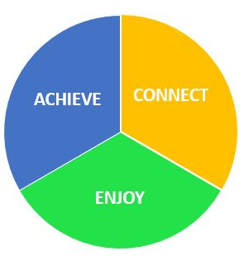

Using the 5 senses, to help you shift focus of attention and ground you into the present moment:
5 things I can see
4 things I can hear
3 things I can touch
2 things I can smell or taste
1 breath. Then continue to just notice your breathing and the sensations of breathing

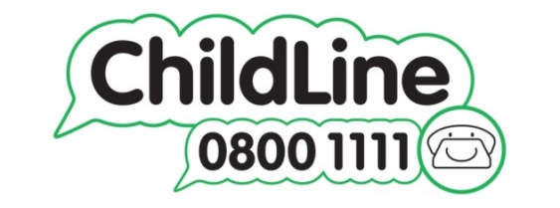

Apps and resources online
- HEADSPACE Your Gym membership for your mind www.headspace.com
- MOOD JUICE emotional problems work towards solving them www.moodjuice.scot.nhs.uk
- GET SELF HELP problems, solutions, downloads, videos www.getselfhelp.co.uk
- SUPPORT LINE confidential advise www.supportline.org.uk
- MIND Apps for wellbeing and mental health www.mindcharity.co.uk

