Torbay Youth Service  Winter Programme 2019 to 2020  Mondays  Targeted Youth Support 1 to 1 support by referral  Tuesdays  Targeted Youth Support 1 to 1 support and groups by referral  Young Men’s Group 11 to 16 years 6.30-9pm Contribute to activities  Wednesdays  Targeted Youth Support 1 to 1 support by referral  Junior Club 10 to 13 years 5-6.30pm £1.00 subs  Thursdays  Targeted Youth Support 1 to 1 support by referral  Children in Care Club & Council 8 to 18 years 5-6.30pm £1.00 subs  Senior Club 13 to 19 years & up to 25 with disabilities. Free 7-8.30pm  Fridays  Targeted Youth Support 1 to 1 support by referral  Young Women’s Group 12 to 16 years 5-6.30pm £1.00 subs  Stay Safe Activities Street-based youth work 11 to 17 years Music/radio 7-9pm Free  Please CONTACT US for details of the activities on offer in the above  Please ring (01803) 208449 and please leave a message if needed and we will come back to you  Email us at youthservice@torbay.gov.uk for details/ referral forms | 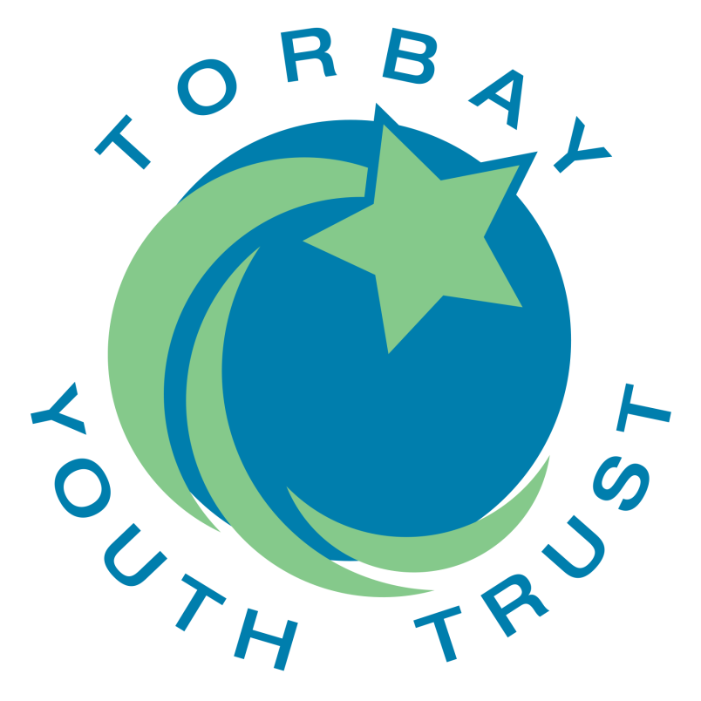  Have fun  Make friends  Info & Support  New skills  Design activities  Learning Outcomes  Every Child Matters  Staying safe, being healthy, enjoy & achieve, make a positive contribution, achieve economic well-being  Outcomes Framework  Communication, confidence and agency, creativity, manage feelings, planning and problem solving, resilience and determination  Activities  Sports, arts and crafts, cooking, music, radio work with Sound Communities, IT, info & support, C-card & SRE, climbing with Reach Outdoors, games, healthy living, outdoor education, outings, informal education, table top roleplay  Clubs are currently taking place in Community Venues  At the Hub, Parkfield in early 2020

