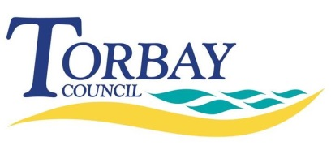
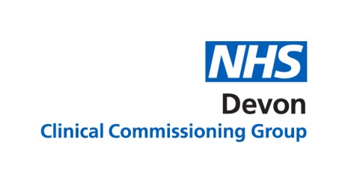
Torbay community investment fund application form

The community investment fund aims to support voluntary sector organisations, group or individuals with project or schemes that can help to improve the health and wellbeing outcomes of people living in Torbay.
Torbay and South Devon NHS Foundation Trust, Devon Clinical Commissioning Group and Torbay Council want to work with the voluntary and community sector in a new way and build a different relationship with local people by building on the strengths and assets that each community has to enhance the way in which we work together.
We are looking for new schemes or projects that align to the priorities and criteria which have been set out in the guidance. The guidance can be found online at www.torbay.gov.uk/cif
We look forward to receiving your application. If you require any help and support please refer back to the guidance document or get in touch with the development and improvement unit via ibcf@torbay.gov.uk
Application form

Part 1: Your contact details

Name: (organisation, group, individual)

Lead:(person or organisation)

Email:

Telephone number:

Address (including postcode):
Website address (if available):
Part 2: What you do

Please tell us a bit about your service:
Part 3: Your idea

Please tell us more about your proposed scheme/project, including your aims and where and how it will be delivered:
(You can use text, photos, video or any format you prefer)
Will your scheme or project be based in: |  | ☐ Torquay  ☐ Paignton  ☐ Brixham  ☐ Baywide
How will your scheme/project help to improve the health and wellbeing of local people? Tell us, how you visualise the success of this project? And what need or gap in the community it will meet?
Could your project be expanded or replicated elsewhere? (If yes please tell us more about how this could work.)
Please tell us how your scheme/project meets the priorities (see guidance)? (Remember it MUST meet one of priorities listed from 1-4 in the first instance, if it also meets one or more of the other additional priorities 1-5 please explain how and why? )
Will you be working in conjunction with any other voluntary sector organisations or community groups?
(If so, please tell us more about how this will work and who you will be working with)
When do you propose a start date (All projects must start before 1st March 2020): |  |  | Click here to enter a date.
Have you or your organisation or group delivered similar projects or work? |  |  | YES/NO
If YES please provide some details:
Please tell us a bit more about your plans to get the project/scheme up and running and how you might do this? (Please also include any timeframes or timelines within this that you may have.)
Part 4: Outcomes and sustainability

How do you propose to measure your scheme or project? (please list and measure the outcomes that you plan to capture which help demonstrate the value of the investment)
How do you plan to sustain your scheme/project if it is successful?
(Please tell us about any sustainability plans beyond the funding?)
How will you promote and publicise your project?
Please use this space to tell us anything else that you wish to record about your project or scheme?
Part 5: Financial information

How much will the scheme/project cost: |  |  |  | £
How much funding from the IBCF do you require: |  |  |  | £
Where will the rest of your funding come from (if needed)?
Can you demonstrate reasonable costings for your project?
Please send your completed form to ibcf@torbay.gov.ukby Sunday 1st December 2019.

What happens next?
Your application form will be reviewed by the voluntary and community sector steering group and you will hear the outcome as soon as this has been decided.
You may be contacted in the meantime for more details about your project/scheme.
The data that you have provided will be stored in accordance with General Data Protection Regulation (GDPR).

