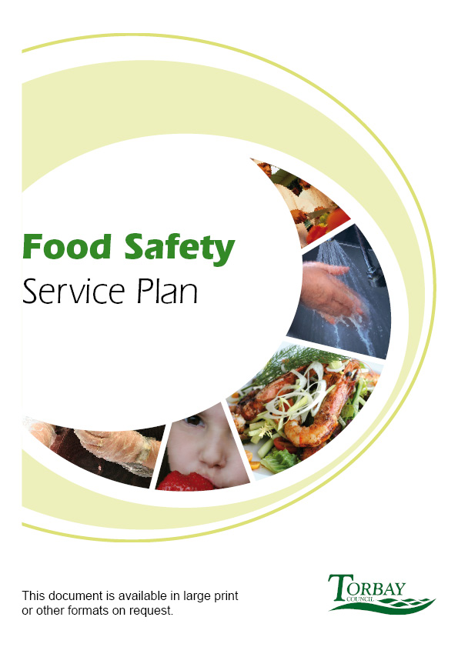
2019/20

Food Safety - why does it matter to Torbay?

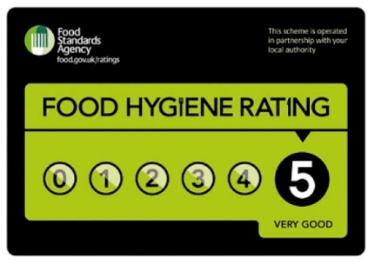 |  | The National Food Hygiene scheme was launched in Torbay in November 2011 and over 1000 food premises are now rated. Because of the scheme many premises have gone from a 0 or 1 to a 4 or 5.  The Food Team continues to undertake a high level of food safety intervention work, completing 96% of the high risk interventions due in 2018/19
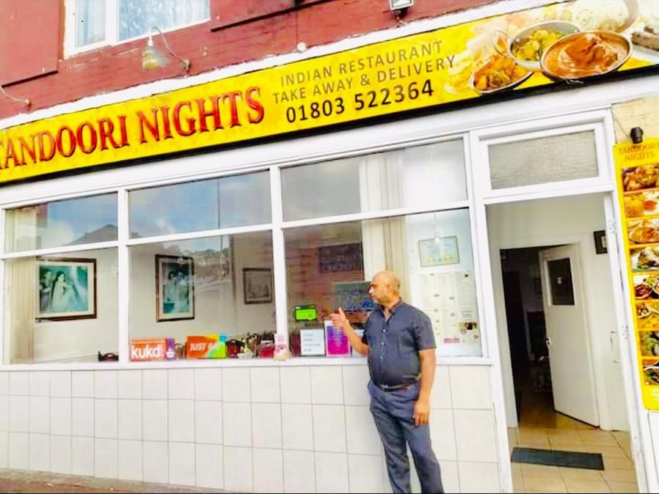 | In 2018/19 and going forward the Community Safety Department continue to play a vital role in a national scheme called Better Business for All. This is a partnership scheme between businesses and regulators such as Environmental Health with the aim of supporting local businesses. Via this scheme the Food Safety team received a grant to undertake a project working with our ethnic businesses to improve our communication with them and therefore help to improve the level of food safety compliance in this business sector. This has involved carrying out free food hygiene training and mentoring sessions for these businesses. On the back of this the TDA provided some business advice sessions.
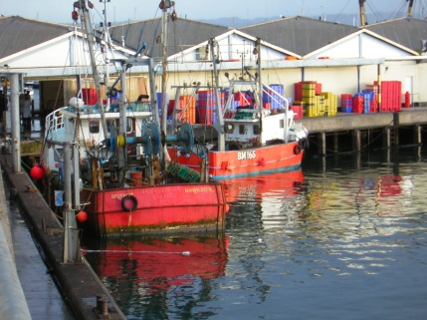 | Fishery establishments in Torbay cannot export their product without the support that is given to them by the Food and Safety Team. Part of the teams work is to sign every Health Certificate that is needed before they can export to countries such as China and America. In 2018/19 the Food Safety Team continued to protect the public health of both residents and visitors alike by ensuring that the mussel beds in Torbay comply with food safety requirements. This area of work will increase during the Brexit transition period in Autumn 2019.
 | In 2018/19 the Food and Safety team ran a Food Safety Update seminar for Category D (medium) risk premises who were broadly compliant with food safety legislation – this educational intervention was used instead of carrying out a full inspection at their premises. The event was attended by 64 delegates and the feedback was very positive with 100% of delegates stating that it had improved their confidence in relation to food safety issues. This model of good practice is now being used by other local authorities across the country.

TORBAY COUNCIL
FOOD SAFETY SERVICE PLAN 2019/20

CONTENTS Page No

- Service Aims and Objectives
1.2 Aims and Objectives 4
1.3 Links to Corporate Objectives and Plans 5

- Background
  - Authority Profile 5
  - Organisational Structure 5
  - Scope of the Food Service 5
  - Demands on the Food Service 6
  - Enforcement Policy 8

- Service Delivery
  - Food Premises Interventions 8
  - Food Complaints 10
  - Primary Authority Principle 10
  - Advice to Business 10
  - Food Inspection and Sampling 11
  - Control and Investigation of Outbreaks and Food Related
Infectious Disease 11
  - Food Safety Incidents 11
  - Liaison with Other Organisations 12
  - Food Safety Promotion 12

- Resources
  - Staffing Allocation 13
  - Staff Development Plan 14

- Quality Assessment
5.1 Quality Assessment 14

- Review Process
6.1 Review against Service Plan 15
  - Identification of any achievements and Variation from the
Service Plan 17
  - Targets and Areas of Improvement for 2019/20 18

Appendix A
Organisational chart for the Service 20

TORBAY COUNCIL

FOOD SAFETY SERVICE PLAN

1.0 Service Aims and Objectives

1.1 | Aims and Objectives |  | This Food Safety Service Plan is required under the Framework Agreement by the Food Standards Agency. The plan is concerned with food safety enforcement work for which Torbay Council is responsible for. This plan is a Key Policy document and as such requires senior manager approval and sign off to ensure there is transparency and accountability and once approved the plan is published on the Councils website.
The Food Safety Service has the following vision:

- To improve public health and safety through partnership, education and enforcement
Torbay Council’s Food Safety Service Aims and Objectives are:

Aim 1: To promote, through education and enforcement, the sale and/or production of food which is fit and without risk to health.
 |  |  | Objective 1.1: To undertake a risk-based programme of inspections and interventions in food premises in accordance with the Food Standards Agency Food Law Code of Practice
 |  |  | Objective 1.2: To register food businesses in accordance with EC852/2004 and the Food Safety and Hygiene (England) Regulations 2013.
 |  |  | Aim 2: To prevent and control the spread of food borne illness through education and enforcement.
 |  |  | Objective 2.1: To provide a risk-based response to all notifications of food related illness or suspected illness in order to minimise effects on the community.
 |  |  | Objective 2.2: To carry out pro-active sampling in accordance with nationally and locally set programmes.
 |  |  | Objective 2.3: To provide information, advice and education on food safety and public health issues to the business and residential community, in line with the principles of Better Business for All.
 |  |  | Objective 2.4: To respond to high risk complaints concerning food and food safety.
 |  |  | Aim3: To take action on a consistent, transparent and proportionate basis.
1.2 | Links to Corporate Objectives and Plans |  | The Council’s Corporate priorities fed from the Community Plan sets out a number of corporate goals. One of these goals has direct links to the Food Safety Service:  - Working for a healthy, prosperous and happy Bay  - Public Health. With the Public Health function sitting within the Local Authority the Food and Safety Team have an important role to play in some of the aims and objectives of the Torbay Public Health Strategy based on the Joint Strategic Needs Assessment.

2.0 | Background

2.1 | Authority Profile |  |  | Torbay Council is a Unitary Authority which comprises of the three main towns of Torquay, Paignton and Brixham on the south coast of England. Tourism is the dominant industry with the majority of employees working in the service industry. There is also a fishing industry predominantly based in the port of Brixham where there is a large fish market.  More details on the profile of the Authority can be found on the website www.torbay.gov.uk
2.2 | Organisational Structure |  |  | The chart attached at Appendix A shows the structure of the Food and Safety Team.  The Food and Safety Team sits within the Commercial Team of the Community Safety Business Unit and comprises of Corporate Health and Safety Officers and Environmental Health Officers.
 |  |  |  | Additional support services:-
Additionally appointed specialist services are provided by the Food Examiner at the NAMAS accredited Public Health England Laboratory in Porton Down and a Public Analyst from PASS Laboratory Services based in Wolverhampton.

Advice and support is also provided by Public Health England.
2.3 | Scope of the Food Service |  |  | The Food Safety service comprises of a range of key functions:  - Programmed food hygiene inspections of food premises within the Bay.  - Implementing and Promoting the National Food Hygiene Rating Scheme across Torbay  - Programmed high risk health and safety inspections and accident investigations, and delivering the Corporate Health and Safety programme of work for the Council.  - Responding to food alerts and incidents of food fraud.  - Investigating food and food related complaints and other service requests on a risk based approach.  - Implementing an annual food sampling programme  - Registering food premises and mobile vehicles  - Assessing imported food and its origin.  - Support, advice and training to food businesses.  - Investigating cases of food related illness and other infectious diseases.  - Issuing of health certificates for the export of food products.  - Specific duties with regard to regulating Brixham Fish Market and the mussel harvesting beds off Brixham.  Until April 2017 The Food and Safety Team had the main responsibility for food standards enforcement work, this work is now carried out by Devon, Somerset and Torbay Trading Standards Partnership as part of a formal contracted service agreement with Devon County Council.  The Food Safety service operates from Torbay Council’s Town Hall between 9.00am and 5.00pm, Monday to Friday. Early morning and late night visits are also undertaken as required.  Emergency food safety issues are currently directed initially to a 24 hour central control team and then onto authorised food officers as required. The Council does not have a formal Out of Hours Service.
2.4 | Demands on the Food Service |  |  | On 1st April 2019 the Council had 1904 registered food businesses. The risk profile of these premises shown in Table 1 has been determined in accordance with the FSA’s Food Law Code of Practice.  Table 1
 |  |  |  |  | Priority | Premises Category | Frequency of Inspection/  Intervention | Total number of premises in category  ( April 2019) | Total number of premises in category due this year.
 |  |  |  |  | A  B  C  D  E  U  Total | High  High  High  Other  Other  - | 6 months  12 months  18 months  24 months  36 months  Awaiting inspection | 10  66  229  685  818  96  1904 | 10  64  142  387  55  96  754
 |  |  |  | The range of premises is as follows:- Primary producers 6, Manufacturers and packers 33, Importers and exporters 2, Distributors 11, Retailers 369 and Restaurants and caterers 457, Hotel/Guest Houses 336, Caring premises 231, Pub/clubs 166, Takeaways 130, School/colleges 53, Supermarkets 45 and Mobile food unit 65.
 |  |  |  | Torbay also has 17 Approved fishery establishments which can be resource intensive particularly in the area of exporting their products outside of the EU.
 |  |  |  | Brixham Fish Quay is also a significant demand pressure to the work of the Food and Safety Team with its daily auction and regular exports to the EU and other nations and involves at least fortnightly food hygiene inspections by officers. There is also a mussel bed off Brixham that requires monthly sampling which has Category B status which means the mussels are required to be purified before sale. In addition there is also a new mussel bed which opened in 2016, 21 miles out to sea for which Torbay Council Food Safety Team is the Enforcing Authority - this is particularly resource intensive.
 |  |  |  | The Torbay area has already been described primarily as a tourist area and there are a large number of hotels and other tourist attractions which are only open during the tourist season between Easter and October. There is also a high turnover of food businesses in Torbay putting an additional pressure on the Food and Safety Team. In 2018/19 there were 311 new Food Registration Forms.
Additional demands for 2019/20 include:

In 2019/20 it is expected that a number of changes in relation to food safety legislation particularly around the exporting of food will be introduced as a result of Brexit although at this current point in time the level of the impact is still not clear.

In 2016/17 Community Safety signed up to a national scheme called Better Business for All which is a partnership between regulators and the business community to help business growth by helping to support them through the regulatory process in an effective and impartial way. As Community Safety which includes the Food Safety Service is the main front facing service of the Council out meeting businesses this ongoing piece of work is not only very exciting but extremely important for the economy of Torbay.

As in 2018/19, the work of the Food Team this year will continue to carry out signposting work on asbestos safety and will also be involved in other statutory health and safety work as well as delivering the corporate health and safety responsibilities for Torbay Council.

In February 2017 Torbay Council Food Safety Team was subject to an audit from the Food Standards Agency because of its LAEMS return for 2015/16. This audit identified that Torbay Council was not meeting its statutory function in terms of food safety. As a result the team’s performance was increased by utilising new initiatives and using a contractor. These improvements in performance have continued to be achieved year on year, however it is vital that this level of intervention is sustained to prevent a potential public health risk. In 2019/20 the aim is to complete the last action and that is to employ a ‘Regulatory Support Officer’ allowing authorised food officers to focus on the inspection programme and carry out less of the administrative tasks that do not need to be done by an authorised officer.

The Food Safety Team have undertaken a business process re-engineering exercise to ensure that the team are working in the most effective way. A number of improvements have been identified and are currently being put in place, the team are also carrying out a mobile working pilot for food inspection reports to inform future service delivery.
2.5 | Enforcement Policy |  |  | The Community Safety Enforcement and Prosecution Policy sets out what food businesses and others being regulated can expect from the service. The Policy is based on the principles contained within the Regulators Compliance Code and has been updated in 2014 to reflect the changes in the Code. A new Food Safety Enforcement Policy has also been introduced in 2019.  All formal enforcement actions such as prosecutions are taken before the departments Enforcement Panel made up of officers from Community Safety and the Councils Legal team.  The service is committed to ensuring the active implementation and monitoring of the Council’s Corporate Equality and Diversity Policy, which states that services will be provided in a fair and equitable way to all groups and individuals in the community.

3.0 Service Delivery

3.1 | Food Premises Interventions |  | Torbay Council has a number of internal performance indicators relating to food safety. For 2019/20 these are as follows:-  ● Number of high risk food premises (food hygiene) inspected (Target 100%)  ● Number of medium risk interventions (Target 100%)  ● Number of low risk interventions (Target 100%)  ● Number of unrated premises receiving an intervention (The target is to keep the number below 100 at any point in time )  Officers will use a range of different interventions depending on the risk of the business and they are required to follow Torbay Council’s internal Intervention Policy.  E risk and new potentially low risk businesses are contacted by the Business Support Team to ensure that they have basic information for compliance and to identify any that might be of higher risk which will then be inspected.  All new businesses receive an informative advice email from a food officer and businesses are offered a chargeable advice visit should they require it. From April 2018 businesses have been paying for any rescore request, which they can do if they score poorly under the Food Hygiene Rating Scheme, to speed up the re-inspection. The take up of chargeable services has been low as expected.
 |  |  | As there is a considerable turnover of premises in Torbay (approx 300 a year) it is currently not possible to inspect them within 28 days, however they are all assessed following receipt of the food registration form and those of a high risk nature are given priority.
 |  |  | All premises where a statutory notice has been served or which are found to require significant work to be carried out will be subject to a secondary visit within an agreed timescale. It is estimated that at least 103 re-visits will be carried out in addition to the programmed inspections and alternative intervention initiatives. There may also be a number of businesses formally requesting to be revisited for the purposes of rescoring under the Food Hygiene Rating Scheme. In 2018/19 the number of requests for rescoring totalled 25.
 |  |  | Environmental Health currently has an estimated FTE of 5.0 officers (See Table 4), working on food safety issues. This has remained the same as last year. A ‘Regulatory Support Officer’ will be appointed in 2019/20 to free up some of the authorised food officers time.
3.2 | Food Complaints |  | The Environmental Health Service responds to all complaints about food or food premises made to the Council, however deciding whether or not they require investigation will be done by using a risk based approach to ensure that resources are used effectively.  There were 23 complaints about defective food received up to the end of March 2019. There were also 891 other service requests received relating to issues such as unhygienic food premises, requests for information and advice that were handled by the Food Safety team in 2018/19.  The way food complaints are handled is currently being improved as a result of a service review .
3.3 | Primary Authority Scheme |  | The Primary Authority Scheme under the Regulatory Enforcement and Sanctions Act 2009 aims to give companies the right to form a statutory partnership with a single local authority. The objective of this is to provide robust and reliable advice on compliance that other Councils must take into account when carrying out inspections or dealing with non-compliant premises.
 |  |  | The Food and Safety Team have one primary authority partnership with Leisureplex Hotels Ltd, this is a joint partnership with Devon, Somerset and Torbay Trading Standards.
3.4 | Advice to Business |  | The Authority is committed to improving food safety standards through both education and enforcement. In order to use limited resources most effectively, advice is targeted and is as follows:  - During inspections and as part of follow up documentation;  - Via electronic Food Safety Newsletters  - New Business advice email  - Charged for advice visits  - Through guidance information available on the Food Safety Teams website  - Distribution of relevant food safety material to food businesses particularly via the website and the Food  Safety Team Twitter account  - Advice and information is given to businesses requesting guidance either by telephone or e-mail.
 |  |  | Work to support business will be further developed through the Better Business for All Steering Group, which includes members from the Federation of Small Businesses, Economic Development and the Regulatory Delivery Office. The Food Safety Team also run a Business Connect group to improve communications and information sharing between all the front facing services of Torbay Council such as Business Rates, Building Control and Food Safety and this is continuing to work well in terms of sharing intelligence across the Council.
3.5 | Food Inspection and Sampling |  | The Service has a documented sampling programme which contains details of the sampling and swabbing to be undertaken for the year.
 |  |  | The sampling programme is drawn up in consultation with the Devon Chief Environmental Health Officers Food Sub Group and the SWERCOTS Food Group, in partnership with the Food Examiner from Public Health England Laboratory covering the Torbay area and the Public Analyst at PASS Laboratory Services.
The programme covers authority, county, national and when required European sampling objectives. Each Authority is allocated sampling credits by Public Health England in order to undertake food hygiene sampling which is resourced from an allocated budget within the Food Safety overall budget.

During 2018/19 217 samples were taken of a range of products including containers used for food storage

Food safety sampling for 2019/20 will include Vac Packed Ready to Eat foods, Salad and Salad garnishes and a number of other PHE National Studies.
3.6 | Control and Investigation of Outbreaks and Food Related Infectious Disease |  | All formal and informal notifications are recorded on the  Environmental Health Service Authority database. Subsequent investigations are based on the type of organism, the number of cases, and are in accordance with Public Health England guidance.
 |  |  | A documented procedure has been produced and agreed with Public Health England and follows the principles established in a countywide procedural document, prepared by the Devon Food Safety Sub Group. During 2018/19 211 infectious disease notifications were received
3.7 | Food Safety Incidents |  | The service has a documented procedure which deals with action to be taken following the receipt or initiation of a food alert. The FSA Food Law Code of Practice has required specific recording of actions taken following the receipt of a food alert.  Food alerts are received from the Food Standards Agency (FSA), by direct emails to the Principal Environmental Health Officer and the Food Safety email box which is checked every day and by text messages to officers’ mobile phones.
The Food Alert warning procedure for food incidents recognises that such issues are required to be dealt with quickly in accordance with the categories for each food alert. The procedure identifies the mechanism for passing on the food alert to the appropriate officer, an outline of the action to be taken. Most food alert warnings received require only a small amount of officer resource.

However on occasions it is necessary to provide more resources to deal with food alerts. Any actions taken on a food alert are documented within the Authority data recording system.
 |  |  | During 2018/19 66 Food Alerts were received by the Food Safety Team, a number of which required local action in food premises in Torbay such as ensuring certain products were withdrawn from sale to protect the health of customers who may have purchased that product.
3.8 | Liaison with other Organisations |  | Consistency and value for money is a key feature in all of the Council’s Environmental Health functions. With regard to the food safety service, this is achieved by:  - Priority being given to attendance and active participation by the Principal Environmental Health Officer at the Devon Chief Environmental Health Officers’ Food Sub Group. This Group co-ordinates peer review and consistency exercises, acts as the discussion forum for topical issues and a means of optimising countywide consistency in enforcement and advice.  - The Food Safety Service also liaises with the following :
- Public Health England
- Torbay Development Agency
- The Food Standards Agency
- Devon and Cornwall Police
- Border Force
- The Office of Product Services and Standards
- Trading Standards Sub Regional Group
 |  |  | The Community Safety Service have access to all development and building control applications and acting as a formal consultee on key planning and building control applications and a statutory consultee on all Licensing Act applications.
3.9 | Food Safety Promotion |  | Education and promotional activities are considered to be important aspects in the delivery of a comprehensive food safety service and it is achieved in the following ways:  - Food Safety articles in the biannual Food and Safety Newsletter e-mailed to all subscribing food businesses in the Bay.  - Running of Level 2 Food Hygiene courses.
- Food information available directly from the Food Safety section of the Council website and from the team directly.

- Targeted advice/information sent to relevant groups on issues of county or national significance e.g. on E Coli 0157 guidance, cooking of rice, Sous Vide etc.

- Targeted seminars and training sessions are undertaken on various food safety subjects e.g. ethnic food business project.

4.0 Resources

4.1 | Staffing Allocation |  | The Community Safety Business Unit structure is based on a number of multidisciplinary teams. The Food Safety Team is located within the wider Commercial Team.
Table 4 shows the current full time equivalent of staff working on food safety enforcement, broken down by the competency requirements of the Food Standards Agency Food Law Code of Practice (England) - General qualification and experience requirements. The Code of Practice was updated in 2015/16 and as a result there is a new competency framework for food officers which has been completed in 2018/19 to ensure that all food officers in Torbay have the correct competencies to undertake their roles effectively, the competency framework will need to be reviewed in 2019/20.

Whilst the table shows a resource of 5.0 FTE is allocated to food safety work, in practice this is reduced to 4.5FTE as 0.5FTE of a post mainly deals with work associated with the fish market, mussel sampling and export certification. This position has been reviewed as a result of the FSA audit and whilst no authorised food officers are being appointed, agreement has been given to appoint a ‘Regulatory Support Officer’ in 2019/20. This will take some of the more administrative and informal sampling off the food officers freeing them up to do more of the high risk work and this should further improve the inspection rate.
 |  |  | EHRB officers are Environmental Health Officers who are registered with the Environmental Health Officers Registration Board, (EHRB), after attaining the approved qualifications in Environmental Health.
Table 4: Staff resources dedicated to food safety
Environmental Health Officer (Food and Safety Team) | EHORB | FTE | Other
Principal EHO | YES | 0.8 | No
Senior EHO | YES | 0.8 | Lead Assessor
Senior EHO | YES | 0.8 | Lead Assessor
Senior EHO | YES | 0.8 | Lead Assessor
Senior EHO | YES | 0.8 | Lead Assessor
Senior EHO | YES | 0.8 | No
Senior EHO | YES | 0.1 | No
Senior EHO | YES | 0.1 | Lead Assessor

4.2 | Staff Development Plan |  | All food safety staff are subject to an annual appraisal and one progress review which tracks and identifies training and development needs. Food safety training needs are prioritised in the context of wider Environmental Health requirements identified within the service wide training plan.
 |  |  | All food safety staff complete a training record log to further assist in identifying development and training needs and for monitoring the competency of individual officers. The officers undertaking specific duties, such as dealing with approved premises, are identified and the training requirements assessed accordingly.
Some of the specific food safety training undertaken by staff during 2018/20 include:-

- PHE Shelf Life training
- Imported food and port health training

5.0 Quality Assessment

5.1 | Quality Assessment |  | The provision of quality services is one of the Council’s three guiding principles and food safety is no exception. With regard to food safety the quality agenda is pursued via a number of methods.  Management Monitoring  The documented quality management procedure includes specific monitoring arrangements that are in place for example checking of inspection letters and notices and joint consistency/quality monitoring visits undertaken by the Principal Environmental Health Officer. Complaints against the service are monitored on a Service and Corporate basis.
Food Standards Agency

The service is required to submit an Annual return, detailing the inspections, enforcement and educational activities undertaken, to The Food Standards Agency who closely monitor performance to ensure compliance with the FSA framework agreement.

The FSA also has the power to set standards and to monitor local authority food law enforcement services under the Food Standards Act 1999. The FSA collects information from all United Kingdom food authorities and submits the information to the European Commission.
 |  |  | As detailed in section 3.8, the Principal Environmental Health Officer attends meetings of the Devon Food Sub Group to discuss relevant issues on a regular basis. This group comprises of representatives of all the District and Unitary councils, and Public Health England.
 |  |  | This forum offers the opportunity to discuss, in detail, a wide range of quality and consistency issues relevant to food safety.

6.0 Review Process

6.1 | Review against the service plan |  | As detailed within Section 1.2, the Council has an established performance management board to monitor the performance of its services.  From an operational perspective the Principal Environmental Health Officer reviews the key performance measures and service improvements contained in the plan on a quarterly basis. Table 5 shows some of the internal indicators covering service delivery and performance as well as the national indicator for food safety. The Principal Environmental Health Officer meets with the Assistant Director of Community and Customer Services on a quarterly basis to discuss food safety performance and any issues are fed up to the Senior Leadership Team as required along the main Food Safety Service Plan on an annual basis .
 |  |  | In addition, regular one to one meetings are held with staff involved in the Food Safety Service. This is to ensure that on-going projects and improvements outlined in this service plan are effectively monitored and managed. The notes for these meetings are documented, along with actions and timescales for relevant staff.

Table 5 – Food Safety Service Performance Indicators

Risk of premises | Risk of premises | 2017/18 | 2018/19 | 2019/20
A risk interventions carried out | Target  Outcome | 100%  100% | 100%  100% | 100%
B risk interventions carried out | Target  Outcome | 100%  100% | 100%  100% | 100%
C risk interventions carried out | Target  Outcome | 100%  97% | 100%  96% | 100%
D risk interventions carried out | Target  Outcome | 100%  80% | 100%  89% | 100%
E risk interventions carried out | Target  Outcome | 100%  92% | 100%  92% | 100%
Number of unrated premises outstanding | Target  Outcome | 250 at start of year reduced to 95 by end of year | Keep number to below 100 at any one time  96 | Keep number to below 100 at any one time

6.2 | Identification of achievements and any variation from the service plan |  | Table 6 below identifies the status of planned service improvement actions from 2018/19. Any remaining improvement objectives are shown in the table below along with the reason for the delay and a revised target, which will be included in the work programme for 2019/20 where appropriate.
Table 6 Achievements and variance from Service Plan 2018/19

Action | Planned Outcome/Output | Achieved Or reason | New Target Date
1.To ensure that the remaining D risk inspections from last year receive an intervention as well as carrying out 100% of this years’ D risk interventions | To ensure that D risk premises are properly rated and receive the most effective intervention to ensure effective food safety is achieved | Achieved: All of our D risk inspections due were undertaken by the end of March apart from those they could not get into (11%). | October 2019
2.To undertake a new business event for food businesses | To improve businesses awareness of food and health and safety requirements and ensure more effective compliance | Achieved: This event was undertaken and attended by 64 delegates.
3.To carry out a piece of work on the E risk premises following the sending out of the Business Compliance checklist last year | To pick up any businesses who did not respond and ensure they receive a further intervention to ensure they are properly risk rated thereby ensuring effective food safety | Achieved: 85%% of this work was completed but there is still some outstanding as the Regulatory Support Officer was not appointed last year. | March 2020
4.To carry out a pilot with Devon County Council in relation to offering a joint Primary Authority partnership with businesses. | To achieve a better standard of compliance and enhance the LA, s working relationships with businesses, this would also provide an income stream to the department | Achieved: Torbay Signed its first Primary Authority partnership with Leisureplex Hotels Ltd, this was done in conjunction with Devon, Somerset and Torbay Trading Standards. | Ongoing
5.To carry out an evaluation of the charged for services offered by the food safety team | To ensure that we are offering what the business wants at a price which is suited to the business and department alike | Achieved: This has been done and a consistency exercise was completed across Devon local authorities in relation to fish export certificate charges. There is however a low uptake on the charged advice visits and rescore inspections . | N/A
6. To carry out a non compliance project with businesses who are a 3 or below on the food hygiene rating scheme. | To ensure the level of non compliance in relation to food safety is reduced and that there is a level playing field for food businesses in Torbay. | Achieved: This has been completed with 75% of the non-compliant businesses achieving compliance.2 formal prosecutions were also successfully completed with non-compliant businesses in Torbay. | N/A
7. To carry out the changes necessary to the food safety registration system in terms of Regulating our Future project. | To ensure that businesses can register effectively and provide the LA with the information it requires  This work will depend on when the FSA produces guidance on this for LAs | Achieved: This has not yet been completed as the FSA scheme is still in the pilot stage and has not yet been rolled out to all local authorities | To consider becoming part of the FSA pilot scheme. By end Oct 2019

6.3 | Targets and areas of Improvement for  2019/20 |  | Targets for 2019/20 are in Table 7 and the current planned improvements for 2019/20 are contained in Table 8.

Table 7 – Targets for 2019/20

SERVICE DELIVERY INDICATORS |  | 2016/17 | 2017/18 | 2018/19 | 2019/20
Number of Category A and B risk food hygiene premises (due every 6 months) inspected | Target | 100% | 100% | 100% | 100%
 | Outcome | 100% | 100% | 100%
Number of Category C risk food hygiene premises (due every 6 months) inspected | Target | 100% | 100% | 100% | 100%
 | Outcome | 96% | 97% | 96%
Number of Category D and E risk food hygiene premises (due every 2 and 3 years respectively) | Target | 100% | 100% | 100% | 100%
 | Outcome | 80% D  No E,s | 80% D  99% E,s | 89% D  92% E’s | 100% for both D and E
No of unrated premises due for an intervention |  |  |  | Keep number of unrated below 100 | Keep number of unrated below 100

Table 8 Areas of Improvement for 2019/20

Service Improvement | Planned Outcome/Output | Link to FSA framework agreement | Target  Date
1.To finish the planned intervention work with the ethnic business community in Torbay and carry out a full evaluation of this work. | To improve the channels of communication with this sector of businesses to improve their understanding of food safety and thereby helping to increase compliance with food safety legislation | All areas of Framework | Dec 2019
2.To develop and implement an allergy management project | To increase awareness of allergy management requirements with the businesses and increase compliance in this area of work. | All areas of Framework Agreement | To train officers by Nov 2019 and develop project plan by Jan 2020
3.To carry out a D Risk business event. | To use this event as an intervention for a group of our compliant D risk businesses to help them maintain a high level of compliance with food safety | All areas of Framework agreement | Oct 2019
4. To carry out a review of the level of non-compliant premises in Torbay | To determine whether or not they need a more formal intervention thereby increasing compliance and ensuring a level playing field. | All areas of Framework Agreement | Nov 2019
5.To ensure that food businesses in Torbay particularly those who export are Brexit ready especially in the event of a No Deal | To ensure that food businesses in the Bay can continue to trade and export with the appropriate documentation. | All areas of the Framework agreement | Ongoing
6.To move the Food Safety Newsletter onto the Mailchimp system | To ensure that the newsletter is GDPR compliant | All areas of framework agreement | July 2019
7.To introduce a mobile working solution in the Food Safety Team | To improve the efficiency of the work carried out by the team as they will be able to access information more readily on site . The use of handheld devices for food inspections is also being explored | All areas of Framework agreement | 1st phase Jan 2020  2nd Phase –TBC
8.To review the food complaint system undertaken by the food safety team | To improve the level of information received from the complainant so they are dealt with more effectively | All areas of Framework agreement | Oct 2019

Appendix A

Appendix A - Organisational Structure Chart for Food and Safety Service

