Attention of all Private Hire Companies & Drivers

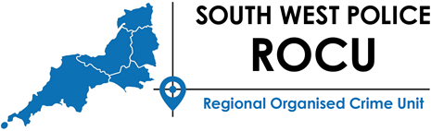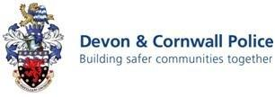

In Confidence

Re: Op Tarak – County Lines drug supply

Dear Sir/Madam,

‘County Lines’ is used to describe the distribution of drugs using a dedicated phone line located in a major city to co-ordinate the movement and supply of drugs. Local ‘runners’ will be used often operating from several addresses.

However, it is not just the obvious criminality of county lines that is a problem. These operations almost always exploit vulnerable people – children and adults – who need safeguarding. Often young females will be forced or coecred into transporting drugs internally or be offered as property/payment between gangs. Vulnerabilities are exploited in a number of ways which include:

• Gangs form a secure base in the home of a vulnerable person, forcing assistance through violence or exploiting a drug dependency.
• Developing a drug dependency amongst members of the dealer network.
• Leaders or dealers enter into relationships with vulnerable young females, which can also lead to sexual or domestic violence.

Typically an unwitting local private hire company/mini cab company will be used to transport local runner and more involved facilitators who will re-stock drugs and collect money. Often these will have non-local accents, minimal local knowledge and be making frequent stops to multiple addresses. Figures from November 2017 show that 33% of drug deliveries are made by taxi.

It is vital that private hire companies and their drivers are fully aware of this and are vigilant when transporting this type of fare. Your assistance in preventing and/or detecting these crimes is essential but please note that in a few cases elsewhere in the country, private hire companies /drivers have been complicit in these crimes and were fully aware of this scam.

*** It is the private hire companies and drivers responsibility to ensure they do not facilitate crime***

Police will thoroughly investigate cases of drugs supply and will prosecute any private hire company or individual facilitating this crime, knowingly being involved in a conspiracy to supply a controlled substance.

The advice from the police is if you have any information or the slightest suspicion about a fare of this nature; contact the Police immediately by emailing 101@devonandcornwall.pnn.police.uk text 67101 or by phoning 101 or 999 if it is an emergency. Alternatively, you can provide information 100% anonymously to the independent charity Crimestoppers 24 hours a day, 365 days of the year. The phone number is not recorded or monitored and does not show on your phone bill, there is also a translation service available. Call 0800 555 111 to speak to one of their friendly call handlers. The online form cannot be traced, is scrambled and deleted within a few hours of being received and the information sanitised before it is passed on securely; Crimestoppers-uk.org. Thank you for your co-operation
Yours Faithfully
Oliver Henton
PC 6453 Olly HENTON
Disruption Team Officer

