Tree management and protection
Frequently asked questions

www.torbay.gov.uk

Introduction
Torbay Council is firmly committed to maintaining and enhancing Torbay’s trees and woodlands as a vital part of the environment. Torbay is one of the UK’s richest areas in terms of biological diversity, and as such, the council seeks to ensure that its commitment to the environment is followed through with actions.
In view of the benefits we receive from trees, and the council’s responsibility for tree management and protection, it is fitting that we set out our approach to these issues. The purpose of this document is to identify and address fundamental issues raised by members of the public. If the advice in this document does not answer your enquiry a tree officer may make further contact with you and respond to your concerns.

The benefits of urban trees in Torbay
There is a substantial body of research that supports the following benefits that trees bring to urban areas.
Environmental
- Reduce localised temperature extremes
- Provide shade, making streets and buildings cooler in summer
- Help to improve air quality
- Help to reduce traffic noise, absorbing and deflecting sound
- Help to reduce local wind speeds
- Increase biodiversity and provide food and shelter for wildlife
- Assist in land remediation
- Reduce the effects of flash flooding by rainfall interception.

Social
- Improve the quality and perception of the urban environment.
- Create community focal points and landmark links
- Create sense of place and local identity
- Benefit communities socially by instilling higher public esteem and pride for an area
- Positive impact on both physical and mental health and wellbeing
- Positive impact on crime reduction
- Improve health in the urban population.

Economic
- Have the potential to increase residential and commercial property values by 7% to 15%
- Improve the environmental performance of buildings and therefore the economic performance through reducing heating and cooling costs
- Can provide mature landscapes that increase development site values
- Assist the increase of property values as trees grow
- Creating a positive perception for prospective purchasers of property
- Enhance the prospects of securing planning permission
- Improve health in the urban population, thus reducing healthcare costs
- Provide a potential long term renewable energy resource.

General guidance

This general guidance and advice will hopefully answer the most frequently asked questions about trees.
Torbay Council frequently receives requests for tree pruning that cannot reasonably be met because they are either damaging to the tree or because they offer no cure to what is often a perceived or temporary problem. Torbay Council, in common with most other local authorities, therefore cannot guarantee that it will prune or remove trees.

Tree Management in your area…
Torbay Council will conduct routine pruning on a ward by ward basis every 15 months in order to keep its tree stock managed. If you think that a tree is in need of maintenance pruning, you can wait for the regular cycle or you can contact the Natural Environment section to request an inspection by an officer who can assess the tree, and any pruning needs, in line with the council’s Tree Risk Management Strategy. The Natural Environment Officer will decide if the tree needs pruning immediately or if the next pruning cycle will alleviate the issues highlighted.
If you would like the tree pruned before that, you can apply for a Tree Work Permit, which allows an approved arborist to perform work on the tree in question. For more details please contact us.
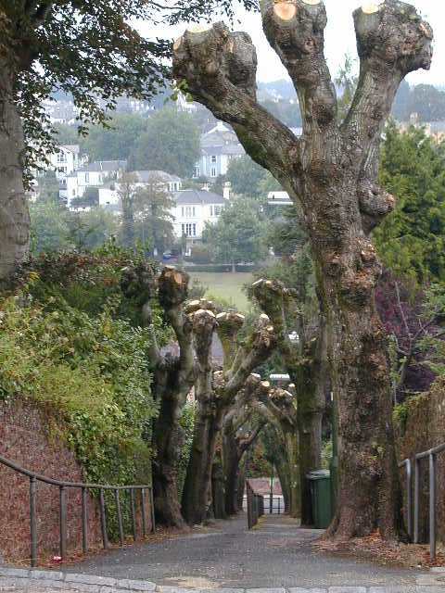
If the tree is entangled in the telephone or electrical wires, please contact either British Telecom or Western Power, as only approved tree contractors are authorised to prune around these services.

Pollarding in Torbay
Torbay is extremely fortunate in containing large numbers of pollarded trees within its boundaries; contributing as they do too many diverse benefits ranging from their visual and aesthetic value, as well as helping to increase biodiversity by providing food sources and valuable shelter for wildlife and even helping us in our goals of climate change mitigation.
Pollarding should not be confused with either topping or lopping which can be described as the removal of large diameter upper branches in order to reduce the height of a tree considerably. This is poor practice and usually creates large wounds, which often allow decay to invade the tree. New branches are often weak and break off after a few years. Topping looks unattractive, leaving the tree with a stunted appearance. The Pollarding Policy is available to view online.

The tree outside my house looks dangerous and moves in the wind…
Torbay Council’s inspectors are qualified tree experts who will inspect a tree following an enquiry or in line with the Tree Risk Management Strategy following routine inspections. All inspections are recorded electronically. It is recognised that the movement of trees in the wind does not automatically signify that the trees is dangerous; our inspection will determine its condition and safety.

The tree outside my house has not been pruned for ages. It is too tall and needs to be lopped back…
Trees in Torbay are regularly inspected and any safety or maintenance related works are reported at this time. Torbay Council does not reduce the height of trees as a matter of course, as this can stimulate rapid regrowth and/or cause significant defects in the tree’s structure, which are later hard to detect.
The Council will routinely prune highways trees to ensure that branches shall be reduced back where they are obstructing roads and footpaths, masking streetlights, road signs and other street furniture, so as to maintain vehicular and pedestrian safety on the highway.

Tree branches are growing across my boundary…
There is no requirement in law to prevent trees spreading over a boundary. However, whilst there is no obligation to prune trees, if branches or roots encroach on to neighbouring land they are legally regarded as a nuisance. Under the terms of law the tree owner is not obliged to cut back the branches overhanging their neighbour’s garden. The owner of the adjacent land has the legal right and ‘abate the nuisance’ by cutting the branches or roots encroaching on other property. Where requests are made to prune trees that overhang a boundary each instance will be assessed on its merits. As a general policy, the council will only undertake work where a tree’s branches touch or are very close to a building. Where overhang of the boundary is relatively minor or at considerable height, works may not be undertaken by the council. They may be considered for re-inspection within two years, depending on the size, type and growth of the trees concerned. Where tree roots are deemed to have encroached, works will only be undertaken where damage to property can be shown, beyond reasonable doubt, to have been a causal factor or damage is reasonably foreseeable in the future.

A council owned tree is shading my property and/ or blocking my view…
Householders have no right to light from across a neighbour’s land. Likewise there is no right to a view, and a view obstructed by the growth of trees cannot legally be regarded as a nuisance. Where requests are made to prune trees to increase light levels, each instance will be assessed on its merits. The householder may be assisted where appropriate, if this is possible without excess damage to or removal of healthy trees or branches. As a general policy the council will not undertake the topping, thinning or felling of trees simply to allow more light to a property, where the trees in question would not otherwise require any surgery.
One of the most common complaints received in respect of trees, is that they block light from properties and shade gardens. The council will not fell or prune council-owned trees solely for the reason that they are allegedly reducing light levels into properties or are casting shade over gardens unless it is demonstrated that a severe restriction, in the opinion of the Officer, has resulted.
A person's tolerance of shade or their need for light is a subjective and personal matter and whilst some people prefer shade there are those that have a desire for sunlight. Many people are aware of the ancient and prescriptive right to light, but this only relates to loss of light over a considerable period of time in certain specific circumstances. Where trees are concerned there is ‘no right to light’. The tree owner is under no legal obligation to prune a tree for the benefit of a neighbour or complainant.
There are a variety of other potential nuisances associated with trees, most of which are minor or seasonal and considered to be social problems associated with living near trees.

Trees are blocking light to my solar panels…
As the number of residential solar panel installations increase there is going to be a greater problem from over shadowing or shading from trees and other obstacles. Trees in particular may cause a problem as even partial shading on some solar arrays can potentially reduce their ability to generate electricity.
The Council will not fell or prune council-owned trees solely for the reason that they are casting shadows over solar panels.

The tree is affecting my television and satellite reception…
There is no legal right to television reception. Existing trees on neighbouring land which interfere with television reception, especially with satellite transmissions, are unlikely to be regarded as a nuisance in law. As a policy the council will not undertake the topping, thinning or felling of trees simply to improve television or satellite reception, where the trees in question would not otherwise require any surgery.
Interference appears to increase when trees are in leaf and in windy weather. This is especially the case with regards to satellite reception, as it appears to be more sensitive to interference than analogue television reception.
In the vast majority of cases, interference can be reduced by the relocation of the aerial or by the use of “booster boxes”, which often improve the reception significantly and can be encouraged. These options are far cheaper and less destructive than pruning or felling the tree. Such alternative solutions should be encouraged.

I have a problem with pollen and allergies…
All vegetation produces pollen as part of its life cycle. Everything from grass to trees can have an effect on allergy sufferers. As this is a natural process, it is not classed as a ‘legal nuisance’ and there is nothing the council can do to alleviate the symptoms and effects on residents.

I have a problem with leaves, seeds and fruit from a nearby tree…
Leaves and seeds are carried freely on the wind and are largely outside the control of Torbay Council. Clearing of leaves from gutters and pathways and weeding of set seeds are considered to be normal routine seasonal maintenance which property owners are expected to carry out.
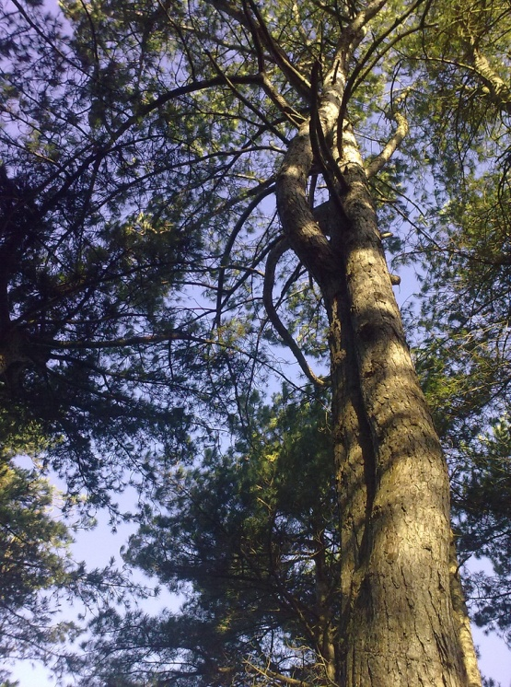
Pruning will not normally be undertaken to attempt to reduce the fall of leaves, seeds or fruit.

The tree is making a sticky mess on my car or garden…
The problem is caused by aphid infestation and is known as honeydew. This is a particular problem with tree species such as lime and sycamore. Unfortunately this is a problem that cannot be solved by pruning or spraying with insecticides. Torbay Council will prune trees where the work complies with best practice but will not fell or disfigure trees to deal with this issue. Honeydew is a mild sugar solution and should not affect paintwork on cars, if they are washed regularly.

Birds roosting in the trees outside my house are creating a mess on my car or drive…
This inconvenience is not sufficient justification to remove or disfigure the tree. Unfortunately pruning the tree is not the solution either, as the birds will simply roost on the remaining branches.
Even when trees are pruned they are still inhabited by wildlife. Healthy and attractive trees are an asset to the environment and bird fouling is not sufficient justification for the tree to be pruned. This is not recognized as a legal nuisance and the inconvenience it may cause is not sufficient justification to remove or disfigure the tree.
Unfortunately pruning the tree is not the solution either, as the birds will simply roost on the remaining branches.
Alternative means of preventing birds roosting and thereby reducing/removing the problem of associated mess are available as follows:
- Installation of commercially available pigeon spikes onto the level limbs where birds are likely to land.
- Use of strung wires along landing areas, also commercially available.
- Application of a non-toxic bird repelling caulk (needs to be topped up annually).
- Installation of audio devices.
- Use of ‘mock’ birds. These do need to be targeted for the correct species

The tree is causing damage to my utility services…
Instances of underground pipes being broken by the growth of tree roots are very rare, but penetration and blockage of damaged pipes is not uncommon. As a general policy the council will not undertake the topping, thinning or felling of trees to prevent roots entering damaged pipes. Repair of the defect in the pipe is the only certain remedy that will prevent future problems. Modern materials and joints will significantly reduce pipe damage and subsequent root encroachment in the future.

The tree is covered in ivy and is killing it…
Ivy is a climbing, scrambling plant abundant as a groundcover shrub in many rural types of woodland. It has a variety of conservation benefits and forms an integral part of woodland’s habitat. In the urban environment there is a need to balance three main considerations for its retention: tree safety, conservation and aesthetics. Ivy causes no direct damage to trees. However, in some situations it may be considered unsightly and more importantly can create problems for efficient management by obscuring structural defects and fungal fruiting bodies. It also increases the weight of a tree’s crown and the ‘sail’ effect during the wet, windier, winter months, when deciduous trees have shed their leaves. As a general policy the council undertakes the removal of ivy from trees only where it is considered necessary to aid visual tree health assessment.

I have a big tree near my property. I am worried about the damage the roots may be doing to my house. What should I do?
Tree roots may potentially cause damage to built structures in two ways:
- Direct damage – this is caused when the physical expansion of tree roots or stem lifts paving stones or cracks walls etc. Due to the weight of a house no amount of physical expansion will affect it, but garden walls and small structures such as garages or outbuildings might be at risk.

- Indirect damage – this can be caused to larger structures such as houses when trees roots grow underneath the foundations, extract the water there causing clay soils to shrink and the structure to subside. If a building has been built on clay soil near an existing tree, and that tree is then removed, the soil may expand which can cause heave (the opposite of subsidence).

Modern building standards mean that the risk to newer buildings tends to be isolated and the council will expect new buildings to be built to industry guidance and therefore they should not subside due to trees that were in existence at the time they were built. It must be noted that tree related subsidence is fairly rare in Torbay because there are few areas of the highly shrinkable clay needed to cause significant structural problems to houses. However, should you believe that trees are the cause of cracking to property; you should consult with your insurers to determine the probable cause.
There is no evidenced based or credible guidance as to how close trees need to be to cause damage although there is some information on the internet, which the council has found to be quite misleading. In our experience given our knowledge of the topography of the Bay and the constraints this poses on land use we find that many trees and houses are able to co-exist happily in often close proximity.

Trees roots are blocking my drains. What can I do?
Instances of underground pipes being physically broken by the growth of tree roots are very rare; however for tree roots to physically break drains, associated pipe work and cause blockage is not uncommon. Tree roots can be opportunistic and if an old pipe with poor joints is leaking into the surrounding soil this will attract the roots that may then exploit the existing weakness. Then, when repairs are required, a proliferation of tree roots often leads to the blame being placed with a nearby tree. However, replacement of faulty drains/pipes with modern materials will usually eliminate the leak and stop problems from re-occurring. If you believe tree roots have caused damage to structures you should consult your insurers or an expert.
As a general policy the council will not undertake the topping, thinning or felling of trees to prevent roots entering damaged pipes. Repair of the defect in the pipe is the only certain remedy that will prevent future problems. Modern materials and joints will significantly reduce pipe damage and subsequent root encroachment.

The trees are in the wrong place and a general nuisance…
Although trees may be considered an inconvenience to those living adjacent to them, by law they must be shown to be a substantial interference to a neighbour’s comfort and convenience to be considered a nuisance. As a general policy the council will not undertake the topping, thinning or felling of trees simply to prevent the accumulation of leaves, seeds or minor debris on adjacent property, where the trees in question would not otherwise require any surgery.

I have a tree outside my property with prolific basal growth and want it removed.
Basal growth is the term used to describe the growth from the base and/or stem of a tree in the spring and summer. This growth occurs on a range of tree species, and it is usually most pronounced on Lime trees.
As this problem is growth related, it often means that all trees will develop the problem at the same time. This is often in late May/early June although it depends on weather conditions. Due to this type of growth we look to pool resources into the worst affected roads first, attending to all the lime trees before moving to another road. If the growing seasons are particularly favourable, it is possible that some trees may have to be treated two or three times within a calendar year.
If your ward is shown as being completed and the tree outside a property has been missed (rather than just re-grown), please contact the council and we can check to see if the work has been ordered.

The tree outside my house in the pavement is blocking the passage of pedestrians and/or vehicles…
Trees will be pruned to meet the legal requirement as stated within the Highways Act as identified by the council’s highways inspectors.

Can I have a new tree planted outside my house/in my street?
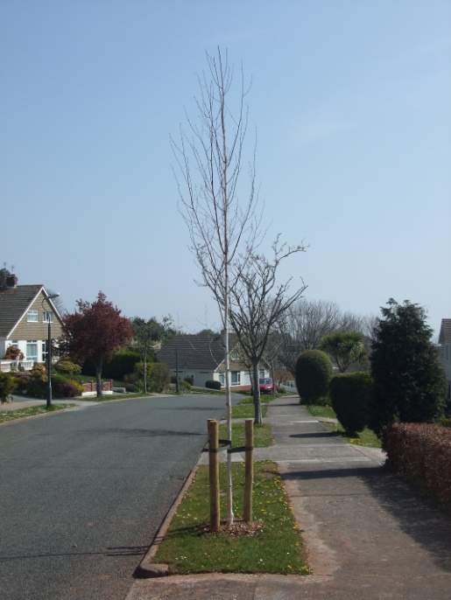
​There is a general presumption by the public that when the council removes a tree, it will replant with a new tree soon afterwards. Planting opportunities after a tree has been removed are becoming increasingly more expensive and difficult as a new tree pit not only has to contend with the underground pipes and cables but also has the aerial competition from street lamps, traffic signs, vehicle sightlines.
The council has not had any significant dedicated planting budget for many years. Consequently it has been unusual for a new tree to be planted following the removal of a tree in recent years.
Torbay Council will therefore aim to maintain the number of street trees in at a consistent and sustainable level. A discretionary programme of tree planting to replace those removed will contribute to this objective. The planting season for new street trees is normally from October to the beginning of March.

A tree is lifting paving slabs/affecting my drive. Can I cut the roots of a protected tree?
Cutting the roots of any tree is generally ill-advised as it may affect the tree’s health and stability. If a tree is covered by a Tree Preservation Order, or if it stands within a Conservation Area, an application will be required before root pruning can take place.

Trees on boundaries
Trees in gardens are often planted towards the peripheries so as to leave open areas where they are needed for outdoor recreation, the result being that neighbours often thoughtlessly plant trees with large growth potential on or near boundaries. Unless the tree damages your property in a direct way there is little you can do to prevent someone planting a tree close to the boundary other than manage the overgrowth.
When a tree causes "actionable nuisance" - nuisance that could give rise to a claim for damages - you should seek legal advice. This is a matter the council cannot become involved in because we have not the legal expertise necessary to advise you properly.

How can I tell if my tree is safe?
Such assessments are best made by qualified experts. This is not a service offered by the council’s arboriculturalist, but details of tree contractors and consultants operating throughout the UK are available from the Arboricultural Association.

I live in a private property; will the Council prune my tree for me?
​No, the Council does not prune trees in private properties. An approved list of contractors is given on the Arboricultural Association web site.
If the tree is subject to a Tree Preservation Order (TPO) further advice should be sought- see Protected Trees FAQs.

My tree doesn’t look very healthy. Can the council advise me? If not, where else can I seek advice?
Local tree contractors and consultants will be able to offer advice on the health and management of trees, but this is not a service currently offered by the council’s arboriculturalist. Details of tree contractors and consultants operating throughout the UK are available from the Arboricultural Association.

My tree has a fungus growing on it. Does this make the tree unsafe?
There are many types of fungi that affect wood. They are often indicative of a wider problem and are a valuable tool in diagnosing what may be wrong with your tree. They are also an invaluable habitat for rare insects and beetles and should not be removed from the tree. Removing fungal fruiting bodies from trees will not get rid of the fungus as it is usually by this stage well established within the tree. If you find fungi growing on your tree call an expert to help identify the potential problem. Further details of tree contractors and consultants operating throughout the UK are available from the Arboricultural Association.

What do I do if I think someone is carrying out work on a protected tree or intends to do so?
Contact Natural Environment Services immediately and we can check to see if the work is authorised and take appropriate action, if necessary. All queries regarding potentially unauthorised works will be dealt with in strictest confidence.

I'm a tenant of a housing association/ council/ private property. Who looks after the tree in my garden?
You need to contact your landlord to find out exactly who is required to do what under the terms of your tenancy. In general terms, the owner of the property is responsible for ensuring the trees in their properties are safe.

My neighbour’s trees are too high and blocking my light. What can I do?
Technically your neighbour only has a duty to ensure their trees are safe. There is currently no height restriction on trees. If you have concerns regarding a tree ask your neighbour how they intend to maintain it. You may be able to cut the overhanging branches back to the boundary. However, before either you or your neighbour undertakes works to any trees it is important to check the protection status of the trees.

My neighbours have a high hedge. What can I do about it?
The High Hedges legislation was introduced on 1 June 2005 under Part 8 of the Anti-social Behaviour Act 2003 and applies to evergreen and semi-evergreen hedges of over two metres in height. The legislation provides for those who feel that a neighbour’s hedge is hindering the reasonable enjoyment of their property to submit a formal complaint to the council. The council will then investigate the matter and may, if considered appropriate, serve a notice on the hedge owner requiring them to reduce the hedge’s height. In most cases, it is possible for neighbours to agree on a course of action without a formal complaint being necessary. This is certainly the preferable approach for all concerned. If you are unable to reach agreement with your neighbour, try contacting a local mediation service as the mediation process is essential before making a formal complaint to the council.

I am worried about the local Birds, Bats and Badgers in my area…
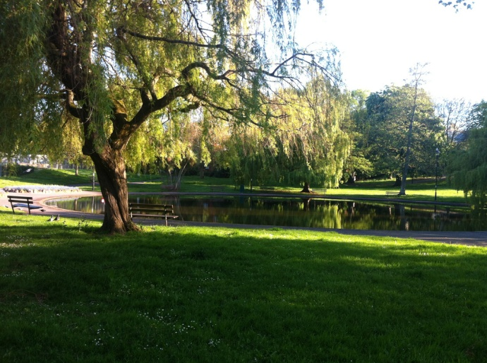
As a general rule, it should be assumed that birds will be nesting in trees, scrub, reeds or substantial ditch side vegetation during the core breeding period from March to August. Although the breeding cycles of most birds are well known there are no fixed dates indicating when site work may be carried out and a thorough inspection should be carried out prior to any works. It is important to understand that the legislation is tied to the reproductive cycles of the birds themselves and is irrespective of when they choose to breed. If no signs of nesting birds are observed then works may start but the site must be constantly monitored during the working period.
All UK bat species rely on trees for part or all of their life cycle. The importance of trees to bats varies with both bat and tree species. The most important species of trees are ash, beech, oak and Scots pine. Trees and hedgerows provide food and shelter, a place to rest and hibernate and a home to give birth and raise young. Bats also use trees, lines of trees and hedgerows to navigate the countryside at night.
Badger numbers have increased over the years; this is the case especially in urban areas. Badgers usually live in woodland areas and can live up to 15 years. Badgers are one of the most popular and well known British mammals. Badgers live in setts which are made up of large tunnels and at the end of the tunnels are chambers which are used for breeding or sleeping. Badgers are nocturnal animals and come out from their setts just after dusk. Due to their protection under the Protection of Badgers Act 1992, any further advice on dealing with them will need to be referred to Natural England - Badgers.
Legislation:
It is an offence under Part 1 Section 1 of the Wildlife and Countryside (WCA) Act 1981 (as amended) to intentionally take, damage or destroy the nest of any wild bird while it is in use or being built. It is also an offence under Part 1 Section 1 of the Wildlife & Countryside Act 1981, as amended by the Countryside and Rights of Way (CRoW) Act 2000, to intentionally or recklessly disturb the active nests of certain rare birds (those of Schedule 1).
Bats and bat roosts are protected by law under Schedule 5 of the Wildlife & Countryside Act (WCA) 1981 (as amended), Schedule 2 of the Conservation (Natural Habitats & c) Regulations 1994 and the Countryside Rights Of Way (CRoW) Act 2000 which applies only in England and Wales. It is an offence to recklessly or deliberately kill, injure or capture (take) bats, recklessly or deliberately disturb bats, damage, destroy or obstruct access to bat roosts.
Conservation of Habitats & Species Regulations 2010 (England and Wales), The European Union’s Directive on the Conservation of Natural Habitats and of Wild Fauna and Flora (otherwise known as the Habitats Directive) was passed in 1992. All EC member states have had to implement the Habitats Directive and in Britain the current Regulations used for this are listed above.
The Regulations largely override the WCA, CRoW Act and other domestic legislation protecting bats. The regulations also relate to European Protected Species (EPS), in which all bat species are included. Bats may also be protected by site safeguard measures, for example by virtue of their roost site or feeding grounds being notified as a Special Area of Conservation (SAC) or a Site of Special Scientific Interest (SSSI).
Badgers and their setts are protected under the Protected Badgers Act 1992, which makes it illegal to kill, injure or take badgers or to interfere with a badger sett. The term ‘badger sett’ is normally understood to mean the system of tunnels and chambers, in which badgers live, and their entrances and immediate surrounds.

Measures Taken By Torbay Council
Torbay Council are contracted to use Hi-Line Contractors SW Limited whose staff are fully trained to deal with any wildlife issues identified both on and off site when carrying out works to council-owned trees. They also have qualified professionals who undertake detailed ecological assessments.
Under The Protection of Badgers Act 1992, a licence has to be obtained before a badger sett in a woodland area can be obstructed, damaged, destroyed or disturbed during forestry operations. DEFRA frequently consult with English Nature over the issuing of licences, as they have considerable expertise in dealing with badger problems.
Woodland and arboricultural operations sometimes involve the felling of potentially large trees, so there is always the risk that falling timber might cause enough of a ground shock or disturbance to cause collapse of the sett or tunnels in and around it. Torbay Council's contractors work to a Code of Conduct for arboricultural operations and associated wildlife.

Grounds Maintenance and Highway Management
If you have any queries concerning the maintenance of council-managed land and/ or parks and open spaces, please refer to our Natural Environment Services: Frequently Asked Questions.
For issues affecting the highway i.e. obstruction, grass cutting, low branches, these can be submitted online or you can telephone the Customer Contact Centre.

Useful Link- Find My Nearest
You can search Torbay Council’s interactive map Find My Nearest for information about your local area. A range of information can be found on this website.

