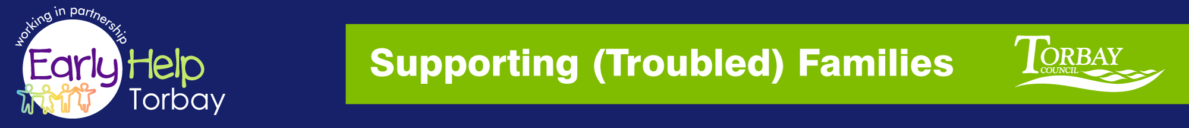
Supporting Families
NETWORK MEETING

THURSDAY 24th January 2019 - 9.30-12.00hrs
At Parkfield, Colin Road Paignton, TQ3 2NR

A GENUINE NETWORKING OPPORTUNITY TO MEET AND SHARE YOUR EXPERIENCES WITH YOUR PARTNERS

Please share with colleagues all welcome

Tables available at venue to advertise your latest initiatives

AGENDA
- Welcome
- Check In
- Steve Leech – S(T)F : Level 2 Support Update
- Vikki McGeough – S(T)F Co-ordinator
  - Guest Speaker: Aisa Withey - Senior Restorative Justice Practitioner
- Refreshment Break – 30mins - meet the partners
- Guest Speaker: David Bevan - Elective Home
Education
- Date, Venue & Time for next meeting
Reply to: nadia.cooper@torbay.gov.uk

steve.l eech@torbay.gov.uk - Interim Supporting (Troubled) Families

ALL MINUTES, INFORMATION LEAFLETS AND FORMS ARE AVAILABLE TO VIEW ONLINE (follow the Link below:-

http://www.torbay.gov.uk/children-and-families/services-and-support/supporting-troubled-families/

