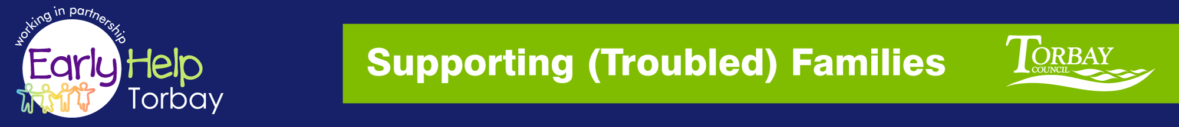

Supporting Families
NETWORK MEETING

THURSDAY 17TH MAY 2018 9.30-12.00hrs
@ Paignton Library

A GENUINE NETWORKING OPPORTUNITY TO MEET AND SHARE YOUR EXPERIENCES WITH YOUR PARTNERS

AGENDA
- Minutes from last meeting
- Q&A Board - please email any questions to be discussed at this meeting
- Steve Leech – Supporting Troubled Families
- Kerrie Ford – Targeted Support
- Guest Speaker: Michelle Taylor: - Youth Genesis
Trust Ltd
- Refreshment Break
- Guest Speaker: Rachel Aggett –Action for Children
- Date, Venue & Time for next meeting tbc

12.00 – 1.00pm Kerrie Ford – Peer Support

Reply to: nadia.cooper@torbay.gov.uk

steve.l eech@torbay.gov.uk - Interim Supporting (Troubled) Families Coordinator

Website: http://www.torbay.gov.uk/children-and-families/services-and-support/supporting-troubled-families/

