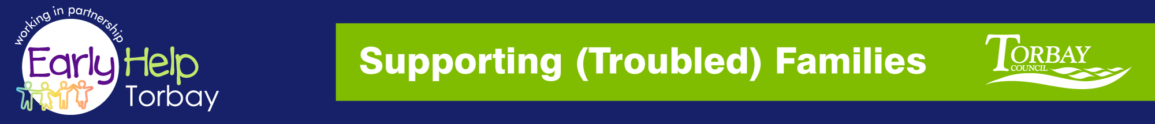

Supporting Families
NETWORK MEETING

TUESDAY 10th October 2017 9.30-12.00hrs
@ Paignton Library

A GENUINE NETWORKING OPPORTUNITY TO MEET AND SHARE YOUR EXPERIENCES WITH YOUR PARTNERS

AGENDA

- Minutes from last meeting
- Guest Speaker: Gail Rogers Children’s Commissioner
- Q&A Board - please email any questions to be discussed at this meeting
- James Tisshaw - Update from Supporting Families
- Guest Speaker: Kelly Givens SENDIAS
- Refreshment Break
- Guest Speaker: Carmen de Silva – Play Torbay
- Date, Venue & Time for next meeting

Reply to: james.tisshaw@torbay.gov.uk

steve.l eech@torbay.gov.uk your Supporting Families Team Around the Family Advisor

