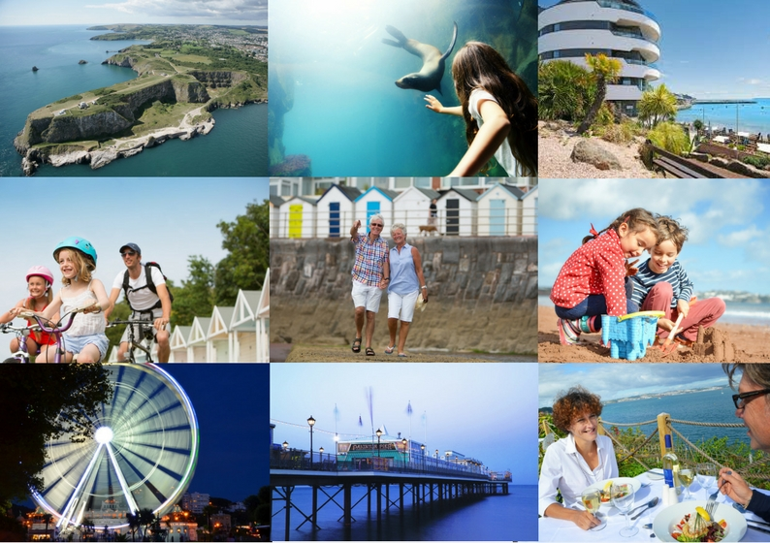
2016-2021  English Riviera Destination  Management Plan 2016-2021  Pride in Place | 2017-2021
English Riviera Destination Management Plan
Delivering a Prosperous and Healthy Torbay

Contents
INTRODUCTION 4
EXECUTIVE SUMMARY 5
Context 6
The Visitor Economy and Market 6
The Tourism Product 6
Policy Context 7
Destination Management, Organisation and Marketing 7
Future Challenges and Trends 8
Objectives 12
Objective and Targeted Actions 12
Priorities 12
Outcomes 13
Action Plan 15
Priority 1: Partnership Working 15
Priority 2: Product Development 15
Priority 3: Market Development and Communication 16
Priority 4: Developing the Destination 17
Priority 5: Visitor Experience 17
Priority 6: Skills and Business Development 19

INTRODUCTION
Torbay, the English Riviera, is a leading UK seaside holiday destination. This Destination Management Plan (DMP) brings the management of the destination together. It aims to provide a shared approach to ensure the whole destination and its tourism businesses are supported and developed. Focussing on developing a successful visitor economy, the Plan presents clear actions and the different stakeholders involved to take Torbay, as a destination, forward. The Plan will align collaborative effort, reduce duplication and maximise local investment.

The Plan builds on the success of the Turning the Tide for Tourism in Torbay Strategy:
- 12% increase in UK visitors with an 8% increase in spend and 1% increase in overseas visitors.
- Achieved UNESCO Global Geopark status, based on the English Riviera’s outstanding internationally significant geological and cultural heritage.
- Delivery of the new South Devon Highway, improving visitor journey times and travel experiences.
- Charitable status obtained for the Agatha Christie Festival, securing Arts Council funding for international development.
- Increased private investment in product development including the refurbishments of hotels improving the quality of accommodation from 2* to 3*, increased the number of quality 5* Boutique B&Bs, development of three new Premier Inns and new 5* boutique spa beach huts.
- Achieved and maintained Purple Flag status for the destination’s night time economy and Blue Flag and Beach Awards status.
- The future of destination marketing secured through the establishment of the new English Riviera Tourism BID Company.
- ‘The English Riviera, South Devon’s Beautiful Bay’ widely adopted across the resort
- New high quality restaurants, cafés and bars, including the popular Abbey Sands development.
- More berths for leisure vessels in Torquay Harbour and new cycle routes have been introduced.
Moving forward, the DMP will make more use of the area’s natural and cultural assets to develop an all year round destination offer, define compelling marketing messages and new products to reach new International and domestic visitors; increasing the quality of the tourism offer and maintaining the resort’s position as a leading South West coastal destination.
The DMP 2017-2021 is underpinned by extensive consultation which has invited tourism stakeholders across the private and public sector locally to share their views. TDA, on behalf of Torbay Council, has also conducted a wide range of research to support the Plan which has been published as Supporting Evidence.

EXECUTIVE SUMMARY
The English Riviera as a leading UK coastal resort faces an exciting future. Since 2010, when the previous Tourism Strategy was approved, both staying domestic visitors and day visitor numbers have increased, supported by year-on-year visitor spend.

The following achievements have been made since the 2010-2015 Turning the Tide Strategy was approved:

Tourism remains a key sector for Torbay and this DMP sets out how we aim to develop the place to meet the needs of today’s and tomorrow’s visitors. Whilst the summer season remains important for the industry and its visitors, many of whom are returning visitors, seizing on new opportunities and new markets to attract new visitors all year round is the ambition of this Plan. More specifically, the Plan seeks to:

- Increase year round growth in numbers for UK domestic and international visitors
- Extend the current season beyond the school holidays
- Attract new international and UK visitors
- Increase visitor spend
- Attract investment and re-investment into the Torbay
- Ensure sustainable delivery of marketing activity for the destination
- Raise skills levels in the sector

As series of priorities and actions have been developed to help achieve these objectives.

These Objectives and associated Priorities and Actions have been developed following extensive visitor and industry surveys conducted during 2016, supported by industry trend data from Visit England and current government policy.

Achieving these objectives will the responsibility of a newly formed Destination Management Group (DMG) which will oversee the delivery of this plan and its actions by reaching out to industry leaders within Torbay such as the Torbay Business Forum and Local Chambers of Commerce to facilitate its delivery; these industry leaders will form a sub-group of the DMG. The DMG will also be the custodians of the destination setting out how we respond to challenges facing the industry and responding to and influencing government policy.

Context

The Visitor Economy and Market
Tourism in England generates £85 billion a year for the economy and employs over 2.6 million people. Latest figures for domestic overnight tourism indicate that there were over 43 million holidays, 40 million visiting friends and family and 14 million business visits. Inbound tourism saw 12 million holidays, 10.5 million visiting friends and family and 7.5 million business visits.
In 2015, over 4.5 million trips were taken to Torbay with £436 million spent by those visitors. The increases in visitor numbers and spend since 2010 when the previous Strategy was adopted are:
- 12% increase in trips by UK Domestic Visitors
- 4% increase in the number of nights spent in Torbay by UK visitors
- Spend by UK visitors has increased from £220,433,000 in 2010 to £274,410,000, which equates to an 8% increase when compound inflation is taken into account.
The table below shows the comparison of Torbay with other Devon destinations in 2015:
 | UK Trips | Overseas Trips | Day Visitors | Total Visitor Spend*
English Riviera | 1,084,000 | 95,600 | 3,389,000 | £436,040,000
Teignbridge | 573,000 | 37,500 | 3,516,000 | £253,484,000
Plymouth | 637,000 | 76,000 | 4,252,000 | £316,553,000
North Devon | 937,000 | 26,000 | 2,964,000 | £345,512,000
* Domestic, overseas and day visitor spend
The 2016 visitor surveys show the English Riviera remains a popular holiday destination. It has a strong and loyal UK market attracting 97% of its visitors from the UK and has an extremely high repeat visitor rate of 87%.

The Tourism Product
Situated within the stunning, rolling hills of South Devon, the English Riviera covers 24 square miles, comprising of the three towns Torquay, Paignton, and Brixham located around the east-facing natural harbour of Tor Bay.
The area includes part of the South West Coast Path, has 18 sandy beaches and is in close proximity to Dartmoor National Park. Known as South Devon’s Beautiful Bay, the area’s attractive coastline, mild-climate, recreational and leisure attractions have won the English Riviera the title of England’s Top seaside destination, and has been included in the country’s Top 10 destinations for the past three years.
In September 2007, the English Riviera received International recognition for its rich geological, historical and cultural heritage and Torbay became a Global Geopark. The designation has full UNESCO programme status that has so far only been awarded to 120 destinations in the world.

Policy Context
The ambition of Torbay Council’s Corporate Plan is to create a prosperous and healthy Torbay. The need to ensure Torbay remains an attractive and safe place to live, visit and work is one of the targeted actions within the Corporate Plan.
Torbay’s Economic Strategy provides a five year plan for growing the area’s economy with a clear action plan focussing on sustainable productive growth. The Strategy places a strong focus upon ensuring that previous investment and job creation is sustained, whilst ensuring the correct environment is in place to maximise growth opportunities, raise productivity levels in businesses and deliver long term prosperity. We recognise that there are increasing opportunities in Torbay, and across the South West, to access higher learning and associated employment opportunities. We are committed to developing a robust education/employment pathway to maximise those opportunities for our young people. Within this, care leavers and children in our care will be a particular priority.
The Economic Strategy encompasses this DMP as well as the Cultural Strategy and the Transformation Strategy for Torbay’s Town Centres. The Council’s Local Plan provides the framework for growth, investment and planning decisions in Torbay, including policies for tourism.
The development of the destination of Torbay will also take place in the context of national and regional policy:
- The recognition by the Government of the need to support growth in the tourism industry
- VisitEngland VisitBritain’s focus on building England’s tourism product, raising Britain’s profile worldwide and increasing the volume and value of tourism exports
- The aims of the Heart of the South West Local Enterprise Partnership to create the right underlying conditions to address productivity barriers and support specific opportunities for high growth
- The objectives of Visit Devon to promote and market the County of Devon as a tourist destination and to act as an official voice for those involved in Devon’s tourism industry.

Destination Management, Organisation and Marketing
To take this DMP forward, which is essential for Torbay’s future growth, the Plan advocates a joined up collaborative approach for tourism, with stakeholders and industry working in partnership to develop the English Riviera’s visitor economy.
This Plan is separate and different to the Business Plan of the English Riviera BID Company. The Company is the official Destination Marketing Organisation for Torbay, overseeing the management, delivery and evaluation of targeted marketing activities. It will operate until 2022, investing £3 million in focussed marketing activity.
The creation of a new Destination Management Group (which will manage the visitor economy and deliver the Destination Management Plan’s objectives) will reach out to stakeholders and industry leaders across all sectors to effectively develop and manage the English Riviera as a whole destination.
Funding opportunities for tourism need to be maximised for tourism and business investments (infrastructure, product development and skills), the Destination Management Group will take a collective role in identify new funding sources, working together with industry to support the growth of the English Riviera’s visitor economy.
Key stakeholders of the Destination Management Group include:

Torbay Council (including Tor Bay Harbour Authority)
English Riviera BID Company
TDA
Torbay Culture Board
TOR2
Torbay Coast and Countryside Trust
English Riviera Global Geopark Organisation
Conference English Riviera
South Devon College
Torbay Business Forum

Whilst, these are the leading organisations, as delivery of the Plan progresses additional members may be identified and invited to join the Group.
As part of the collaborative working partnership approach and the shared vision to develop the destination’s visitor economy, building effective strategic partnerships (local and regional) is essential for the future of tourism in Torbay. A Sub Reference Group will therefore also be established, supporting the Destination Management Group and who can be called upon on an ad-hoc basis to assist in the development and delivery of the Action Plan. Members of the Sub-Reference Group will include business representatives across sectors including retail, as well as organisations such as the Chamber of Commerce, Torbay Licensing Forum, Events Forum and Transport Operators (Stagecoach, First Great Western, local Boat Operators and Exeter Airport for example).
Torbay will continue to work with other partners across the South West where there are shared benefits.

Future Challenges and Trends
TDA’s industry research (which is set out in the accompanying Evidence base) shows there are emerging trends and opportunities which are areas of opportunity for the English Riviera:
- Increase in popularity of short breaks
- Growing popularity of staycations
- Increase in business and conference tourism
- Growing national trend for wellness tourism
- Building on existing assets to increase cultural tourism
- Maximising the opportunities from TV and film production
The following pages show the strengths, issues and opportunities which are the basis on which the DMP has been developed and stem from the Evidence Base. The Plan sets the framework to bring these together to develop the English Riviera’s aspirations as the preferred South West coastal tourist destination.

STRENGTHS | ISSUES | OPPORTUNITIES
- Strong UK market with three quarters of visitors from outside the South West region, with large amounts of visitors coming from the M1, M6 corridors, central and north areas.  - Current visitors are happy and like what they experience - high resort recommendation score.  - 79% of visitors are staying are overnight  - Popular location for taking a leisure trip/holiday.  - High proportion of affluent ABC1s visitors and in full time employment.  - Exceptional high return of repeat and loyal visitors.  - The majority of staying visitors are without children and in adult only groups.  - Strong family market, (predominately during school holidays), seeing an increase of groups with children and increase in group size from 2.58 to 2.64 people.  - Accessible location - highest proportion of visitors travelling by car.  - Visitors feel well informed with information was easy or very easy to find during their visit.  - Strong ‘traditional seaside experience’ with 62% of visitors giving this as the main reason for visiting.  - High visitor satisfaction for ‘resort enjoyment’  - A good range of ‘things to do’ and attractions with good satisfaction scores.  - Successful new developments, (e.g. Abbey Sands). The restaurants in this development are often full highlighting the fact that if a quality product is developed, people are willing to use them and spend the money.  - Strong industry confidence both in the future of their business and in planning to develop and grow their business in the next 5 years.  - Strong desire for partnership and joined-up working from the Industry, for sharing of information/ events, promoting Torbay and improving the quality of offer.  - Businesses are engaging digitally.  - High delegate satisfaction score for the UNESCO Global Geopark Conference. | - Torbay has an ageing visitor profile.  - Low rate of first time visitors.  - Extreme seasonality, predominately during the school holidays.  - Low rate in overseas visitors.  - The average length of stay has decreased from 5.40 nights to 4.76 nights.  - The car parking offer is seen as the biggest issue  - The physical environment of the high street is seen as run down – empty retail shops and dirty streets.  - Increased presence of anti-social behavior and homeless people on the streets/open public areas.  - The proportion of business trips is continuing to decline.  - Lapsed/ non visitors do not think they can find a quality offer in Torbay (specifically food and drink).  - Torbay is seen as a value for money destination.  - No new destination related issues deterring visitors, but existing issues need addressing.  - Half of tourism businesses experience issues as a result of Torbay’s seasonality.  - Low industry confidence in visitor demand, increased competition, the economy (Brexit), recruitment/retention of staff.  - Short supply of high-end accommodation.  - There needs to be a better link between culture and tourism and how this offer is promoted to attract new visitors.  - The English Riviera is a strong brand for current visitors but the brand can be confusing, as the area is also known as Torbay with the towns Torquay, Paignton and Brixham.  - Current visitors are on a budget and are using On-line Travel Agents more to find the best deals.  - Working in the tourism industry is not perceived as a career option impacting on staff recruitment and retention.  - Torbay is seen as too far to travel by lapsed/non visitors.  - There are perceived delays in the development of new development projects. E.g. Torwood Street, Oldway Mansion, Pavilion.  - 1/3 of businesses feel training isn’t relevant to their business on a range of key topics and 1/3 don’t provide any training at all.  - April to September is the core trading period for businesses.  - Low delegate satisfaction score for the quality of resort accommodation from the UNESCO Global Geopark Conference delegates. | - Promote the English Riviera as a year round destination, extending the season.  - Maximise visitors’ interest in the local food/drink and the outdoors.  - Agatha Christie provides a useful cultural offer  - Utilise local events in a co-ordinated marketing programme to attract new visitors and engage with local businesses and residents.  - Increased UNESCO Geopark awareness with 40% of visitors wanting to find out more.  - Review the success of the UNESCO Geopark conference and make best use of its legacy for the business/conference and international market.  - Research the UK and International conference and business market to identify opportunities for the resort and the Riviera International Conference Centre.  - The majority of staying visitors are without children and in adult only groups, presenting the opportunity to further develop this market to increase the shoulder season and occupancy.  - Develop the quality offer and fill bed spaces out of peak summer months utilising the mix of accommodation and large stock available.  - New product development to support growth in international visitors.  - Day visitors staying in other areas of Devon/South West are travelling up to 1 hour to Torbay whilst on their trips.  - Torbay’s car parking offer can be used to attract shoppers and day visitors.  - The resort can become a touring base for Devon  - A higher percentage of non-visitors are looking for history, heritage and culture for a holiday and which they don’t think they can find here.  - Increase use of digital by visitors to research, book and review their trips.  - New developments (e.g. Abbey Sands attracting leading restaurants) provide an opportunity to attract similar developments to Torbay.  - 8% VFR market – this seems low, but may be the second reason for visiting.  - Increase in shorter stays and maximise the visitor spend in this market trend.  - Maximise current visitor’s high recommendation scores.  - Brexit is likely to lead to an increase in staycationing whilst making the UK an attractive place to visit for Europeans due to currency changes.  - The South Devon Highway has improved accessibility to the area bringing Exeter/Bristol Airport closer in terms of travel times, potentially opening up new markets.  - Accommodation providers can help to promote events, what’s on/things to do.  - Successful VisitEngland Discover England Fund project (England’s Seafood Coast) will create a strong quality food and drink offer to attract new International visitors.  - The new Tourism BID Company will provide a clear way forward for destination marketing.  - Businesses are engaging digitally, there are opportunities to help businesses to use these platforms more effectively.

Objectives

Objective and Targeted Actions

The objective of the English Riviera’s DMP is:

To strengthen and develop the English Riviera’s tourism offer.

This will be achieved by delivering, in partnership with local stakeholders, the following targeted actions:

Priorities
To deliver these targeted actions there are six priorities, which are all connected to ensure the success of the English Riviera’s visitor economy. Whilst these priorities can stand alone, there is likely to be some overlap (i.e. developing the destination will also have an impact upon marketing and communication).

- Priority 1: Partnership Working: We will work collectively with joint responsibility to deliver the Destination Management Plan in order to grow of the English Riviera’s visitor economy.
- Priority 2: Product Development: We will strengthen the English Riviera’s all year round product, extending the season and jointly developing an increased number of compelling visitor experiences. We will build on the success of our quality natural and cultural assets, the UNESCO Geopark and Agatha Christie to attract new international and UK visitors.
- Priority 3: Market Development and Communication: We will identify new and emerging markets and how best to communicate with them We will make the most of our existing assets and all year round destination to attract new international and UK visitors as a key focus for marketing the English Riviera.
- Priority 4: Developing the Destination: We will ensure the English Riviera remains an attractive destination to live, visit and work in order to grow the visitor economy through improving the physical destination and the natural environment.
- Priority 5: Visitor Experience: We will ensure the English Riviera as a destination offers a quality experience across the whole resort, welcoming new visitors and encouraging their return.
- Priority 6: Skills and Business Development: We will work collaboratively to support tourism businesses to improve skills (including online digital) to develop the destination and to meet visitor needs and expectation.

Outcomes
Through focused and managed actions in relation to the Priorities, this Plan will strengthen the English Riviera visitor economy and will achieve the following outcomes:
- Increased visitor numbers and spend
- Extending the season beyond the school holiday periods
- Attracting new visitors
- Attracting investment and reinvestment
- Ensuring sustainable delivery of marketing activity for the destination
- Improved quality of accommodation offer
- Improved infrastructure, parking and retail offer
- Improved hotel occupancy throughout the year
- Improved visitor satisfaction results and recommendation rates across all areas
- Increased number of businesses taking up training opportunities
- Better connection with education providers and take up of apprenticeships
- Improving the perception of tourism of a career choice, retaining skills and local talent

Action Plan

This section builds upon the presented six Priorities and sets out a series of key actions which the Destination Management Group (with a lead organisation for each action) will take forward. It should be noted that whilst these actions can stand alone, there is likely to be some overlap. The timescales and key milestones will be monitored and measured by the lead organisation, who can also call upon other organisations to support and deliver the priority.

Priority 1: Partnership Working

Key Actions | Lead Organisation
- Create the Destination Management Group and set the Terms of Reference, to manage the delivery of the Plan and develop the English Riviera’s visitor economy. | Torbay Council
- Create the Sub Reference Group to support the Destination Management Group and the delivery of the Plan. | Destination Management Group
- Prioritise our looked after children and care leavers within the activities in this Plan. | Destination Management Group

Priority 2: Product Development

Key Actions | Lead Organisation
- Develop an all-year round seasonal product, extending the season to attract new Domestic and International visitors and overcome extreme seasonality in peak summer months. Supporting marketing and communications, promoting the English Riviera as an all year round destination, extending the season and attracting new visitors all year round. | Destination Management Group
- Define Torbay’s cultural offer to target and attract new visitors; develop new itineraries making the most of cultural assets including Agatha Christie and UNESCO Geopark, and further explore opportunities in this new market; further supporting the all year round offer and attracting international visitors. | Torbay Culture Board
- Develop a range of packages and experiences to exploit new opportunities and satisfy the needs of new visitor markets; Develop compelling packages and targeted marketing messages to attract new Domestic and International visitors, as well as re-engaging with lapsed/non visitors; including quality food and drink, history heritage and culture, natural assets and outdoor experiences/activities. | English Riviera BID Company

Priority 3: Market Development and Communication

Key Actions | Lead Organisation
- Develop an all-year round seasonal offer, extending the season, marketing the English Riviera as an all-year round destination, using Torbay’s natural assets throughout the year to define and promote the offer. This should include evolving the current calendar of events/activities, making the most of big and annual events, using key seasonal messages to attract new UK and International visitors. | English Riviera BID Company
- Ensure regular market intelligence and evaluation takes place to inform effective market development - keeping the English Riviera businesses up to date with visitor trends, emerging markets and associated opportunities and further developing the offer | English Riviera BID Company
- Scope new opportunities and development into new UK and International visitor markets. Identifying the new trends and how to maximise the opportunities to extend the season and increase new visitors. To include increasing short breaks and maximising the rise in ‘staycations’, international visitors, engaging with non/lapsed visitors, under 35’s, business/conference tourism and exploring TV/film opportunities. | English Riviera BID Company
- Develop the UNESCO Geopark offer to maximise visitor interest and increase new International and Domestic visitor markets. The offer should be accessible online, reflecting visitor trends, defining how both visitors and residents can benefit; further supporting product development and the English Riviera’s all year round offer. | English Riviera Global Geopark Organisation
- Build upon Torbay’s digital presence - improving the quality and accessibility of visitor information, and also increasing direct online bookings with businesses through improved e-commerce websites; Working with industry for a joined up approach to cross-promote and aligning with national VisitEngland VisitBritain campaigns which are digitally focused, including the creation and sharing of quality content, guides, itineraries and images. | English Riviera BID Company

Priority 4: Developing the Destination

Key Actions | Lead Organisation
- Maintain the strategic partnership focus for the development of the English Riviera’s visitor economy to ensure the Plan’s Objectives are achieved. | Destination Management Group
- Aligning with Torbay Council’s Corporate Plan, ensure the English Riviera remains an attractive and safe place to live, visit and work. This includes seeking to ensure service delivery, infrastructure and public open spaces accessed by visitors are maintained to support the destination’s product development and meets the needs of visitors | Torbay Council
- Review Torbay’s retail and parking offer, as well as gateway and signage, to understand how it can be used to improve the quality of the visitor experience and overall welcome to the English Riviera. Ensure alignment to Torbay Masterplans’ implementation timeframes and communication plans, further supporting product development and the quality of the visitor experience, specifically to overcome negative resort perceptions. | Retail – TDA  Parking – Torbay Council
- Support Torbay Council’s policy for accommodation change of use; to better understand the impact on the visitor economy, the provision of support information for businesses and the future development of good quality accommodation, to attract new visitors and to meet their needs. | Torbay Council
- Attract new high quality investments to further develop the English Riviera’s offer and to attract new UK and International visitors. Specifically, making better use of Torbay Council existing capital infrastructure assets and empty buildings which are perceived negatively, including Torwood Street, Torre Abbey, Oldway Mansion and Broadsands Beach. This investment further improves the quality of offer, whilst also generating revenue for the visitor economy. | Torbay Council
- Review Torbay’s digital connectivity offer, ensuring the English Riviera offers exceptional, accessible Wi-Fi across the resort and in public spaces, improving the quality of visitor welcome and experience for both residents and visitors. This further supports product development and increasing the ‘visiting friends and relatives market’. We know visitors are online during their stay to access information, book restaurants/things to do, as well as leaving online reviews. This provision therefore recognises and supports this trend, whilst improving the visitor experience. | TDA

Priority 5: Visitor Experience

Key Actions | Lead Organisation
- Continue to develop exceptional customer care across the resort, giving the best welcome to all visitors and maintaining high satisfaction; Providing a quality offer and visitor experience consistently all year round, attracting and maintaining visitors to a quality destination. | Destination Management Group
- Ensure modern, well-informed parking services are provided for all visitors, as detailed in Torbay Council’s Parking Strategy 2016-2021; including the adoption of clear pricing options and seasonal campaigns, increasing revenue. Further supporting the all year-round product development, providing quality, affordable and accessible parking services will meet visitor expectations and overcome negative resort experiences and improve satisfaction rates. | Torbay Council
- Ensure industry and local residents are well informed to provide up to date information to visitors/relatives on what the resort offers. Improving the communication and promotions of resort events/services, through a joined up approach will increase attendance, visitor spend and local awareness, improving the overall visitor experience | English Riviera BID Company
- Identify areas of opportunities to increase visitor satisfaction scores into other resort services. Overall resort recommendation is high for example from current visitors; by developing weaker areas of visitor satisfaction, such as car parking facilities, public toilets and beach services it will positively impact on the visitor experience. | Destination Management Group
- Maximise the opportunities through awards and accreditations to raise the profile of the English Riviera as a quality destination to new visitor markets. Promote and support businesses to enter awards and gain accreditations/recognition, including TripAdvisor, VisitEngland and Purple Flag. | English Riviera BID Company

Priority 6: Skills and Business Development

Key Actions | Lead Organisation
- Develop the evidence base; conduct regular industry intelligence to understand the needs of industry, informing business and skills development. Ensure market-led business support is taking place, further supporting developing the destination and the visitor experience. | TDA
- Support industry by changing perceptions for the tourism sector as an attractive career path and to retain local talent. By developing the destination and the all year round offer, it will support the industry with current issues experienced by seasonality, and the over reliance on cheap, seasonal, low skilled labour. | TDA
- Develop an accessible and affordable programme of business support; encouraging tourism businesses throughout the destination to embrace the all year round offer and adapt to changing visitor trends. Business support should include key areas such as addressing key industry issues and those associated with ‘Brexit’; recruitment and retention of staff; (linking to action 23); barriers to growth; developing digital skills; increasing revenue and maximising all opportunities to increase the visitor economy. | TDA
- Identify future funding opportunities for business skills development, supporting the development of the visitor economy and maximising the funding opportunities. This also supports product development and developing the destination. | Destination Management Group
- Encourage adoption of apprenticeship schemes throughout the industry, helping to overcome the barriers of recruitment and retention of staff, an issue often seen by tourism businesses due to Torbay’s seasonality. Encourage the sector to take part in National Apprenticeship Week bringing together employers, schools and education providers and young people. | Destination Management Group

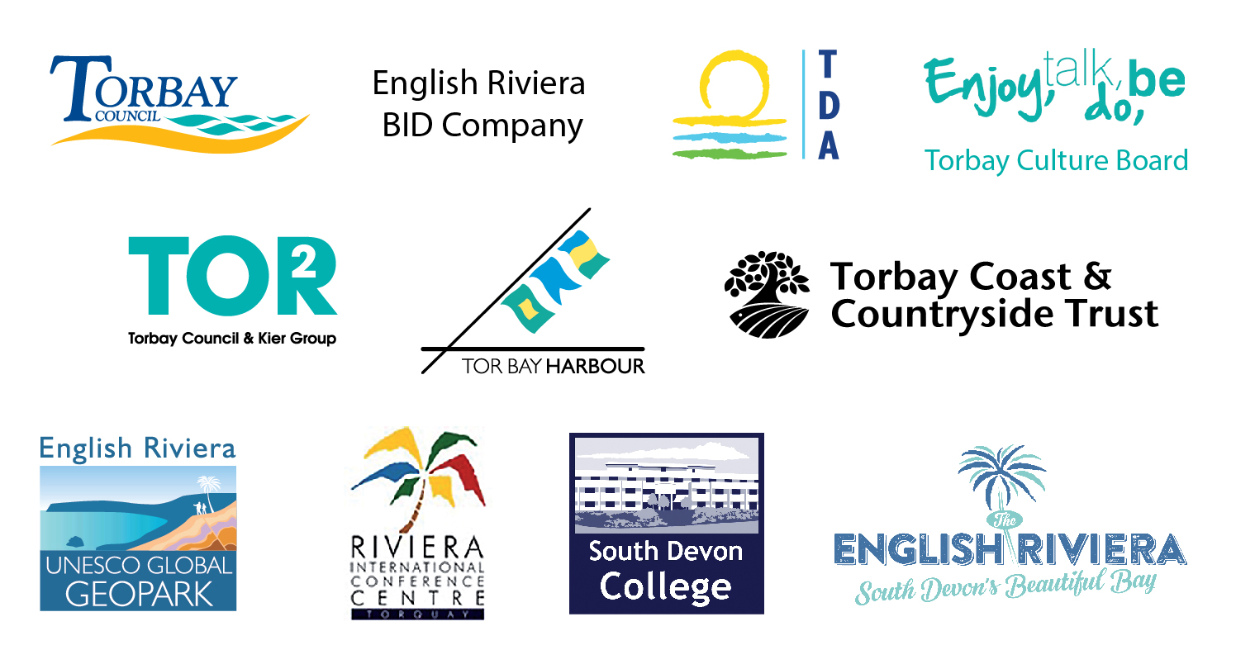
Contributors to Destination Management Plan

A DMP is a concept and shared approach to effectively manage the whole tourism destination. VisitEngland VisitBritain sees the development of Destination Management Plans, which are increasingly being introduced across regions, as an essential tool further supporting Government policy, encouraging destination organisations to become focussed and efficient.
2010:2015 comparison English Riviera visitor data
Tourism in England – Key Facts and Trends 2015
South West Research Company
TripAdvisor 2015 Travellers Choice Awards

