To promote fitness within community’s Torbay Council and South Devon NHS Foundation Trust installed a number of outdoor exercise trail equipment at sites across Torbay

Fresh Air Fitness has installed a range of fitness equipment at

- St Mary’s Park, Brixham
- Goodrington Sands, Paignton
- Preston Green, Paignton
- Upton Park, Torquay

For many people those first initial steps to becoming more physically active can be the hardest. This outdoor fitness trail is a great way to a healthier lifestyle for people of all ages.

Being free, convenient and accessible to all, it removes many of the barriers that might otherwise prevent people from taking those first steps. Well-documented research has shown that even small amounts of regular exercise have measurable benefits towards physical and mental health and wellbeing.

Here is some of the equipment available and what it does.

Please note that each area offers different equipment, not all of the below list is available at each location.

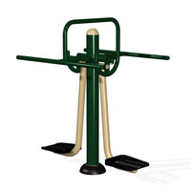 | Air Skier  By swinging both legs together from side to side the Air Skier strengthens and develops the lower abdomen hips and thighs, improves balance and co-ordination through "core" activation. Excellent warm-up and work-out for skiers, but also can provide gentle exercise for fitness beginners.
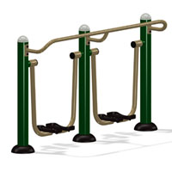 | Double Air Walker  This universally popular apparatus provides excellent cardiovascular exercise while developing the leg muscles. Allows a full range of movement in the hip joint improving flexibility and strength, without any impact or stress to joints and back. Suitable for all ages and especially for those for whom jogging and power walking are not suitable.
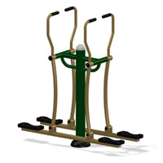 | Double Cross Country Skier  Similar to an Elliptical Cross Trainer this movement is less arduous and great for less agile users. Simply stand on the unit and let your feet slip back and forth whilst controlling the movement through the handles. Great for working in pairs and to encourage social interaction.
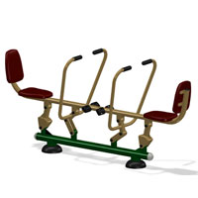 | Double Rower  For use by either 1 or 2 users. There aren’t many boats where rowers face each other! This equipment provides all the benefits of rowing while encouraging social interaction and making it fun to use. The back support prevents over extension of the back.
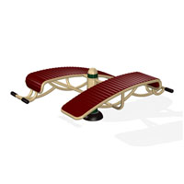 | Double Sit-up Boards  The design and construction of these sit-up boards helps to encourage correct action and to prevent lower back strain, while at the same time putting the abdominal muscles through a fuller range of movement from extension to contraction. Suitable for all ages and abilities.
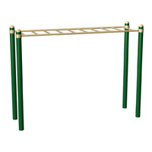 | Horizontal Ladder  Also known as Monkey bars, this is a strenuous exercise for arms and shoulders "walking" hand over hand the length of the ladder. Can also be used for chin-ups. Suitable for teenagers and adults
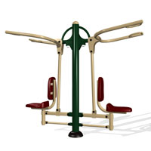 | Pull-Down Challenger  Also known as a lat pull station, this provides an excellent work-out for arms shoulders and back, building strength and stamina.
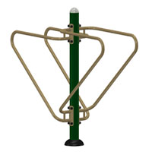 | Push-up and Dip Station  Two sets of parallel bars set at different heights allow for push-up and dip exercises and inclined press ups or assisted squat, a strenuous exercise to develop strength in arms and shoulders. Can also be used for knee raises. A simple and versatile piece of equipment.
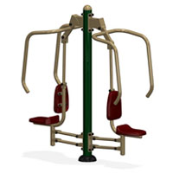 | Seated Chest Press  This apparatus develops power and strength in arms chest shoulders and back. A strenuous work-out that can be assisted by pushing up with the legs.
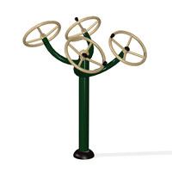 | Tai Chi Spinners  These wheels are designed to promote flexibility and co-ordination in wrists arms and shoulders as well as improving circulation and providing an excellent warm-up. Suitable for all ages as well as wheel-chair bound users and an excellent physiotherapy routine.
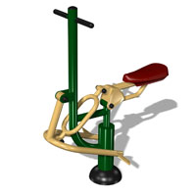 | The Rider  Similar to a rowing machine but in a more upright position the Rider gives a full-body cardiovascular and toning work-out, pushing with the legs while pulling with the arms against resistance. Works arms shoulders, back legs, abdomen and legs with low impact exercise.
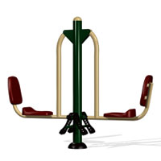 | Seated Leg Press  Excellent work-out for thighs and hips without any of the risks to the knee joints associated traditional squats. Suitable for all ages and abilities. Increase speed and or the number of repetitions for more strenuous exercise. Can be used individually or by two people together for paired exercise.

Strength
Helps to build and tone muscle tissue.
Cardiovascular (CV)
Helps to strengthen the heart and improve heart lung efficiency
Flexibility
Stretches muscles, tendons and ligaments and/or increases range of movement
Balance & Co-ordination
Improves reflexes and mind/body interaction

