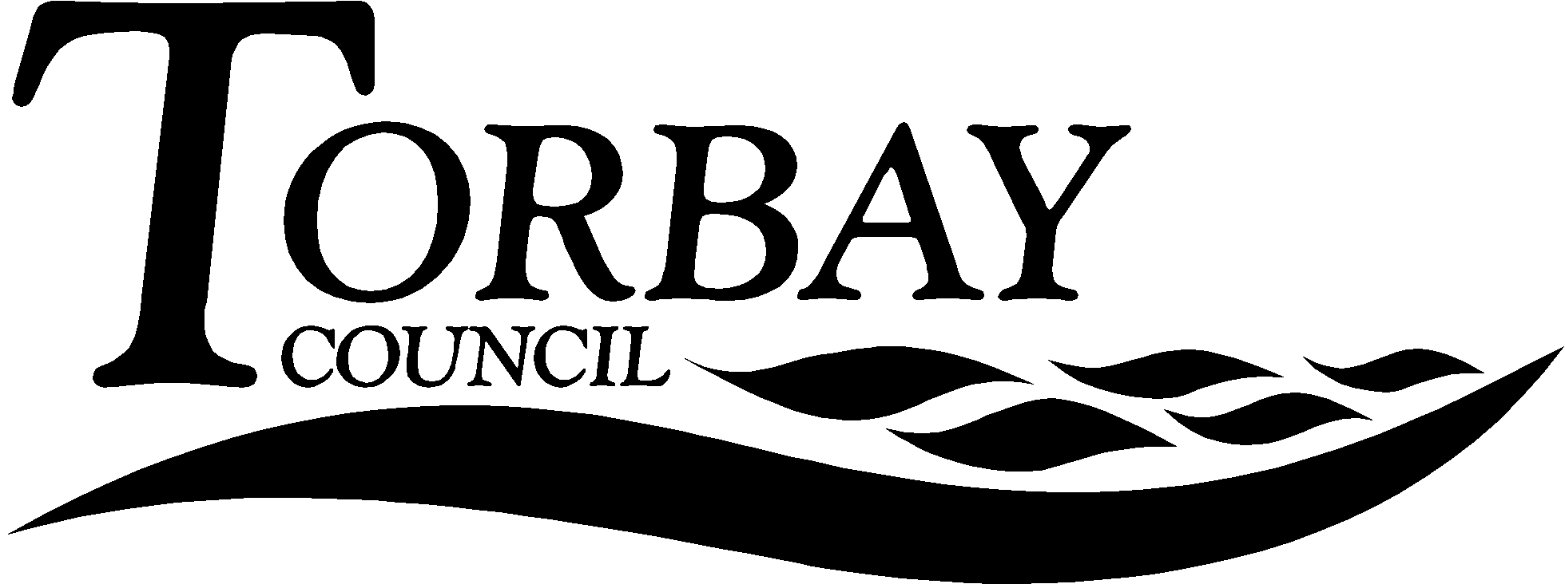

Title: Doing Good: A Future for Christianity in the 21st Century and Understanding Christianity

This report relates to a report published by Theos on 14th December 2016 written by Nick Spenser relating to the place of Christianity in British public life on the basis of current social trends. It suggests that this report be made available to RE in teachers in Torbay’s schools and academies. It also updates SACRE on the latest developments regarding the National Society’s Understanding Christianity project and resource.
Wards Affected: | All
To: | SACRE |  | On: | Date
Contact Officer: | RE Adviser
Telephone: | 07855 235865
E.mail: | hampshireeducational@outlook.com

1. Key points and Summary

  - The purpose of this report is bring to the attention of SACRE members the paper published by Theos in December 2016 and to update SACRE members on the Understanding Christianity project. It is a responsibility of SACREs to recommend resources to schools within its Authority.
2. Introduction

2.1 Theos is a Christian Think-tank launched in 2006, which ‘conducts research, publishes reports, and holds debates, seminars and lectures on the intersection of religion, politics and society in the contemporary world. We also provide regular comment for print and broadcast media and briefing and analysis to parliamentarians and policy makers. To date, Theos has produced over 50 research reports focusing on the big issues impacting British society, including welfare (The Future of Welfare: A Theos Collection), law (“Speaking Up” – Defending and Delivering Access to Justice Today), economics (Just Money: How Catholic Social Teaching can Redeem Capitalism), multiculturalism (Making Multiculturalism Work), voting reform (Counting on Reform), as well as on a range of other religious, legal, political and social issues.’ As such it has free online resources that are useful for teachers of RE and for secondary pupils.

The paper: A Future for Christianity in the 21st Century looks at social trends, where religion in Britain is changing, as seen by the report of the Commission on Religion and Belief in British Public Life (CORAB, 2015) and the place that Christianity plays within it. It also take seriously the current state of Britain in relation to the welfare state and the end of welfare utopianism (Woodhead, L. and Catto, R. (2012) Religion and Change in Modern Britain. Abingdon, Routledge).

The paper is useful for teachers as it provides them with useful CPD in relation to their own understanding of Christianity and can be a useful resource for secondary pupils in looking at the way some Christians are thinking about the place of Christianity in a changing Britain. What is of interest is that whilst Christian churches are predicted to become smaller the work they do will become increasingly important for society as a whole. The paper also explores issues relating to evangelism and it explore the concept of ‘social liturgy’.

What is useful about this essay is that it shows how theological thinking occurs in a Christian context relative to a changing socio-cultural scene where Christianity is ceasing to be the dominant cultural force but remains significant in a society that retains a Christian infrastructure. Both for teachers of RE and for secondary pupils this is a useful process in their own religious education.

2.2 SACRE has previously looked at Understanding Christianity and this report provides an update on previous reports.

Understanding Christianity has become part of the strategy for RE for Exeter Diocese (see: http://exeter.anglican.org/schools/religious-education-worship/christianity-project/) but it is a resource intended for non-Anglican schools to use. The project comes with a training package as well as resources for primary and secondary schools. It’s focus is around helping schools to represent Christian theology to pupils in line with that held by the National Church (represented on SACREs by Group B).

3.0 Recommendation

  - That SACRE recommend the Theos report A Future for Christianity in the 21st Century to schools to inform their teaching of Christianity and to contribute to teacher’s own continuing professional development.

  - That SACRE note the update on Understanding Christianity.

Andrew Strachan
Chair of SACRE

Appendices

Spenser, N. (2016). A Future for Christianity in the 21st Century. London, Theos.

Documents available in members’ rooms

Torbay Agreed Syllabus 2015

Background Papers:

Torbay Agreed Syllabus 2015

Online resources:
http://www.understandingchristianity.org.uk
https://corablivingwithdifference.com

