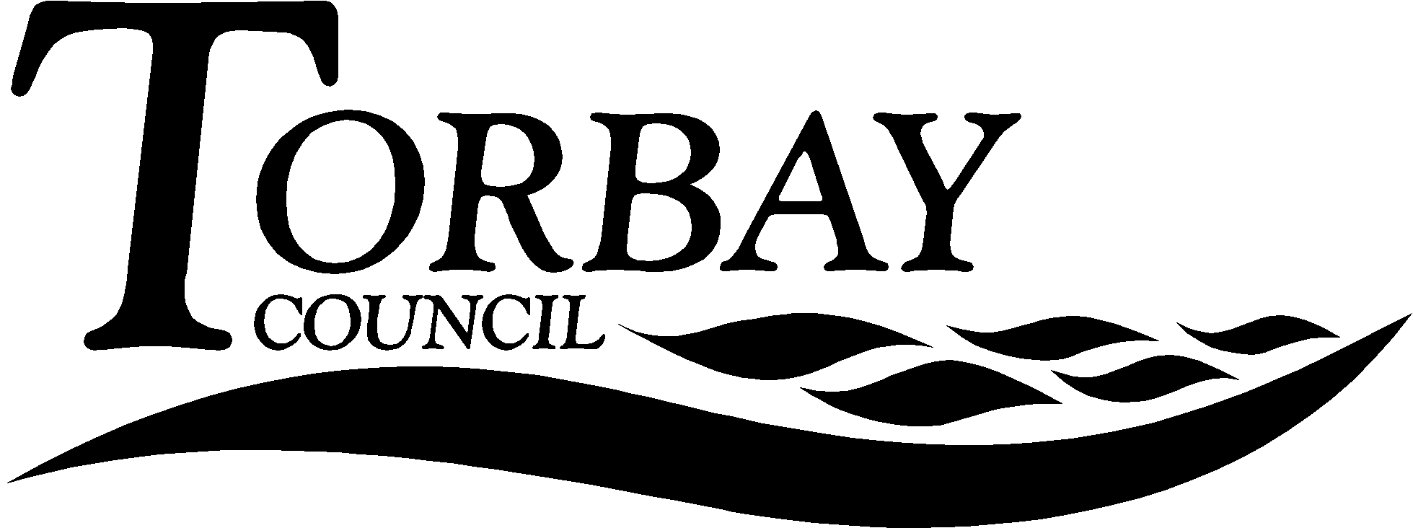

Title: | Inter Faith Week 2017
This report relates to Inter Faith Week, a national event that has happened in the third week of November every year since 2009. This report recommends policy for 2017, given that Inter Faith Week will be taking place during the week that SACRE meets.
Wards Affected: | All
To: | SACRE |  | On: | Date 15th November, 2016
Contact Officer: | RE Adviser
Telephone: | 07855 235865
E.mail: | hampshireeducational@outlook.com

1. Key points and Summary

  - The purpose of this report is make SACRE aware of Inter Faith Week and to encourage SACRE to recommend to the local authority and its schools that they participate in the Week.
2. Introduction

2.1 Currently, it has been the policy of SACRE to support Inter Faith Week and the work of the Torbay Interfaith Forum (http://devonfaiths.org.uk/groups/torbay-interfaith-forum/) who are represented on SACRE.

2.2 The Inter Faith Week website: http://www.interfaithweek.org/ has been developed by the staff at the Inter Faith Network to support organisations of all sorts to put on Inter Faith Week events, including promotional materials and a Toolkit designed with a section for local authorities and schools.

2.3 As can be seen some events will have taken place by the time the SACRE meeting has taken place, Appendix 2.

3.0 Recommendation

  - That SACRE recommend to the local authority that it investigate the possibility of holding an annual Inter Faith Week 2017 event with the Torbay Interfaith Forum.

  - That SACRE recommend to schools that they mark Inter Faith Week 2017 with an event and are made aware of the resources on the Inter Faith Week website for schools to help them in that task.

Andrew Strachan
Chair of SACRE

Appendices

Appendix 1: Inter Faith Week Flyer 2016
Appendix 2: Devon Faith and Belief Forum event In preparation for Interfaith Week 2016 (14th 20th Nov)

Documents available in members’ rooms

Background Papers:

