M J Oxford CEcol. FIEEM.

Kestrel Wildlife Ltd

February 2015

Report for Torbay Council

Dr Laurent Duvergé
Kestrel Wildlife Ltd
May 2013

Report for Teignbridge District Council

HRA Site Appraisal Report of Torbay Local Plan
Strategic Delivery Areas
(Proposed Submission Plan - February 2014)

HRA Site Appraisal Report of Proposed Additional Sites with
Potential for Development to be included as Proposed Main Modifications to the Submission Local Plan

February 2015

HRA Site Appraisal Report of Torbay Local Plan
Strategic Delivery Areas
(Proposed Submission Plan - February 2014)

HRA Site Appraisal Report of Proposed Additional Sites with
Potential for Development to be included as Proposed Main Modifications to the Submission Local Plan

February 2015

Prepared by Kestrel Wildlife Ltd

Date: February 2015

Version: Final Version for Torbay Council

Recommended Citation: Oxford M. (2015) HRA Site Appraisal Report of Torbay Local Plan Strategic Delivery Areas (Proposed Submission Plan - February 2014) HRA Site Appraisal Report of Proposed Additional Sites with Potential for Development to be included as Proposed Main Modifications to the Submission Local Plan

A report by Kestrel Wildlife Ltd on behalf of Torbay Council.
Contents

- Introduction 4

- Structure of This Report 4
- Potential Development Sites (Primarily Housing)

  - Land South of White Rock (Brixham Strategic Delivery Area) 5
  - Shoalstone Overflow Car Park (Brixham Strategic Delivery Area) 9
  - Sladnor Park (Torquay Strategic Delivery Area) 11

Appendix A SAC Conservation Objectives and GHB Conservation Objectives 15

Appendix B Protection and Enhancement of Ecological Network 16

References 17

HRA Site Appraisal Maps, Figures and Photos

Figure 1 Location Map for Land South of White Rock 19

Figures 2&3 Shoalstone Overflow Car Park Location Map and Site Boundary 20

Figure 4 Location Map for Sladnor Park 21

Figure 5 Sladnor Park Boundary and Key Internal Features 22

Figure 6 Sladnor Park 2006 Proposed Development Layout 23

Photo 1 Shoalstone Overflow Car Park 9

1. INTRODUCTION AND BACKGROUND

1.1 Introduction

    - The following report, commissioned by Torbay Council (TC), forms an addendum to the full Habitat Regulations Assessment (HRA) Site Appraisal produced for the Council through the summer and autumn of 2014 (in terms of integrity of the South Hams Special Area of Conservation (SAC) for greater horseshoe bats). As such the methods to undertake the Appraisal are the same as described in Section 2 of the main HRA Appraisal Document.

    - This addendum has been specifically prepared to examine three ‘Potential Development Sites’; these are:

- Land South Of White Rock - Proposed Main Modification Notation (MM 3) Policy SS2 New Future Growth Area (Local Plan Broad Allocation);

- Shoalstone Overflow Car Park - Proposed Main Modification Notation (MM 12) Potential Development Site (Primarily Housing) for Consideration in the Brixham Peninsula Neighbourhood Plan;

- Sladnor Park - Potential development site (Primarily Housing) for consideration in the Torquay Neighbourhood Plan.

2. STRUCTURE OF THIS REPORT

An appraisal is presented in Section 3 of this report and examines whether the three sites listed above are likely to affect the Berry Head Component of the South Hams SAC.

This appraisal provides information on the following:

- Key physical characteristics of the site;
- Whether future development of the site has the potential to impact the integrity of the South Hams SAC;
- Whether it is likely that potential impacts will require Habitat Regulations Assessment (HRA);
- Whether it is likely that likely impacts can be mitigated effectively.

A colour code is provided alongside the title of each site report to give an ‘at-a-glance’ impression of the site’s suitability for development.
Green indicates that the integrity of the SAC is unlikely to be affected and proposals could be taken forward that would not require HRA.

Amber indicates that the issue of whether or not the integrity of the SAC is likely to be affected by development depends on the details of the proposal and the form of mitigation provided. HRA would be required.

Red indicates that initial screening suggests that this site should not be brought forward for development because the site is considered key to the integrity of the SAC and it is unlikely that effective mitigation or compensation would be possible. HRA would be required.

3. POTENTIAL DEVELOPMENT SITES

  - LAND SOUTH OF WHITE ROCK

Proposed Main Modification Notation (MM 3)
Policy SS2 New Future Growth Area

Key Characteristics

    - The site (hereafter referred to as the ‘Site’) is identified in Figure 1 of this HRA Site Appraisal and proposes to allocate land for the development of up to 460 dwellings.

    - The site lies to the west of the built up area of Paignton and falls within the Sustenance Zone for the Berry Head Component of the South Hams greater horseshoe bat Special Area of Conservation (SAC). Natural England have also identified two Strategic Flyways near to the ‘Site’; one to the sout-west along the River Dart and the other, to the north-west, along the valley between Collaton St Mary and Stoke Gabriel.

    - The site is located west of the A3022 and covers an area of approximately 31ha, and is centered on Ordnance Survey (OS) grid reference SX886578. The site is largely comprised of semi-improved and improved grassland, arable fields, hedgerows, two ponds, and small blocks of semi-natural broadleaved (mixed) woodland. In addition, a few buildings are present in the north-east corner of the site beside the A3022.

    - Most of the hedges across the site are intensively managed and do not therefore provide the structural height and diversity that would offer either optimal foraging or commuting habitat for greater horseshoe bats (GHBs).

    - The A3022 bounds the site along the entire eastern edge, with the urban area of Hookhills and Goodrington (a residential suburb of Paignton) beyond. Residential and employment units are being developed to the north on the other side of Long Road, whilst open fields lie to the south and west where the landscape rolls away down to the River Dart.

    - The hedgerows across the site tend to be intensively managed, being annually flailed and kept low and compact. Consequently, in their current condition, they do not providing optimal foraging or commuting for GHBs, although this situation could be changed with more ‘sympathetic’ management that allows them to grow taller and bushier.

    - A large proportion of the ‘Site’ is grazed pasture and, as such, represents good or even optimal foraging habitat for GHBs.

    - There is a small block of woodland on the south-western edge of the ‘Site’ that also provides suitable habitat for foraging and commuting GHBs.

    - The landscape to the west of the ‘Site’ is formed of small fields and mature tall mature hedges along the sides of the Dart Valley.

Site Based Evidence

    - An ecological report has been prepared for the landowners by Ecosulis Ltd (dated July 2014). This report includes the results of bat surveys undertaken across the area during the period between May and September 2014. The Ecosulis Report is not adequate to inform any future planning application because the degree of survey effort is not consistent with Natural England’s 2010 SAC Guidance and does not provide sufficient evidence of use of the ‘Site’ by GHBS.

NOTE: The Ecosulis Report is considered inadequate, because it does not cover the full survey period through the year (as recommended by Natural England in their SAC Guidance) and the methods used do not include sufficient numbers of transect surveys during the required period between April and October. Also, significantly, the surveys only included the use of static detectors in August and at only one location. This is considered to be a major failing of the report. To be consistent with the NE survey protocol in the SAC guidance, greater survey effort using static detectors is required. From experience across the South Hams SAC, it has become apparent that far more records of greater horseshoe bats are recorded using static detectors, than relying almost solely on the results of transect surveys – as is the case with the Ecosulis work.

    - However, notwithstanding its weaknesses, the Ecosulis report does provide useful confirmation that GHBs are using at least some features across the site, especially along the southern and western boundaries.

Wider Context Provided by Other Bat Data

    - As part of their 2010 SAC Guidance, Natural England show known commuting routes used by GHBs, that have been identified through radio-tracking studies undertaken in the early 2000s. These radio-tracking studies have recorded bats leaving the Berry Head roost and flying around the southern edge of Brixham to locations within only one or two kilometres of the southern edge of this ‘Site’.

    - From bat surveys undertaken over the last few years associated with other nearby developments, GHBs are known to be present in the wider landscape around the ‘Site’. For instance, they are present on Churston Golf Course (approx. 2km to the south-west). They have also been recorded immediately to the north on land currently being built on as part of the current White Rock development. In addition, just to the north of White Rock, further records of greater horseshoe bats have been recorded in recent bat surveys near Yalberton.

    - The Devon Bat Group also hold records of known greater horseshoe bat roosts to the south (near Galmpton and Dittisham) and to the north-west along the valley between Collaton St Mary and Stoke Gabriel.

    - Evidence therefore shows that GHBs are commuting, foraging and roosting through the north-western quadrant of the SAC Sustenance Zone – in which the ‘Site’ lies.

Does future development of the site have the potential to impact the integrity of the South Hams SAC?

    - The growth area is within the South Hams (Berry Head) Sustenance Zone.

    - A number of landscape features, likely to be of importance to GHBs, offer suitable foraging and commuting habitat. These include:

- Cattle-grazed pasture across large parts of the ‘Site’;

- The network of Devon hedge banks across the ‘Site’;

- The small woodland copse on the south-west boundary.
    - Inappropriately located and/or designed development has the potential to adversely affect GHBs and thereby be likely to impact on the integrity of the South Hams SAC. This might be as a result of one or more of the following

- loss of grazed pasture which would reduce the extent of foraging habitat available to bats within the SAC Sustenance Zone;

- severance of habitat connectivity through and around the site, caused through loss of hedgerows;

- disturbance to bat foraging and commuting habitat (e.g. as a result of increased light levels) so that GHBs are no longer able to make use of these features.

    - In order to meet the requirements of Habitat Regulations Assessment, it is therefore essential that adequate mitigation be provided that ensures (i) there are no restrictions on potential movement of GHBs through the wider landscape (ii) the retention and enhancement of foraging opportunities across cattle-grazed pasture.

Is it likely that potential impacts will require Habitat Regulations Assessment (HRA)?

    - Development of the ‘Site’ will need to be informed by detailed bat surveys and accompanying ecological assessments. Wherever GHBs are confirmed to be present, then a Habitat Regulations Assessment will be required to determine whether the integrity of the SAC is likely to affected adversely. It will only be possible to avoid a full Appropriate Assessment if detailed mitigation measures are incorporated into development proposals to demonstrate (when examined against the ‘Likely Significant Effect’ (LSE) test) that there will be no likely significant adverse effect on the integrity of the South Hams SAC.

Is it likely that impacts can be mitigated effectively?

    - Mitigation measures for GHBs should support the SAC Conservation Objectives set by Natural England and also promote Favourable Conservation Status for this species (see Appendix A). Mitigation measures should also support statutory requirements to protect and enhance ecological networks used by Annex II species e.g. greater horseshoe bats (See Appendix B). As such, mitigation measures for the ‘Site’ should aim to:

Facilitate ease of movement and conserve energy expenditure by Greater Horseshoe Bats by providing optimal daily and seasonal commuting routes through and around the proposed new built up areas and by retaining and enhancing foraging and roosting opportunities.

    - In order to achieve the above aim, and to provide the certainty necessary to satisfy the requirements of the HRA process, the following mitigation objectives must be incorporated into the master-planning process for the ‘Site’. This mitigation proposals should be developed in conjunction with master-planning and must be informed by adequate greater horseshoe bat surveys. Subsequent mitigation must then be secured and implemented in full at such time as development applications are brought forward. Such mitigation should be a combination of identifying and recognising:

- key design constraints required to avoid or minimise adverse effects, and;
- habitat mitigation/enhancement opportunities to provide overall net gains for GHBs specifically and for wider biodiversity in general.
    - Design Restrictions/Constraints should:

- Maintain existing connectivity of bat commuting and foraging habitat within the wider landscape on the edge of and around the site;

- Achieve no net loss of potential cattle grazed foraging habitat across the whole site – this may required contributions to secure appropriate areas of off-site cattle grazed mitigation land;

- Achieve no overall net loss of existing hedgerows and trees within the site (possibly in conjunction with (ii) above or through landscape planting of green corridors on the edge of the development;

- Avoid light spill in bat flyways and foraging areas i.e. achieve light levels less than 0.5 lux in sensitive locations;

- Achieve road layouts associated with new development that do not sever or interrupt key bat flyways;

Habitat Mitigation/Enhancement Opportunities should:

- Create a green corridor along the southern edge of the ‘Site’ that remains dark and suitable habitat for commuting and foraging GHBs;

- Undertake habitat creation/enhancement to provide new tree lines and hedgerows in the surrounding landscape to strengthen bat commuting habitat in the wider landscape – especially between the ‘Site’ and the River Dart;

- Provide landscape buffers between bat flyways/foraging habitat and the new built development – these should ideally be 10m wide;

- Create a ‘string’ of new bespoke bat roost(s) to support and improve viability of green corridors around the built development and in the wider landscape;

- Provide long-term habitat management for GHBs, through a Landscape and Ecological Management Plan (LEMP), secured through a planning condition and/or obligations;

- Implement development through the means of a prior-approved Construction Environmental Management Plan (CEMP), secured through a planning condition and/or obligations;

- Undertake appropriate and proportionate ecological monitoring of the LEMP(s) to establish the effectiveness of proposed mitigation measures and to provide early warning of any necessary contingency or remedial measures required to meet original objectives;

    - The provision of such measures would be consistent with the four principles set out in the proposed modified Local Plan Policies SS8 and NC1.

3.2 SHOALSTONE OVERFLOW CAR PARK

Proposed Main Modification Notation (MM 12)
Potential Development Site (Primarily Housing) for Consideration in the Brixham Peninsula Neighbourhood Plan

Key Characteristics

    - The coastal location of this site (hereafter referred to as the ‘Site’) is shown in Figures 2 and 3 of this HRA Site Appraisal and proposes to allocate land for the development of up to 6 dwellings.

    - The site sits at the base of a low cliff adjacent to existing residential development to the west (at ground level) and to the south (at the top of the cliff). Berry Head Road, further housing, and the entrance to Shoalstone Car Park mark the northern boundary. Immediately to the north of these are the seafront and rocky foreshore.

    - In stark contrast to land-use on the above boundaries, to the east of the site, there is broadleaved mixed woodland which extends towards Berry Head providing almost continuous wooded habitat; broken only by the road which winds through the woodland.

    - The contrasting land-use around this site is shown in Photo 1 of this HRA Site Appraisal, where the woodland can be seen to be encroaching on the eastern boundary.

Photo 1 Overflow Car Park – Showing the Woodland, the Cliff and Residential Properties

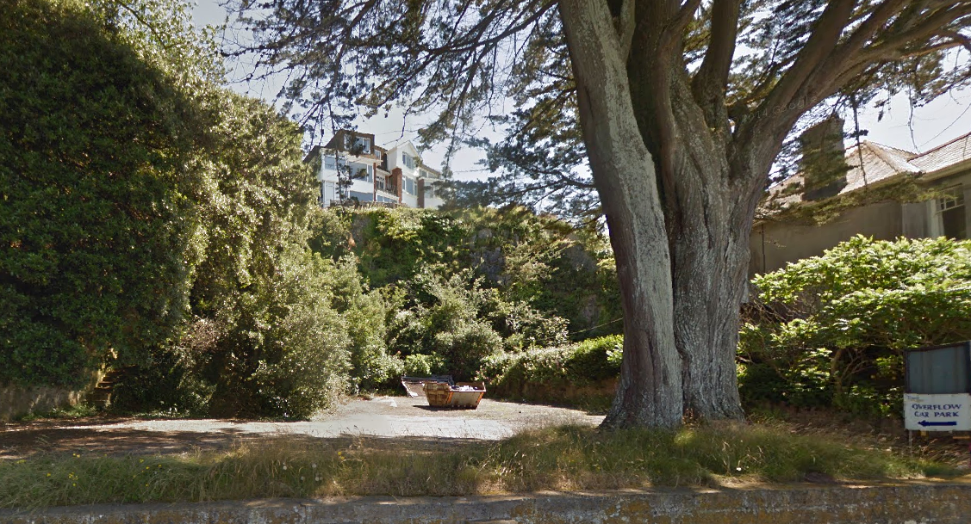

Proximity to Ash Hole Cavern

    - To the east of the site (<50m), to the left in the above photograph, is a cave known as Ash Hole Cavern (entrance approx 3m-5m high). This is set back in the woods, approximately 50m from Berry Head Road. As such it is very close to the proposed site.

    - The cave is a Schedule Ancient Monument (SAM) and the ‘Reason for Designation’ states that it contains “intact deposits of cave earth dating from the Pleistocene era above which are archaeological cave earth deposits of the Neolithic to the Romano-British period, and it is has been demonstrated by excavation to be particularly rich in Bronze Age pottery”.
    - The SAM Reason for Designation also states that, in addition to the main chamber, the cavern also includes a number of associated fissures and smaller chambers.

    - There are no known records of greater horseshoe bats roosting in this cave, but after a preliminary investigation of the main cave entrance, and with the known presence of fissures and smaller chambers deeper in the cave, it is certainly possible that it provides suitable roosting opportunities for bats moving from the Berry Head SAC roost along the coast towards Brixham Harbour.

Does future development of the site have the potential to impact the integrity of the South Hams SAC?

    - While there are no actual site records of GHBs near to the ‘Site’ there is anecdotal evidence from members of Devon Bat Group, that GHBs have been observed flying across Brixham Harbour, moving in the direction towards Fishcome Cove. GHBs are known to be capable of flying across open sea, so it is quite possible that they are moving from Berry Head towards landfall to the north of Brixham. If this were the case, such flight routes would bring them along the coast in front of Shoalstone Car Park. It is also possible that the bats will reach the coast by coming through the broadleaved woodland that stretches from the edge of the Overflow Car Park up on to Berry Head.

    - Development of the overflow car park therefore has the potential to have a likely significant adverse effect on GHBs, especially through light spill from any new buildings, external lighting and vehicle movements.

    - However, the site is already in an area subject to artificial lighting and existing vehicle movements along Berry Head Road. It is therefore unlikely that the development of up to six residential units (and on the edge of built development) would add significantly to surrounding light levels to such an extent that they would deter commuting GHBs – either as they move through the woodland or along the coast.

    - However, to ensure that light levels are very carefully controlled, any development of the ‘Site’ should be subject to very strict control to ensure that light spill does not exceed 0.5 lux along the eastern boundary of the site where it abuts with the woodland.

    - It is also recommended that any planning application for this site be informed by a comprehensive greater horseshoe bat activity survey. This survey should also include Ash Hole Cavern to establish whether it supports roosting bats. Such surveys would be required to ensure that bringing built development (and therefore the risk of physical human disturbance) closer to the cave, would not result in any direct or indirect adverse effects on potential roosts within the cave.

Is it likely that potential impacts will require Habitat Regulations Assessment (HRA)?

    - The removal of woody vegetation along the eastern boundary of the overflow car park (e.g. required to facilitate development) and/or the introduction of lighting into a sensitive location would therefore be a ‘likely significant effect’ (LSE) that would require HRA.

    - Is it likely that impacts can be mitigated effectively?

    - Effective mitigation measures could be provided through a combination of sensitive lighting design in association with sympathetic new landscape planting, and a restriction on removal of any substantial semi-natural vegetation along the eastern boundary (e.g. scrub and trees). These would have the aim of restricting light spill into adjacent areas of woodland.
3.3 SLADNOR PARK

Potential Development Site (Primarily Housing) for Consideration in the Torquay Neighbourhood Plan

Key Characteristics

    - The site (hereafter referred to as the ‘Site’) is identified in Figure 4 of this HRA Site Appraisal and proposes to allocate land for the development of up to 25 dwellings.

    - The site incorporates a large area (22 ha) of land to the north of the main conurbation of Torquay and falls partly within a Strategic Flyway identified by Natural England in their 2010 SAC guidance.

    - Views into the site from roads and public footpaths are limited, but from study of Ordnance Survey maps and satellite images, the site can be characterized as having higher ground on the western side with predominantly woodland cover, with the lower steeply sloping ground on the western side under permanent pasture.

    - The site is bounded on the western edge by the A379 Teignbridge Road and on all other sides it is circled by a series of narrow lanes with tall ancient hedgerows (Rock House Lane to the south, Brim Hill to the east and Sladnor Park Road to the north). See Figure 5 of this HRA Site Appraisal for site boundary and key internal features.

    - Ambios Environmental Consultants (AEC), who were commissioned by Meedhurst Project Management Ltd, acting on behalf of Barchester Care Villages Ltd, surveyed the central part of the ‘Site’ in 2006. This work was undertaken to provide a baseline ecological assessment of the land in advance of proposed new development for a new Care Village. Fortunately, the Ambios report provides useful contextual information that would otherwise not be available. When describing the site and its habitats, it states (page 5):

“The development site comprises a disused holiday complex, with a few derelict chalet and other buildings, surfaced roads, an old swimming pool and tennis court, and areas of rough grassland, brambles and light scrub. A number of wooden lodges are still occupied in the southeastern corner of the site. Surrounding land includes mature woodland (to the immediate north, west and south) and extensive areas of unmanaged semi-improved grassland (to the immediate east).

    - The woodland and semi-improved grassland referred to above, are included within the boundary of the Potential Development Site subject to this HRA site appraisal (see Figure 5 of this HRA Site Appraisal). The woodland is comprised of mature beech, sycamore, ash and lime.

    - The Ambios report (page 5) continues:

“Much of the development site is relatively open and characterized by extensive concrete hard-standing and building foundations, interspersed with a mixture of tall rough grassland, more extensive beds of brambles, and occasional stands of developing scrub (in the main dominated by ash and Buddleja). None of these habitats have any intrinsic ecological value, though the presence nearby of specially protected animal species means that they may be of local significance to these species”.

    - The Ambios report (page 5) also states:

“The extensive areas of grassland to the east of the development site provides ideal habitat for breeding cirl bunting, and offers potential feeding habitat for greater horseshoe bats”.
    - With regard specifically to greater horseshoe bats, the Ambios report states:

“The survey identified a narrow tunnel in the north-western corner of the development site. The tunnel entrance is found approximately 2 metres above ground level, adjacent to a number of sheds at this location. The tunnel runs in a westerly direction into the sandstone cliff for a distance of approximately 15 metres, and a smaller tunnel runs north for approx. 8 metres. At the time of the survey an umber of greater horseshoe droppings were found in the main tunnel – three separate piles were seen, all with at least 50 droppings of various ages. The tunnel wil be consistently cool and humid, and the number and age of droppings indicates that it is likely to be used by a small number of bats throughout the year”.

    - The exact status of this roost remains unknown so it is not clear to what extent, if any, it may serve as an important satellite to the known SAC roosts e.g. as a possible ‘mating’ roost, or ‘formation’ or ‘post-breeding’ roost; all of which have been recognised as being important to the overall lifecycle of horseshoe bats.

    - Much of the woodland and semi-improved grassland habitat on site (e.g. subject to the HRA Site Appraisal) and in the surrounding landscape provides suitable, and possibly optimal, foraging habitat for greater horseshoe bats. If and when cattle grazed, the fields on the lower slopes on the eastern half of the site could be particularly important.

Current Planning Consent for Sladnor Park

    - Planning consent was granted in 2006 for:

Redevelopment To Provide "Retirement Village" (Class C2) Comprising 24 Independent Living Units, 92 Care Suites, 90 Bed Care Unit, Associated Healthcare, Leisure And Restaurant Facilities. Retention Of 3 Pairs Of Existing Lodges; Landscaping And Parking.

    - The proposed footprint for the above development is shown in Figure 6 of this HRA Site Appraisal. The development consented in 2006 occupies the centre of the Potential Development Site subject to this HRA Site Appraisal, avoiding direct impacts on the woodland to the north, west and south, and on the semi-improved grassland to the east.

    - The exact location of the tunnel is not clear from the Ambios report (2006) so it is difficult to establish the extent to which the above development layout would impact on greater horseshoe bats attempting to access the tunnel.

    - It does not appear that there was any comprehensive ecological assessment undertaken to support the planning application (other than the report prepared by Ambios 2006), and nor was the application subject to Habitat Regulations Assessment by Torbay Council at that time.

Does future development of site have the potential to impact the integrity of the South Hams SAC?

    - The proposed development (for up to 25 residential units) that is being considered as part of the Local Plan identified Site (for inclusion in the TNP), is envisaged as occupying approximately the same area of land as that covered by the 2006 planning consent. It therefore includes only a small proportion of the total 22 hectares of Sladnor Park, and does not propose development areas within the woodland or semi-improved grassland.

    - In relation to the known greater horseshoe bat roost on site (in the tunnel), the Ambios report (2006; page 8) concluded that:
“Obstruction of the entrance to the tunnel will prevent access by horseshoe bats. Significant removal of vegetation and/or extant buildings around the tunnel entrance may disrupt existing ‘flight lines’ to and from the tunnel, thus reducing levels of use by bats. In the long-term, open access to the tunnel may lead to levels of human disturbance that cause the bats to stop using this roost”.

    - In addition, the introduction of artificial light in proximity of the tunnel entrance and associated flight access lines could equally have an adverse effect.

    - Likewise, any development resulting in the loss of woodland, semi-improved grassland habitat and/or hedgerows could also have a likely significant effect on greater horseshoe bats foraging and commuting in the wider landscape within Sladnor Park.

Is it likely that potential impacts will require Habitat Regulations Assessment (HRA)?

    - Development of the Sladnor Park Potential Development Site will need to be informed by detailed bat surveys and accompanying ecological assessments.

    - Since the site is in part within a Strategic Flyway (identified by Natural England) a Habitat Regulations Assessment will be required to determine whether the integrity of the SAC is likely to be affected adversely. It will only be possible to avoid a full Appropriate Assessment if detailed mitigation measures are incorporated into development proposals to demonstrate (when examined against the ‘Likely Significant Effect’ (LSE) test) that there will be no likely significant adverse effect on the integrity of the South Hams SAC.

Is it likely that impacts can be mitigated effectively?

    - Mitigation measures for GHBs should support the SAC Conservation Objectives set by Natural England and also promote Favourable Conservation Status for this species (see Appendix A). Mitigation measures should also support statutory requirements to protect and enhance ecological networks used by Annex II species e.g. greater horseshoe bats (See Appendix B). As such, mitigation measures for the ‘Site’ should aim to:

Protect existing roosting features on site and also facilitate ease of movement and conserve energy expenditure by greater horseshoe bats by providing optimal daily and seasonal commuting routes through and around the proposed new development and by retaining and enhancing foraging and roosting opportunities.

    - In order to achieve the above aim, and to provide the certainty necessary to satisfy the requirements of the HRA process, the following mitigation objectives must be applied to emerging development proposals for the Sladnor Park Potential Development Site. This mitigation must then be implemented in full at such time as development applications are brought forward. Such mitigation should be a combination of identifying and recognising:

- key design constraints required to avoid or minimise adverse effects, and;

- habitat mitigation/enhancement opportunities to provide overall net gains for GHBs specifically and for wider biodiversity in general.
    - Design Restrictions/Constraints should:

- Protect the tunnel entrance and retain all identified flight routes into and out of the tunnel (the latter to be established through future detailed GHB survey work);

- Avoid light spill around the tunnel entrance and in all bat flyways and foraging areas i.e. achieve light levels less than 0.5 lux in sensitive locations;

- Maintain existing connectivity of bat commuting and foraging habitat through and around the ‘Site’;

- Achieve no net loss of foraging habitat;

- Achieve no overall net loss of existing hedgerows and trees within the ‘Site’;

Habitat Mitigation/Enhancement Opportunities should:

- Secure favourable long-term management of foraging habitat e.g. through the introduction of cattle grazing on the semi-improved fields on the eastern part of the ‘Site’;

- Provide long-term management through a Landscape and Ecological Management Plan (LEMP), secured through a planning condition and/or obligations;

- Implement development through the means of a prior-approved Construction Environmental Management Plan (CEMP), secured through a planning condition and/or obligations;

- Undertake appropriate and proportionate ecological monitoring of the LEMP to establish the effectiveness of proposed mitigation measures and to provide early warning of any necessary contingency or remedial measures required to meet original objectives;

The provision of such measures would be consistent with the four principles set out in the proposed modified Local Plan Policy NC1.

Contingency to Compensate for Loss of Roost in Tunnel (Measure of Last Resort)

- If it proves impossible to retain access to the existing tunnel (and/or an adequate dark flight routes to it), then an alternative roost will need to be provided. This would need to be created, and proven to be functioning as a roost, prior to the original tunnel being closed or development being built in close proximity.

NOTE: Such works to affect the tunnel will need to be undertaken under the control of a Natural England European Protected Species (EPS) licence.

APPENDIX A SAC CONSERVATION OBJECTIVES AND GHB CONSERVATION STATUS

South Hams SAC Conservation Objectives
    - As required by the Habitats Directive, high level ‘Conservation Objectives’ for the South Hams SAC have been identified by Natural England. An overarching objective and a list of further generic objectives aim to:

‘Avoid the deterioration of the qualifying natural habitats and the habitats of qualifying species, and the significant disturbance of those qualifying species, ensuring the integrity of the site is maintained and the site makes a full contribution to achieving Favourable Conservation Status of each of the qualifying features.’

This is to be achieved by, subject to natural change, maintaining and restoring:

- The extent and distribution of the qualifying natural habitats and habitats of qualifying species.
- The structure and function (including typical species) of qualifying natural habitats and habitats of qualifying species.
- The supporting processes on which qualifying natural habitats and habitats of qualifying species rely.
- The populations of qualifying species.
- The distribution of qualifying species within the site’.

NOTE Natural England is in the process of preparing site-specific objectives for each SAC and SPA in England.

    - The application of these objectives will be site specific and dependant on the nature of the site and its features. The local planning authorities should take these objectives into account when undertaking Habitat Regulations Assessments.

  - Favourable Conservation Status (FCS)

    - Article 2(1) of the Habitats Directive states that ‘Measures taken pursuant to this Directive shall be designed to maintain or restore at favourable conservation status, natural habitats and species of wild fauna and flora of Community interest’ (emphasis added).

    - The concept of ‘conservation status’ is therefore fundamental to the purposes of the Habitats Directive. Article 1(i) defines the conservation status of a species as:
‘the sum of the influences acting on the species concerned that may affect the long-term distribution and abundance of its population within the territory referred to in Article 2’ and continues that the conservation status of the species will be taken as ‘favourable’ when:

- ‘population dynamics data on the species concerned indicate that it is maintaining itself on a long-term basis as a viable component of its natural habitats, and
- the natural range of the species is neither being reduced nor is likely to be reduced for the foreseeable future, and
- there is, and will probably continue to be, a sufficiently large habitat to maintain its populations on a long-term basis’

APPENDIX B Protection and Enhancement of Ecological Networks

    - Across Europe, all of the Special Areas for Conservation (SACs) and Special Protection Areas (SPAs) together contribute to the European Natura 2000 network. The protection, management, and enhancement of such ecological networks, and especially those relating to the Natura 2000 network, are identified as being particularly important in the EU Habitats Directive.

    - Article 3 of the Directive states:

Where they consider it necessary, Member States shall endeavour to improve the ecological coherence of Natura 2000 by maintaining, and where appropriate developing, features of the landscape which are of major importance for wild fauna and flora, as referred to in Article 10.

    - Article 10 then goes on to explain:

Member States shall endeavor, where they consider it necessary, in their land use planning and development policies and, in particular, with a view to improving the ecological coherence of The Natura 2000 network, to encourage the management of features of the landscape which are of major importance for wild fauna and flora. Such features are those which, by virtue of their linear and continuous structure (such as rivers with their banks or the traditional systems of marking field boundaries) or their function as stepping stones (such as ponds or small woods), are essential for the migration, dispersal and genetic exchange of wild species.

    - The Conservation of Habitats and Species Regulations (2010) transpose the above EU Directive into English legislation. Regulation 39 requires development plan policies to include policies that implement at the local level the requirements of Article 10 so as to encourage the management of features of the landscape which are of major importance for wild flora and fauna.

    - In relation to the potential development sites discussed in this report, Regulation 39 provides Torbay District Council with an opportunity to link conservation objectives to the allocation of some or all of the sites finally adopted. In particular, the LPA has both a justification and a statutory mechanism by which they can seek through their development plan policies the management and enhancement of landscape features in and around the Local Plan Areal which are of major importance for GHBs.

    - For instance, planning for Green Infrastructure in and around the proposed future growth areas could also lead to significant biodiversity gains and substantial improvement of GHB commuting and foraging habitat providing the bats with a very much enhanced flyways around the town. Such measures could also contribute to wider Green Infrastructure objectives and achieve benefits that could then also be enjoyed by the local community.

REFERENCES

References in Relation to Habitat Regulations Assessment of Development Plans

Tydesley D. and Chapman C. (2013) The Habitat Regulations Handbook. David Tyldesley Publication Ltd

Natural England (2010) South Hams SAC – Greater Horseshoe Bat Consultation Zone Planning Guidance.

The Conservation of Habitats and Species Regulations 2010. London. TSO

References in Relation to Local Plan

Torbay Council (2011) Brixham Urban Fringe Landscape Study.

Torbay Council and Devon County Council (2011) Local Transport Plan 3. Implementation Plan (Part B: Torbay).

Torbay Council (2014) Torbay Local Plan A Landscape for Success. The Plan for Torbay – 2012 to 2032 and Beyond. Proposed Submission Plan. Feb. 2014

Torbay Council (2014) Habitat Regulations Assessment. Torbay Local Plan A Landscape for Success. The Plan for Torbay – 2012 to 2032 and Beyond. Proposed Submission Plan. Feb. 2014

Torbay Council (2014) Key Diagram and Policies Map Booklet. Torbay Local Plan A Landscape for Success. The Plan for Torbay – 2012 to 2032 and Beyond. Proposed Submission Plan. Feb. 2014

Enderby Associates (2010) Landscape Character Assessment of Torbay. May 2010.

Ecological References in Relation to Inform HRA Site Appraisals

Land South of White Rock – Potential Development Site

Ecosulis (2014) White Rock, Torbay. Bat Activity Survey

Shoalstone Overflow Car Park – Potential Development Site

Ash Hole Cavern Scheduled Ancient Monument – Reason for Designation

Sladnor Park – Potential Development Site

Ambios Environmental Consultants (2006) Baseline Ecological Assessment Sladnor Park, Maidencombe, Torquay.

HRA Site Appraisal Addendum

Maps and Figures

Figure 1 Location Map for Land South of White Rock

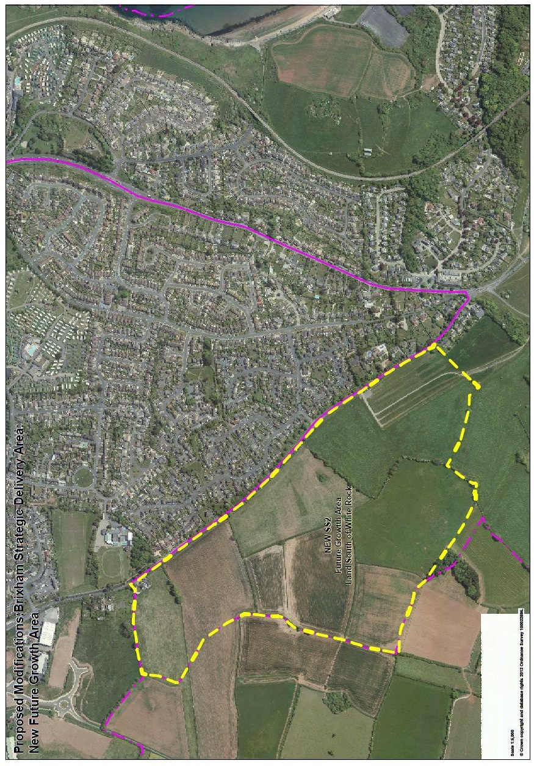
Figures 2 and 3 Shoalstone Overflow Car Park Location Map and Site Boundary

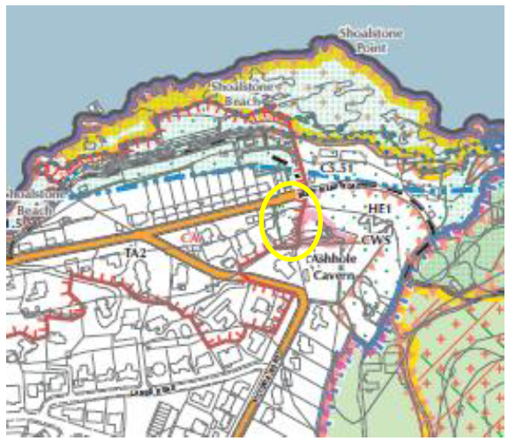

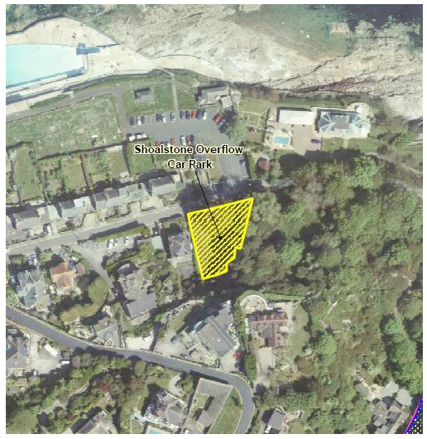

Figure 4 Location Map for Sladnor Park

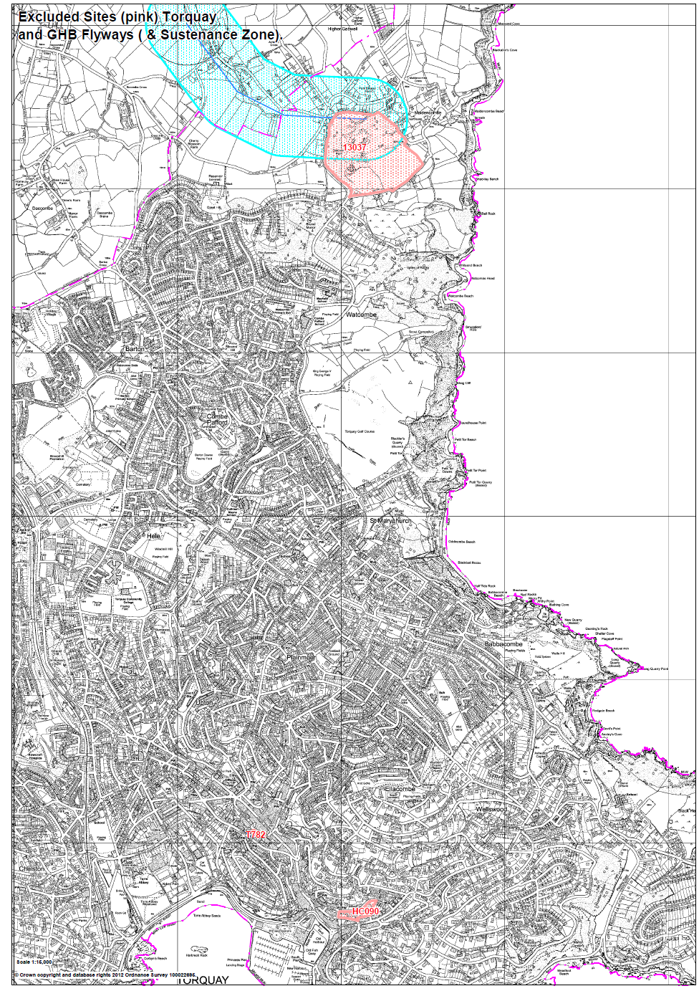

Figure 5 Sladnor Park Boundary and Key Internal Features

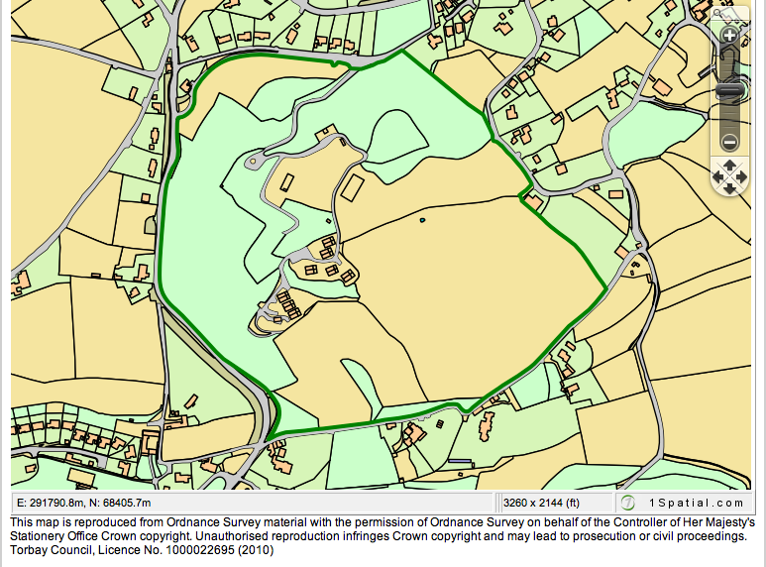

Figure 6 Sladnor Park 2006 Proposed Development Layout

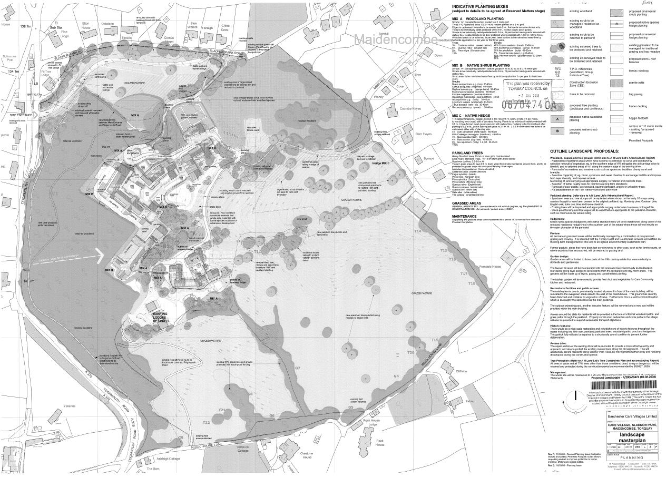

Natural England (2010) South Hams SAC – Greater Horseshoe Bat Consultation Zone Planning Guidance.
Natural England (2010) South Hams SAC – Greater Horseshoe Bat Consultation Zone Planning Guidance.
Adverse effects should be ‘minimised’ to the point where either alone or in combination with other effects they do not have an adverse effect on the integrity of the South Hams SAC.
The achievement of a net gain for biodiversity is consistent with the objectives set out in Local Plan Policy NC1 Biodiversity and Geodiversity.
Adverse effects should be ‘minimised’ to the point where either alone or in combination with other effects they do not have an adverse effect on the integrity of the South Hams SAC.
The achievement of a net gain for biodiversity is consistent with the objectives set out in Local Plan Policy NC1 Biodiversity and Geodiversity.

