M J Oxford CEcol. FIEEM.

Kestrel Wildlife Ltd

October 2014

Report for Torbay Council

Dr Laurent Duvergé
Kestrel Wildlife Ltd
May 2013

Report for Teignbridge District Council

HRA Site Appraisal Report of Torbay Local Plan
Strategic Delivery Areas
(Proposed Submission Plan)

HRA Site Appraisal Report of Torbay Local Plan
Strategic Delivery Areas
(Proposed Submission Plan)

Prepared by Kestrel Wildlife Ltd

Date: 20 October 2014

Version: Final version for Circulation within Torbay Council and with Natural England

Recommended Citation: Oxford M. & Jenkins, J. (2014) HRA Site Appraisal Report of Torbay Local Plan
Strategic Delivery Areas, (Proposed Submission Plan)

A report by Kestrel Wildlife Ltd on behalf of Torbay Council.
Contents

Acknowledgements

Summary

- Introduction
  - Introduction 6
  - Background 7
  - Strategic Landscape Approach to Greater Horseshoe Bat Conservation 8

- Methodology
  - Desk study 9
  - Site visits 9

- Structure of This Report 10

- Sites in Torquay Strategic Delivery Area

  - Edginswell Future Growth Area 11

- Sites in Paignton Strategic Delivery Area

  - Preston Down Road 13
  - Great Parks 13
  - Totnes Road Future Growth Area 16
  - Yalberton Industrial Estate and Claylands 23
  - Brixham Road Future Growth Area 25
  - Clennon Valley Leisure Hub 28

- Sites in Brixham Strategic Delivery Area

  - Fishcombe 29
  - Wall Park Future Growth Area 31

Appendices

Appendix A Protection and Enhancement of Ecological Networks 35
Appendix B SAC Conservation Objectives and GBH Conservation Status 36

References 37

HRA Site Appraisal Maps

Map 1 Local Plan Key Diagram 40
Map 2 Greater Horseshoe Bat Favourable Buffers and Potential Pinch Points 41
Map 3 Edginswell Future Growth Area, Torquay 42
Map 4 Preston Down, Paignton 43
Map 5 Great Parks, Paignton 43
Map 6 Totnes Road Future Growth Area, Paignton 44
Map 7 Topography around Collaton St Mary, Paignton 45
Map 8 Yalberton and Claylands, Paignton 45
Map 9 Brixham Road Future Growth Area, Paignton 46
Map 10 Clennon Valley Leisure Hub, Paignton 46
Map 11 Fishcombe Cove, Brixham 47
Map 12 Wall Park Future Growth Area, Brixham 47
Acknowledgements

Thanks to the Strategic Planning Team at Torbay Council for commissioning Kestrel Wildlife Ltd to undertake this piece of work to support the HRA of the Local Plan.

We have drawn on a range of ecological reports and studies in the Torbay area, and are grateful to a number of people who have provided information. Our thanks in particular to Laura Horner (Natural England) for background information on the HRA process associated with Neighbourhood Plans and for useful discussion relating to wider HRA issues.

This report was prepared by:

Mike Oxford M.Sc., FIEEM, CEcol. Kestrel Wildlife Ltd
Summary

The following report, commissioned by Torbay Council (TC), provides results on site appraisals undertaken for the three Neighbourhood Plan Areas in the Torbay Local Plan - 'A landscape for success: The Plan for Torbay - 2012 to 2032 and beyond' (Proposed Submission Plan February 2014).

Strategic Delivery Areas (SDAs), shown outlined in red on the Local Plan’s Key Diagram, are the foci for the delivery of growth and change in the Bay area over the plan period. Future Growth Areas (related to Local Plan Policy SS2) are located within these SDAs. The Local Plan states that development in these areas will be set out in detail via masterplanning, concept plans and/or Neighbourhood Plans.

This report has been prepared in support of the HRA of the Local Plan, and provides an appraisal of key site proposals within the Plan. It also identifies the likely effects arising from those proposals (e.g. their likely effect on the integrity of South Hams SAC in relation to greater horseshoe bats), and makes recommendations, where required, for appropriate mitigation measures (commensurate with levels of information and certainty available at the Plan Making stage of the planning process).

Some of the proposed Future Growth Areas and other key allocations/potential development sites, fall within or are close to the Strategic Flyways and Sustenance Zones for greater horseshoe bats (Rhinolophus ferrumequinum) (GHBs) identified by Natural England in its planning guidance relating to the South Hams Special Area of Conservation (SAC). Consequently, any future development of these allocations could have implications for the integrity of the SAC and the bats using it.

The appraisal has been undertaken of proposal sites likely to have a significant effect on the South Hams SAC. These are taken to be those sites that are within the Berry Head Sustenance Zone and/or within Strategic Flyways. Local Plan proposals outside of these areas have generally not been subject to appraisal since they are not triggered by Natural England’s SAC guidelines. Similarly, areas within the Sustenance Zone that are within existing built up areas have also not been subject to appraisal because such areas do not have suitable habitat to support either commuting or foraging GHBs.

The following Local Plan Proposals have therefore been selected on the basis that they are either within the South Hams (Berry Head) SAC Sustenance Zone and/or because they are within or likely to affect a GHB Strategic Flyway.

This report forms part of the evidence base prepared by the Council in support of its HRA of the Torbay Local Plan. Future Growth Areas and potential development sites covered include the following:

Torquay Strategic Delivery Area
SDT 3 Edginswell (Torquay Gateway) FGA

Paington Strategic Delivery Area
SDP3 Paignton North & Western Area:
SDP 3.1 Preston Down Road
SDP 3.2 Great Parks
SDP 3.3 Totnes Road (Collaton St Mary) FGA
SDP 1 Yalberton Industrial Estate and Claylands
SDP 3.4 & 3.5 Brixham Road and White Rock Growth Areas
SDP 4 Clennon Valley Leisure Hub

Brixham Strategic delivery Area
SDB 3.2 Wall Park FGA
SDB 1 Fishcombe Cove (redevelopment of holiday chalets into residential)
1. Introduction and Background

1.1 Introduction

    - The following report, commissioned by Torbay Council (TC), provides results on site appraisals undertaken for the three Neighbourhood Plan Areas in the Torbay Local Plan - 'A landscape for success: The Plan for Torbay - 2012 to 2032 and beyond' (Proposed Submission Plan February 2014).

    - Strategic Delivery Areas (SDAs), shown outlined in red on the Local Plan’s Key Diagram (see Map 1 with this report), are the foci for the delivery of growth and change in the Bay area over the plan period. Future Growth Areas (related to Local Plan Policy SS2) are located within these SDAs. The Local Plan states that development in these areas will be set out in detail via masterplanning, concept plans and/or Neighbourhood Plans.

    - Under Regulation 102 of the Habitat and Species Regulations (2010) local planning authorities are required to undertake a Habitat Regulations Assessment (HRA) of all landuse plans. Such plans may be adopted only after it has been ascertained that the plan will not adversely affect the integrity of a European site (e.g. a Special Area of Conservation).

    - In addition, when setting out proposals for Neighbourhood Development Plans, the plan making authority must have regard to the protection of European ‘Habitats’, under Regulation 32 of the Neighbourhood Planning (General) Regulations (2012) and through the provisions of Schedule 2(1); which states:

In relation to the examination of neighbourhood development plans the following basic condition is prescribed for the purpose of paragraph 8(2)(g) of Schedule 4B to the 1990 Act(c)

The making of the neighbourhood development plan is not likely to have a significant effect on a European site (as defined in the Conservation of Habitats and Species Regulations 2010(d)) or a European offshore marine site (as defined in the Offshore Marine Conservation (Natural Habitats, &c.)

    - This means that, for the purposes of Habitat Regulations Assessment, when proposing Neighbourhood Plans, the local planning authority must identify in the Local Plan the necessary mitigation measures that will be required to bring forward the Neighbourhood Plan proposals. Mitigation cannot be left until later stages of the planning process; appropriate measures must be identified in the Local Plan itself.

    - This report has therefore been prepared in support of the HRA of the Local Plan, and provides an appraisal of key site proposals within the Plan. It also identifies the likely effects arising from those proposals (e.g. their likely effect on the integrity of South Hams SAC in relation to greater horseshoe bats), and makes recommendations, where required, for appropriate mitigation measures (commensurate with levels of information and certainty available at the Plan Making stage of the planning process).

1.2 Background

    - Some of the proposed Future Growth Areas and other key allocations/potential development sites, fall within or are close to the Strategic Flyways and Sustenance Zones for greater horseshoe bats (Rhinolophus ferrumequinum) (GHBs) identified by Natural England in its planning guidance relating to the South Hams Special Area of Conservation (SAC). Consequently, any future development of these allocations could have implications for the integrity of the SAC and the bats using it.

    - As such, this report concentrates solely on the likely effects of development on greater horseshoe bats as the ‘feature of interest’ associated with the South Hams SAC. Therefore, for the sake of clarity, this report does not address other interest features within the South Hams SAC (such as calcareous grassland at Berry Head), and nor does the report relate to any other SACs (e.g. the Lyme Bay to Torbay Marine cSAC). Nor does it relate to any other protected species other than greater horseshoe bats.

    - The appraisal has been undertaken of proposal sites likely to have a significant effect on the South Hams SAC. These are taken to be those sites that are within the Berry Head Sustenance Zone and/or within Strategic Flyways. Local Plan proposals outside of these areas have generally not been subject to appraisal since they are not triggered by Natural England’s SAC guidelines. Similarly, areas within the Sustenance Zone that are within existing built up areas have also not been subject to appraisal because such areas do not have suitable habitat to support either commuting or foraging GHBs.

    - The following Local Plan Proposals have therefore been selected on the basis that they are either within the South Hams (Berry Head) SAC Sustenance Zone and/or because they are within or likely to affect a GHB Strategic Flyway.

    - This report forms part of the evidence base prepared by the Council in support of its HRA of the Torbay Local Plan. Future Growth Areas and potential development sites covered include the following:

Torquay strategic Delivery Area
SDT 3 Edginswell (Torquay Gateway) FGA

Paington Strategic Delivery Area
SDP3 Paignton North & Western Area:
SDP 3.1 Preston Down Road
SDP 3.2 Great Parks
SDP 3.3 Totnes Road (Collaton St Mary) FGA
SDP 1 Yalberton Industrial Estate and Claylands
SDP 3.4 & 3.5 Brixham Road and White Rock Growth Area
SDP 4 Clennon Valley Leisure Hub

Brixham Strategic Delivery Area
SDB 3.2 Wall Park FGA
SDB 1 Fishcombe Cove (redevelopment of holiday chalets into residential)

1.3 Strategic Landscape Approach to Greater Horseshoe Bat Conservation

Maintaining and Enhancing Linear Features and Stepping Stones in the Landscape

    - In undertaking an appraisal of the above proposals, there has been a need to consider the conservation of a highly mobile species such as the greater horseshoe bat at the landscape scale. Consequently, appraisal of the above allocations has considered how (i) the conservation status of the bats and (ii) the conservation objectives for the South Hams SAC can be applied practically at a strategic landscape level in the Torbay Local Plan. To do this, in addition to the requirements for plan and project level Habitat Regulations Assessment (HRA), policy proposals have been put forward based on other relevant statutory provisions.

    - For instance, Regulation 39 of The Conservation of Habitats and Species Regulations (2010) transposes the requirements of Article 10 of the EU Habitats Directive (1992) into English legislation. Regulation 39 requires development plan policies to include policies that encourage the management of features of the landscape which are of major importance for wild flora and fauna. Article 10 states:

“Member States shall endeavour, where they consider it necessary, in their land use planning and development policies and, in particular, with a view to improving the ecological coherence of The Natura 2000 network, to encourage the management of features of the landscape which are of major importance for wild fauna and flora. Such features are those which, by virtue of their linear and continuous structure (such as rivers with their banks or the traditional systems of marking field boundaries) or their function as stepping stones (such as ponds or small woods), are essential for the migration, dispersal and genetic exchange of wild species”.

    - In response to the above, and as a result of the ongoing iterative process associated with the HRA of the Local Plan, a minor modification has been proposed for Policy NC1 ‘Biodiversity and geodiversity’, which now includes the following in relation to protection of GHBs and the South Hams SAC.

“Development around the edge of the built up area that is within the Berry Head SAC Sustenance Zone and/or is coincident with any of the Strategic Flyways, will, as appropriate, be required to provide:

- ‘linear features’ and ‘stepping stones’ in order to maintain and improve the ecological coherence of the landscape necessary to maintain in ‘favourable conservation status’ the Torbay population of greater horseshoe.

- To ensure this, development likely to have a significant effect on the integrity of the South Hams SAC will be required to provide biodiversity conservation measures that contribute to the overall enhancement greater horseshoe bat habitat in Torbay. Such measures should be based on the following principles:

- The maintenance of GHB dark and unlit habitat connectivity across the landscape;
- The provision of adequate foraging habitat;
- The provision, where appropriate, of adequate permeability through built development following existing and new flight paths;
- The provision of new bespoke roosts where they will provide ‘stepping stones’ across the landscape”.

    - In addition, this minor modification has been introduced into Policy NC1 to also reflect the requirements of Article 3 (paragraph 3) of the EU Habitats Directive (1992), where there is a requirement to seek improvement in the ‘ecological coherence’ of European sites (e.g. SACs) through appropriate measures that enhance features of the landscape which are of major importance for wild fauna and flora.

NOTE: In the context of the Regulations, the ‘integrity’ of a site is defined as ‘the coherence of its ecological structure and function across its whole area, that enables it to sustain the habitat, complex of habitats and/or levels of populations of the species for which the site is designated’.

    - The principles set out in the proposed modified Policy NC1 have been applied to each of the site appraisals presented in this report, and where appropriate, these have been further translated into allocation-specific mitigation objectives that may be used to inform the next stage of plan making e.g. master-planning and neighbourhood planning.

Identification of ‘Pinch Points’ Along Strategic Flyways

    - Natural England’s South Hams SAC Greater Horseshoe Bat Consultation Zone Planning Guidance (page 20) provides a map showing the five designated roost sites that comprise the South Hams SAC. This map also identifies a Sustenance Zone around each SAC roost site along with a network of Strategic Flyways.

    - In their ‘Glossary’ (South Hams SAC guidance; page 19), Natural England state the Strategic Flyways represent a:

“key network of flight path zones connecting the component roosts of the South Hams SAC. The strategic flyways have been made 500 meters wide to provide a combination of alternative suitable routes. Flyways subject to a ‘pinch point’ scenario are particularly susceptible to development pressure”.

    - Natural England (page 10) explain the pinch point issue in more detail:

“The strategic flyways connecting key SAC roosts through urban areas/urban fringe
with the surrounding countryside are particularly sensitive to change and development pressure. This ‘pinch point’ scenario is based upon the assumption that there are likely to be a shortage of suitable commuting features in and around urban areas. In other words, suitable commuting features in these situations are likely to be particularly important due to a lack of alternative commuting features”.

    - The work undertaken to carry out and prepare this HRA Site Appraisal has examined, through desk studies, aerial photographs and on the ground walk-over surveys, where Strategic Flyways run through urban areas and/or the urban fringe.

    - Map 2 of this report shows the location of ‘pinch points’ where a Strategic Flyway is significantly constrained (i.e. is much less than 500m wide) by built development and/or associated street/external lighting and/or the coast. Consequently, the quality of habitat and/or width of commuting routes through these ‘pinch points’ are much reduced, with there being few, if any, alternative routes available at these locations.

2. Methodology

2.1 Desk Study

    - A preliminary appraisal of habitat and landscape features in and around each of the Future Growth Areas and proposed allocations was undertaken with reference to relevant Ordnance Survey maps and aerial photographs. These were used to identify key topographical features associated with each area as well as prominent habitat features capable of supporting greater horseshoe bats, such as hedgerows, woodlands, water courses and land-use (e.g. where it was possible to distinguish between pasture and arable land).

    - Where available, further information has been gathered from a wide selection of ecological surveys and reports that have been prepared over the last 4-5 years in support of planning applications within the Torbay area. Detailed reports with results from bat surveys have been particularly useful and these provided invaluable information on the occurrence and distribution of greater horseshoe bats within each of the study areas in question. Taken together, they present an overview of where and how greater horseshoe bats are using the wider landscape in the Torbay area.

  - Site Visits

    - The following report was informed by walk over surveys undertaken in the Torbay area during May, June and early July 2014 by M. Oxford (FCIEEM, CEcol). Access for these visits was obtained from public rights of way or from views obtained from adjacent roads. Also, where necessary, access was gained in the area around Collaton St Mary under Torbay Council’s powers under Section 324 of the Town and Country Planning Act 1990, whereby a local planning authority may authorise a person to enter any land for the purpose of surveying it in connection with the preparation, adoption or approval of a local development document.

    - The purpose of the walkover surveys was to ground-truth topographic and habitat features identified through the desk studies and, in particular, to identify habitat features within the landscape that are capable of supporting foraging and commuting greater horseshoe bats. Once identified these features were used to establish likely flight routes and areas used for foraging within the local area of each proposed Future Growth Area and other relevant Local Plan allocations.

    - Site visits were also used to establish sources of artificial light in the landscape and to assess where greater horseshoe bats would be able to forage and commute unimpeded by light spill and also where they would be significant likely ‘barriers’ because of the disturbance effects associated with bright light.

2.3 Structure of This Report

    - An appraisal is presented in Sections 4 to 6 below for each of the Local Plan Strategic Delivery Areas or potential development sites where there is likely to be a significant effect on the South Hams SAC. These appraisals are based on the desk studies and walk over surveys described in Section 2 above. These appraisals provide information on the following:

- Key physical characteristics of the site;

- Whether future development of the site has the potential to impact the integrity of the South Hams SAC;

- Whether it is likely that potential impacts will require Habitat Regulations Assessment (HRA);

- Whether it is likely that likely impacts can be mitigated effectively.

    - Appendix A provides a brief description of statutory powers and mechanisms that may be used to secure appropriate biodiversity enhancements for GHBs across the network of landscape features upon which they are dependent.

    - Appendix B provides a copy of Natural England’s Conservation Objectives for the South Hams SAC, as well as defining how ‘Favourable Conservation Status’ for GHBs should be established (as defined the EU Habitats Directive 1992).

    - A colour code is provided alongside the title of each site report to give an ‘at-a-glance’ impression of the site’s suitability for development.

Green indicates that the integrity of the SAC is unlikely to be affected and proposals could be taken forward that would not require HRA.

Amber indicates that the issue of whether or not the integrity of the SAC is likely to be affected by development depends on the details of the proposal and the form of mitigation provided. HRA would be required.

Red indicates that initial screening suggests that this site should not be brought forward for development because the site is considered key to the integrity of the SAC and it is unlikely that effective mitigation or compensation would be possible. HRA would be required.

4. SITES IN TORQUAY STRATEGIC DELIVERY AREA (SDT 1)

4.1 Edginswell (Torquay Gateway) Future Growth Area (SDT 3)

Key Characteristics

    - The proposed Future Growth Area lies between the A380 dual carriageway (Hamelin Way) and the built up edge of north-west Torquay. For the purposes of this report, the Future Growth Area has been divided into three distinct areas, shown on Map 3 as areas ‘A’, ‘B’ and ‘C’. The Future Growth Area straddles a gently sloping valley with the highest point in area ‘C’ and the lowest in area ‘A’.

    - Area ‘A’ forms the northern part of the growth area and is divided into two by the Newton Abbot to Torquay railway line and the A3022 dual carriageway (Riviera Way). Much of area ‘A’ is already developed or has planning consent for development. There is a small industrial estate north of the A3022 (north-west of Kerswell Gardens Roundabout), and between the A3022 and Edginswell Lane there is consent for mixed use development – some of which has already been built. The historic hamlet of Edginswell forms the southern edge of area ‘A’. Many of the old buildings in the hamlet are likely to provide roosting opportunities for various species of bats.

    - Area ‘A’ is at the eastern end of a greater horseshoe bat Strategic Flyway that runs along the valley from Kingskerswell towards Torquay. This flyway leads as far as area ‘A’ where it meets a dead end against the built up edge of Torquay. Given the nature of landuse in adjacent areas, which includes extensive existing development and well-lit roads, area ‘A’ does not appear to provide any important routes between high quality foraging habitats and any key roost sites.

    - Area ‘B’ is very different in character to areas ‘A’ and ‘C’. It is formed of small irregularly shaped pasture fields with very tall thick hedges and substantial tree-lines, giving the impression of a quite wooded landscape. If cattle grazed and if physically accessible to GHBs, it is likely that these fields would provide sheltered and optimal bat foraging habitat. However, access to the whole of the growth area, and in particular to the fields in area ‘B’, is restricted by built development to the east and the substantial barrier presented by the A380 to the west. The safest and most attractive access for GHBs would appear to be from the south, across Marldon Road, from the direction of Cockington.

    - Area ‘C’ is comprised of large regularly shaped fields under arable cultivation or predominantly grass leys. Hedgerows are more compact and intensively managed and there are far fewer hedgerow trees (with the exception of the southern corner of the area which also has thicker hedges and smaller fields near the Marldon Road and Cockington Woods Farm). Note the South Devon Link Road junction will abut the western edge along the A380 (Hamlin Way) and should be completed in December 2015

Does future development of the Future Growth Area have the potential to impact the integrity of the South Hams SAC?

    - The whole of the Edginswell Future Growth Area is outside of the Berry Head Sustenance Zone, and it is unlikely that development here would have an effect on the integrity of the SAC through an effect on the ‘zone’ itself. Area ‘A’ is, however, at the eastern end of a greater horseshoe bat Strategic Flyway.

    - Planning permission was granted for mixed-use development in area ‘A’ in 2008 (Refs: P/2007/1743/MOA and P/2008/1682/MPA). Since then, a further application has been submitted for a new Tescos Supermarket (Ref: P/2013/0677) and has been accompanied by two ecological assessments, prepared by Aspect Ecology (March 2012 / June 2013) on behalf of Tescos. The Aspect reports include the results from both manual and static bat surveys, and these surveys follow earlier ecological work undertaken in 2004 and 2005. None of the bat surveys across these dates have detected use of area ‘A’ by GHBs.
    - Consequently, since there appears to be no likely significant effect on the extreme eastern end of the Strategic Flyway, an HRA screening assessment (LSE test) for the Tesco’s application (conducted by Torbay Council August 2013) concluded that development of the supermarket would not be likely to have significant effect on the South Hams SAC. In the absence of any records of GHB activity in this area, this conclusion applies to all development within area ‘A’.

    - Also, since areas ‘B’ and ‘C’ within the growth area, are outside of the Strategic Flyway, it follows that development in these two areas is also unlikely to have a significant effect on the SAC. However, a caveat should be placed on such a conclusion because (i) there are no detailed bat survey results for areas ‘B’ and ‘C’ and (ii) it does appear that the habitat in area ‘B’, in particular, is comprised of small fields and mature hedgerows that would provide suitable foraging habitat for GHBs.

    - Without detailed bat surveys it is therefore difficult to draw any final conclusions over exactly how valuable this area might be to foraging and commuting bats. If greater horseshoes are successfully navigating their way into area ‘B’ (perhaps from the direction of Cockington in the south), then development of areas ‘B’ and ‘C’ may become more sensitive. However, as stated in paragraph 4.1.5 above, access to area ‘B’ is restricted by surrounding built development and the A380.

    - It is anticipated that all future development proposals within the Future Growth Area will be accompanied and informed by the ‘normal’ suite of studies; including ecological assessments. Bat surveys associated with the latter should be used to establish the extent to which GHBs are using the site and especially whether they are using area ‘B’ and, if so, how they may be affected.

Is it likely that potential impacts will require Habitat Regulations Assessment (HRA)?

    - In the absence of current evidence to show that any part of Edginswell Growth Point supports GHBs, and because it is outside of the Sustenance Zone and Strategic Flyway, HRA is not (at this stage at least) triggered by Natural England’s 2010 SAC Guidance.

    - However, if the results of future bat surveys show that there is substantial use of some parts of the Growth Point by GHBs then – even though it is not within the Berry Head Sustenance Zone - development should be assessed for its potential affect on the SAC through formal HRA.

Is it likely that impacts can be mitigated effectively?

    - Any detailed proposals for development of the Growth Point should first be informed by appropriate bat surveys undertaken during a suitable time of year. Such information is required to inform how, if at all, the site may be used by GHBs and to then assess what possible impacts may require mitigation or compensation and the likely effectiveness of such measures.

    - If the site is developed, consideration should be given to seeking a biodiversity offset for loss of grassland (foraging) habitat and internal hedgerows.

    - It is expected that a wide landscape buffer would be required along the western edge of the Growth Area between any future built development and the A380. This buffer (see Map 3) would provide opportunities to retain or create connective corridors of suitable commuting and foraging habitat for a wide variety of biodiversity, including bats in general, and GHBs in particular.

    - The provision of such a western buffer would be consistent with the four principles set out in the proposed modified Local Plan Policy NC1.
5.0 SITES IN PAIGNTON STRATEGIC DELIVERY AREA (SDP1)

5.1 SDP 3.1 Preston Down Road

Key Characteristics

    - Preston Down Road is a site formed from two arable fields that straddle Preston Down Road. Both fields are bounded on their eastern edge by existing built development; this forms the north-eastern edge of Paignton. The site sits on the top of a ridge between two wooded valleys to the north and south (See Map 4 of this report).

    - The northern and western boundaries of the northern field are marked by substantial hedgerows with line of mature trees, and a market garden lies to the immediate west and north.

    - The southern boundary of the southern field abuts the wooded edge of Occombe Valley Woods Local Nature Reserve and County Wildlife Site. To the immediate west of the southern field is an area of existing low-density residential properties, intermixed with mature trees and open amenity grassland.

    - The site offers very limited opportunities for foraging GHBs and the most likely route for any commuting is in an east-west direction, not through the site, but going around it to the north and south where there is more suitable habitat (e.g. through woodland and pasture).

    - NOTE: Preliminary Ecological Appraisals have been prepared on behalf of Torbay Development Agency by GreenEcology Ltd dated April 2014 and provide more detailed descriptions of habitats present and likely species interest.

    - Does future development of the site have the potential to impact the integrity of the South Hams SAC?

    - While the site is not within the South Hams (Berry Head) SAC roost Sustenance Zone, and nor is it in an identified Strategic Flyway, it was included within this appraisal because it lies on the outer edge of the built up area of Torbay and is adjacent to open countryside. However, it has minimal habitat of value to GHBs and it is therefore very unlikely that development of these two fields would have a significant effect the integrity of the South Hams SAC.

    - Is it likely that potential impacts will require Habitat Regulations Assessment (HRA)?

    - It is unlikely that development will require HRA.

5.2 SDP 3.2 Great Parks

Key Characteristics

    - The site comprises approximately 10 ha of currently unmanaged agricultural land to the east of King Ash Road on the western edge of Paignton. Residential land lies to the east of the site and forms the eastern edge of Paignton (See Map 5 of this report).

    - An earlier phase of housing development at Great Parks (c.1995) is located to the immediate south, whilst to the west lies agricultural pastures and grass leys. The site is bounded to the north by Hilltop Plant Nursery, as well as a small number of detached residential properties and equine holdings. The site is located on a plateau with a valley system. The land slopes downward to the west of the site into the Great Parks Valley and to the north east into the Westerland valley. A masterplan has been drafted for this area and part of the site already has planning consent for 84/92 dwellings

    - The site lies within the northern part of the South Hams (Berry Head) SAC Sustenance Zone. The edge of a Strategic Flyway also crosses the northern part of the site. Less than a kilometer to the south, this same Strategic Flyway also runs through the north-eastern part of the Totnes Road Future Growth Area before connecting to the Clennon Valley to the east of the A380.

    - Detailed bat surveys were undertaken on behalf of Torbay Development Agency by SLR Consulting Ltd (dated 2012) in order to assess levels and patterns of greater horseshoe bat activity. In total, results were collected from a combination of 60 hours of manual activity and 700 hours static detector surveys. These bat surveys found only occasional use by small numbers of GHBs and there was no evidence of sustained foraging or regular commuting by this species across the proposal site. There was no clear pattern of activity through the season, and low levels of greater horseshoe bat activity were recorded throughout the night in all months and no clear concentration of passes close to sunset or sunrise which might otherwise be associated with bats emerging or returning to nearby roosts.

    - SLR (2012) recorded peak levels of greater horseshoe activity (during May) along the western and northern hedges on the outer edge of the proposal site; such activity in these locations would be consistent with expected use of the Strategic Flyway, in which these hedges sit.

Does future development of the site have the potential to impact the integrity of the South Hams SAC?

    - The northern part of the site is within a Strategic Flyway.

    - From the SLR surveys (2012), it is clear that GHBs are active across the site, albeit in quite low numbers. In the absence of mitigation, development could have an adverse effect upon such activity and represent a likely significant effect upon the SAC – primarily through effects within and adjacent to a Strategic Flyway. These include:

- loss of non-grazed pasture likely to provide sub-optimal foraging habitat;
- complete or partial loss of local commuting routes (hedgerows) around and across the site;
- disturbance of boundary hedgerow features to be retained (e.g. from increased light levels) so that the bats are no longer able to make use of them.

Is it likely that potential impacts will require Habitat Regulations Assessment (HRA)?

    - Greater horseshoe bats have been confirmed as using this proposal site and, since part of the site is within a Strategic Flyway, the site should at least be subject to HRA screening to determine likely significant effect (the LSE test). If adequate mitigation is incorporated into scheme design, then further assessment may not be necessary. However, if any doubt remains about the efficacy of proposed mitigation, the site must be subject to full Appropriate Assessment and consent only granted if it can be confirmed that there will be no adverse effect on the integrity of the SAC.

Is it likely that impacts can be mitigated effectively?

    - Any detailed proposals for development of this site, and associated mitigation for GHBs, should first be informed by up to date and appropriate surveys consistent with good practice guidance (e.g. NE South Hams SAC Guidelines 2010). The surveys by SLR Consulting Ltd were undertaken in 2012 and further update surveys would be required if development proposals are not brought forward within 3 to 4 years of this date.

    - The SLR report also makes recommendations for greater horseshoe bat mitigation and suggests that these should be incorporated into future masterplanning for the site. These include:

“The northern and western boundaries of the application site which fall within the South Hams SAC greater horseshoe bat flyway were found to be used by a range of bat species, including small numbers of greater horseshoe bats for commuting; these should be retained and buffered with additional shrub planting. This would minimise potential operational impacts such as light spill and noise disturbance.

The emerging master plan should consider locating low intensity development such as public open space, private gardens or allotments close to these boundaries and a lighting plan should be prepared which ensures maintenance of night time light levels of below 0.1 Lux in these areas (maximum). This can be achieved by completely avoiding lighting where possible and using directional, low-level, low-power lighting where essential, with consideration for control of lighting through motion sensors and / or timers.

Luscombe Lane along the southern edge of the site is heavily overhung by canopies of tall hedgerows and this was found to be regularly used by foraging pipistrelle and Myotis bats. This feature should be retained and managed if possible”.

    - These recommendations appear to provide a sound basis upon which future mitigation can be planned and prepared. However, to achieve consistency with emerging requirements in the Local Plan, the following additional mitigation objectives have been identified for Great Parks:

Design Restrictions/Constraints should:

- Maintain existing connectivity of bat commuting and foraging habitat around the edge of Great Parks by provision of a landscape buffer of 10m width between built development and the open countryside to the west and north;

- Achieve no net loss of foraging habitat (e.g. through provision of offsite measures where necessary);

- Achieve no overall net loss of existing hedgerows (e.g. through provision of offsite mitigation);

- Avoid light spill in the landscape buffer i.e. achieve light levels less than 0.5 lux;

Habitat Mitigation/Enhancement Opportunities should:

- Undertake habitat creation/enhancement to provide new tree lines and hedgerows in the surrounding landscape (e.g. within the proposed Community Parkland planned to adjoin the site) to strengthen bat commuting habitat in the wider landscape;

- Create at least one new bespoke bat roost(s) in an appropriate location on the outer edge of the landscape buffer;

- Provide long-term habitat management for greater horseshoe bats, for each development, through a Landscape and Ecological Management Plan (LEMP), secured through a planning condition and/or obligations;

- Implement development through the means of a prior-approved Construction Environmental Management Plan (CEMP), secured through a planning condition and/or obligations;

- Undertake appropriate and proportionate ecological monitoring of the LEMP(s) to establish the effectiveness of proposed mitigation measures and to provide early warning of any necessary contingency or remedial measures required to meet original objectives.

    - The provision of such measures would be consistent with the four principles set out in the proposed modified Local Plan Policy NC1.
5.3 SDP3.3 Totnes Road Future Growth Area

Key Characteristics

    - The Totnes Road (Land around Collaton St Mary) Future Growth Area is a composite site centred around the village of Collaton St Mary; as such it encompasses a number of land parcels and these are shown on Map 6 of this report. Each are identified separately by a capital letter (e.g. ‘A’, ‘B’, ‘C’ etc) and their key characteristics are described in turn below.

NOTE: Further details on the landscape character of the area around Collaton St Mary can be found on pages 28-29 and pages 65–67 of the Torbay Landscape Character Assessment.

    - This Future Growth Area lies within the northern part of the Berry Head Component of South Hams SAC Sustenance Zone (an area identified in Natural England’s South Hams SAC guidance (2010) as being of particular importance for GHBs). It also has several Strategic Flyways running through it and these generally follow the lower slopes of the valleys (see Map 6 at the end of this report). One flyway runs along the northern side of Area ‘A’, while the others run through the centre of the village in an approximately north-south direction through areas C, F and G (see Map 6 of this report).

    - There are historic records of at least 6 Greater Horseshoe Bat roosts along the valley between Collaton St Mary and Stoke Gabriel (approx 3km) to the south. There is also a historic record of a roost just outside of Collaton St Mary to the north-east of the village. And the porch at St Mary’s Church is also believed to be a ‘night perch’ for what is probably an individual bat foraging in the immediate vicinity (bat droppings were most recently identified on the floor of the porch on the 5th June 2014).

    - Based on the precautionary principle, and informed by the local proximity of these roosts on either side of the village, it is assumed that GHBs commute through Collaton St Mary, moving in an approximately north-south direction and vice versa.

    - Map 7 shows the high ground around Collaton St Mary and emphasizes that Natural England’s Strategic Flyways runs through the valley bottoms. Further general context is also presented in Photo 1 (looking toward the centre of the village from the high ground just to the north-east of St Mary’s Church) and in Photo 2 (looking north-eastward towards the centre of the village from a location east of Brake Copse). It is clear from these photos the extent to which tall hedgerows and mature trees are prevalent through and around the centre of the village; as such, these are likely to offer suitable and sheltered flyways for commuting bats.

    - Area ‘A’ is comprised of an area of high ground to the north of Collaton St Mary on the southern slopes of the Upper Clennon Valley. The area appears to be quite intensively farmed, with a mix of pasture, ryegrass leys and arable fields. To the north and east, the area slopes gently downhill towards the built-up edge of Paignton, with the eastern boundary being marked by the wide and well-lit A380 (Kings Ash Hill). The highest part of the area is marked by a long line of mature trees running approximately south-east to north-west, and to the south of this the land slopes more steeply down to the village and the A385.

    - With the exception of mature trees and the tall hedgerow in the valley bottom along the northern boundary of area A, other hedgerows across this area tend to be relatively low and well maintained in a box shape. There are two small woodland copses on the upper northern and eastern slopes and, while the copses and hedges offer some shelter for commuting/foraging GHBs, the areas of higher ground are generally quite open and exposed. Consequently, the Strategic Flyway identified through this area (see Map 6) follows the more sheltered line of the northern most hedge along the bottom of the valley.

NOTE: The Strategic Flyway through area ‘A’ connects open countryside to the west with the Clennon Valley which lies to the east of the A380. There are historic records of greater horseshoe bat roosts in the Clennon Valley (e.g. near Paignton Zoo) meaning that, at least in the past, GHBs have been using the valley.

There are substantial areas of suitable foraging habitat throughout the valley; including: areas of open grassland (although most of this is amenity); substantial areas of broadleaved woodland and scrub; and a string of open water bodies stretching from Paignton Zoo (at the upper end) to the southern edge of the sports pitches associated with Torbay Leisure Centre (at the lower end of the valley).

The open undeveloped eastern end of the Clennon Valley is approximately 250 metres wide and is separated from the coast by the A379. However, this main road is unlikely to act as a complete barrier to GHB movement, as there are hedges, scrub and tall trees along both sides of this section of the road. And it is not lit as brightly as the pinch points long the A380 and A3022 at the top end of the valley (see points 7 and 12 on Map 6). Also, in places mature conifer trees along the A379, and nearby hedges and scrub, offer GHBs the opportunity of potentially safe, high level ‘hop overs’ across the road.

If GHBs do cross the A379 it is possible that they regularly or seasonally commute and/or migrate back and forth along the coast towards the Berry Head Roost. This route into the Clennon Valley would be far less ‘intimidating’ to GHBs than via the intensively developed, and very well lit, western end of the valley around the Totnes Road, A380 and A3022 junctions.

    - Area ‘B’ lies on the lower slopes of the high ground identified in area ‘A’ above, and sits against the northern side of Collaton St Mary (see distant views on the right hand side of Photo 2).

    - The fields appear to be under permanent pasture and tend to be slightly smaller than on the northern slopes of area ‘A’. As such, area ‘B’ probably offers slightly better and more sheltered foraging habitat for GHBs. The village church and surrounding tall trees and mature hedges form the western boundary of this area, while the eastern boundary abuts the housing at the end of Borough Park Road. There is a possible horseshoe bat roost (source Natural England) towards the eastern side of area ‘B’. Mitigation associated with development within area ‘B’ should be in accordance with the mitigation objectives set out in paragraph 5.3.39 below (in particular with objectives ii, iii, x, xi, xii, xiii, xiv and xv).

    - Area ‘C’ is in the valley bottom to the north of the A385 and is formed from a series of long thin pasture fields (pony paddocks) that extend from the village school and church in an approximately north-easterly direction along the valley bottom. The northern boundary of area ‘C’ is marked by a brook, a tall mature hedge with tall hedgerow trees, and the lane that runs to Lower, Middle and Higher Blagdon. There are also a string of eight small ponds along the inside of the hedge through area ‘C’.

    - The southern boundary is also formed by a tall mature hedgerow that abuts area ‘D’. GHBs have been recorded along this hedgerow (from results of work undertaken by EAD Ecological Consultants in 2013 on behalf of Taylor Wimpey to inform their planning application for residential development on area ‘D’).

    - This area runs along the centre line for the Strategic Flyway identified by Natural England (see Map 6 at the end of this report).

    - Planning permission for a new poultry unit has been granted consent by Torbay Council at the northern end of area ‘C’ adjacent to the northern apex of area ‘D’ (planning reference P/2012/0865). As a condition of consent, this unit will be unlit and it is not expected to affect the movement of horseshoe bats through these fields or along the adjacent hedgerows.

    - Area ‘D’ is comprised of one large triangular field of semi-improved grassland; currently used for a hay crop and occasional use for car-boot sales. The southern boundary runs along the A385 and is marked by a 2-3 metre grass verge, an old metal fence and a line of planted semi-mature trees. The highest point of area ‘C’ is to the west, and from here the land slopes down toward the village centre and also towards the hedges on the north-western and north-eastern boundaries. These boundary hedges are mature and contain numerous tall trees.

    - Tall mature hedges, with hedgerow trees, lie along both the north-eastern and north-western boundaries.

    - A full season of survey effort has been undertaken in accordance with NE’s 2010 South Hams SAC guidance on behalf of Taylor Wimpey in support of their planning application for the site (planning reference P/2013/0572). The results of these surveys show that there was some greater horseshoe bat activity along the hedges on the north-western and north-eastern boundaries, with overall greatest activity along the latter hedge, which is shared with area ‘C’. However, no horseshoe bats have been recorded foraging across the open grassland in area ‘D’.

    - Area ‘E’ lies opposite area ‘C’ on the southern side of the A385 (Totnes Road). There is a line of built development along almost the entire northern edge of area ‘E’ where it abuts the main road. In the western part of this area, there is also a hotel complex and next to this, to the east, is a dense area of small residential ‘mobile’ homes.

    - The land behind the residential development along the A385 slopes downhill for a short distance before rising again towards the high ground around Brake Copse south of Collaton St Mary (see details of topography on Map 7). The land immediately behind the settlement is largely under arable cultivation while the higher slopes appear to be under a mix of arable and permanent pasture.

    - Two tall very well developed hedges run up the slopes in a southerly direction (see Photo 2), and these would provide a strong sheltered corridor for commuting horseshoe bats. They also link the Strategic Flyway in the valley bottom with Brake Copse and the open countryside beyond; also permanent pasture immediately to the east of Brake Copse may provide suitable foraging habitat for foraging bats.

    - Area ‘F’ has residential properties along its northern boundary (fronting onto the A385) and also along the southern boundary along St Mary’s Park road. The area is relatively low lying with the highest point in the south-west corner.

    - There are three fields (pasture) and one large residential property (Marbrook) situated in the middle of area ‘F’. All of the boundaries around area ‘F’ are comprised of tall mature hedges with tall hedgerow trees (see Photo 2 - right hand side beyond the closest hedgerows).

    - The hedge along the eastern boundary is particularly noteworthy because it forms a very strong linear landscape feature running approximately north-south and, as such, offers an almost optimal commuting route for horseshoe bats passing through the middle of the village. It also forms the western edge of area ‘G’ which appears to offer optimal foraging opportunities over cattle-grazed pasture in association with a water course and damp/marshy habitat (see ‘G’ below).

    - In the northern part of area ‘F’, the line of residential properties along the A385 are broken by two vegetated gaps (see pinch point 2 on Map 6 of this report). In effect, these form two narrow green corridors and in association with tall trees on either side of the A385 (in particular a mature Holm Oak on the southern side), they offer a potential dark high level ‘hop over’ across the main road for commuting bats (see Photo 3).

    - Area ‘G’ is formed of flat low-lying land and is located in the centre of the village. It has a small watercourse running through it, flowing north-south, and on either side of this there is cattle-grazed pasture in association with areas of tall damp/marshy habitat. As such, this type of habitat mosaic offers potentially optimal foraging opportunities for horseshoe bats. The hedge along the western boundary of area ‘G’ is also particularly noteworthy because it forms a very strong linear landscape feature running approximately north-south and, as such, offers an almost optimal commuting route for horseshoe bats passing through the middle of the village. There is a similar tall hedgerow feature, also running north-south, towards the eastern edge of area ‘G’, although this is only 100m (approx.) in length. To the east of this latter feature is a very narrow field that abuts Stoke Road, where the boundary is marked by a post and rail fence and short broken sections of thin hedgerow.
    - The northern edge of area ‘G’ has residential and commercial properties that front onto the A385 in the centre of the village. These include a car showroom and the Parker Arms Public House on the corner of Stoke Road. These properties represent an almost unbroken line of development along the southern side of the A385. However, there is a thin green corridor (comprised of a large private garden) that follows the line of the brook where it passes under the A385 and then links into the grounds of the primary school at the southern end of area ‘C’ (see point 1 on Map 6). This pinch point appears to offer one of the most likely flight routes across the main road, especially as it is linked, both north and south, to near-optimal foraging and commuting habitat. The A385 Improvement Scheme will need to take account of this pinch point.

    - The southern tip of area ‘G’ narrows into another pinch point between residential properties and where the Stoke Road takes a series of sharp bends (see point 3 on Map 6). There are a number of streetlights at this location, which might to large extent normally deter greater horseshoe bat movement. However, as with the northern pinch point in area ‘G’, horseshoe bat habitat immediately to the north and south are near-optimal and this location is considered to offer the most likely route through the southern end the village – and a crucial one if Natural England’s Strategic Flyway is to function through the landscape as hoped. It should therefore not be developed.

    - South of point 3, horseshoe bats would appear to have two alternatives for commuting routes

  - To follow uninterrupted dark flyways southward along the tall hedges on both sides of Stoke Road (see point 4) and/or:
  - To follow the line of the watercourse, a small block of woodland and a relict tall hedgerow running through the Yalberton Industrial Estate (see point 5 and area ‘H’ on Map 6). This area is well lit at night.

    - Area ‘H’ covers the Yalberton Industrial Estate. While it does not form an integral part of the Local Plan proposals for the Totnes Road Future Growth Area, the Estate does form an important element within the ‘landscape’ south of Collaton St Mary and provides further context for how GHBs may be active in the wider area around the Growth Point (identified as a Neighbourhood Plan potential employment development (improvement) area).

    - A full characterisation and appraisal for area ‘H’ is provided in Section 5.4 of this report.

Does future development of the Totnes Road Growth Area have the potential to impact the integrity of the South Hams SAC?

    - The growth Area is within the South Hams (Berry Head) Sustenance Zone and also has two Strategic Flyway running through it.

    - A number of landscape features, likely to be of major importance to GHBs, offer suitable (or even optimal) foraging and commuting habitat close to and through the village (see Map 6). These include:

- The long thin fields, small ponds, watercourse and mature hedgerows in area ‘C’;
- The watercourse, tall mature hedges and cattle-grazed pasture in area ‘G’;
- The mature hedgerows around area ‘F’;
- The mature hedgerows running southward through area ‘E’.
- The watercourse, hedges and garden features either side of the A385 at Pinch Point 1 on Map 6

    - These landscape features contribute to the overall connectivity and functionality of the Strategic Flyway along the valley through Collaton St Mary.

    - Development in an inappropriate location and/or of an inappropriate design have the potential to adversely affect GHBs and thereby be likely to impact on the integrity of the South Hams SAC. This might be as a result of one or more of the following

- loss of grazed pasture which would reduce the extent of potential foraging habitat available to bats;

- severance of habitat connectivity through the centre of the village (particularly at pinch points) caused through loss of mature hedgerows and/or tree lines and/or through widening of the A385;

- loss of tall trees and associated woody vegetation on either side of the A385 that currently are assumed to provide relatively dark and safe crossing points over the main road;

- disturbance to bat foraging and commuting habitat that is to be retained within future development (e.g. as a result of increased light levels) so that GHBs are no longer able to make use of these features.

    - The most likely significant effect from proposed development within the Future Growth Area is the potential restriction on the bats’ ability to disperse and move to and from foraging areas either side of the village. Such movement may occur on a regular daily basis, or on a more infrequent seasonal basis e.g. in the early spring and late autumn when the bats may be using routes through the village in order to migrate to and from their hibernation roosts used through the winter.

    - In order to meet the requirements of Habitat Regulations Assessment, it is therefore essential that adequate mitigation be provided that ensures (i) there are no further restrictions on potential movement of GHBs along the strategic flyway through the village and (ii) the retention and enhancement of foraging opportunities (see para 5.3.37 below).

Is it likely that potential impacts will require Habitat Regulations Assessment (HRA)?

    - Development of the Totnes Road Future Growth Area will need to be informed by detailed bat surveys and accompanying ecological assessments. Wherever GHBs are confirmed to be present, then a Habitat Regulations Assessment will be required to determine whether the integrity of the SAC is likely to affected adversely. It will only be possible to avoid a full Appropriate Assessment if detailed mitigation measures are incorporated into development proposals to demonstrate (when examined against the ‘Likely Significant Effect’ (LSE) test) that there will be no likely significant adverse effect on the integrity of the South Hams SAC.

Is it likely that impacts can be mitigated effectively?

    - Mitigation measures for GHBs should support the SAC Conservation Objectives set by Natural England and also promote Favourable Conservation Status for this species (see Appendix B). As such, mitigation measures for the Totnes Road Future Growth Area should aim to:

Facilitate ease of movement and conserve energy expenditure by Greater Horseshoe Bats by providing optimal daily and seasonal commuting routes through the existing and proposed new built up areas and by retaining and enhancing foraging and roosting opportunities.

    - In order to achieve the above aim, and to provide the certainty necessary to satisfy the requirements of the HRA process, the following mitigation objectives must be incorporated into the master-planning process for the Totnes Road Future Growth Area. This mitigation must then be implemented in full at such time as development applications are brought forward. Such mitigation should be a combination of identifying and recognising:

- key design constraints required to avoid or minimise adverse effects, and;
- habitat mitigation/enhancement opportunities to provide overall net gains for GHBs specifically and for wider biodiversity in general.

    - Design Restrictions/Constraints should:

- Maintain existing connectivity of bat commuting and foraging habitat through and around Collaton St Mary in accordance with the flyways shown on Map 6 (unless it can be established through detailed bat surveys that relevant areas are not in use by GHBs);

- Achieve no net loss of foraging habitat (especially within area G on map 6) unless it can be established through detailed survey that the affected areas do not (and could not) support foraging GHBs;

- Achieve no overall net loss of existing hedgerows and trees within the Future Growth Area identified on Map 6;

- Avoid light spill in bat flyways and foraging areas i.e. achieve light levels less than 0.5 lux in sensitive locations;

- Achieve road layouts associated with new development that do not sever or interrupt key bat flyways;

- Establish the proposed village green outside of optimal areas of foraging habitat in area G (e.g. locate village green on the eastern side of area G rather than in the centre of this area);

- Ensure that the design of any new proposed bus lane (See Transport Local Plan 3 March 2011 Section 7.20) and associated cycleway and footpaths along the A385 avoids any adverse effects on habitat connectivity at the pinch points at 1 and 2 on Map 6, including those arising from:

- widening the road to accommodate a bus lane/cycleway/footpath that would require removing trees on one or both sides of the carriageway), and/or;
- introducing new and/or brighter street lighting through the pinch point.

Habitat Mitigation/Enhancement Opportunities should:

- Create a green corridor along the northern edge of area F (behind the properties fronting the A385) in order to maintain access to ‘hop-over’ points provided by mature trees along the main road (see point 2 on Map 6);

- Enhance/replace existing street lighting in ‘Pinch Points’ (see Map 6) to reduce current extent and/or levels of illumination (while maintaining necessary highway and pedestrian safety) in order to minimise disturbance and severance effects from light spill across key flyways;

- Undertake habitat creation/enhancement to provide new tree lines and hedgerows in the surrounding landscape (e.g. within the proposed Green Infrastructure) to strengthen bat commuting habitat in the wider landscape;

- Provide landscape buffers between bat flyways/foraging habitat and the new built development – these should ideally be 10m wide;

- Create a ‘string’ of new bespoke bat roost(s) to support and improve viability of green corridors through the built development (e.g. provision of new bat roost within (a) western boundary of area G, (b) within northern part of area C and (c) in an appropriate location to the south of Collaton St Mary and to the west of Stoke Road);

- Provide long-term habitat management for GHBs, for each development, through a Landscape and Ecological Management Plan (LEMP), secured through a planning condition and/or obligations;

- Implement development through the means of a prior-approved Construction Environmental Management Plan (CEMP), secured through a planning condition and/or obligations;

- Undertake appropriate and proportionate ecological monitoring of the LEMP(s) to establish the effectiveness of proposed mitigation measures and to provide early warning of any necessary contingency or remedial measures required to meet original objectives;

    - The provision of such measures would be consistent with the four principles set out in the proposed modified Local Plan Policy NC1.

Photo 1 Photo 2

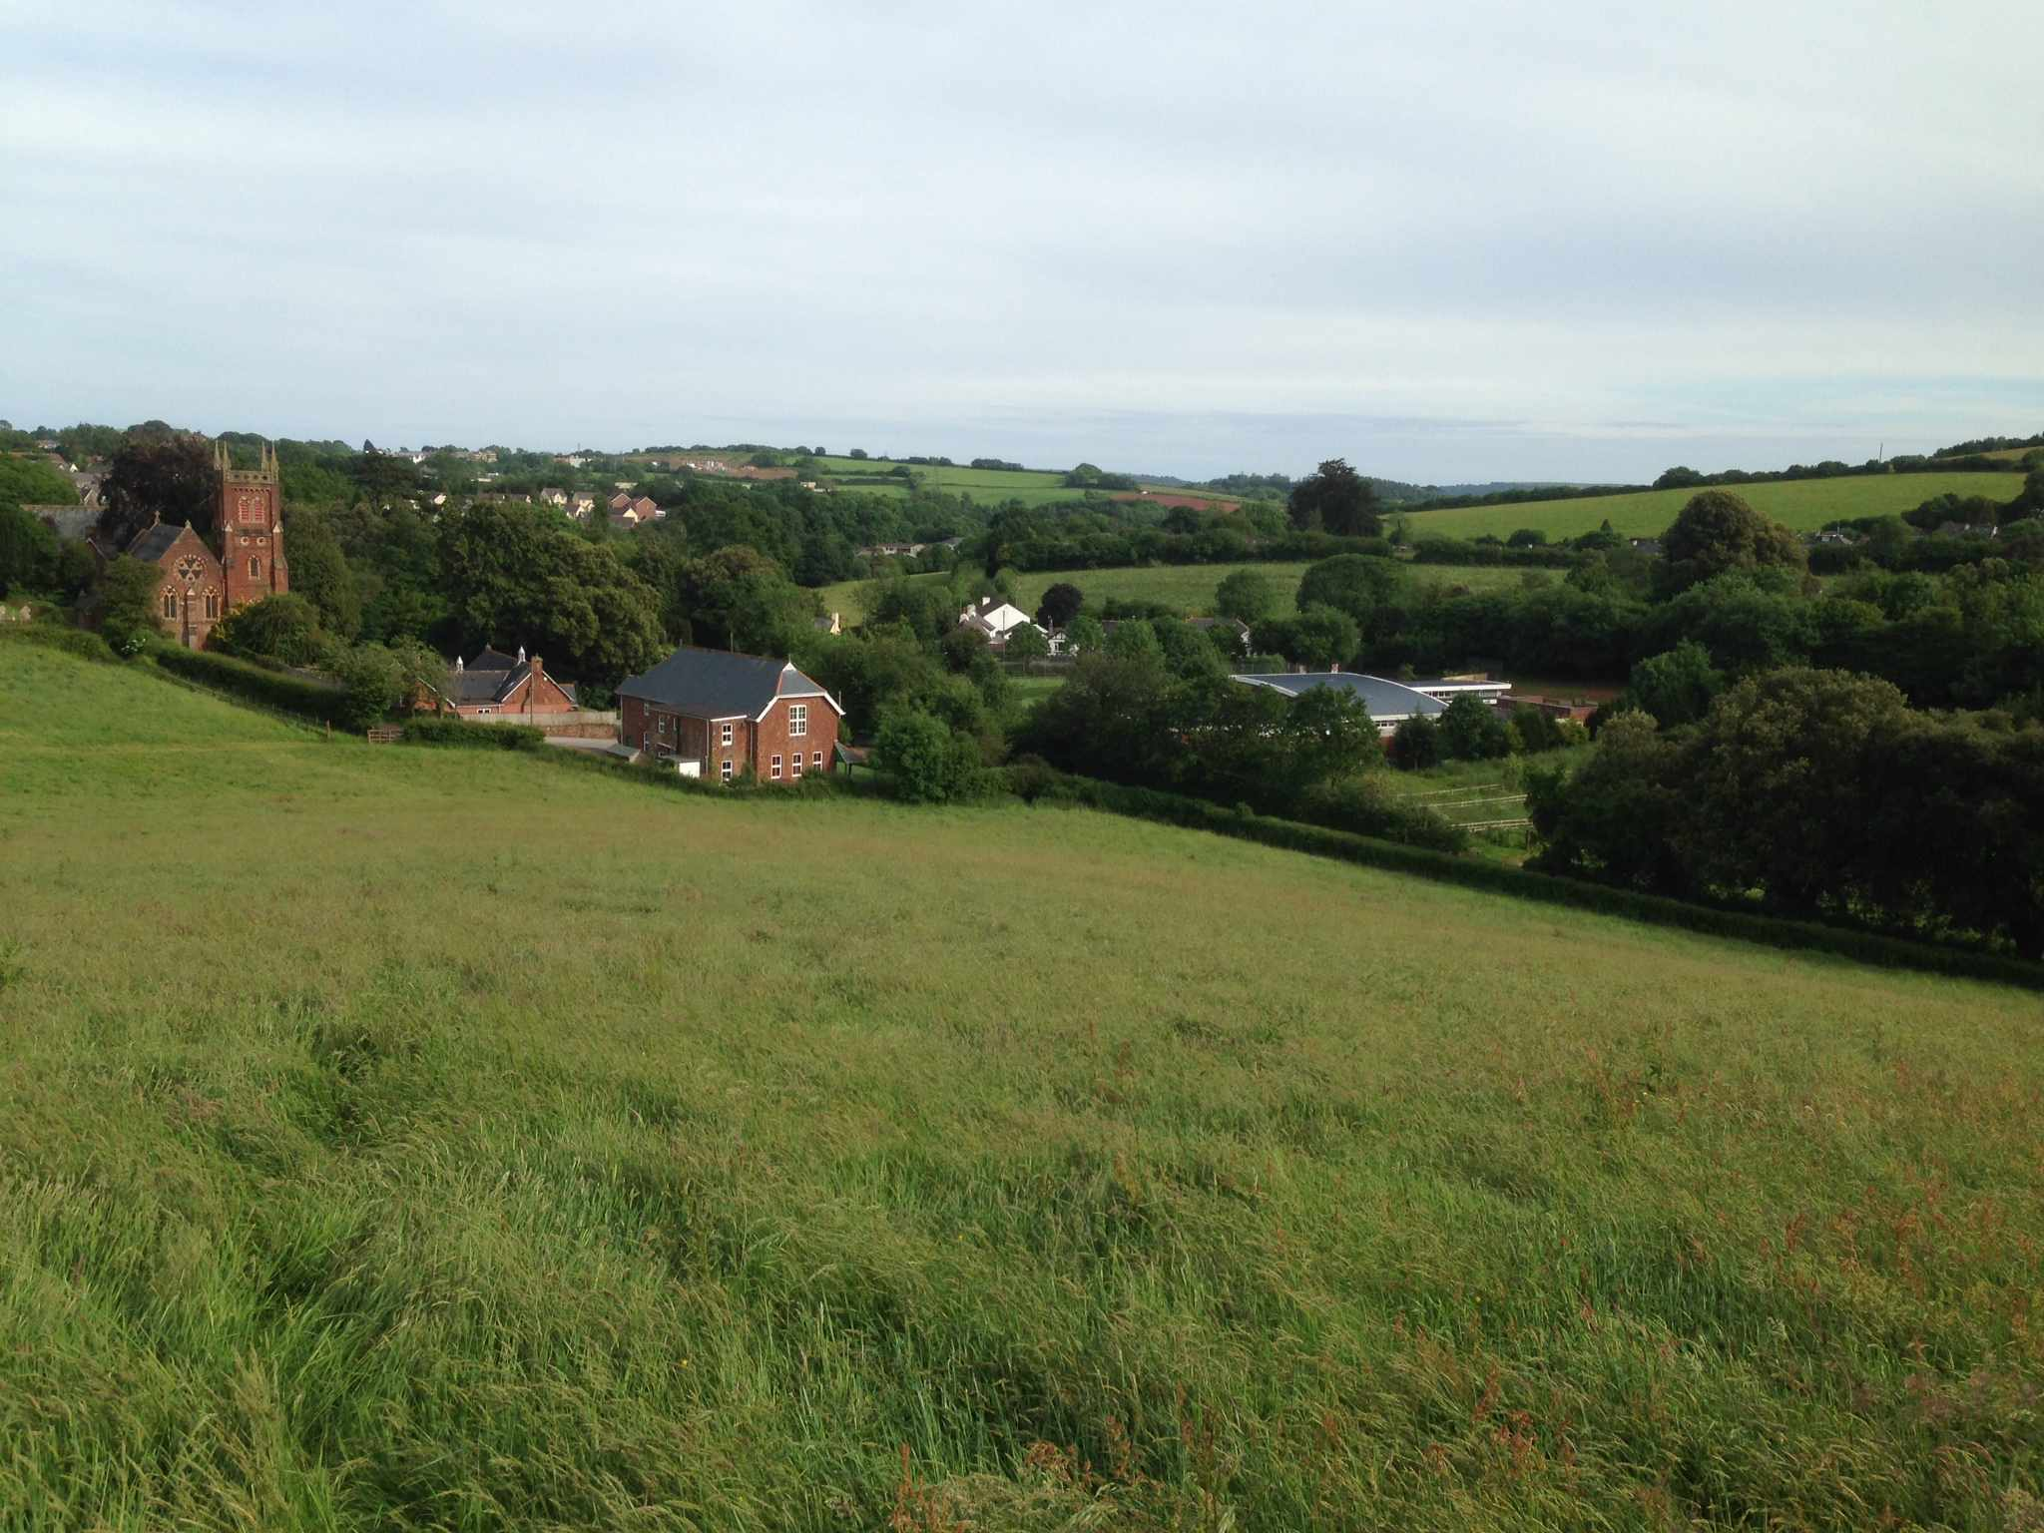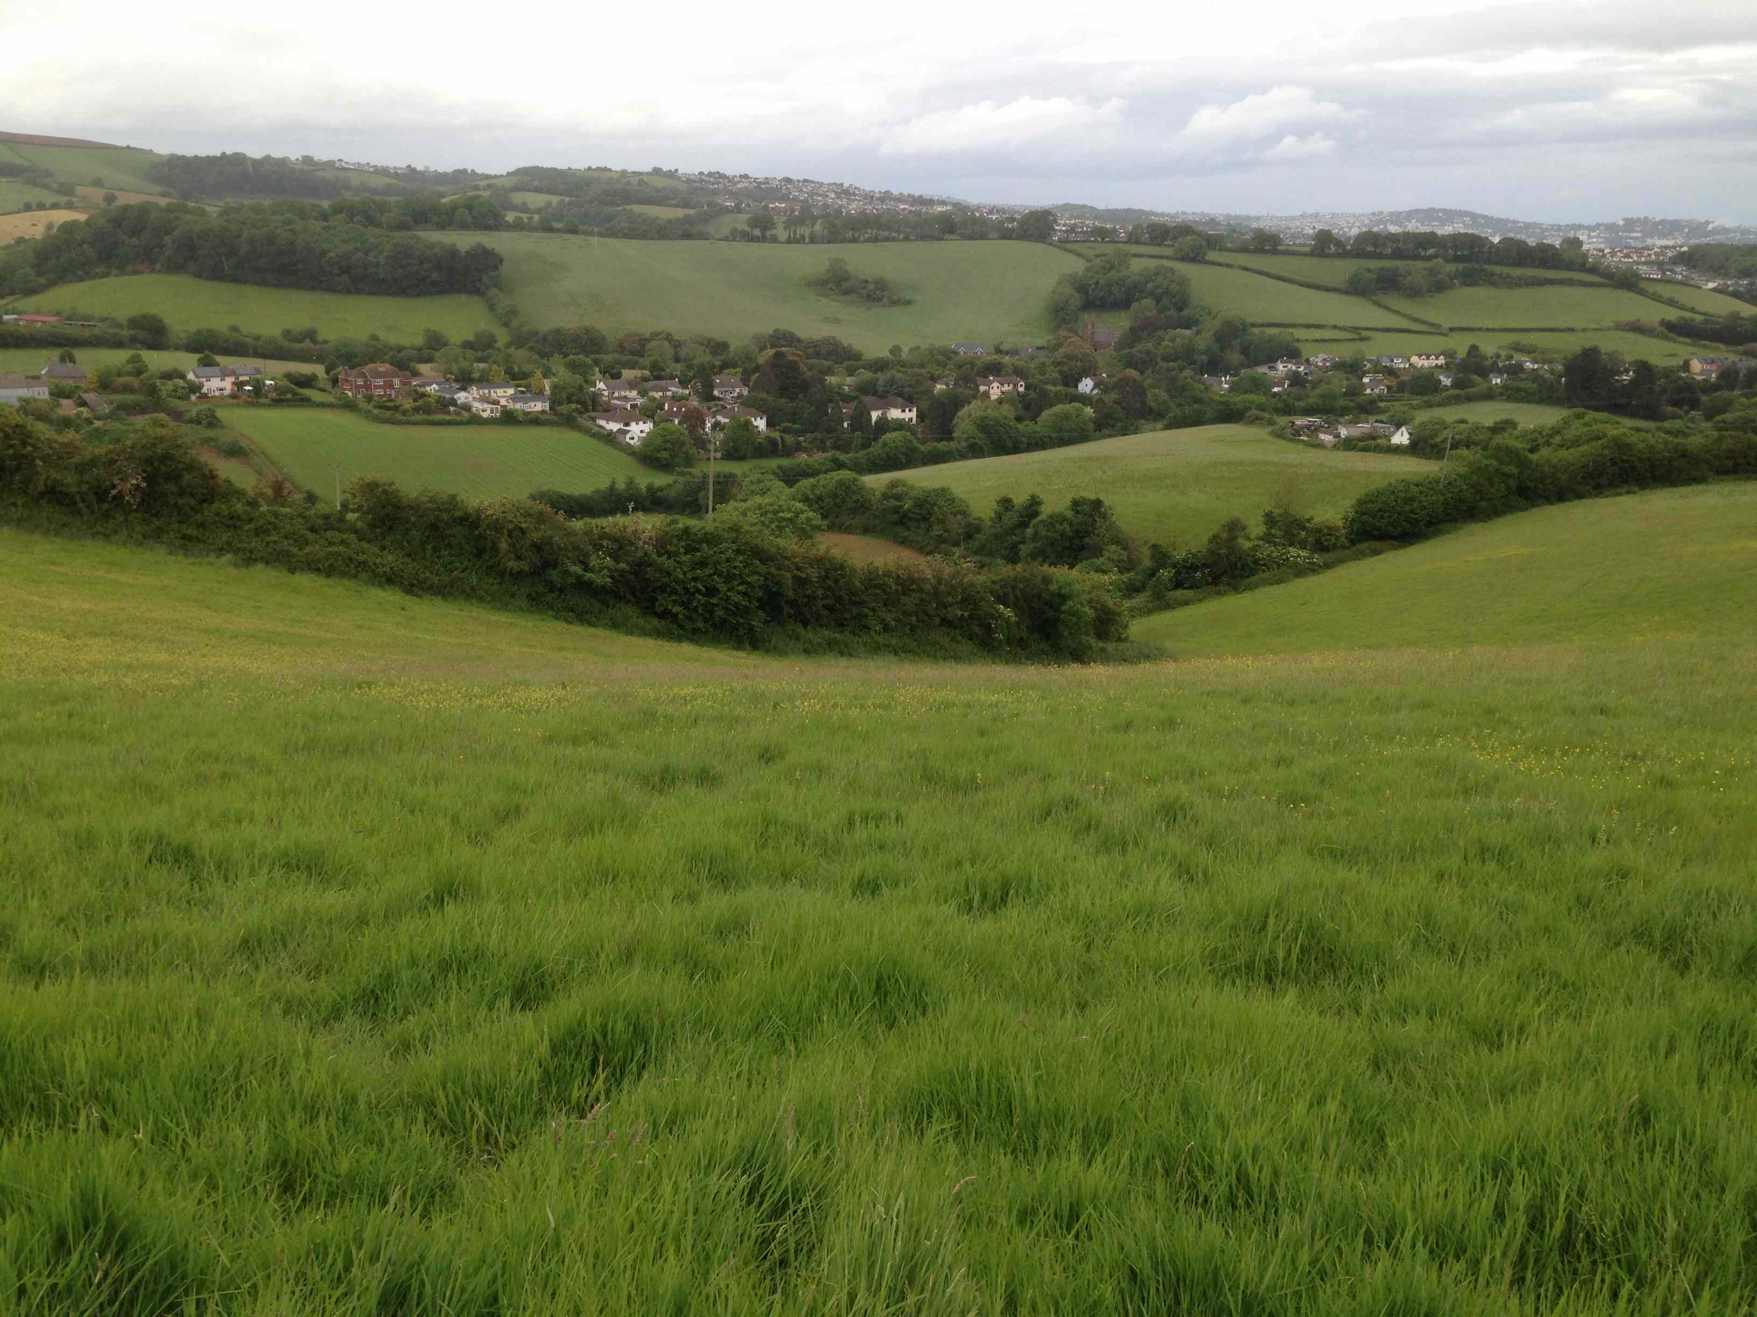

Photo 3

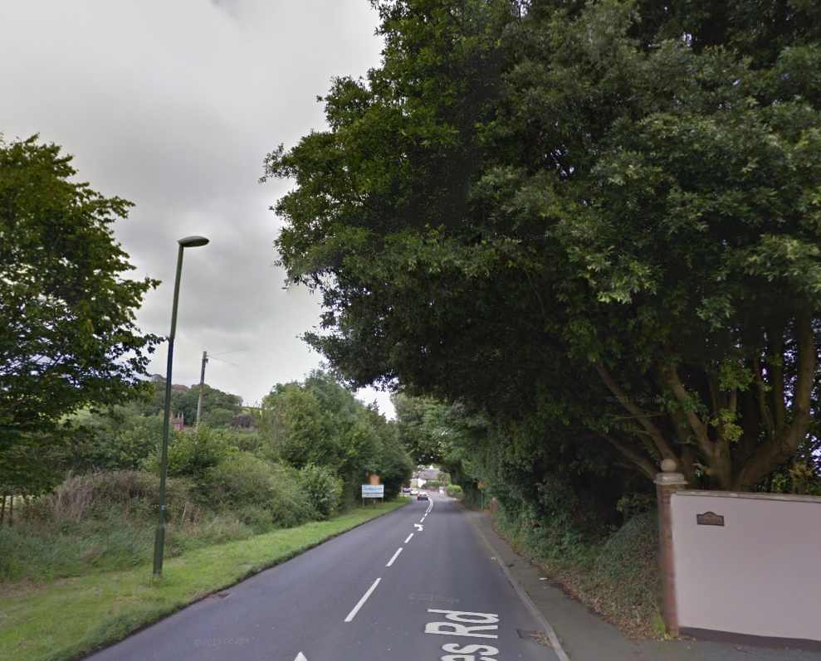

5.4 SDP1 Yalberton Industrial Estate and Claylands

Key Characteristics

    - These two Neighbourhood Plan potential employment (residential) development sites lie either side of the A3022 (Brixham Road) (see Map 8). While they are distinct areas within the local plan, historically, it is likely that green corridors allowed for movement of bats between the two areas. This would have further facilitated use of the Strategic Flyway in the Clennon Valley (see Maps 6, 8 and 10).

    - The Yalberton Industrial Estates is shown as Area ‘H’ on Map 8 of this report, and is within the of South Hams (Berry Head) SAC Sustenance Zone.

    - The estate is an extensive site comprising a large number of industrial and commercial units, with associated car parking and outside storage areas. Small blocks of woodland, mature tree belts and tall thick hedgerows form a vegetated boundary around most of the Industrial Estate, and also along some of the lanes through the estate. These natural features act as a substantial barrier to light spill from the estate into the surrounding open countryside.

    - Most of area ‘H’ is well lit at night with the exception of a narrow strip of land adjacent to the northern boundary (see point 6 on Map 8). This northern part of area ‘H’ is a mosaic of small patches of grassland and scrub, with the northern boundary marked by a well-developed mature hedgerow. It also has a number of footpaths running through it.

    - At one time, this northern area may have provided a link to further bat flyways eastward across the A3022 towards the Claylands (see point 11 on Map 8) and, beyond it, the Clennon Valley (identified by Natural England as providing another Strategic Flyway for GHBs). However, in recent years there has been development east of Yalberton Industrial Estate (around the area shown as point 12 on Map 8) and there have been road and lighting improvements along the A3022 (either side of the Tweenaway junction completed in 2012). Together, these appear to have removed much of the potential habitat linkage that may once have existed. It is not known whether there is still sufficiently dark green space left to now function as a viable flight corridor between points 6 and 11 on Map 8.

    - Claylands is shown as Area ‘I’ on Map 8 of this report. The site was originally a quarry and has in more recent years been used as a refuse tip. The site is bounded:

- To the west by the A3022 (and beyond it the Yalberton Industrial Estate);
- To the south by Claylands Cross public open space (a children’s playground);
- To the east by Paignton Zoo;
- To the northwest by residential development beyond the Battersway Road and to the northeast by a Morrisons Supermarket (separated by a small woodland).

    - The Claylands also sits at the south-western end of the Clennon Valley, which has been identified by Natural England as a greater horseshoe bat Strategic Flyway (see Maps 6, 8 and 10). The area is also within the South Hams (Berry Head) SAC Sustenance Zone.

    - Stands of semi-mature broad-leaved woodland are present within the northern and eastern boundaries and there are extensive areas of developing scrub across the site. While these habitats provide some potential foraging and commuting opportunities for GHBs, actual use of the site is not known.

    - As stated in 5.4.1 above, there may historically have been habitat connectivity for bats between the Clennon Valley to the east, through the Claylands, across the A3022 and beyond towards the Yalberton Industrial Estate. However, recent small-scale developments in the vicinity, as well as improvements to the A3022, may have restricted whatever original connectivity existed (see pinch point 12 on Map 8).

Does future development of these sites have the potential to impact the integrity of the South Hams SAC?

    - Yalberton Industrial Estate: While there are very limited opportunities for foraging GHBs within the estate, there are possible routes through it that might be used by commuting bats. The most likely of which would follow the line of the watercourse that flows into the estate in the north from the direction of Collaton St Mary (see Map 6 of this report). This line is also marked by a tall mature hedgerow – a relict from a rural landscape prior to the development of the industrial estate (see point 5 on Map 8). Unfortunately, much of this hedgerow is bordered by industrial units and/or areas of parking and/or outdoor storage; all of which are normally well lit at night for security reasons. GHBs may also use the thick mature wooded margins of the industrial estate for both foraging and commuting.

    - Claylands: Development of the Claylands is likely to cause loss of some semi-natural woody vegetation and is also likely to increase levels of disturbance e.g. through increased levels of light. Development may also represent a further barrier to GHBs commuting in and out of the Clennon Valley in a east-west direction (and vice versa) over the A3022 (see points 11 and 12 on Map 8).

Is it likely that potential impacts will require Habitat Regulations Assessment (HRA)

    - Yalberton Industrial Estate: Increased disturbance and/or severance of the linear features through the estate, or of the wooded margins, would therefore be a ‘likely significant effect’ (LSE) that would require HRA. Detailed GHB surveys will therefore be required to inform the HRA process.

    - Claylands: Loss of foraging and commuting habitat, and increased disturbance would therefore be a ‘likely significant effect’ (LSE) that would require HRA. Detailed GHB surveys will therefore be required to inform the HRA process.

Is it likely that impacts can be mitigated effectively?

    - Agreement over what will be necessary mitigation for the Industrial Estate and the Claylands must be informed by detailed bat surveys to establish levels of use of the site by GHBs. The survey results should then inform detailed design of appropriate mitigation.

    - Yalberton Industrial Estate: There is potential for some of the linear route through area ‘H’ (see point 5 on Map 8) to be enhanced and to be made more attractive to commuting horseshoe bats. For instance, a single streetlight could be removed where this route crosses Aspen Way, thus helping to make the potential corridor darker where it crosses the road (see point 5 on Map 8). There may also be opportunities to bring tree and hedgerow planting up to the road edge at this point, thus reducing the gap that bats would have to bridge when crossing Aspen Way. Further enhancements may also be possible with the cooperation of the owners/occupiers of some of the industrial units adjacent to the brook and hedgerow, such as the introduction or reduced lighting, or lighting set to come on with motion sensors or timers.

    - Any future major redevelopment of any of the individual units within the Industrial Estate should maintain the existing hedgerows and consider opportunities for more substantial habitat enhancements e.g. through the reduction of disturbance (e.g. from artificial lighting) and through more sympathetic landscaping planting to enhance permeability for bats moving through the area. Any development proposals around Point 6 on Map 8 should be informed by comprehensive bat surveys to establish to what extent, if any, the semi-natural habitat in this area supports commuting and/or foraging bats. Should it be established that this area forms part of an important longer link with open countryside to the west and the Clennon Valley to the east, then it is likely that development might have a significant effect on local connectivity with the nearby Strategic Flyways and therefore on the integrity of the South Hams SAC. It would be difficult to mitigate for such a closure of a narrow route such as this.

    - Claylands: Retention of the wooded margins and control of light spill from new development will be required to mitigate for likely effects GHBs. The amount of semi-natural habitat to be retained should be informed by detailed bat surveys – that should also establish whether a local flyway should be retained through or around the site to enable movement back and forth across the A3022 to the west.

5.5 SDP 3.4 Brixham Road Future Growth Area

Key Characteristics

    - The Brixham Road Future Growth Area lies to the west of the A3022 on the western edge of Paignton. For the purposes of this report, the growth point has been divided into four distinct areas, shown on Map 9 as areas ‘A’, ‘B’, ‘C’ and ‘D’ (see Map 9 of this report).

    - The Future Growth Area lies within the South Hams (Berry Head) SAC Sustenance Zone and just to the east of areas ‘A’ and ‘B’ a Strategic Flyway runs up the valley from Stoke Gabriel to Collaton St Mary. There area also historic records of greater horseshoe bat roosts in this valley.

    - Area ‘A’ (the Jackson Land) forms the northern part of the growth point. This area is bound to the north by Yalberton Road, and a supermarket and beyond these by Yalberton Quarry and Yalberton Industrial Estate. To the east of area ‘A’, there is planning consent for new residential and commercial development (which is currently under construction – see area ‘B’ below). To the south and west there is a continuation of mixed agricultural fields.

    - The majority of area ‘A’ is under arable cultivation with a network of mature hedgerows and trees forming the boundary between all fields. The land is highest in the south and slopes down towards the Yalberton Industrial Estate.

    - A Bat Activity Survey has been prepared for area ‘A’ by Bluebell Ecology (February 2014) as part of a wider Preliminary Ecological Appraisal (PEA) completed by Sunflower Ecology on behalf of Waddeton Park Ltd (October 2013).

    - The Bluebell Ecology Bat Activity Survey states:

“The bat activity survey was undertaken in accordance with guidance provided by the South Hams SAC – Greater Horseshoe Bat Consultation Zone (Natural England 2010).

The bat activity survey identified a moderate level of bat activity, comprising of an exceptional diversity of bat species, including at least twelve species. This activity predominantly consisted of recordings by common pipistrelle bats including a lesser extent of other species, including the rarer species of greater horseshoe (Rhinolophus ferrumequinum), lesser horseshoe (Rhinolophus hipposideros) and barbastelle (Barbastella barbastellus).

Individual lesser and greater horseshoe bats were recorded infrequently in close association
with the hedgebank field boundaries”.

    - Area ‘B’ (the Cavanna Land) abuts area ‘A’ on its western and southen boundaries and also slopes downhill towards the north. The eastern boundary is adjacent to the A3022 and the existing built up edge of Paignton. The southern boundary is immediately adjacent to a sports pitch and a small nature area managed by South Devon College. South of these are extensive areas of car parking, also associated with the College which is a little further to the South (see northern part of area ‘C’).

    - Area ‘B’ has planning consent for a mix of residential and commercial development and this is currently under development. Bat surveys undertaken to inform the planning application for this development were undertaken by Baker, Shepherd and Gilespie Ecological Consultants between May and September 2010. GHBs were detected at three locations in area ‘B’ and all in close proximity to hedgerows.

    - As a requirement of planning consent, the new development has provided a narrow buffer/corridor along the western boundary and a bespoke bat roost within this buffer. Greenspace on site will also be subject sympathetic landscaping, designed to provide foraging opportunities for GHBs among the mixed habitats to be created e.g. boundary hedgerows, mixed scrub, and open grassland. The public open space will be managed by a management company specially set up for the purpose. Planning conditions also prohibit light spill into sensitive bat habitats.

    - Much of Area ‘C’ (the Waddeton Industrial Estate/Devonshire Park) is an old industrial estate that is currently undergoing demolition in advance of new development. As such it is a brown field site with few if any features of value to foraging or commuting horseshoe bats. However, there is a sports pitch on the high ground on the northern edge of area ‘C’ (shown on Map 9 as being surrounded on three sides by area ‘B’, with which it shares hedges and semi-natural vegetation along the boundaries.

    - Area ‘D’ (including White Rock) forms the southern part of the Brixham Road Future Growth Area. It includes an area of existing commercial and industrial units immediately south area ‘C’ and South Devon College. And to the south of these, planning permission (P/2011/0197) has recently been granted for a mix of commercial and residential development – the White Rock proposals.

    - The A3022 and existing built edge of Paignton forms the eastern edge of area ‘D’, and the southern and western boundaries are adjacent to open farmland (a mix of arable and pasture).

    - The planning application for White Rock was accompanied by an Ecological Report prepared by Ecosulis, and this was informed by bat activity surveys conducted in 2010 ad 2011. The results of these surveys showed irregular use of the site by only a few GHBs, and these were thought to be individuals mainly commuting across the site and occasionally foraging along hedgerows.

    - A new bat roost and a Landscape and Ecological Management Plan (LEMP) have been secured through the planning permission, and the latter provides for new offsite woodland and hedgerow planting/enhancement, secured in the long-term by a management agreement. Planning conditions also prohibit light spill into sensitive bat habitats. The LEMP site is identified under Policy SS9.3 Countryside access and enhancement scheme.

NOTE: A masterplan has not been commissioned for Brixham Road, Paignton because there are active planning applications for these areas. White Rock, Paignton has permission (See area ‘D’ above. Reference: P2011/0197) for a mixed use development, which is subject to an Ecological Impact Assessment and off site mitigation. Similarly, planning permission has been granted for mixed use development on the Cavanna Land (see area ‘B’ above. Reference: P/2010/0289) which has also been subject to ecological assessment.

Does future development of the Brixham Road Future Growth Area have the potential to impact the integrity of the South Hams SAC?

    - The planning applications in areas ‘B’ and ‘D’ have required HRA because without adequate mitigation there was a likely significant effect on the South Hams SAC. Both applications were going to cause loss of some potential foraging habitat within the SAC Sustenance Zone and also loss or disturbance to hedgerows likely to be used by locally commuting GHBs.

    - Future developments within the Brixham Road Future Growth Area, especially within area ‘A’ are likely to result in further loss of hedgerows and foraging habitat and to cause disturbance through, for instance, uncontrolled light spill. Consequently, where this occurs, such development has the potential to affect the integrity of the SAC.

Is it likely that potential impacts will require Habitat Regulations Assessment (HRA)?

    - Future developments within the Brixham Road Future Growth Area are also likely to require HRA where such proposals result in loss of foraging or commuting habitat (e.g. grassland, woodland or hedgerows) and/or light spill into open countryside.

Is it likely that impacts can be mitigated effectively?

    - By following a similar approach, as has already been applied in areas ‘B’ and ‘D’, it should be possible to provide adequate mitigation for new development. This should be informed by full detailed bat surveys (consistent with NE SAC guidance) and should address adverse effects arising from loss of roosts, foraging habitat and likely local flyways and commuting routes.

    - The provision of such measures should be designed to be consistent with the four principles set out in the proposed modified Local Plan Policy NC1.

5.6 SDP 4 Clennon Valley Leisure Hub

Key Characteristics

    - The Clennon Valley Strategic Delivery Area stretches from the area around Claylands, Tweenaway and Paignton Zoo down towards the coast at Goodrington Sands (See Map 10 of this report).

    - A greater horseshoe bat Strategic Flyway runs along the valley and continues westward across the A380 into area ‘A’ (see Map 6 of this report) within the Totnes Road Growth Point.

    - There are historic records of greater horseshoe bat roosts in the Clennon Valley (e.g. near Paignton Zoo) meaning that, at least in the past, GHBs have been using the valley.

    - There are substantial areas of suitable bat foraging habitat throughout the valley; including: areas of open grassland (although most of this is amenity); substantial areas of broadleaved woodland and scrub; and a string of open water bodies stretching from Paignton Zoo (at the upper end) to the southern edge of the sports pitches associated with Torbay Leisure Centre (at the lower end of the valley – see point 1 on Map 10). The western and southern parts of the valley have been designated as a County Wildlife Site (CWS).

    - The western end of the valley is adjacent to the built up areas around the junction of the A380, A3022 and A385 (the Tweenaway junction). This is an area with very little semi-natural vegetation and is well lit along all of the main road (see ‘pinch points’ 7 and 12 on Map 6).

    - In contrast, the open undeveloped eastern end of the Clennon Valley is approximately 250 metres wide and is separated from the coast by only the A379. Fortunately, this main road is unlikely to act as a complete barrier to GHB movement, as there are hedges, scrub and tall trees along both sides of this section of the road. It is also not lit as brightly as the pinch points around the Tweenaway Junction at the top end of the valley (see points 7 and 12 on Map 6). Also, in places mature conifer trees along the A379, and nearby hedges and scrub, offer GHBs the opportunity of potentially safe and high level ‘hop overs’ across the road. While planning permission (June2014) for a Closed Road Cycle Circuit has been granted (P/2013/1189) at the western end of the valley (and is now in operation), it is not likely to have a significant effect on the South Hams SAC (e.g. it is not floodlit at night).

    - If GHBs do cross the A379 it is possible that they regularly or seasonally commute and/or migrate back and forth along the coast towards the Berry Head roost. This route into the Clennon Valley would be far less ‘intimidating’ to GHBs than via the intensively developed, and very well lit, western end of the valley around the Totnes Road, A380 and A3022 junctions.

Does future development of the site have the potential to impact the integrity of the South Hams SAC?

    - No major development, or loss of semi-natural habitat, is proposed in the Local Plan for the Clennon Valley; and Policy SDP4 sets out the criteria that all development proposals must meet in order to achieve a planning consent. However, leisure related activities do have the potential to cause disturbance to the Strategic Flyway e.g. through the introduction of artificial external lighting. Also, loss of semi-natural vegetation along the southern (and eastern) side of the valley (especially to the south of the existing sports pitches) could also significantly affect the Flyway through severance or disruption of the wooded corridor.

    - In addition, built and/or tourism related development along the margins of the valley (for instance in and around Devon Bay Holiday Park – see point 3 on Map 10) could also cause disturbance to the Strategic Flyway just to the north e.g. through light spill.

    - Similarly, the Neighbourhood Plan potential residential development around Torbay Golf Centre (see point 2 on Map 10) could result in the loss of potential foraging and commuting habitat, especially along the eastern edge of this area where there is scrub and young woodland along a steep embankment.

    - Development proposals within or along the margins of the valley should therefore be informed by appropriate bat surveys and, where necessary, accompanied by a set of mitigation measures. As part of these studies, surveys should concentrate on identifying bat activity within identified ‘pinch points’ in and around the Clennon Valley (see Map 2 of this report). As and where greater horseshoe bat activity is confirmed through surveys, appropriate mitigation will be required; such as through retention of hedgerows, trees and other foraging habitat where their loss would result in a significant effect on the Strategic Flyway. Light spill greater than 0.5 lux should also be restricted from identified flight routes.

Is it likely that potential impacts will require Habitat Regulations Assessment (HRA)?

    - Local Plan Policy SDP4 precludes leisure-related development that would have an adverse effect on the integrity of the SAC. Development that results in the loss of semi-natural vegetation or the introduction of new lights sources in the valley should therefore be subject to HRA to ensure statutory and policy compliance.

Is it likely that impacts can be mitigated effectively?

    - Leisure related development within the valley and tourism related development along its margins should provide appropriate mitigation measures based upon all of the principles set out in modified Local Plan Policy NC1.

    - Mitigation measures should include: provision of landscape buffers between development and areas of semi-natural vegetation in the valley; control of light spill; mitigation for the loss of potential foraging and commuting habitat to ensure retention of connectivity along the valley; retention, where appropriate, of features through development that are likely to be used by GHBs; and developer contributions towards the provision of bespoke purpose-built roosts in appropriate locations along the valley.

6.0 SITES IN BRIXHAM STRATEGIC DELIVERY AREA (SDB1)

  - SDB 1 Fishcombe Cove

Key Characteristics

    - The plan allocation at Fishcombe is on the coast at the top of a small cove approximately 0.5km west of Brixham Outer Harbour. The site lies within the South Hams (Berry Head) SAC Sustenance Zone (see Map 11 of this report).

    - There is broadleaved woodland to the east and west of the site and to the north (opening out towards the sea) there is scrub and a wooded slope that drops down to the beach. The Brixham Holiday Park, to the south, forms the only ‘built up’ and lit boundary to this site.

    - Does future development of the site have the potential to impact the integrity of the South Hams SAC?

    - The site was originally developed in the past with thirty holiday chalets, although these have remained unoccupied for a number of years. Consequently, in February 2014, Torbay Council approved the issue of a Certificate of Lawfulness for the use of the holiday chalets as dwellings without any limitation on occupancy.
    - The chalets are currently under refurbishment as part of the process of converting the site for residential use. In association with this, a recent planning application has been submitted to Torbay Council for a new car park and enclosed glass-fronted swimming pool. Planning permission for this application will be granted subject to condition that neither the car parking area nor the swimming pool will be lit.

    - The applicant/developer has agreed that a separate planning application will be submitted to obtain permission for the installation of lighting across the site.

    - While the redevelopment of the chalets per se does not pose a potential impact on the integrity of the SAC, the introduction of new lighting into a wooded coastal location could have adverse effects on greater horseshoe bat activity within the local area.

    - Such an adverse effect could be more significant if it is established that GHBs fly over open water around Brixham Harbour from the Berry Head roost, because one of the most likely first landfalls for these bats would be around Fishcombe Cove. If this is the case, the development at the top of the cove may contribute towards the creation of a pinch point for bat activity along this part of the coast.

    - For this reason, any future proposals to intensify use of the site and/or to extend the existing footprint of development should be informed by adequate greater horseshoe bat surveys and should be subject to HRA.

NOTE: There is evidence that greater horseshoe bats will cross open sea because they have been recorded on Drake’s Island in Plymouth Sound and also on islands of the coast of Pembrokeshire in South Wales.

    - Is it likely that potential impacts will require Habitat Regulations Assessment (HRA)

    - The further removal of woody vegetation (e.g. on the margins of the site and/or between the site and the beach) and/or the introduction of lighting into such a sensitive location would therefore be a ‘likely significant effect’ (LSE) that would require HRA.

    - Is it likely that impacts can be mitigated effectively?

    - Effective mitigation measures could be provided through a combination of sensitive lighting design in association with sympathetic new landscape planting (and a restriction on removal of any further semi-natural vegetation (e.g. scrub and trees). These would have the aim of restricting light spill into adjacent areas of woodland and into the cove itself.

  - SDB 3.2 Wall Park Future Growth Area

Key Characteristics

    - The Wall Park Future Growth Area is located on the north-eastern edge of Brixham on a relatively flat site on the Berry Head peninsular. The site is surrounded by housing to the north-west and south-west; and is bordered by Gillard Road, open farmland and the Landscove Holiday Park to the south; with Berry Head to the east. See Map 12 of this report.

    - The northern and central part of the area includes vacant single and two storey buildings associated with a former holiday park, which has been closed since 2008 (see area ‘A’ on Map 12 of this report). The eastern edge of the Holiday Park is marked by a hedgerow and belt of trees, and between this and Gillard Road, to the east, is a large field under permanent pasture.

    - The southern part of the Future Growth Area (see area ‘B’ on Map 12) includes a caravan/camping park accessed off of Gillard Road close to its junction with Centry Road. This caravan park currently makes use of the long thin fields at the southern end of the site; tall mature hedgerows with some mature trees separate these fields. The remainder of the area includes small pasture fields and areas of scrub (particularly around the northern margins of the site).

    - The whole of the Future Growth Area lies within Berry Head Component of South Hams SAC Sustenance Zone (an area identified in Natural England’s South Hams SAC guidance (2010) as being of particular importance for GHBs). Notably, parts of the area are also within 1km of the SAC roost and this inner core of the Sustenance Zone is considered to be particularly important, each summer, to newly foraging ‘juvenile’ greater horseshoe bats.

    - The Growth Area also lies within a crucial Strategic Flyway from the SAC roost at Berry Head, where this flyway forms one of the main routes from the roost to the open countryside beyond the built up area of Brixham.

    - A summary landscape analysis for Wall Park is provided in the Brixham Urban Fringe Landscape Study (see page 40; Landscape Compartment 6 Wall Park Camp).

    - Wall Park is also the subject of a current planning application (P/2013/0785) for 165 dwellings, touring caravan park and sports pitch/overflow car park, with associated landscape and ecological enhancement works. The application has been accompanied by an Environmental Statement (ES), prepared on behalf of the applicant by the Cooper Partnership (dated July 2013). The ES includes a detailed ecological assessment (prepared by Cresswell Associates as part of the Hyder Consulting Group). Ecological surveys underpinning this work were undertaken in 2008 and 2012.

    - The ecological surveys undertaken to inform the above application have confirmed that greater horseshoe bats are passing through the Future Growth Area on a very regular basis (i.e. throughout the spring and summer at dusk and dawn as the bats leave and return to the roost at Berry Head).

    - Ecological surveys were also undertaken by Baker Shepherd Gilespie Ecological Consultants in support of a planning application for the extension of the Landscove Holiday Park to the east of Wall Park. The results from these surveys were presented in the Environmental Statement prepared on behalf of the applicant by Peter Brett Associates (dated April 2009). This work again confirms the importance of the Strategic Flyway and has additionally identified, as part of the flyway, that greater horseshoe bats are moving between the Landscove Holiday Park and the development on the northern side of Gillard Road that is adjacent to the Wall Park eastern boundary.

    - The survey results from the work undertaken for the above applications has therefore revealed that there are a number of important routes, within the Strategic Flyway, that are used by the bats as they move to and from the Berry Head roost (see dotted lines on Map 12 of this report).

Does future development of the Wall Park Future Growth Area have the potential to impact the integrity of the South Hams SAC?

    - The non-developed areas of the Growth Area (see area ‘C’ on Map 12) are likely to be of major importance to GHBs, offering crucial foraging and commuting habitat close to the SAC roost (see Map 12); including:

- A network of hedgerows and trees providing linear features along which the bats can commute daily and migrate seasonally;

- Fields with permanent pasture capable of providing optimal foraging opportunities;

    - Development within the Growth Area in an inappropriate location and/or of an inappropriate design therefore have the potential to adversely affect GHBs and thereby be likely to impact on the integrity of the of the South Hams SAC. Such effects might be caused by one or more of the following

- Loss of grazed pasture which would reduce the extent of potential foraging habitat available to bats;

- Severance of habitat connectivity (particularly that enabling movement to and from the SAC roost to open countryside around and beyond Sharkham Point);

- Disturbance to bat foraging and commuting habitat that is to be retained within or adjacent to future development (e.g. as a result of increased light levels) so that GHBs are no longer able to make use of these features.

    - The most likely significant effect from proposed development within the Future Growth Area is the potential restriction on the bats’ ability to disperse and move to and from foraging areas beyond Brixham. Such movement may occur on a regular daily basis, or on a more infrequent seasonal basis e.g. in the early spring and late autumn when the bats may be using routes through the growth area in order to migrate to and from their hibernation roosts used through the winter.

    - Also, the proposed development site falls within the 1km radius around roosts that are important to support juvenile bats for foraging activity. Research has shown that juvenile greater horseshoe bats tend to forage within a 1km radius of the maternity roost. The 1km radius surrounding the Berry Head roost is subject to very limited foraging opportunities. The permanent loss of existing or potential habitat (including amenity grassland) within the sustenance zone and in proximity to Berry Head has the scope to adversely affect the favourable conservation status of the Berry Head maternity colony.

    - In order to meet the requirements of Habitat Regulations Assessment, it is therefore essential that adequate mitigation be provided that ensures (i) there are no further restrictions on potential movement of GHBs along the strategic flyway through the future growth area and (ii) the retention and enhancement of foraging and on-site roosting opportunities.

Is it likely that potential impacts will require Habitat Regulations Assessment (HRA)?

    - Development of the Wall Park Future Growth Area will need to be informed by detailed bat surveys and accompanying ecological assessments.

    - Habitat Regulations Assessment will be required to determine whether the integrity of the SAC is likely to affected adversely. It will only be possible to avoid a full Appropriate Assessment if detailed mitigation measures are incorporated into development proposals to demonstrate (when examined against the ‘Likely Significant Effect’ (LSE) test) that there will be no likely significant adverse effect on the integrity of the South Hams SAC.

Is it likely that impacts can be mitigated effectively?

    - Mitigation measures for GHBs should support the SAC Conservation Objectives set by Natural England and also promote Favourable Conservation Status for this species (see Appendix B). As such, mitigation measures for the Wall Park Future Growth Area should aim to:

Facilitate ease of movement and conserve energy expenditure (especially by juvenile greater horseshoe bats) by strengthening the boundary and internal hedgerow network, introducing cattle grazing onsite throughout the bats’ active season, and by providing alternative roosting opportunities.

    - In order to achieve the above aim, and to provide the certainty necessary to satisfy the requirements of the HRA process, the following mitigation objectives must be applied to emerging development proposals for the Wall Park Future Growth Area. This mitigation must then be implemented in full at such time as development applications are brought forward. Such mitigation should be a combination of identifying and recognising:

- key design constraints required to avoid or minimise adverse effects, and;

- habitat mitigation/enhancement opportunities to provide overall net gains for GHBs specifically and for wider biodiversity in general.

    - Design Restrictions/Constraints should:

- Maintain existing connectivity of bat commuting and foraging habitat through and around the Growth Area in accordance with the flyways shown on Map 12;

- Achieve no net loss of foraging;

- Achieve no overall net loss of existing hedgerows and trees within the Growth Area;

- Avoid light spill in bat flyways and foraging areas i.e. achieve light levels less than 0.5 lux in sensitive locations;

Habitat Mitigation/Enhancement Opportunities should:

- Create a substantial green corridor along the eastern undeveloped half of the Growth Area based on the existing pasture fields;

- Undertake habitat creation/enhancement to provide new tree lines and hedgerows through the eastern half of the growth area to strengthen bat commuting habitat;

- Secure favourable long-term management through the introduction of cattle grazing to support greater horseshoe bats (especially juveniles foraging within 1km of the SAC roost);

- Provide landscape buffers between bat flyways/foraging habitat and the new built development – these should ideally be 10m wide;

- Provide new bat roost(s) to support and improve viability of bat flyways;

- Provide long-term management for all landscape through a Landscape and Ecological Management Plan (LEMP), secured through a planning condition and/or obligations;

- Implement development through the means of a prior-approved Construction Environmental Management Plan (CEMP), secured through a planning condition and/or obligations;

- Undertake appropriate and proportionate ecological monitoring of the LEMP(s) to establish the effectiveness of proposed mitigation measures and to provide early warning of any necessary contingency or remedial measures required to meet original objectives;

The provision of such measures would be consistent with the four principles set out in the proposed modified Local Plan Policy NC1.

APPENDIX A Protection and Enhancement of Ecological Networks

    - Across Europe, all of the Special Areas for Conservation (SACs) and Special Protection Areas (SPAs) together contribute to the European Natura 2000 network. The protection, management, and enhancement of such ecological networks, and especially those relating to the Natura 2000 network, are identified as being particularly important in the EU Habitats Directive.

    - Article 3 of the Directive states:
Where they consider it necessary, Member States shall endeavour to improve the ecological coherence of Natura 2000 by maintaining, and where appropriate developing, features of the landscape which are of major importance for wild fauna and flora, as referred to in Article 10.

    - Article 10 then goes on to explain:
Member States shall endeavour, where they consider it necessary, in their land use planning and development policies and, in particular, with a view to improving the ecological coherence of The Natura 2000 network, to encourage the management of features of the landscape which are of major importance for wild fauna and flora. Such features are those which, by virtue of their linear and continuous structure (such as rivers with their banks or the traditional systems of marking field boundaries) or their function as stepping stones (such as ponds or small woods), are essential for the migration, dispersal and genetic exchange of wild species.

    - The Conservation of Habitats and Species Regulations (2010) transpose the above EU Directive into English legislation. Regulation 39 requires development plan policies to include policies that implement at the local level the requirements of Article 10 so as to encourage the management of features of the landscape which are of major importance for wild flora and fauna.

    - In relation to the potential development sites discussed in this report, Regulation 39 provides Torbay District Council with an opportunity to link conservation objectives to the allocation of some or all of the sites finally adopted. In particular, the LPA has both a justification and a statutory mechanism by which they can seek through their development plan policies the management and enhancement of landscape features in and around the Local Plan Areal which are of major importance for GHBs.

    - For instance, planning for Green Infrastructure in and around the proposed future growth areas could also lead to significant biodiversity gains and substantial improvement of GHB commuting and foraging habitat providing the bats with a very much enhanced flyways around the town. Such measures could also contribute to wider Green Infrastructure objectives and achieve benefits that could then also be enjoyed by the local community.

APPENDIX B SAC CONSERVATION OBJECTIVES AND GHB CONSERVATION STATUS

South Hams SAC Conservation Objectives

    - As required by the Habitats Directive, high level ‘Conservation Objectives’ for the South Hams SAC have been identified by Natural England. An overarching objective and a list of further generic objectives aim to:

‘Avoid the deterioration of the qualifying natural habitats and the habitats of qualifying species, and the significant disturbance of those qualifying species, ensuring the integrity of the site is maintained and the site makes a full contribution to achieving Favourable Conservation Status of each of the qualifying features.’

This is to be achieved by, subject to natural change, maintaining and restoring:

- The extent and distribution of the qualifying natural habitats and habitats of qualifying species.
- The structure and function (including typical species) of qualifying natural habitats and habitats of qualifying species.
- The supporting processes on which qualifying natural habitats and habitats of qualifying species rely.
- The populations of qualifying species.
- The distribution of qualifying species within the site’.

NOTE Natural England are in the process of preparing site specific objectives for each SAC and SPA in England.

    - The application of these objectives will be site specific and dependant on the nature of the site and its features. The local planning authorities should take these objectives into account when undertaking Habitat Regulations Assessments.

  - Favourable Conservation Status (FCS)

    - Article 2(1) of the Habitats Directive states that ‘Measures taken pursuant to this Directive shall be designed to maintain or restore at favourable conservation status, natural habitats and species of wild fauna and flora of Community interest’ (emphasis added).

    - The concept of ‘conservation status’ is therefore fundamental to the purposes of the Habitats Directive. Article 1(i) defines the conservation status of a species as:
‘the sum of the influences acting on the species concerned that may affect the long-term distribution and abundance of its population within the territory referred to in Article 2’ and continues that the conservation status of the species will be taken as ‘favourable’ when:

- ‘population dynamics data on the species concerned indicate that it is maintaining itself on a long-term basis as a viable component of its natural habitats, and
- the natural range of the species is neither being reduced nor is likely to be reduced for the foreseeable future, and
- there is, and will probably continue to be, a sufficiently large habitat to maintain its populations on a long-term basis’

REFERENCES

References in Relation to Habitat Regulations Assessment of Development Plans

Tydesley D. and Chapman C. (2013) The Habitat Regulations Handbook. David Tyldesley Publication Ltd

Scottish Natural Heritage (2012) Habitats Regulations Appraisal of Plans. Guidance for Plan-making Bodies in Scotland.

Natural England (2010) South Hams SAC – Greater Horseshoe Bat Consultation Zone Planning Guidance.

The Conservation of Habitats and Species Regulations 2010. London. TSO

References in Relation to Local Plan

Torbay Council (2011) Brixham Urban Fringe Landscape Study.

Torbay Council and Devon County Council (2011) Local Transport Plan 3. Implementation Plan (Part B: Torbay).

Torbay Council (2014) Torbay Local Plan A Landscape for Success. The Plan for Torbay – 2012 to 2032 and Beyond. Proposed Submission Plan. Feb. 2014

Torbay Council (2014) Habitat Regulations Assessment. Torbay Local Plan A Landscape for Success. The Plan for Torbay – 2012 to 2032 and Beyond. Proposed Submission Plan. Feb. 2014

Torbay Council (2014) Key Diagram and Policies Map Booklet. Torbay Local Plan A Landscape for Success. The Plan for Torbay – 2012 to 2032 and Beyond. Proposed Submission Plan. Feb. 2014

Enderby Associates (2010) Landscape Character Assessment of Torbay. May 2010.

South Devon and Dorset Shoreline Management Plan available at: http://www.sdadcag.org/index.html

Ecological References in Relation to Potential Impacts on the South Hams SAC

Edginswell (Torquay Gateway) Future Growth Area

Aspect Ecology (2012) Edginswell Park, Torquay. Ecological Assessment. March 2012

Preston Down Road

GreenEcology (2014) Preston Down Road North, Paignton. Preliminary Ecological Appraisal. April 2014.

GreenEcology (2014) Preston Down Road South, Paignton. Preliminary Ecological Appraisal. April 2014.

Great Parks

SLR December (2012) Great Parks, Paignton. Extended Phase 1 Habitat Survey Report. December 2012. Revision D.

Totnes Road Future Growth Area

Devon Biodiversity Record Centre (2010) Phase I Survey Report. Totnes Road, Collaton St Mary. April 2010.

EAD Ecological Consultants (2012) Ecological Impact Assessment. Collaton St Mary. Taylor Wimpey. October 2012.

Brixham Road Future Growth Area

WSP (2010) Land at Brixham Road, Paignton (Part of Land at Yalberton Road allocated as site E1.16c in Torbay Local Plan). Updated Phase 1 Habitat Survey. Cavanna Homes (Southwest) Ltd. March 2010.

Baker, Shepherd Gilespie (2010) Bat Survey for Cavanna Homes, Land at Brixham Road.

Ecosulis (2011) Land at White Rock, Torbay. Ecology Addendum to Environmental Statem
Sunflower International (2013) Land at Yalberton, Paignton. Preliminary Ecological Appraisal for Waddeton Park Ltd. (October 2013).

Bluebell Ecology Ltd (January 2014) Bat Activity Survey, Preliminary Bat Roost Inspections, Bat Emergence Surveys & Dormice Surveys. Revision 08.
ent.

Wall Park Future Growth Area

Cooper Partnership (2013) Former Holiday Centre. Wall Park Road, Brixham. Environmental Statement – Volume 1. Section 12 Ecology. July 2013.

HRA Site Appraisal Maps

Map 1 Local Plan Key Diagram

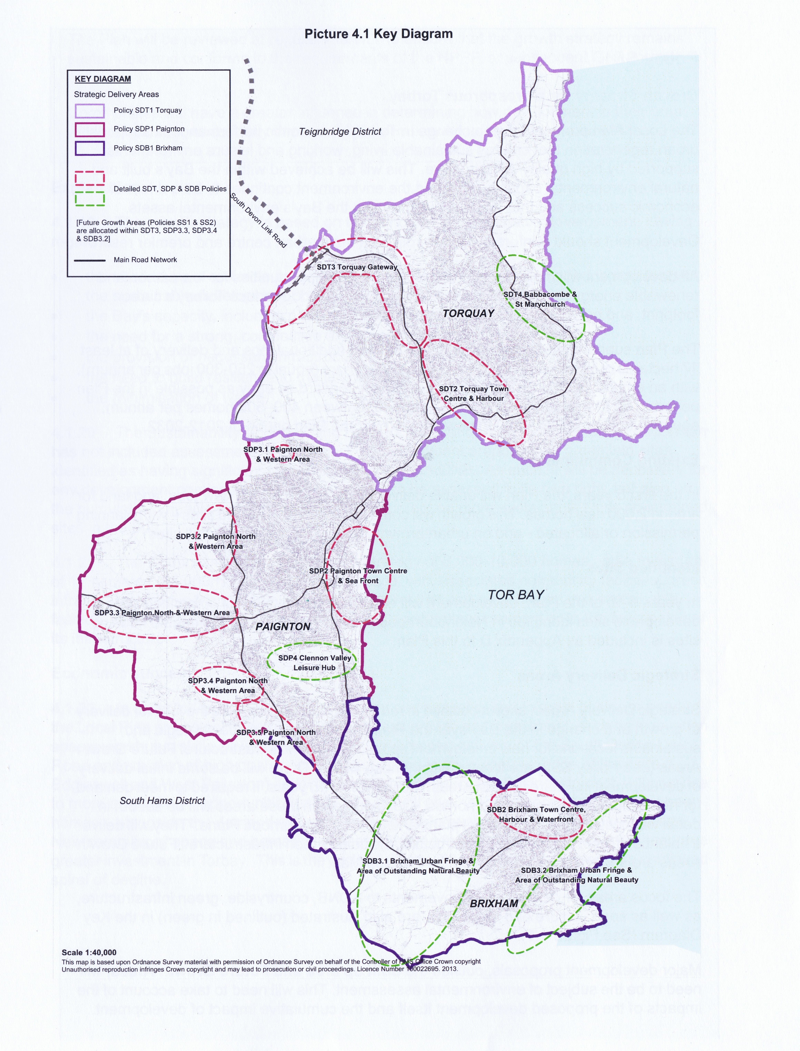
Map 2 Greater Horseshoe Bat Strategic Flyways and Potential Pinch Points

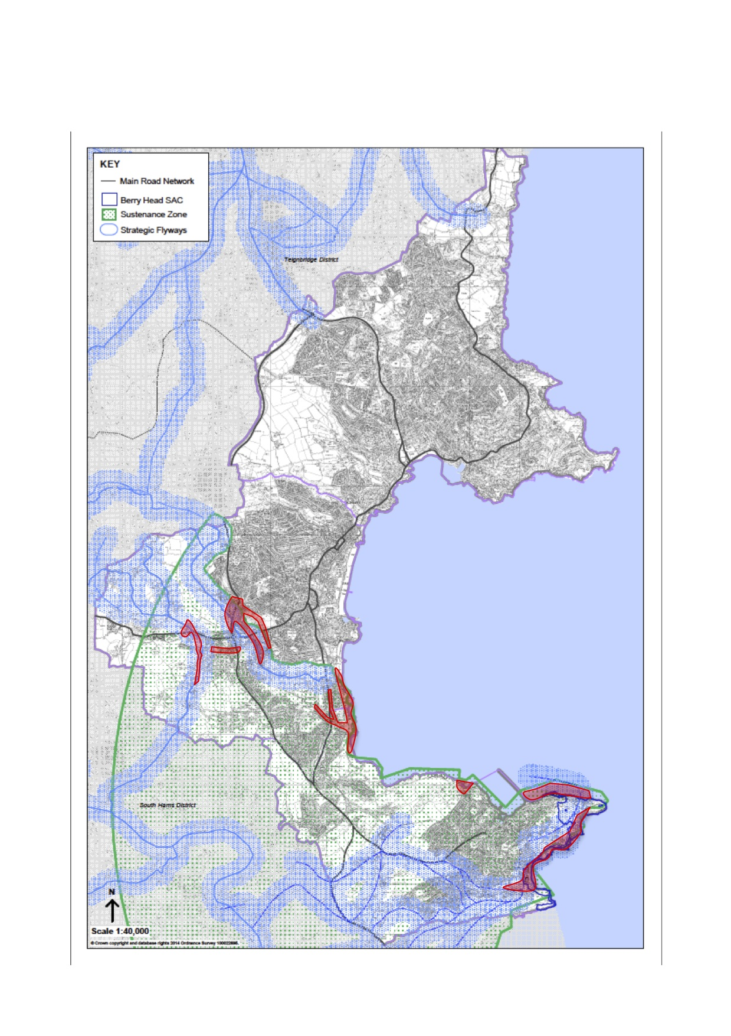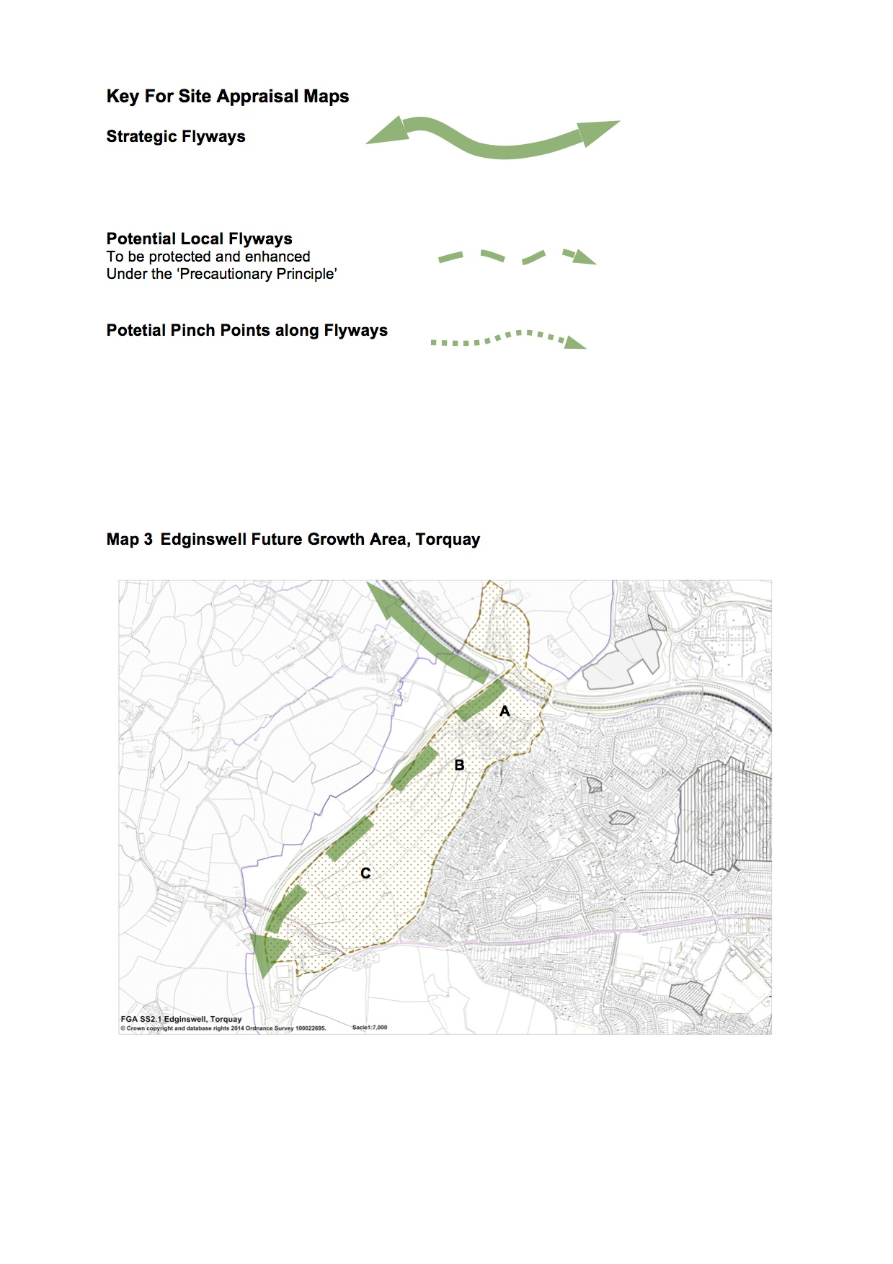

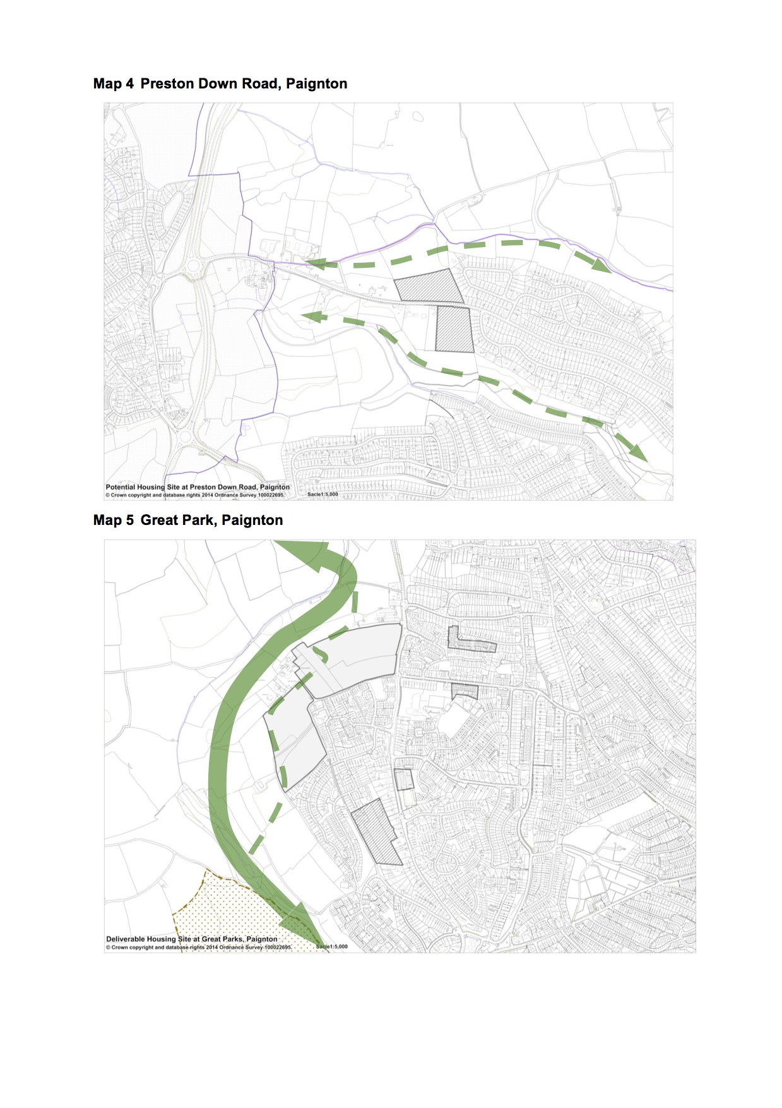
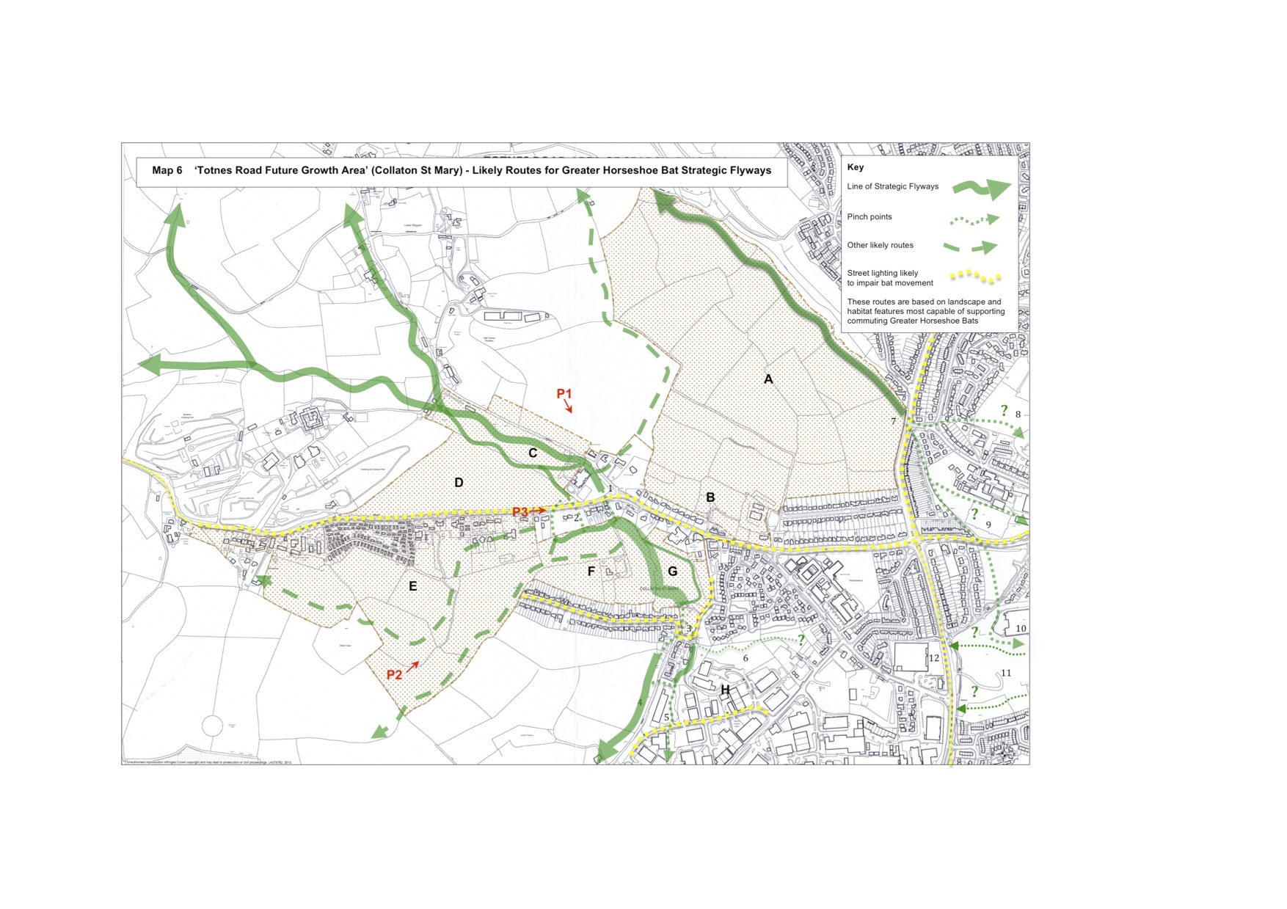
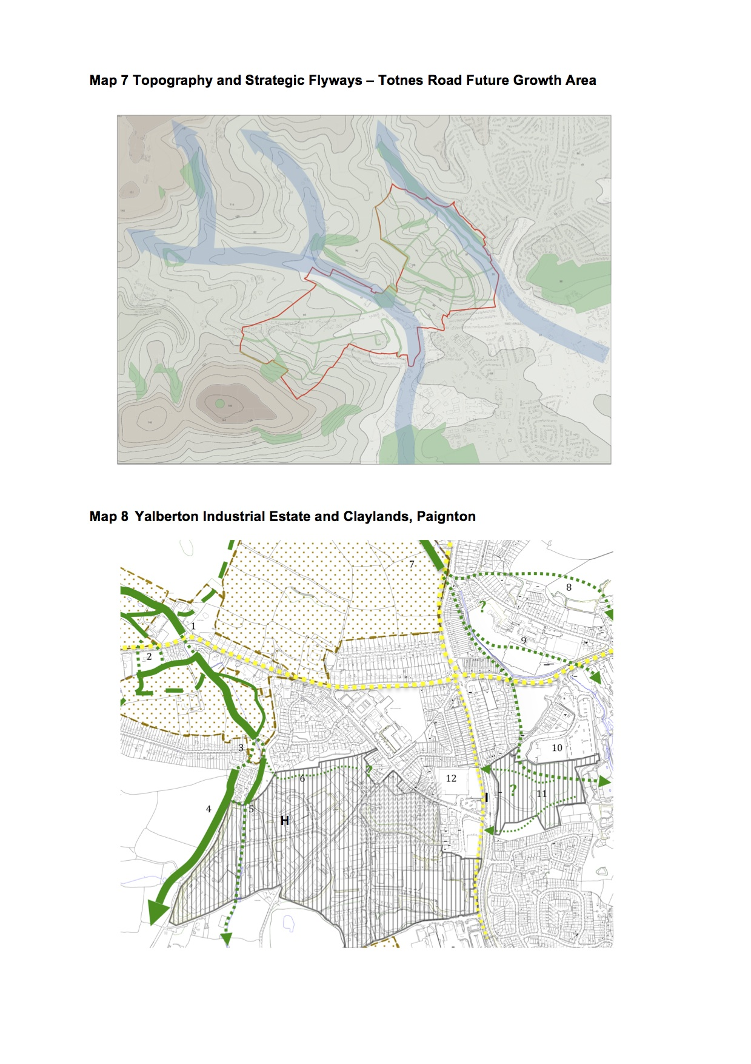
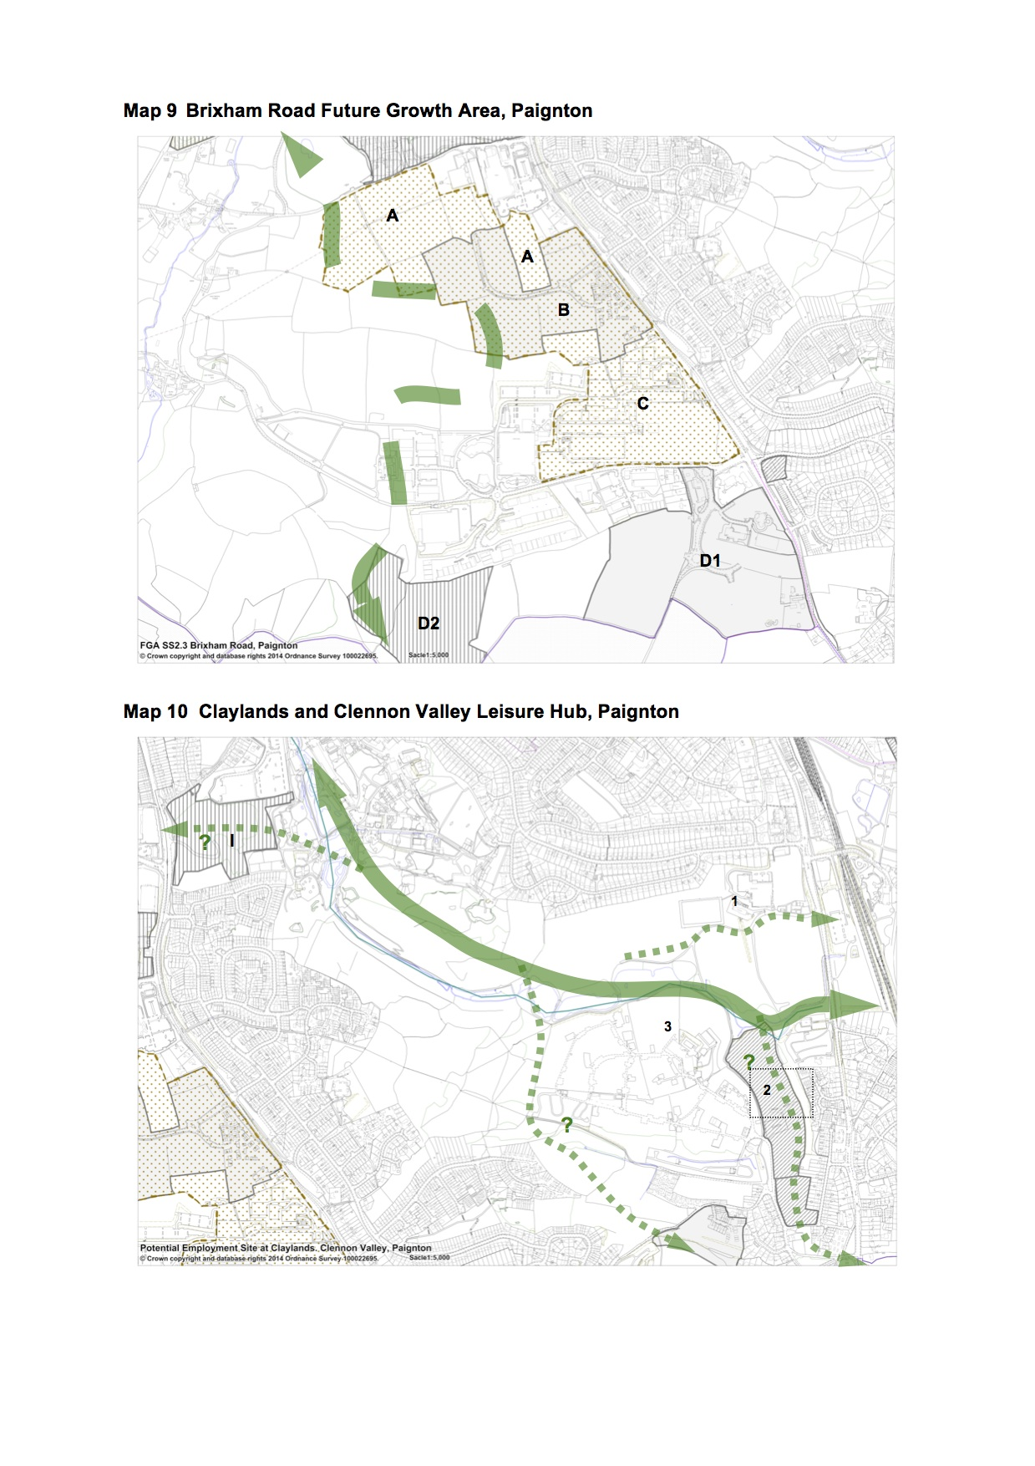

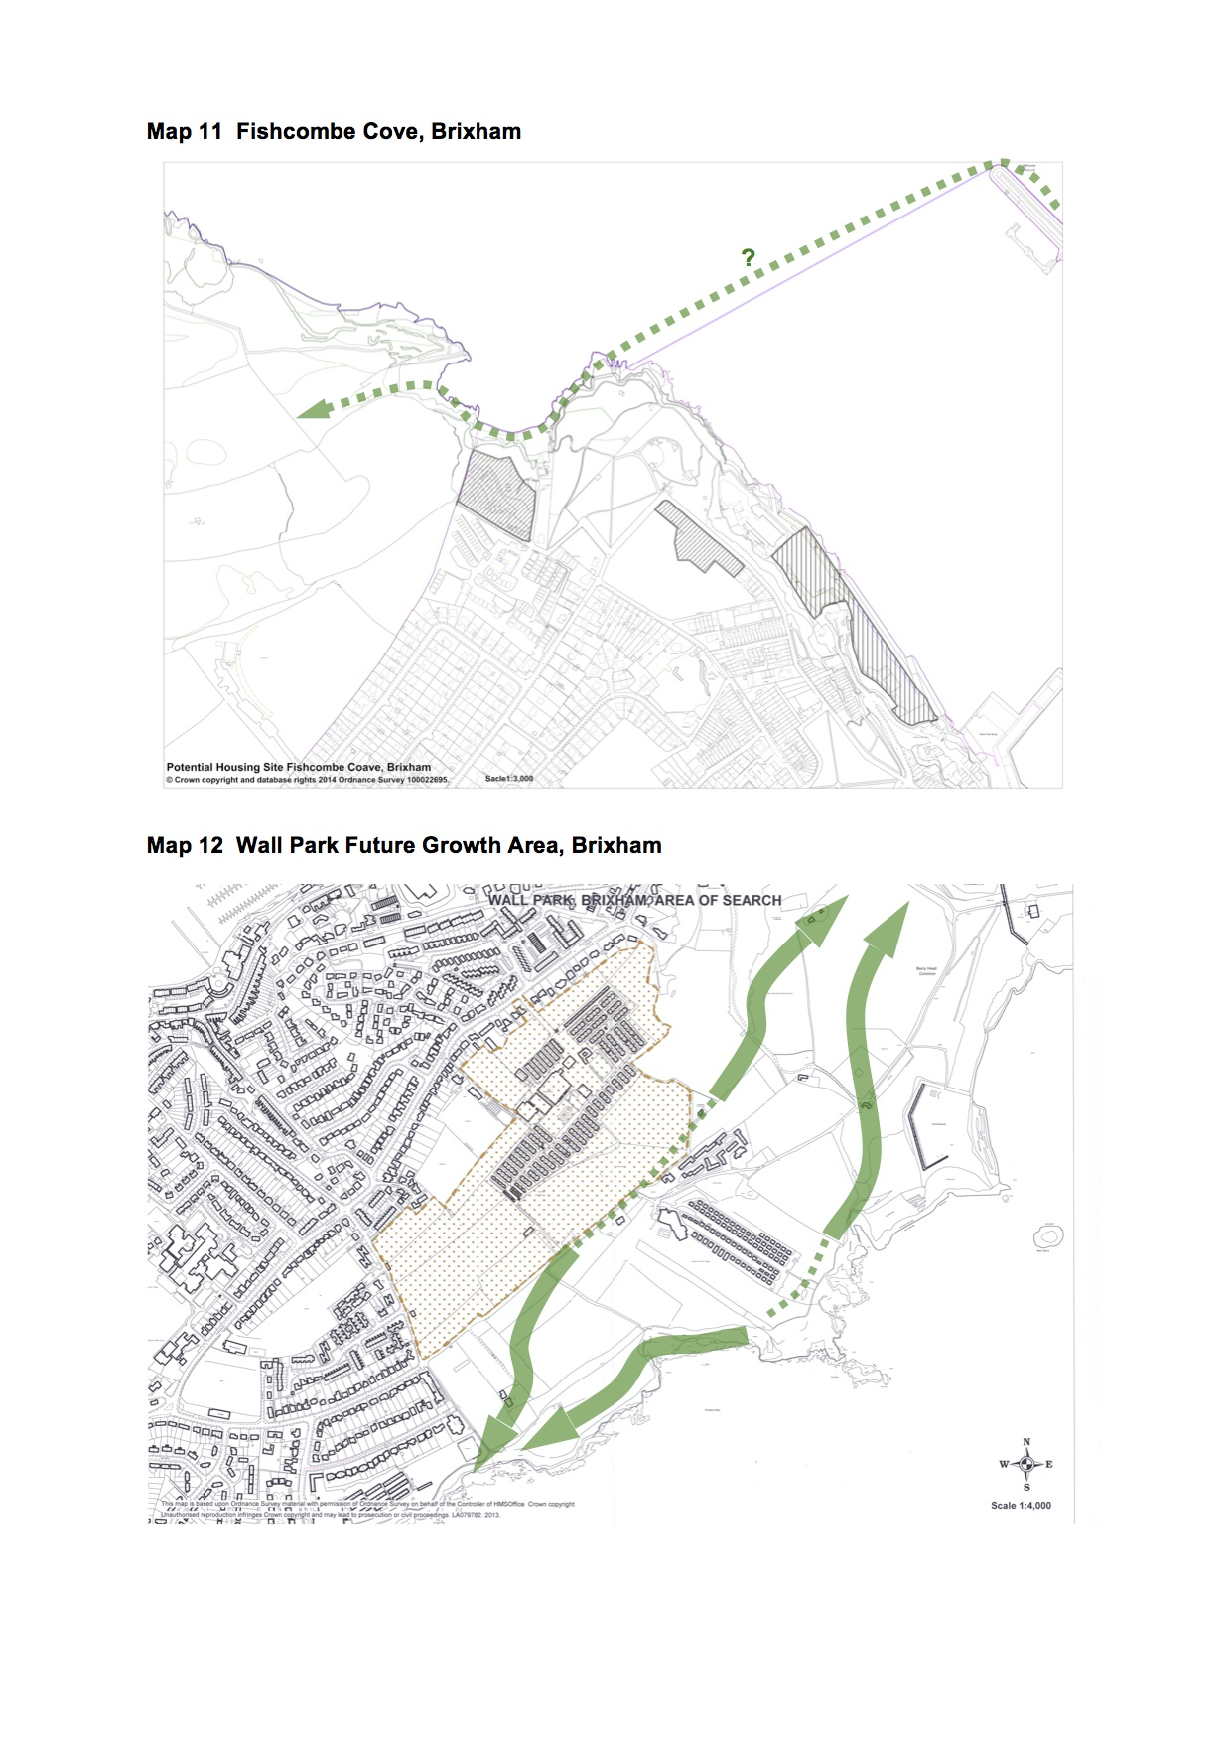
B
C
A

NOTE: Under Section 38B(1)(b) of the Localism Act (2011) a neighbourhood development plan “may not include provision about development that is excluded development”, where excluded development is defined in Section 61K(c) of the Act as including: ”development that falls within Annex 1 to Council Directive 85/337/EEC on the assessment of the environment”. Section 61J of the Act also states that “a Neighbourhood Development Order may not grant planning permission for any development that is excluded development.”
European habitats are those designated as Special Protection Areas (SPAs) and Special Areas of Conservation (SACs).
South Hams SAC – Greater Horseshoe Consultation Zone Planning Guidance (Natural England June 2010)
Such measures are supported by Regulation 39 of the Habitat and Species Regulations 2010. For more details see Appendix 1 of this report.
(As identified in Natural England’s South Hams SAC guidance (2010) as being of particular importance for Greater Horseshoe Bats).
Adverse effects should be ‘minimised’ to the point where either alone or in combination with other effects they do not have an adverse effect on the integrity of the South Hams SAC.
The achievement of a net gain for biodiversity is consistent with the objectives set out in Local Plan Policy NC1 Biodiversity and Geodiversity.
For more details of the Tweenaway Junction improvements go to: http://www.torbay.gov.uk/index/yourservices/transportandstreets/highwayimprovement/tweenawaycross.htm
A masterplan has currently not been commissioned for Wall Park, because the area is subject to an active planning application. Also, whilst the Berry Head peninsula is not subject of a masterplan, it is the subject of the Brixham Urban Fringe Study (September 2011), which sets out measures for the conservation of the area’s special landscape and ecological importance, and includes a section on Natural England’s advice on greater horseshoe bats.
Adverse effects should be ‘minimised’ to the point where either alone or in combination with other effects they do not have an adverse effect on the integrity of the South Hams SAC.
The achievement of a net gain for biodiversity is consistent with the objectives set out in Local Plan Policy NC1 Biodiversity and Geodiversity.

