**How to order a replacement Drivers Badge**

To start, please log onto the web address – [www.torbay.gov.uk/taxis](http://www.torbay.gov.uk/taxis) then select the ‘Licensing Public Registers’ tab.

1

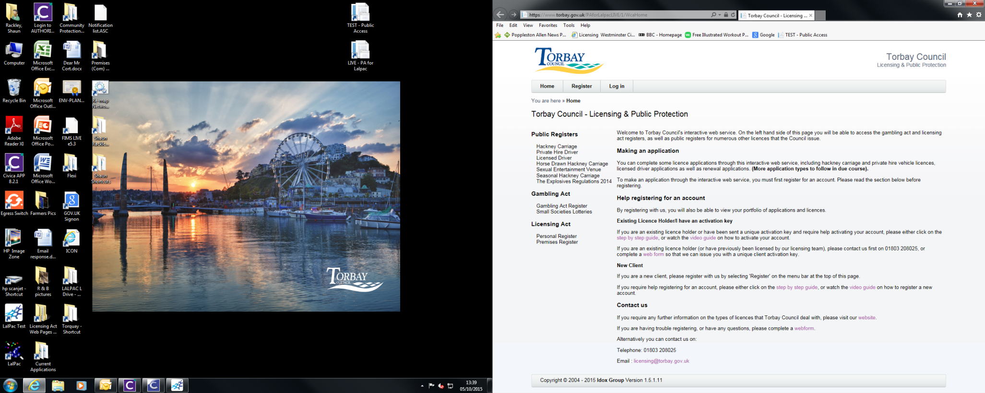

Next, Log into your online account using your registered email address and password.

2

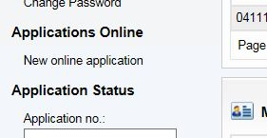

To make an application, click ‘NEW ONLINE APPLICATION’.

3

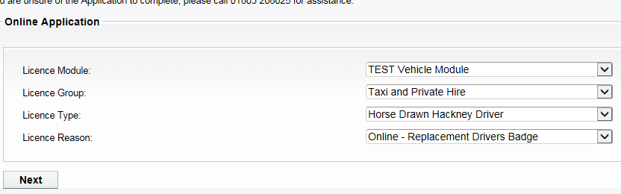

Now select the following options:-

**Licence Module** = VEHICLE MODULE

**Licence Group** = TAXI & PRIVATE HIRE

**Licence Type** = HORSE DRAWN HACKNEY DRIVER

**Licence Reason** = ONLINE-REPLACEMENT BADGE

4

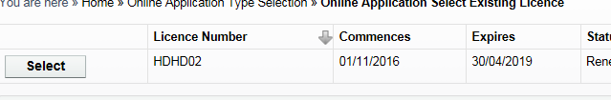

Now select the Licence that you wish to order a replacement drivers badge for.

5

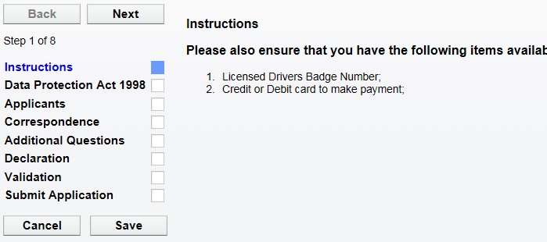

Please read the instructions of what documents are needed to complete this application.

When you have the documents ready, click ‘NEXT’.

6

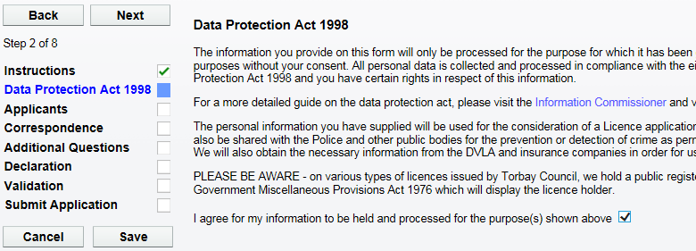

Now click ‘NEXT’ to proceed.

Please now agree to the Data Protection agreement by ticking this box.

7

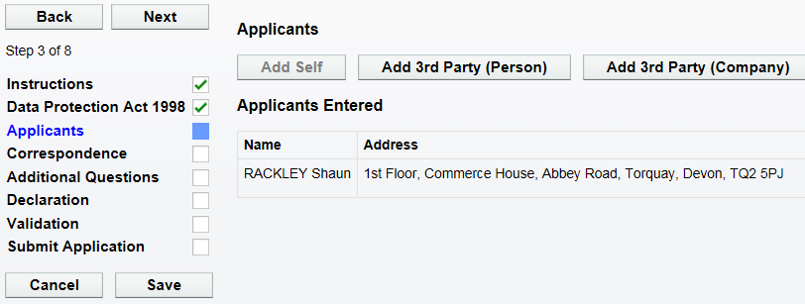

Now click ‘NEXT’ to proceed.

Now you will find your personal details. **DO NOT** change these.

8

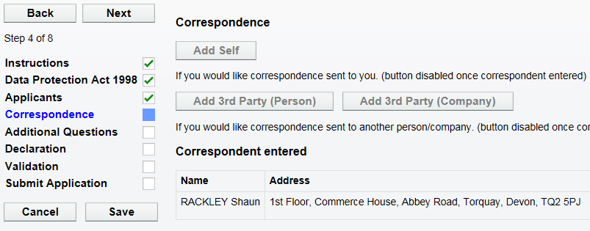

Now click ‘NEXT’ to proceed.

Next your correspondence details are shown here. **DO NOT** change these.

9

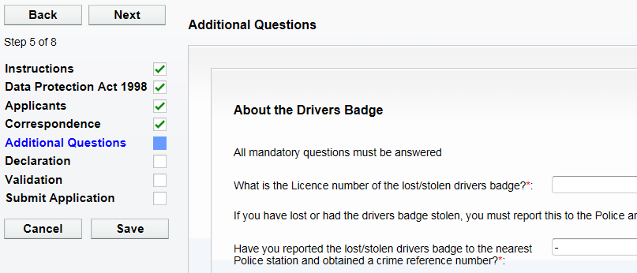

Now click ‘NEXT’ to proceed.

10

Now complete all of the questions on ‘ADDITIONAL QUESTIONS Page 1’.

Now click ‘NEXT’ to proceed.

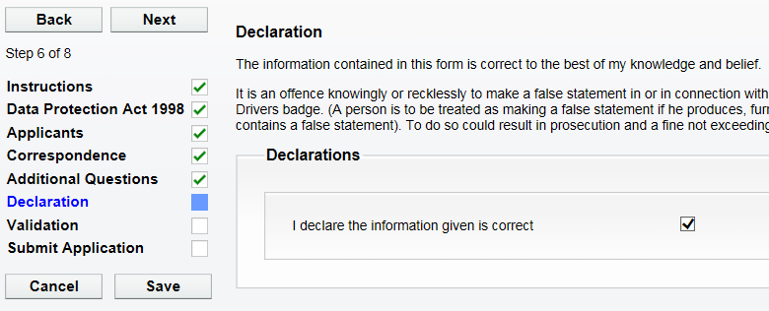

11

Now click ‘NEXT’ to proceed.

Please tick the declaration to confirm you have entered all the details correctly.

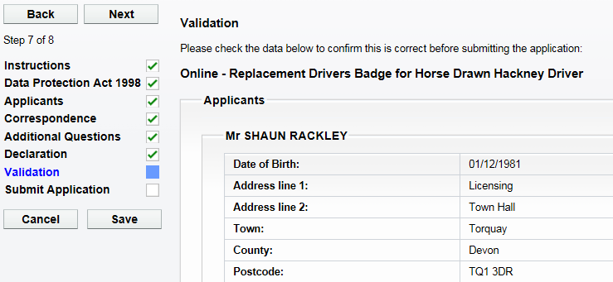

12

Now click ‘NEXT’ to proceed.

Please check all the personal details on this screen are correct.

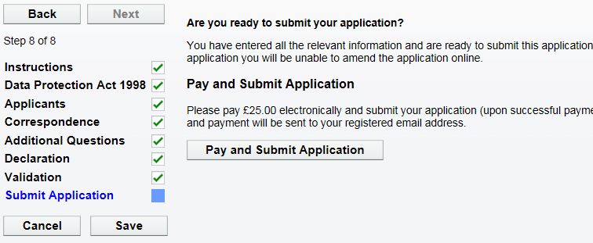

When you are ready to submit the application and make the payment, click on ‘PAY & SUBMIT APPLICATION’. You will then be transferred to Torbay Council’s payment site.

13

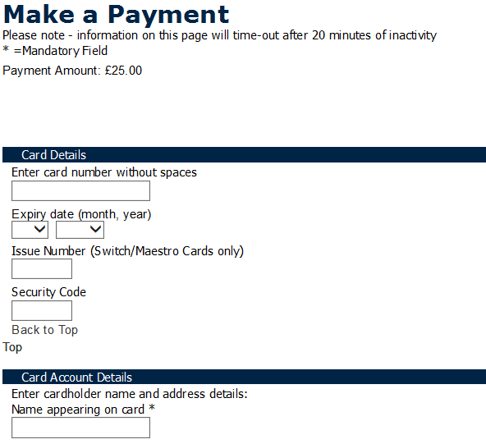

14

Please now enter your debit/credit card details, including the address details where the card is registered to.

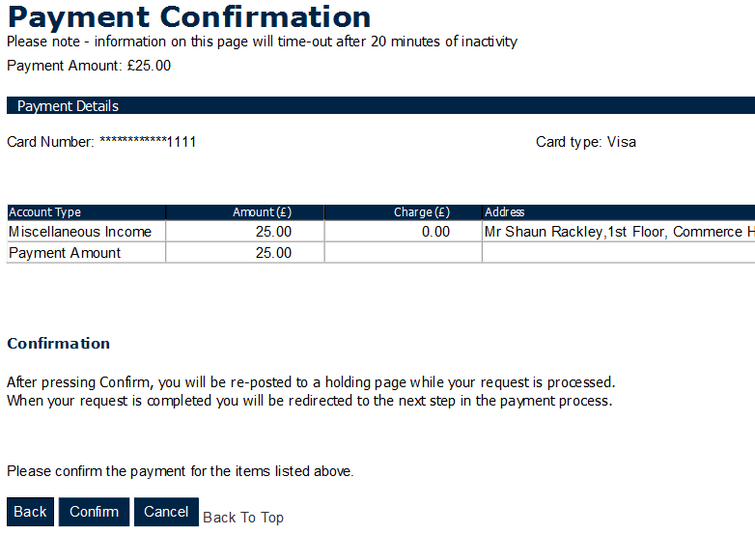

15

Please now check the amount you are about to pay and click ‘CONFIRM’.

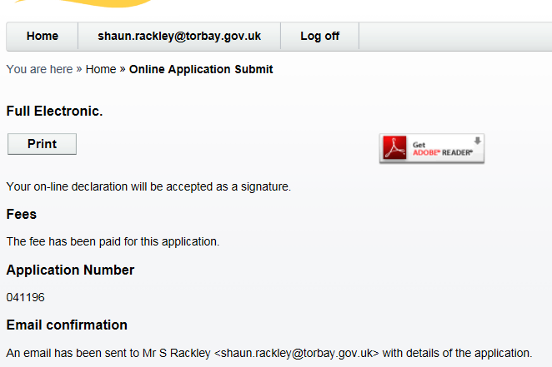

You will now be re-directed and have confirmation that the application has been submitted.

16

17

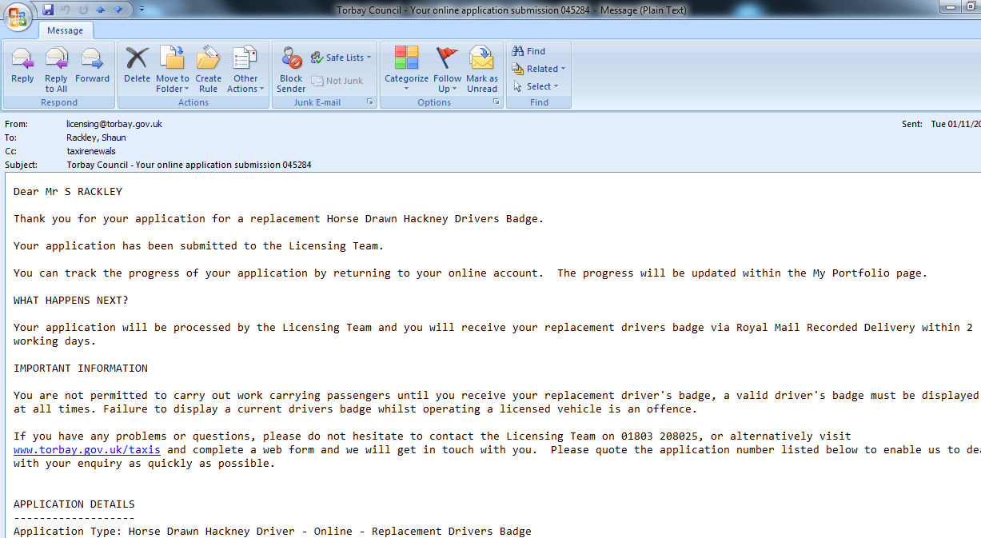

You will now receive an email to confirm that the application has been submitted and what happens next. You will also find receipt details within this email.