FORM AR

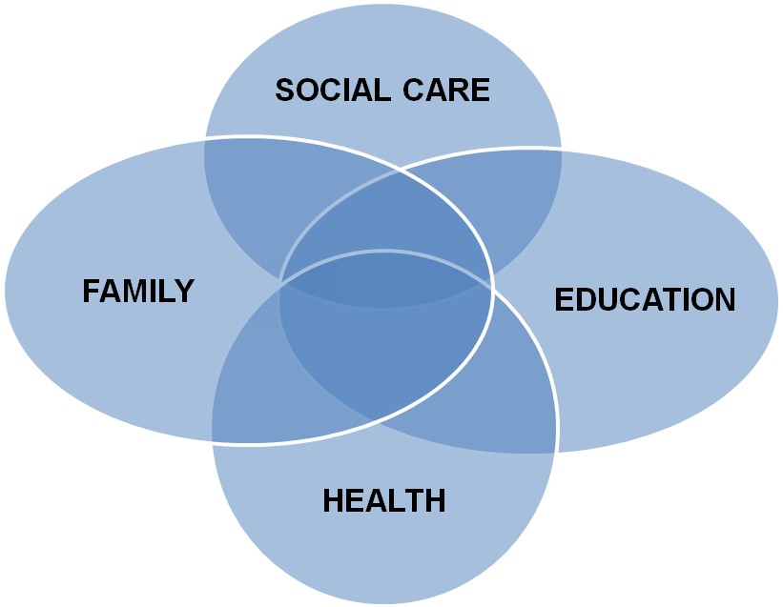

Young Person’s Name
D.O.B.
Year 11-13
Preparation for and review of Post 16 planning/
Transfer Review of Statement of Special Educational
Needs to an Education, Health and Care Plan

School: ....................................................... Date of Review: ......................
Send to SEN within 2 weeks Date to send to SEN ..............
Year Group: ..................................................................................................
Attendance: ..................................................................................................
Date of issue of original statement/ EHCP : ............................................................

Year 11/13 Transitional Conversion Review of
Statement of Special Educational Needs to an
Education, Health and Care Plan
Child’s Name
D.O.B.
School: ....................................................... Date of Review: ......................
Send to SEN within 2 weeks Date to send to SEN ..............
Year Group: ..................................................................................................
Attendance: ..................................................................................................
Date of issue of original statement: ...............................................................

PHOTO
(Optional)

Family
And
Child

ANNUAL REVIEW OF STATEMENT OF
SPECIAL EDUCATIONAL NEEDS / EDUCATION, HEALTH AND CARE PLAN

Name
Date of Birth
Gender
Home Address
Contact Number
Ethnicity
Home Language
Name of Parent/Carer
Relationship to child
Address if different from above
Is the child Looked After | YES / NO
Type of Care Order
Who holds parental responsibility
Contact Number
NHS Number
PARIS Number
UPN Number

Please name everyone who has attended the review and/or is involved with .................. and his/her family including all professionals
Name and contact details including address and telephone contact/e-mail | Title / Role | Indicate their contribution  i.e. report, letter attended the meeting, phone call | Report Attached (inc author/date of report)  including any discharge (e.g. SALT)

How has the Young person and his/her family participated in the development of this plan and review process?
Parent/Carer has provided substantial parental advice for young person’s statutory assessment and liaised with SEN Team and services as required.
Parent/Carer is very involved in young person’s life and actively interacts with the young person to review his/her educational needs and progress.
Young person has engaged in meetings with the Educational Psychology Service and completed a One page Profile which reflect their aspirations, what is important to them and how best to support them.

Young person’s family and home
(Historical and Current)

Historical and current information only required if this is a conversion review.
Current information only for all other reviews.
Young Person’s Primary area of Special Educational Need
Educational settings/schools previously attended
Young person’s preferred method of Communication

Young person’s profile)
This information has been provided by: ................................................................................

My name is ...................................................... and I am ....... years old
Things that make me happy are: (Good Day)

Home:

School:

Things that upset me: (Bad Day)

Home:

School:

Things I find easy:

Home:

School:

Things I find difficult:

Home:

School:

Things you need to know about me:

Home:

School:

I would like to be able to do :

Current Strengths and Needs
Please refer to the strengths and needs section in the Statement / Education Health and Care Plan (only add changes and any amendments to the original EHCP, no need to copy it all again if it is still relevant)

Cognition and Learning | Current C&L strengths  Add any significant changes or amend existing strengths from current EHCP/Statement/previous AR
Current C&L area of need/difficulties
Add any significant changes or amend existing needs from current EHCP/Statement/previous AR

 | Evidence of any additional needs (from professional’s assessments, reports or observations)
Social, Emotional and Mental Health | Current SEMD strengths  Add any significant changes or amend existing strengths from current EHCP/Statement/previous AR
Current SEMD area of need/difficulties
Add any significant changes or amend existing needs from current EHCP/Statement/previous AR

 | Evidence of any additional needs (from professional’s assessments, reports or observations)
Communication and Interaction | Current C&I strengths  Add any significant changes or amend existing strengths from current EHCP/Statement/previous AR
Current C&I area of need/difficulties
Add any significant changes or amend existing needs from current EHCP/Statement/previous AR

 | Evidence of any additional needs (from professional’s assessments, reports or observations
Sensory and/or physical needs | Current S & PD strengths  Add any significant changes or amend existing strengths from current EHCP/Statment/previous AR
Current S & PD area of need/difficulties
Add any significant changes or amend existing needs from current EHCP/Statement/previous AR

 | Evidence of any additional needs (from professional’s assessments, reports or observations

Review of the long term outcomes as detailed on the Statement or EHCP for the past 12 months
.........’s Long Term outcomes (taken directly from the Statement or EHCP) | Medium term targets set by the school over the past year to meet the long term outcomes | Summary of provision and resources provided including any exam dispensation | Progress made
Cognition and learning
Social, Emotional and mental health
Communication and Interaction
Sensory and/or physical needs

How the long term outcomes from the statement or EHCP will be supported for the NEXT 12 months
SENCO to liaise with the relevant professionals and complete below
.........’s Long Term outcomes (taken directly from the Statement or EHCP) | Medium term targets set by the school over the past year to meet the long term outcomes | Strategies, Resources and Provision to be delivered over the next 12 months including any exam dispensation | Frequency of support and by whom? | Who is responsible for monitoring this (named person/people and agency)?
Cognition and learning
Social, Emotional and mental health
Communication and Interaction
Sensory and/or physical needs

PREPARING FOR ADULTHOOD – TRANSITION YEAR 11-13
xxxx’s PLAN - WHAT WOULD I LIKE TO DO NEXT?
WHAT WILL SCHOOL/COLLEGE/TRAINER OFFER?

PLEASE NOTE: The Children and Families Act 2014 gives the onus of decision making to the young person.
‘after compulsory school age ( the end of the academic year in which they turn 16) the right to make
requests and decisions applies to them directly rather than the parents’ Code of Practice 2014 8.15

The Mental Capacity Act 2005 states that it should be assumed that anyone over the age of 16 or older has
has full legal capacity to make decisions for themselves (the right to autonomy) unless it can be shown that
they lack capacity to make a decision for themselves at the time the decision needs to be made.

EDUCATION / COLLEGE  - In the next 12 months I will be able to complete?  - e.g. exams, work experience, Ten Tors, college visits, hobbies  - I will work towards?  - e.g. qualifications, travel training, job, college, essential living skills | - Who will help me?  - Who will help me?  - Were there any issues that I needed help with? Would I need this help in the future?
PREPARATION FOR ADULTHOOD – ASPIRATIONS  EMPLOYMENT  - What job would I like?  - Response from tutor/job coach/ careers advisers | How do I achieve this? - e.g.  - Work experience  - What qualifications do I need? | Outcome: SMART target e.g.  - Retail qualification – 12 months

INDEPENDENT LIVING & COMMUNITY  At home I would like to be able to e.g.  - Cook my own meals  - Buy my own clothes  - Response from involved adult | How do I achieve this? e.g.  - Prepare a meal with a parent | Outcome: SMART Target e.g.  - In 6 months I will be able to cook a simple meal by myself

INDEPENDENT LIVING – GETTING OUT AND ABOUT  I would like to be able to e.g.  - Go to the cinema with my friends  - Response from involved adult | How do I achieve this? e.g.  - Plan a route to the cinema, collect friends contact details. | Outcome: SMART Target e.g.  - In 12 months I will have met my friends at the cinema at least twice

HEALTH  Aspirations – e.g.  - I would like to lose weight  - I would like to improve my fitness  - I will manage my own medication | How do I achieve this? e.g.  - I will stop snacking  - I will walk for 20 minutes per day | Outcome: SMART Target e.g.  - In the next 12 months I will walk for 20 minutes without being out of breath

As a result of this review do the professionals and parents consider the EHCP should be maintained? YES/NO

Does the Young person want the EHCP maintained?
YES/NO

If no please refer the Young Person to the SEN Team to discuss the implications of this decision.
Parent’s / Carer’s / Guardian’s views on last year’s progress and any additional comments

Is the additional support having a positive impact on the young person’s progress?
Primary Area of need: |  | Academic attainment/progress
 | Yes/No |  | Yes/No
Made progress |  | Made progress
Remained the same |  | Remained the same
Not maintained previous level of skill |  | Not maintained previous level of skill
If NO then please give brief details why not? |  | If NO then please give brief details why not?

(Section J – 9.62 – SEND Code of Practice. Refer to appendix A for further info)
PERSONAL BUDGET (1)
There are different ways in which a personal budget can be used to secure provision.

- Direct Payments – where individuals receive the cash to contract, purchase and manage the service themselves

- Notional Budget – whereby the local authority, school or college holds the funds and commissions the support specified in the plan

- A combination of the above

In some circumstances it may be agreed that the person responsible for managing a direct payment (the child’s parent or the young person) will need the support of a third party. In this circumstance it will need to be agreed by the Education, Health and Care Panel due to the cost of providing this service. Information regarding these options will be provided by the lead professional from Education, Health or Social Care.

Personal budgets discussed YES/NO

Leaflet given out YES/NO

Follow up actions ...................................................................................
(Refer to SEN)

THIS ANNUAL/TRANSITIONAL REVIEW MUST BE EMAILED TO EHCP@torbay.gov.uk WITHIN 2 WEEKS OF THE REVIEW BEING HELD. THIS DOCUMENT WILL ONLY BE ACCEPTED WHEN E-MAILED FROM A SCHOOL EMAIL ADDRESS.

