**FORM AR / TAR**



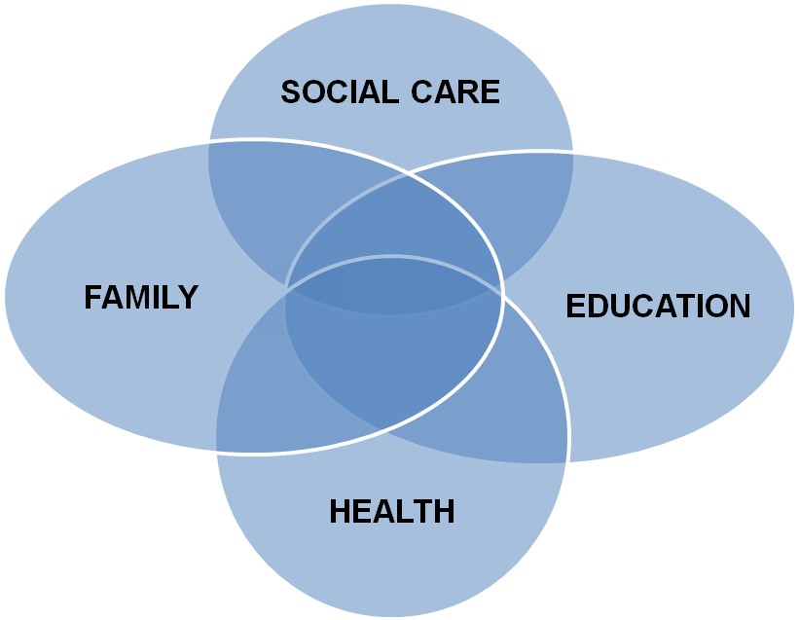

**Child’s Name**

**D.O.B.**

**Year 9**

**Transitional Conversion Review of**

**Statement of Special Educational Needs to an**

**Education, Health and Care Plan**

School: ....................................................... Date of Review: ......................

Send to SEN within 2 weeks Date to send to SEN ..............

Year Group: ..................................................................................................

Attendance: ..................................................................................................

Family

And

Child

**PHOTO**

**(Optional)**

**PLEASE NOTE**

**YOU MUST HAVE A COPY OF THE CHILD’S STATEMENT OR EDUCATION, HEALTH AND CARE PLAN WHEN UNDERTAKING A REVIEW.**

**FOR TRANSITION/CONVERSION REVIEWS PLEASE ANNOTATE ANY RELEVANT INFORMATION ON A COPY OF THE STATEMENT OR EDUCATION, HEALTH AND CARE PLAN. THIS MAY BE USED AS EVIDENCE TO AMEND THE STATEMENT OR PLAN.**

**TRANSITIONAL CONVERSION REVIEW OF STATEMENT OF**

**SPECIAL EDUCATIONAL NEEDS TO AN EDUCATION, HEALTH AND CARE PLAN**

|  |  |
| --- | --- |
| **Name** |  |
| **Date of Birth** |  |
| **Gender** |  |
| **Home Address** |  |
| **Contact Number** |  |
| **Ethnicity** |  |
| **Home Language** |  |
|  |  |
| **Name of Parent/Carer** |  |
| **Relationship to child** |  |
| **Address if different from above** |  |
| **Is the child Looked After** | **YES / NO** |
| **Type of Care Order** |  |
| **Who holds parental responsibility** |  |
| **Contact Number** |  |
|  |  |
| **NHS Number** |  |
| **PARIS Number** |  |
| **UPN Number** |  |

|  |  |  |  |
| --- | --- | --- | --- |
| **Please name everyone who has attended the review and/or is involved with .................. and his/her family including all professionals** | | | |
| **Name and contact details** | **Title / Role** | **Contribution**  **i.e. report, at a meeting, phone call** | **Report Attached (inc author/date of report)**  **including any discharge (e.g. SALT)** |
|  |  |  |  |
|  |  |  |  |
|  |  |  |  |
|  |  |  |  |
|  |  |  |  |
|  |  |  |  |

**FAMILY**

|  |
| --- |
| **..................................’s family and home** |
|  |
| **Are there any safeguarding issues?** |

|  |
| --- |
| **.............................. aspirations for child/young person** |
|  |

|  |
| --- |
| **How has .............................. and his/her family participated in the development of his/her plan/review?** |
|  |

**CHILD FRIENDLY PROFILE (option 1 – to be used as appropriate)**

|  |
| --- |
| **This information has been provided by:** |

|  |
| --- |
| **My name is ...................................................... and I am ....... years old** |
| **Things that make me happy are: (Good day)**    **Home:**  **School:** |
| **Things that make me sad: (Bad day)**  **Home:**  **School:** |
| **Things I find easy:**  **Home:**  **School:** |
| **Things I find difficult:**  **Home:**  **School:** |
| **Things you need to know about me:**  **Home:**  **School:** |
| **I would like to be able to:** |

**CHILD FRIENDLY PROFILE (option 2 – to be used as appropriate)**

|  |
| --- |
| **This information has been provided by:** |

|  |
| --- |
| **My name is ...................................................... and I am ....... years old** |
| **Things that make me happy are: (Good day)**  **Home:**  C:\Users\edps073\AppData\Local\Microsoft\Windows\Temporary Internet Files\Content.IE5\HQ3Z6YIQ\MC900423171[1].wmf **School:** |
| **Things that make me sad : (Bad day)**  **Home:**  **C:\Users\edps073\AppData\Local\Microsoft\Windows\Temporary Internet Files\Content.IE5\WOQ3SX9T\MC900423165[1].wmf School:** |
| **Things I find easy:**  **Home**  C:\Users\edps073\AppData\Local\Microsoft\Windows\Temporary Internet Files\Content.IE5\HQ3Z6YIQ\MC900440442[1].wmf **School:**  EASY |
| **Things I find difficult:**  **Home:**  **C:\Users\edps073\AppData\Local\Microsoft\Windows\Temporary Internet Files\Content.IE5\FALS1047\MC900423153[1].wmf School:** |
| **Things you need to know about me:**  **Home:**  **C:\Users\edps073\AppData\Local\Microsoft\Windows\Temporary Internet Files\Content.IE5\WOQ3SX9T\MC900440428[1].wmf** **School:** |
| **I would like to be able to:**  C:\Users\edps073\AppData\Local\Microsoft\Windows\Temporary Internet Files\Content.IE5\HQ3Z6YIQ\dglxasset[1].aspx |

**CHILD FRIENDLY PROFILE (option 3 – to be used as appropriate)**

|  |
| --- |
| **This information has been provided by: ................................................................................** |

|  |
| --- |
| **My name is ...................................................... and I am ....... years old** |
| **Things that make me happy are: (Good day)**  **Home:**  **School:** |
| **Things that upset me: (Bad day)**  **Home:**  **School:** |
| **Things I find easy:**  **Home:**  **School:** |
| **Things I find difficult:**  **Home:**  **School:** |
| **Things you need to know about me:**  **Home:**  **School:** |
| **I would like to be able to:** |

**Current Strengths and Needs**

**This section of the Review sets out xxxxxxxxxxx’s additional needs. xxxxxxxxxxxxx’s primary area of need which calls for special educational provision is.........................................................................................................................**

|  |  |
| --- | --- |
| **Please describe the strengths and needs that have been identified in the Integrated Assessment (in priority order of needs where possible) in the following areas (if you have quoted from a report, please make reference to the specific report from which this quote has been drawn).** | |
| **Cognition and Learning** | Strengths |
| Needs |
| Long Term Outcomes |
| Progress since last review *(include levels of achievement towards long term outcomes for current and previous year)* |
| **Social, Emotional and Mental Health** | Strengths |
| Needs |
| Long Term Outcomes |
| Progress since last review |
| **Communication and Interaction** | Strengths |
| Needs |
| Long Term Outcomes |
| Progress since last review |
| **Sensory and/or physical needs** | Strengths |
| Needs |
| **Specific Requirements**   * Is there a medical care plan in place? * Does this need updating? *(please attach copy)* * Do you have any specific requirements for visits / trips? YES / NO |
| Long Term Outcomes |
| Progress since last review |

**Long term outcomes will be support for the next 12 months from the plan below**

**SENCO to liaise with the relevant professionals for desired outcomes and complete below**

|  |  |  |  |  |  |
| --- | --- | --- | --- | --- | --- |
| **.........’s Long Term Objectives (as taken from the Statement or EHCP)** | **12 Month Desired Outcomes (what this will mean for**  **xxxxxxxxxxx)** | **This is what xxxxx needs to support him/her** | **How often will this happen?** | **Who is responsible for this support (named person/ people and agency)?** | **Who will carry out this support (named person/agency)?** |
|  |  |  |  |  |  |
|  |  |  |  |  |
|  |  |  |  |  |
|  |  |  |  |  |
|  |  |  |  |  |  |
|  |  |  |  |  |
|  |  |  |  |  |
|  |  |  |  |  |
|  |  |  |  |  |  |
|  |  |  |  |  |
|  |  |  |  |  |
|  |  |  |  |  |

**PREPARING FOR ADULTHOOD - TRANSITION YEAR 9 AND YEAR 10**

**xxxx’s PLAN - WHAT WOULD I LIKE TO DO NEXT?**

***Consent to share information***

***I am happy for the information in my Education, Health and Care Plan to be shared with people who will help me***

***YES NO***

**EDUCATION / COLLEGE / JOB**

|  |  |  |
| --- | --- | --- |
| **SCHOOL**  What do I need to do?  Additional exam Arrangements | Who will help me?  Who will help me? | When?  When? |
| **COLLEGE**  What do I need to do?  Additional exam Arrangements | Who will help me?  Who will help me? | When?  When? |
| **JOB**  What do I need to do? | Who will help me? | When? |

**SOCIAL**

|  |  |  |
| --- | --- | --- |
| Where would I like to live? | Who will help me? | When? |
| What transport can I use? | Who will help me? | When? |

**HEALTH**

|  |  |  |
| --- | --- | --- |
| How do I keep myself healthy?  Do I need any specialist advice or equipment? | Who will help me?  Who will help me? | When?  W |
| How do I keep myself safe? | Who will help me? | When? |

**Have any new needs been identified and agreed at the review?**

|  |  |
| --- | --- |
| **Cognition & Learning** | **Identified new need:** |
| **Source of evidence:** |
| **Emotional, Social & Mental Health** | **Identified new need:** |
| **Source of evidence:** |
| **Cognition & Interaction** | **Identified new need:** |
| **Source of evidence:** |
| **Physical, Sensory, Medical** | **Identified new need:** |
| **Source of evidence:** |

|  |
| --- |
| **Parents’/Guardians’/Carers’ view of past year’s progress and any additional comments.** |
|  |

|  |
| --- |
| **Should the Statement/EHCP be maintained?** |
|  |

|  |
| --- |
| **Any other discussions/comments generated from the review.** |

|  |
| --- |
| **Headteacher’s Summary:** |

|  |
| --- |
| **Name and Job Title of Person undertaking the Review:** |

**If a personal budget has been allocated please complete the information below**

*(Section J – 9.62 – SEND Code of Practice. Refer to appendix A for further info)*

**PERSONAL BUDGET (1)**

There are different ways in which a personal budget can be used to secure provision.

* Direct Payments – where individuals receive the cash to contract, purchase and manage the service themselves
* Notional Budget – whereby the local authority, school or college holds the funds and commissions the support specified in the plan
* A combination of the above

In some circumstances it may be agreed that the person responsible for managing a direct payment (the child’s parent or the young person) will need the support of a third party. In this circumstance it will need to be agreed by the Education, Health and Care Panel due to the cost of providing this service. Information regarding these options will be provided by the lead professional from Education, Health or Social Care.

|  |  |  |  |
| --- | --- | --- | --- |
| **Do xxxxxxx and his/her parents want to take a personal budget for his/her support?** | | | |
| **Agency** | **Y/N** | **If Yes, who will manage the Personal Budget** | **Contact Details** |
| Education |  |  |  |
| Health |  |  |  |
| Social Care |  |  |  |

Please refer to appendix A for an example of how to complete the personal budget section.

**Detail of Services procured via a Personal Budget (2)**

|  |  |  |  |  |  |
| --- | --- | --- | --- | --- | --- |
| **Education** | | | | | |
| **Type of PB** | **Description of Support** | **Flexibility of usage** | **Need being addressed and expected outcome (as per EHCP support plan)** | **Weekly Cost** | **Annual Cost** |
|  |  |  |  |  |  |
|  |  |  |  |  |  |

|  |  |  |  |  |  |
| --- | --- | --- | --- | --- | --- |
| **Health** | | | | | |
| **Type of PB** | **Description of Support** | **Flexibility of usage** | **Need being addressed and expected outcome (as per EHCP support plan)** | **Weekly Cost** | **Annual Cost** |
|  |  |  |  |  |  |
|  |  |  |  |  |  |

|  |  |  |  |  |  |
| --- | --- | --- | --- | --- | --- |
|  | **Social Care** | | | | |
| **Type of PB** | **Description of Support** | **Flexibility of usage** | **Need being addressed and expected outcome (as per EHCP support plan)** | **Weekly Cost** | **Annual Cost** |
|  |  |  |  |  |  |
|  |  |  |  |  |  |

**Summary of Personal Budget (3)**

|  |  |  |
| --- | --- | --- |
| **xxxxx’s Personal Budget total allocation is:** | **Weekly Total** | **Annual Total** |
| Education |  |  |
| Health |  |  |
| Social Care |  |  |
|  |  |  |
| Additional third party support costs  (direct payments only) |  |  |
|  |  |  |
| **Total** | **£** | **£** |

**Direct Payments note**

Where Personal Budget is being received as a direct payment, a Direct Payment Agreement must be signed by the parents and/or young person (if aged 16 years or over) and the authorising manager(s). All parties must receive a signed copy of the direct payment’s agreement. The direct payment outlines the terms and conditions associated with the use of and monitoring of the direct payment.

**THIS ANNUAL/TRANSITIONAL REVIEW MUST BE EMAILED TO** [**EHCP@torbay.gov.uk**](mailto:EHCP@torbay.gov.uk) **WITHIN 2 WEEKS OF THE REVIEW BEING HELD. THIS DOCUMENT WILL ONLY BE ACCEPTED WHEN EMAILED FROM A SCHOOL EMAIL ADDRESS.**

**If you or the parent consider there may be transport needs the parent/carer will need to complete and return a transport application form which can be obtained from the Children’s Services Transport Team:**

**Tel: 01803 208240**

**e-mail: cstransport@torbay.gov.uk**

**Appendices**

**Appendix A – Example of completed personal budget section**

**Personal Budgets detail**

|  |  |  |  |  |
| --- | --- | --- | --- | --- |
| **Education** |  | | | |
| **Description of Support** | **Flexibility of usage** | **Need being addressed and expected outcome (as per EHCP support plan)** | **Weekly Cost** | **Annual Cost** |
| Additional 1:1 teaching support for reading and writing | 4 hours per week within school hours. E.g. a teaching assistant not a necessarily a qualified teacher (directed by the teacher). Not including school holidays.  Not to be used toward travel expenses | To make progress in reading and writing as demonstrated by attainment reported by teacher | 4 x £12 = £48 | £48 x 39 weeks =  £1872 |

|  |  |  |  |  |
| --- | --- | --- | --- | --- |
| **Health** |  | | | |
| **Description of Support** | **Flexibility of usage** | **Need being addressed and expected outcome (as per EHCP support plan)** | **Weekly Cost** | **Annual Cost** |
| N/A |  |  |  |  |

**Social Care**

|  |  |  |  |  |
| --- | --- | --- | --- | --- |
| **Description of Support** | **Flexibility of usage** | **Need being addressed and expected outcome (as per EHCP support plan)** | **Weekly Cost** | **Annual Cost** |
| Personal assistant to look after XXX for 4 hours every weekend. Including, accompanying XX on visits to local shops and/or activities with parental consent. | The 4 hourly sessions can be saved up and used over any agreed days within a month as required by XX. E.g a whole day of 8 hours could be taken instead 2 sessions of 4 hours.  Cannot be used for overnight care.  Hours cannot be ‘carried over’ into the following month without prior agreement with your lead professional. | To allow X to attend clubs / parks / shops independently of his parents.  To give parents a regular short break | £32 per week | £1664 |