FORM AR / TAR
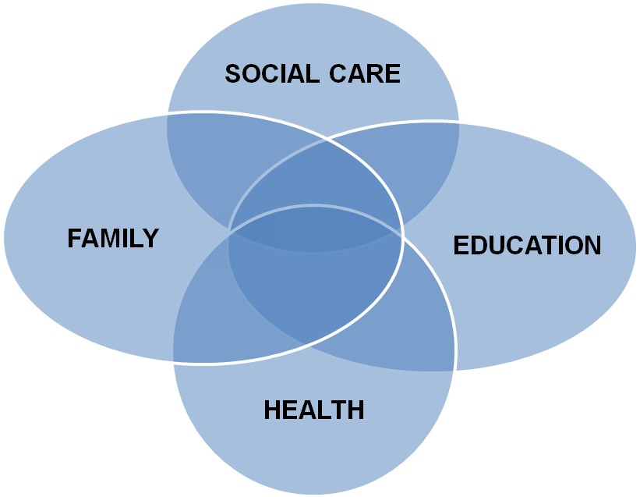

Child’s Name
D.O.B.
Early Years
Transfer Review of
Education, Health and Care Plan

School: ....................................................... Date of Review: ......................
Submit to the SEN Department within 2 weeks by ..........................................
Year Group: ..................................................................................................
Attendance: ..................................................................................................
Date of issue of original EHCP: ...............................................................
FORM AR / TAR

Early Years Transition/Conversion Review of
Statement of Special Educational Needs to an
Education, Health and Care Plan
Child’s Name
D.O.B.
School: ....................................................... Date of Review: ......................
Send to SEN within 2 weeks Date to send to SEN ..............
Year Group: ..................................................................................................
Attendance: ..................................................................................................
Date of issue of original statement: ...............................................................

PHOTO
(Optional)

Family
And
Child

PLEASE NOTE

YOU MUST HAVE A COPY OF THE CHILD’S EDUCATION, HEALTH AND CARE PLAN WHEN UNDERTAKING A REVIEW.

FOR TRANSITION REVIEWS PLEASE ANNOTATE ANY RELEVANT INFORMATION ON A COPY OF THE EDUCATION, HEALTH AND CARE PLAN. THIS MAY BE USED AS EVIDENCE TO AMEND THE PLAN.
TRANSITIONAL REVIEW OF THE EDUCATION, HEALTH AND CARE PLAN
Name
Date of Birth
Gender
Home Address
Contact Number
Ethnicity
Home Language
Name of Parent/Carer
Relationship to child
Address if different from above
Is the child Looked After | YES / NO
Type of Care Order
Who holds parental responsibility
Contact Number
NHS Number
PARIS Number
UPN (Unique Pupil Number)

Please name everyone who has attended the review and/or is involved with .................. and his/her family including all professionals
Name and contact details | Title / Role | Contribution  i.e. report, at a meeting, phone call | Report Attached (inc author/date of report)  including any discharge (e.g. SALT)

How has the Child/Young Person and his/her family participated in the development of this plan and review process?

Parent/Carer has provided substantial parental advice for child/young person’s statutory assessment and liaised with the SEN Team and services as required.
Parent/Carer is very involved in child/young person’s life and actively interacts with child/young person to review his/her educational needs and progress.

Child/Young Person has engaged in meetings with the Educational Psychology Service and completed a One Page Profile which reflect; their aspirations, what is important to them and how best to support them.

Child/Young person’s family and home
(Historical and Current)
Historical information only required if this is a conversion review.

Child/young person’s Primary area of Special Educational Need and Summary of how this presents in educational setting
Educational Provisions attended
Child/young person’s preferred method of Communication

Child/Young person’s Aspirations (What would you like to be able to do by the end of term / the next year?)
Short term
To include information on: education/play/health/friendships

Child/Young person’s Aspirations (What would you like to be able to do in the future?)
Long term
To include information on: sixth form/FE/independent living/university/employment

Parent/Carer’s aspirations for Child/Young person (What would you like your child to achieve in the future)
Short term (by the end of the year or Key Stage)
To include information on: education/play/health/friendships

Parent/Carer’s aspirations for Child/Young person
Long term
To include information on: sixth form/FE/independent living/university/employment

ADD PHOTO
What is important to me….

What people like about me…

How to support me…..

Current Strengths and Needs
Please refer to the Strengths and Needs section in the Statement or Education and Health Care Plan (only add changes and any amendments to the original EHCP, no need to copy it all again if it is still relevant)

Cognition and Learning | Current C&L strengths  Add any significant changes or amend existing strengths from current EHCP/Statement/previous AR
Needs

Add any significant changes or amend existing needs from current EHCP/Statement/previous AR

 | Evidence of any additional needs (from professional’s assessments, reports or observations)
Social, Emotional and Mental Health | Strengths  Add any significant changes or amend existing strengths from current EHCP/Statement/previous AR
Needs

Add any significant changes or amend existing needs from current EHCP/Statement/previous AR

 | Evidence of any additional needs (from professional’s assessments, reports or observations)
Communication and Interaction | Strengths  Add any significant changes or amend existing strengths from current EHCP/Statement/previous AR
Needs
Add any significant changes or amend existing needs from current EHCP/Statement/previous AR

 | Evidence of any additional needs (from professional’s assessments, reports or observations)
Sensory and/or physical needs | Strengths  Add any significant changes or amend existing strengths from current EHCP/Statement/previous AR
Needs
Add any significant changes or amend existing needs from current EHCP/Statement/previous AR

 | Evidence of any additional needs (from professional’s assessments, reports or observations)

Review over the past year
of the long term outcomes as detailed on the Statement or Education and Health Care Plan
.........’s long term outcomes (taken directly from the Statement or EHCP) | Short term targets set by the school over the past year to meet the long term outcomes | Summary of provision and resources provided | Progress made
Cognition and Learning

Social, Emotional and Mental Health

Communication and Interaction

Sensory and/or physical needs

How the long term outcomes from the EHCP will be supported for the NEXT 12 months
SENCO to liaise with the relevant professionals and complete below
.........’s long term outcomes (as taken directly from the Statement or EHCP) | Medium term objectives to be set by the school to address the long term outcomes (an individual support plan should use these to detail termly short term targets) | Strategies, Resources and Provision to be delivered over the next 12 months | Frequency of support and by whom? | Who is responsible for monitoring this (named person/ people and agency)?
Cognition and Learning

Social, Emotional and Mental Health

Communication and Interaction

Sensory and/or physical needs

Parent’s/Carer’s/Guardians views on last year’s progress and any additional comments

Is the additional support having a positive impact on the child/young person’s progress?
Primary Area of Need: |  | Academic attainment / progress
 | Yes / No |  | Yes / No
made progress |  | made progress
remained the same |  | remained the same
not maintained previous level of skill |  | not maintained previous level of skill
If No then please state brief details why not? |  | If No then please state brief details why not?

Should the Statement/EHCP be maintained?

Any other discussions/comments generated from the review.

Headteacher’s Summary:

PREPARING FOR PRIMARY TRANSITION

xxxx’s PLAN
EDUCATION

SCHOOL  When will I visit my primary school  Things my parents/carers and I are looking forward to  Things my parents/carers and I are worried about  How will I travel to my primary school? | Who will take me?  Who will help us?  Who will help me? | When?  When?  When?

HEALTH
How do I keep myself healthy?  What does my primary school need to know about my health? (do I need a medical plan?)  Do I need any specialist advice or equipment in school?  Do I need help on school trips/visits?  How do I keep myself safe? | Who will help me?  Who do we need to tell?  Who will help me?/Who do we need to tell?  Who will help me?  Who will help me? | When?  When?  When?  When?  When?

If a personal budget has been allocated please complete the information below

(Section J – 9.62 – SEND Code of Practice. Refer to appendix A for further info)
PERSONAL BUDGET (1)
There are different ways in which a personal budget can be used to secure provision.
- Direct Payments – where individuals receive the cash to contract, purchase and manage the service themselves
- Notional Budget – whereby the local authority, school or college holds the funds and commissions the support specified in the plan
- A combination of the above

In some circumstances it may be agreed that the person responsible for managing a direct payment (the child’s parent or the young person) will need the support of a third party. In this circumstance it will need to be agreed by the Education, Health and Care Panel due to the cost of providing this service. Information regarding these options will be provided by the lead professional from Education, Health or Social Care.

Do xxxxxxx and his/her parents want to take a personal budget for his/her support?
Agency | Y/N | If Yes, who will manage the Personal Budget | Contact Details
Education
Health
Social Care

Please refer to appendix A for an example of how to complete the personal budget section.

Detail of Services procured via a Personal Budget (2)
Education
Type of PB | Description of Support | Flexibility of usage | Need being addressed and expected outcome (as per EHCP support plan) | Weekly Cost | Annual Cost

Health
Type of PB | Description of Support | Flexibility of usage | Need being addressed and expected outcome (as per EHCP support plan) | Weekly Cost | Annual Cost

 | Social Care
Type of PB | Description of Support | Flexibility of usage | Need being addressed and expected outcome (as per EHCP support plan) | Weekly Cost | Annual Cost

Summary of Personal Budget (3)
xxxxx’s Personal Budget total allocation is: | Weekly Total | Annual Total
Education

Health

Social Care

Additional third party support costs
(direct payments only)
Total | £ | £

Direct Payments note
Where Personal Budget is being received as a direct payment, a Direct Payment Agreement must be signed by the parents and/or young person (if aged 16 years or over) and the authorising manager(s). All parties must receive a signed copy of the direct payment’s agreement. The direct payment outlines the terms and conditions associated with the use of and monitoring of the direct payment.
THIS ANNUAL/TRANSITIONAL REVIEW MUST BE EMAILED TO EHCP@torbay.gov.uk WITHIN 2 WEEKS OF THE REVIEW BEING HELD. THIS DOCUMENT WILL ONLY BE ACCEPTED WHEN EMAILED THROUGH EGRESS
If you or the parent consider there may be transport needs the parent/carer will need to complete and return a transport application form which can be obtained from the Children’s Services Transport Team:
Tel: 01803 208240
e-mail: cstransport@torbay.gov.

