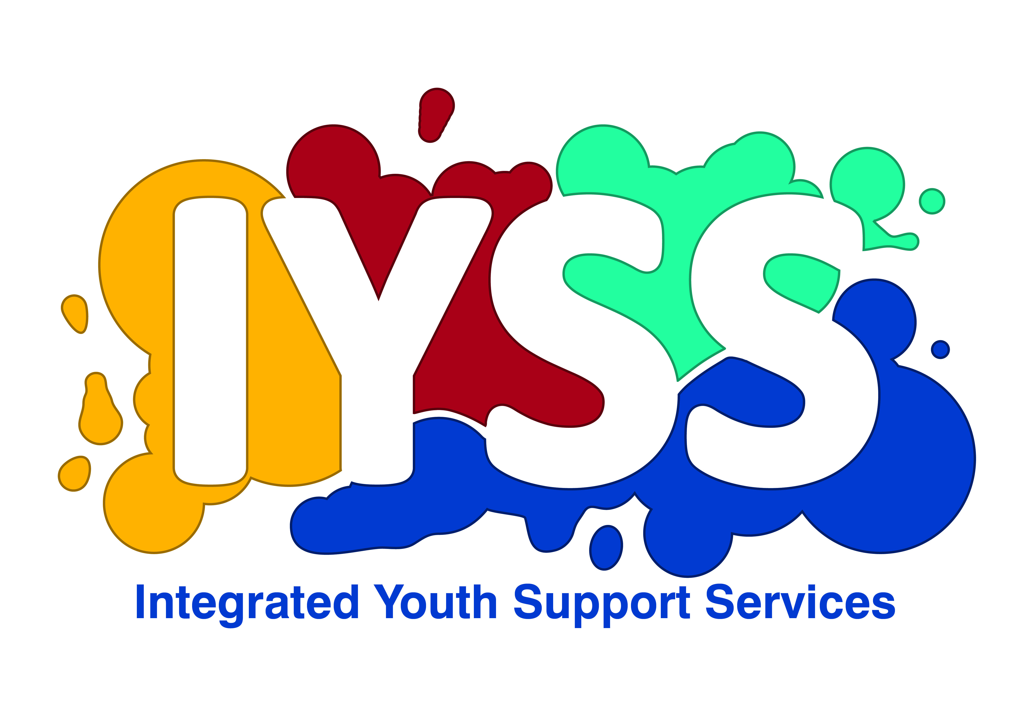
Integrated Youth Support Service (IYSS) After Care Service
Money for higher education from Torbay Children Services

This is a general outline of the financial support you can expect Torbay to provide you with if you are starting a higher education course and have been in our care. If there is anything else you think you will need to help you through your higher education course, make sure you discuss it with your personal adviser as extra support may be available for you on top of what is listed here.

Is there an age limit?
Support that you get as a care leaver would usually end on your 21st birthday, but if you started a higher education course before you turned 21 then you can continue getting this support from the IYSS After Care Provision until you turn 24 or until you complete your degree – whichever happens first.

If you are aged 21 -24
The law now says that if young people previously eligible for a leaving care service are resuming programmes of education or training after their 21st Birthday and before they are 25 years of age they are entitled to continuing support from a Personal Advisor from their Local Authority

This might include options such as completion of a basic skills course so that you have the numeracy and literacy skills needed to compete in the jobs market; take up of a course of further education; take up a university place; support to enable you to complete a recognised postgraduate qualification or participation in vocational training and apprenticeships If you want to do this speak to your to the IYSS After Care Provision Team or your Personal Advisor to discuss your plans

First Steps
Ensure you have discussed your course /Access qualifications needed with Connexions and or your Personal Advisor. The course must be achievable and the steps to access the course identified in your existing or new Pathway Plan. The practical and financial support offered will depend on the type of course you want to complete.

University
Ensure that when you approach a university or further education course you let them know you are a care leaver as you will get extra help. The info will be kept confidential.

Bursaries
Top Tip ~ Check what’s available for care leavers. Bursaries are paid by your university or college. There is specific funding available for care leavers. Many institutions may offer bursaries in cash or ‘in Kind’ making contributions towards accommodation, costs of books, course costs / expenses. Once you have been offered a bursary it is usually paid the whole way through the course.

Each institution offers different levels of Bursaries and you will need to find out what are different levels of Bursaries and you will need to find out what is available directly from the institution you apply for.

It is probably not a good idea to use the bursary as the main reason for choosing the course or institution, but it might help you decide between courses. The main issue is to get the right course.

Make sure it’s in your Pathway Plan
A realistic outline of your costs, as well as the financial support the IYSS After Care Provision team has agreed to give you while you are in higher education, should be set out clearly in your Pathway Plan.

Applying for higher education
- We will pay the UCAS application fee.
- We will pay for you and a staff member to go to an Open Day at a university or college including travel costs and one night’s accommodation in a hotel if it is a considerable distance away.

Course costs
- We will provide you with a laptop, a memory stick and the relevant software needed for your higher education course. We will also consider any equipment costs for your course including books, uniform and etc.

Travel costs
- We will provide you with a rail warrant to pay for travel to and from your university or college at the beginning and end of each term.

Term-time accommodation
- We will pay the deposit for student accommodation on your behalf.

Vacation accommodation
- Where you are able to return to your previous carer, we will pay your carer an allowance while you are staying or we can agree to support an alternative arrangement identified in your Pathway Plan
- Where alternative accommodation is needed, we will pay the cost of your rent up to £100 per week or pay you a living allowance – not both.
Top tip: Find some part time work to get you more funds to live on

Contact Details
Torbay Children Services
Integrated Youth Support Services (IYSS)
After Care Provision
Parkfield House,
38, The Esplanade,
Paignton,
TQ3 2NH
C/O Town Hall
Castle Circus
Torquay
TQ1 3DR

Tel: 01803 208400 (Main office)

Tel: 208332 (Main office)

Other Support
The support in this leaflet is provided by Torbay Social Services and comes on top of the student finance package available to eligible full- and part-time higher education students. Find out more about money for higher education in the main booklet or at www.direct.gov.uk/studentfinance



