How to register an online account as a new user

1
To start, please log onto the web address – www.torbay.gov.uk/taxis then select the ‘Licensing Public Registers’ tab.

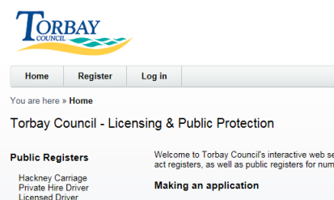
2
To register for an online account, please click ‘Register’.

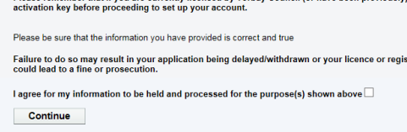
3
On the Data Protection screen, please agree to the ‘Data Protection’ statement.
Next, click ‘CONTINUE’.

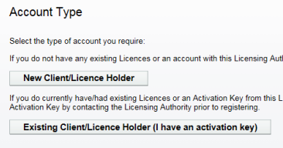
4
Next, select the ‘New Client/Licence Holder’ option. Please only select this option if you DO NOT hold, or have never held a licence with Torbay Council. If you hold, or have ever held a licence, please contact us on 01803 208025, or visit www.torbay.gov.uk/taxis and complete a web form to obtain an activation code.

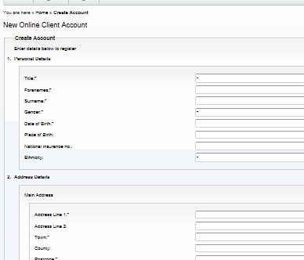
Please enter your personal details on this page. You are required to supply name and address details as well as a valid email address. You will also be asked to create an account password. When all the sections are complete, click ‘Create Account’.
5

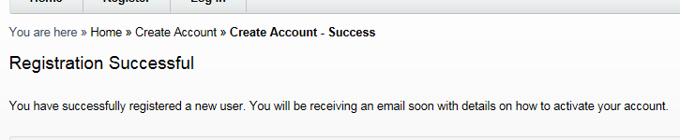
6
Registration is successful; you will now be sent a confirmation email to finalise your registration securely.

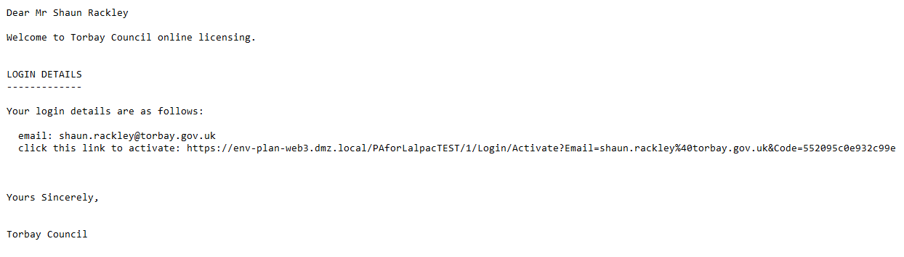
7
When you receive the account registration email, click on the link to finalise the registration.

After clicking on the email link, you will receive a message to confirm the account has been activated successfully. To log into your account, click on ‘Log in’.

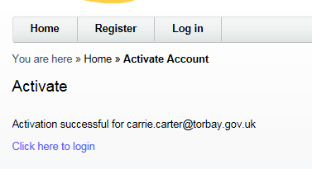
8
After clicking on the email link, you will receive a message to confirm the account has been activated successfully. To log into your account, click on ‘Log in’.

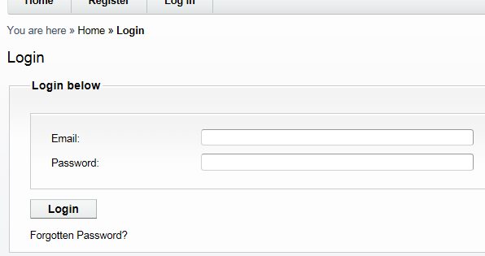
9
To ‘Log in’, enter your registered email address and password here and then click ‘Login’.
Next, click ‘Login’.

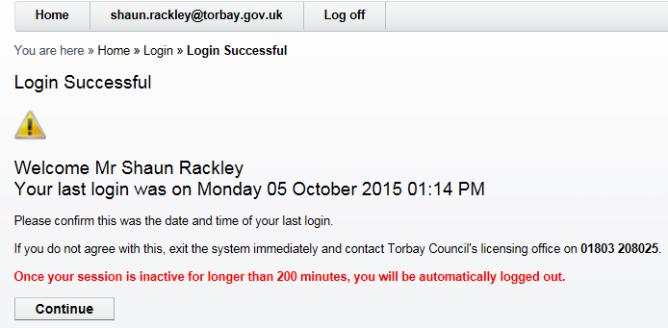
10
On this screen, it will tell you when you last logged into the account.
Then click ‘Continue’.

11
Welcome to your new online interactive account. From this screen you will be able to view any licences that you hold with Torbay Council, make applications and track any submitted applications.

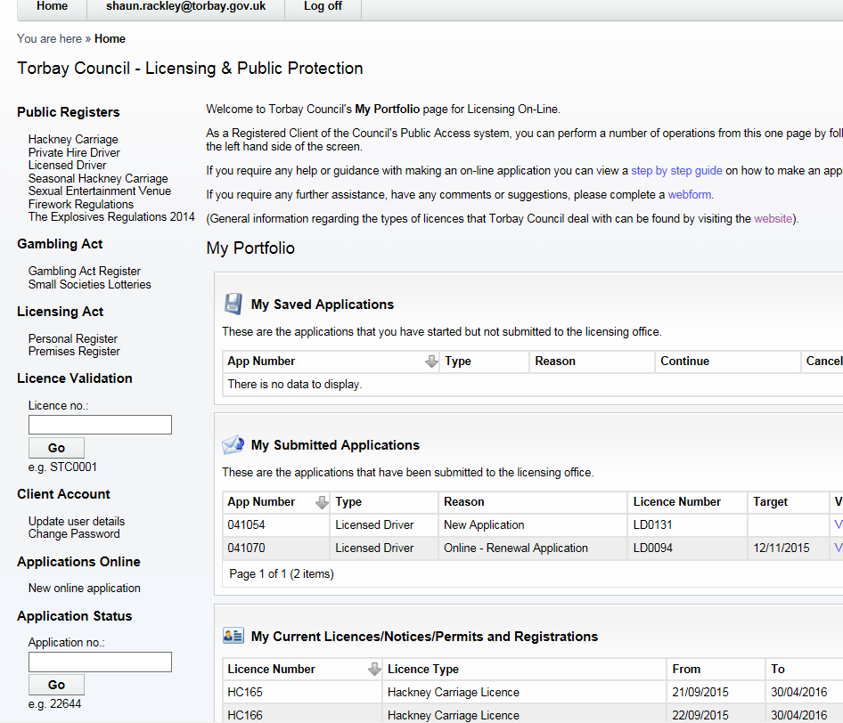
If you are completing an online application, you can save the application at any point and come back to it at a later time. The application will be shown in this section.
You can view any licences held with Torbay Council in this section.
You can make a new online application by clicking here.
When you have submitted an online application, you can track the progress and view when it has been granted.
If you require any help completing an application, you can refer to a step by step guide by clicking here.

