Applying for a licence using the online facility

- Registering as a user

From our licensing pages, you will be able to choose which type of licence to apply for. The link will bring you to the UK Welcomes Business website. You will be able to register as a user from this page.

Having registered, return to this page to apply for a licence

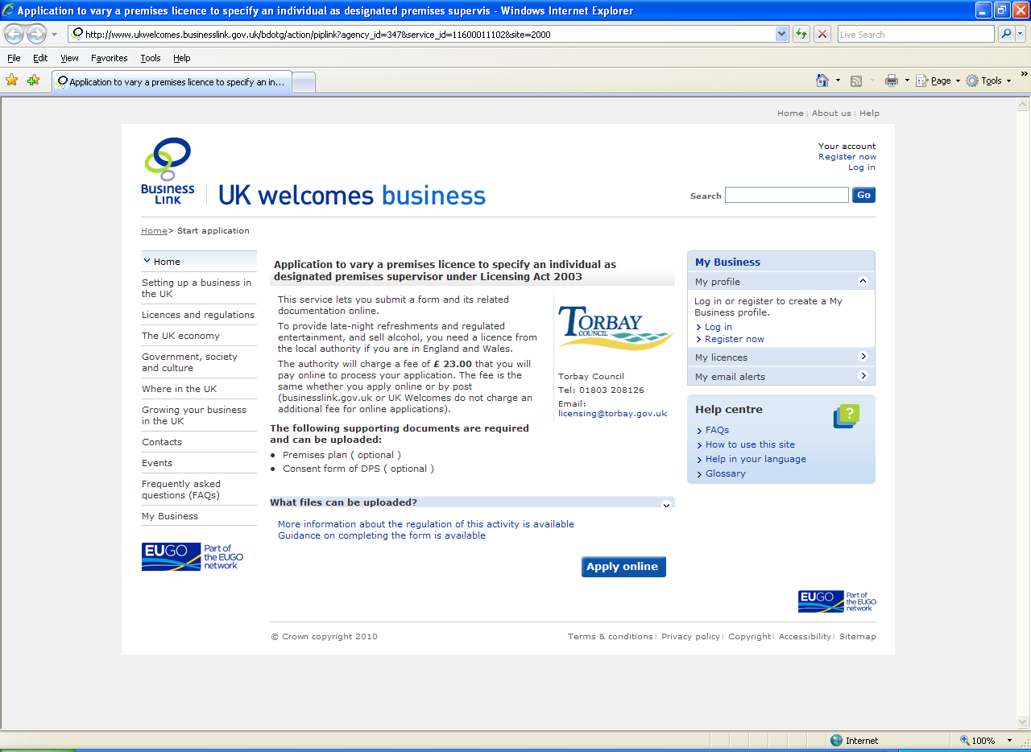

Once you have created an account, you will receive an email asking you to validate your registration. Follow the link supplied. Keep your username details and password safe.

Once you click on the Apply online button, you will be asked to log in, using your new credentials. At the Consent to disclose data, tick the box if you are happy with the condition. If you aren’t, you will not be able to continue and will have to apply using paper forms.

- Completing the form

You will be brought to the Online Application portal. This process consists of four steps.

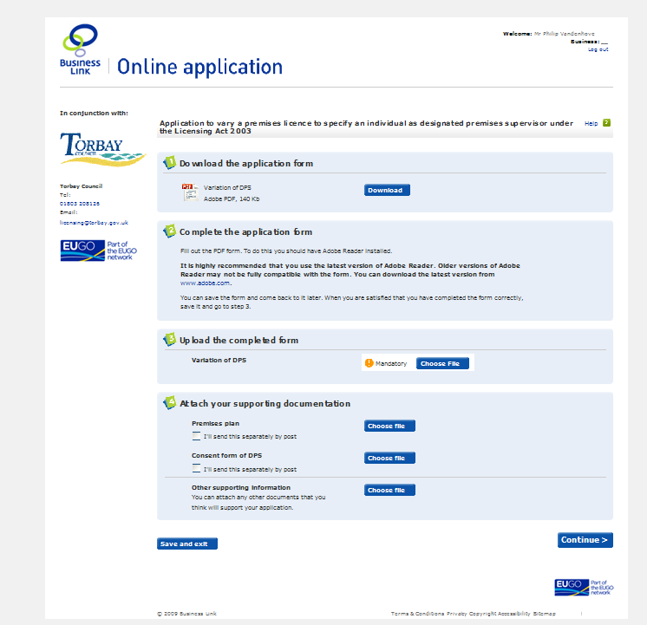
Fsdffsdfsas

- Download the application form: click on the download button to access the form and view it in a PDF format.

- Complete the form – make sure to complete the form fully. All boxes and field highlighted in red should be completed / answered. Save your form regularly by: > Clicking on File / Save as,
> Choose a suitable location e.g. Desktop or My Documents, make sure you know where you have saved the file
> Naming the file as you wish

- Once you have completed the form, make sure to save your document. Do not click on Continue until you have saved your document. If you do, you will lose the work you have done.

- Upload the completed form – this is a mandatory step. Click on the Choose file button to browse to the folder where you saved your completed application form and click on Open then Continue

- For most licence and certificates, it is important to send additional documents, such as insurance certificates, plans, consent forms, etc. it is possible to attach them electronically or post them to the relevant office (you will be notified of the address at a later stage. If you intend to post the supporting documents, please tick the relevant box).
Please note that applications will only be accepted once all documents have been received by the licensing authority

- Click on Continue – this will bring you to an invoice page, informing you of the amount to pay. Some licences have varying fees, instructions will be given to you on how to calculate the appropriate fee.

- Click on Submit application to be brought to Torbay Council’s online payment system. Enter your card details, and the cardholder details. If the amount is not fixed (e.g. premises licence renewal, skip licences, etc), you will need to enter the amount according to the circumstances.
Please note that an application cannot be accepted without the correct payment

- Once payment has been authorised, you will receive a confirmation email. This email includes a link to your account, where you will find a payment receipt reference number.

