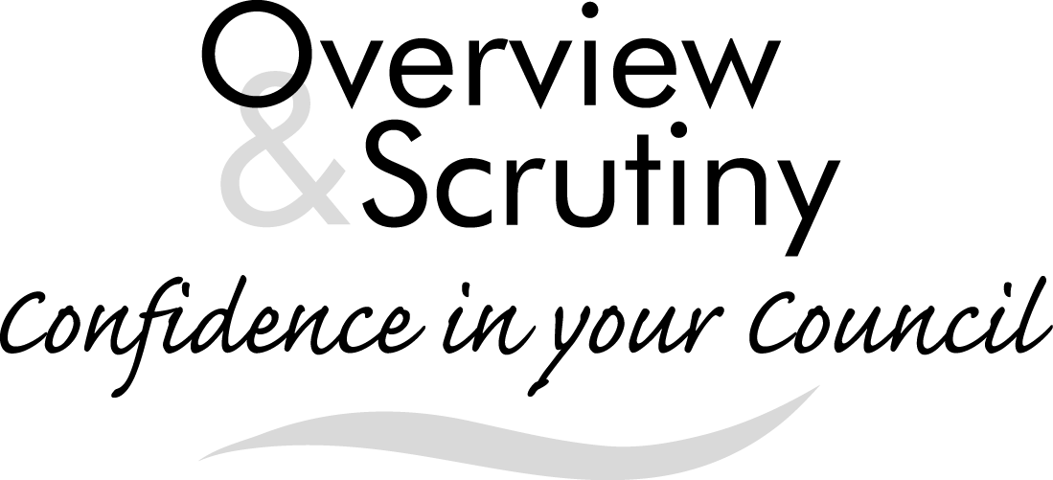
Annual Report 2018/2019

Foreword
Once again it has been a busy year for the Overview and Scrutiny Board, as can be seen from this report. As always we have taken a leading role in the Elected Mayor’s Budget. I am pleased to say he listened to our recommendations and, in part, took them into account. In addition to the budget the Board has investigated a number of issues and I believe has made a difference in some of the key decisions made by the Elected Mayor and Council.
I would like to thank all the officers at the Town Hall for their help and assistance during our busy year. In particular I would like to thank Kate Spencer on behalf of the Board for her help, dedication and assistance throughout the year.
I would also like to thank all members of the Board who have played their part in our discussions and recommendations.
Councillor Chris Lewis
Overview and Scrutiny Co-ordinator
Introduction
Overview and scrutiny…
- is one of the ways the Council improves services and the quality of people’s lives in Torbay
- acts as the Council’s “watchdog” and challenges decisions taken by the Mayor and looks at decisions in more detail
- reviews existing policies and issues of concern
- is a constructive and independent way of looking at an issue, highlighting areas that work well and suggesting where improvements can be made.
Torbay Council has agreed that overview and scrutiny should operate in accordance with following principles:
- Focusing on the issues which matter:

- Policy Development is of equal importance to “holding to account”

- The Forward Plan is the key tool for managing the decision making process

- The relationship between overview and scrutiny and the executive should seek to complement one another

- All Councillors should have the opportunity to help shape policy decisions at an early stage
This report gives details of the work which has been undertaken by the Overview and Scrutiny Board over the course of 2018/2019.
The operation of overview and scrutiny
The Council re-appointed Councillor Chris Lewis as the Overview and Scrutiny Co-ordinator in May 2018. He is supported by Councillors Barnby, Bent, Darling (S) and Long as Overview and Scrutiny Lead Members.
The membership of the Overview and Scrutiny Board over the course of the year has comprised Councillors Barnby, Bent, Bye, Darling (S), Lewis (C), Long, Morey and Sykes.
Focusing on the issues which matter
The Overview and Scrutiny Board has continued to undertake its health scrutiny duty and has maintained oversight of the implementation of the Sustainability and Transformation Plan for Devon. This has included receiving updates on the proposed merger of the two Clinical Commissioning Groups in Devon and the development of the accountable care system.
The Board has continued to receive regular reports on the Council’s revenue and capital budgets. It has closely monitored the performance of Children’s Services both in terms of outcomes for children and the costs of the service.
The Board has provided an assurance role on a number of projects within Council’s Transformation Portfolio, including the ongoing review of the TOR2 contract.
Equal importance placed on policy development
The Board and its Monitoring Groups provided feedback during the development of a number of policies over the course of the year, including the Joint Health and Wellbeing Plan, the Disadvantage Strategy and the Annual Agreement between Torbay Council, the Clinical Commissioning Group and the Torbay and South Devon NHS Foundation Trust.
Complementing the work of the executive
The Overview and Scrutiny Board continue to seek to complement the work of the Elected Mayor and his executive. It regularly reviews the Forward Plan in order to identify issues which it would wish to consider ahead of final decisions being made. The Overview and Scrutiny Board held a series of meetings to discuss the Elected Mayor’s proposals for the budget for 2019/2020.
Call-ins
The call-in process is one of the mechanisms which can be used to hold the Elected Mayor to account.
The purpose of call-in is to examine the decisions reached by the Elected Mayor (or other decision makers) and the reasoning behind those decisions. The process enables further public debate to be held on the subject. The Overview and Scrutiny Board can then consider whether the decision was appropriate and make recommendations accordingly.
Over the course of the year, the Overview and Scrutiny Board have considered five call-ins.
Future Work Programme
Following the Local Elections in May 2019, the Board determine how it will set its Work Programme within the new governance arrangements for Torbay Council. However, the Forward Plan will continue to be the key tool for managing the decision making process.
It is expected that the Board will play an active role in supporting the new Leader and Cabinet. In accordance with the Principles of Overview and Scrutiny, the Board will seek to involve all members in forthcoming issues from an early stage and to complement the work of the executive.
The formal Work Programme will be agreed by the Overview and Scrutiny Board at its first meeting in the new Municipal Year although it will continue to have the flexibility to react to issues as they arise.
Contact Details
Overview and Scrutiny scrutiny@torbay.gov.uk
Torbay Council www.torbay.gov.uk/scrutiny
Town Hall
Torquay
TQ1 3DR
01803 207014

