ADMISSIONS

POLICY

2020-2021

TORQUAY ACADEMY

Admissions Policy

TORQUAY ACADEMY ADMISSION ARRANGEMENTS FOR 2020/2021

BACKGROUND

Torquay Academy is a Trust Academy and operates its own Admissions Policy as set out below. This policy is the responsibility of the Governing Body of the Academy.

Co-ordinated admissions schemes operate in Torbay for admissions to Year 7 and for in year admissions (see Appendix 1). Applications for places in Year 7 in the main admission round must be made through a student’s home local authority.

PURPOSE

The purpose of this policy is to ensure that all prospective students are treated fairly and that Torquay Academy continues to provide an educational facility to serve its local community in which it resides. To achieve this, it will work in co-operation with other admitting Authorities within Torbay.

PUBLISHED ADMISSION NUMBERS FOR YEAR 7 IN 2020-21

The admission number for Year 7 is 240.

OVER-SUBSCRIPTION CRITERIA – MAIN ROUND ENTRY TO YEAR 7

Children with statements of Special Educational Needs or an Education, Health and Care Plan which names the Academy on the Statement or Plan will have automatic entitlement to a place at the Academy.

Where there are fewer applications than places, no application will be refused. Where the school is oversubscribed the following criteria will be used to prioritise applications:

- Looked-after children. This covers children who are looked after by a local council in accordance with Section 22 of the Children Act 1989(b) and formerly looked-after children who have been adopted or made subject to a residence or special guardianship order.
- Students qualifying for a place in
  - the Football Academy – up to 8 places
  - the Performing Arts Academy – up to 8 places
- Children of staff at the school, who have parental responsibility, in either or both of the following circumstances:
- where the member of staff has been directly employed by the school for two or more years at the time at which the application for admission to the school is made, and/or
- the member of staff is recruited to fill a vacant post for which there is a demonstrable skill shortage
- Children who will have a sibling on roll at the Academy at the time of application
- Other children living in the designated area served by the Academy (as shown in Appendix 7)
- Other children living outside the designated area

Football Academy
No. of places available: 8 for Year 7 only
The Football Academy is for committed players who demonstrate a high aptitude in football. The programme aims to develop footballing potential as well as enabling players to gain academic qualifications in addition to high quality coaching.

In addition to completing a common application form, applicants must complete a registration form (Appendix 4) that is available from Torquay Academy or Torbay Council’s website. The registration forms must be received by the Academy on or before 20th September 2019. If there are more applicants who have an aptitude for football than places available, priority will be given to those who score the highest in the aptitude tests.

Details of the allocation process are available in Appendix 2.

Performing Arts Academy
No. of places available: 8 for Year 7 only

The Performing Arts Academy is for committed singers, dancers, actors and musicians who demonstrate a high aptitude in these areas. The programme aims to develop potential as well as enabling students to gain academic qualifications in addition to high quality instruction.

In addition to completing a common application form, applicants must complete a registration form (Appendix 5) that is available from Torquay Academy or Torbay Council’s website. The registration forms must be received by the Academy on or before 20th September 2019. If there are more applicants who have an aptitude for the performing arts than places available, priority will be given to those who score the highest in the aptitude tests.

Details of the allocation process are available in Appendix 3.

If there are fewer than 8 places given to each specialism, any remaining places will be available to applicants in criteria 3-6.

Children of Staff
If applying for a place under this criteria, the supplementary form (Appendix 6) should be completed.

Further Information
Should it be necessary to further distinguish between applications within any of the above categories, priority will be given to those living closest to the Academy. Measurements will be taken by a straightline distance using the Council’s electronic mapping system (GIS). Measurements will be made from the co-ordinates of the home address as pinpointed on the Council’s system, to the co-ordinates of the school as pinpointed on the Council’s system. The pinpoint will be within the boundary of the property and its precise location will be determined by Torbay Council. This is for admissions purposes only and is not used to determine eligibility for school transport. In the event that applicants cannot be separated using the distance tie-breaker (i.e. they live identical distances from the school), the allocation of a place will be by random selection using a random number generator and in the presence of a senior manager.

Where applications are received from families with multiple birth siblings (twins, triplets, etc.) every effort will be made to allocate places at the Academy, including offering place(s) above the Published Admission Number (PAN) wherever possible.

Where applications are made at the same time for two children not falling within multiple birth siblings, (sometimes referred to as contemporaneous admissions) the application will not be considered under the ‘sibling’ criterion.

ACADEMY ADMISSIONS PANEL
The Academy Admissions Panel for Torquay Academy will consist of the Principal, the Academy’s Admissions Officer, plus 3 members of the Governing Body of the Academy. This Panel will be responsible for the allocation of places for Torquay Academy, and it is not possible for any individual member to allocate a place.

RESIDENTIAL ADDRESS
The child’s home address is taken to be the address of the persons with parental responsibility with whom the child lives for the majority of the Academy week. The Academy may seek proof of residence. Evidence such as a utility bill, Council Tax demand or solicitor’s letter confirming a signed contract for a house purchase would be deemed appropriate. A deliberate attempt to mislead the Academy may lead to the withdrawal of the place if it has been offered.

ADMISSIONS OUTSIDE A CHILD’S NORMAL AGE GROUP

You can request a place in a different Year Group to the one your child would normally enter according to his or her age. This may happen where, for example, a child is particularly gifted or talented or has missed a significant period of education through ill health.

Where a parent requests a delayed transfer to secondary school for a child who has a Statement of Special Educational Needs or Education, Health and Care Plan and the delay in transfer is the means of meeting the child’s specific educational needs as agreed at the Annual Review Meeting, a child will be admitted outside the normal age cohort. Other requests will be considered on their individual merits.

Where a parent requests that their child transfers early to secondary school, evidence will be required to show that the primary school is unable to provide a curriculum appropriate to the child’s needs. The Governing Body will need to be satisfied that an appropriate curriculum cannot be offered at the primary school. A report from the Primary school Headteacher will be required.

Where this occurs it will be necessary for schools to accept children outside the normal age cohort, but within the over-subscription criteria.

Where a child has been attending an independent school, and admission to a maintained school has been requested, there will be an expectation that that child will be admitted to a school appropriate to the child's age range.

IN YEAR ADMISSIONS (MID-PHASE ADMISSIONS)

This section refers to admissions to Years 7-11 of the school outside of the normal admission round, i.e. after the start of the autumn term for Year 7 students and at any time for students in Years 8 – 11. In year admissions are progressed by staff in the Pupil Services Team at the LA in conjunction with the Academy.

Over-Subscription Criteria
Children with statements of Special Educational Needs or an Education, Health and Care Plan which names the Academy on the Statement or Plan will have automatic entitlement to a place at the Academy.

Where there are fewer applications than places, all students will be given a place. Where the school is oversubscribed the following criteria will be used to prioritise applications:

- Looked-after children. This covers children who are looked after by a local council in accordance with Section 22 of the Children Act 1989(b) and formerly looked-after children who have been adopted or made subject to a residence or special guardianship order.
- Children of staff at the school, who have parental responsibility, in either or both of the following circumstances:
- where the member of staff has been directly employed by the school for two or more years at the time at which the application for admission to the school is made, and/or
- the member of staff is recruited to fill a vacant post for which there is a demonstrable skill shortage
- Children who will have a sibling on roll at the Academy at the time of application
- Other children living in the designated area served by the Academy
- Other children living outside the designated area

Should it be necessary to further distinguish between applications within any of the above categories, priority will be given to those living closest to the Academy. Measurements are taken by a straightline distance using the Council’s electronic mapping system (GIS). Measurements will be made from the co-ordinates of the home address as pinpointed on the Council’s system, to the co-ordinates of the school as pinpointed on the Council’s system. The pinpoint will be within the boundary of the property and its precise location will be determined by Torbay Council. This is for admissions purposes only and is not used to determine eligibility for school transport. In the event that applicants cannot be separated using the distance tie-breaker (i.e. they live identical distances from the school), the allocation of a place will be by random selection using a random number generator and in the presence of a senior manager.

WAITING LISTS

A waiting list will be maintained after the Allocation Day (March 2020) until 31 December 2020. Children will be ranked in the same order as the oversubscription criteria (see page 3 for main round admissions and pages 5-6 for in-year admissions).

DEFINITIONS

Sibling: children who live as brother or sister in the same house, including natural brothers or sisters, adopted siblings, stepbrothers or sisters and foster brothers and sisters.

Designated area: a designated area /catchment area is a distinct geographical area that is served by a school. A map showing our designated area can be found in Appendix 7 and on Torbay Council’s website.

Home address: address of the person with parental responsibility for the child and with whom the child lives for the majority of the week, at the time of application.

Demonstrable skill shortage: a range of situations in which an employer finds it hard to find an employee with the right skills. Positions that are determined to have a demonstrable skill shortage will be decided by the Principal and either the Chair or Vice Chair of Governors.

APPEALS

Parents who have been refused a place at an Academy can appeal to an independent appeal panel. Information about the appeals procedure can be obtained from the Academy office 01803 329351 and from Torbay LA Student Services, telephone 01803 208908.

FAIR ACCESS PROTOCOL

The LA and other Admission Authorities in Torbay have agreed a Fair Access Protocol which governs the admission of children who have no Academy place and those with challenging behaviour. A copy of the Protocol is available from Torbay LA Admissions and Student Services, telephone 01803 208908.

DISCRETIONARY CLOTHING GRANT
All students in Years 7 to 11 inclusive are expected to conform to the Academy’s uniform policy, which is published in the Academy Prospectus. For families in severe hardship, a discretionary clothing grant is available for exceptional cases, and further information should be sought from the Academy.

APPENDIX 1

Co-ordinated Admissions Scheme for Secondary Schools in Torbay in September 2020

The current version can be found on Torbay Council’s website:

www.torbay.gov.uk/schooladmissions

APPENDIX 2

TORQUAY ACADEMY

Allocation Process for students based on ‘Aptitude in Football’

Torquay Academy will allocate up to 8 places for students qualifying for the Football Academy based on their aptitude in football. Applications are welcomed from children from within as well as outside our designated area.

A student with aptitude is one who is identified as being able to benefit from elite football coaching or who demonstrates a particular capacity to succeed in football. Through the allocation process the Academy will assess whether the applicants have an aptitude for football by determining whether they demonstrate a particular capacity to learn or to develop skills, and can benefit from the particular expertise and facilities at the school.

There will be a sporting aptitude assessment based on physical tests. Each applicant will be awarded a standardised score with the highest scores being allocated places based on football aptitude. The assessment will be objective, have a distinctive subject focus and will not discriminate against applicants in any way, including on the grounds of gender, ethnic origin, disability or family background. The assessment will only assess aptitude in football and not ability or aptitude in any other subject.

Whilst no previous experience in football is required in order to take the test, it is expected that applicants wishing to apply under this criterion have an interest in football and we would expect them to participate fully in the Football Academy in the school should they gain a place.

Up to a maximum of 8 students will be allocated a place on their aptitude in football.

Students will be required to attend an aptitude test at the school. This will be held on Saturday 5th October 2019.

It will not be possible to take the test after 5th October 2019.

The applicants will be assessed in:

- Technique test
- Games-based performance
- Endurance/speed
- Games-based intelligence test

Assessment criteria have been written but these and the tasks will be given on the day and not in advance, to prevent prior training or coaching of applicants.

Quality and fairness will be assured with a specialist teacher from the school leading the assessment whilst another specialist teacher observes and assesses.

Please complete the separate registration form (Appendix 4) for the Football Academy and send it to Torquay Academy by 20th September 2019 (registration opens 1st April). Any registration forms received after this date will not be accepted.

APPENDIX 3

TORQUAY ACADEMY

Allocation Process for students based on ‘Aptitude in the Performing Arts’

Torquay Academy will allocate up to 8 places for students qualifying for the Performing Arts Academy based on their aptitude in one or more of the three Performing Arts disciplines: Dance, Drama and Music. Applications are welcomed from children from within as well as outside our designated area.

A student with aptitude is one who is identified as being able to benefit from teaching in the Performing Arts subjects of Drama, Dance or Music or who demonstrates a particular capacity to succeed in one or more of these subjects. Through the allocation process the Academy will assess whether the applicants have an aptitude for a subject by determining whether they demonstrate a particular capacity to learn or to develop skills in the Performing Arts, and can benefit from the particular expertise and facilities at the school.

There will be workshop aptitude assessments in all three disciplines; students can apply to take part in one or more of these. The tests will be objective, have a distinctive subject focus and will not discriminate against applicants in any way, including on the grounds of gender, ethnic origin, disability or family background. The assessment will only assess aptitude in the three disciplines of Music, Dance and Drama and not ability or aptitude in any other subject.

Whilst no previous experience in performing arts is required in order to take the test, it is expected that applicants wishing to apply under this criterion have an interest in music, dance or drama and we would expect them to participate fully in the performing arts life of the school should they gain a place.

Up to a maximum of 8 students will be allocated a place on their aptitude in any one discipline or a combination of the three disciplines.

Students will be required to attend an aptitude test at the school. This will be held on Saturday 5th October 2019.

It will not be possible to take the test after 5th October 2019.

Assessment criteria have been written for each subject area but these and the tasks will be given on the day and not in advance, to prevent prior training or coaching of applicants.

Quality and fairness will be assured with a specialist teacher from the school leading the workshop assessment whilst another specialist teacher observes and assesses.

Please complete the separate registration form (Appendix 5) for the Performing Arts Academy and send it to Torquay Academy by 20th September 2019 (registration opens 1st April). Any registration forms received after this date will not be accepted.

TORQUAY ACADEMY
APPENDIX 4
Registration Form - Football Academy

Aptitude Test Date: Saturday 5th October 2019
9.00am – 12.00pm
Student Details
First Name |  | Surname
Date of Birth |  | Gender
Address
Town
County |  | Post Code
Parent Contact Name
Home Tel. |  | Mobile Tel.
Email
Current School

Parent Signature:
Signed (e-signature also accepted)
Print Name
Date

Please return completed registration forms by 20th September 2019 to: admin@tqacademy.co.uk or send direct to Torquay Academy, Cricketfield Road, Torquay, TQ2 7NU.

TORQUAY ACADEMY
APPENDIX 5

Registration Form – Performing Arts Academy

Aptitude Test Date: Saturday 5th October 2019
9.00am – 12.00pm
Student Details
First Name |  |  | Surname
Date of Birth |  |  | Gender
Address
Town
County |  |  | Post Code
Parent Contact Name
Home Tel. |  |  | Mobile Tel.
Email
Current School
Area of Interest (please circle) | Music | Drama |  |  | Dance

Parent Signature:
Signed (e-signature also accepted)
Print Name
Date

Please return completed registration forms by 20th September 2019 to: admin@tqacademy.co.uk or send direct to Torquay Academy, Cricketfield Road, Torquay, TQ2 7NU.

APPENDIX 6
SUPPLEMENTARY ADMISSION FORM (SUPP 1)
CHILDREN OF STAFF
This form should only be completed where children of staff are prioritised in the school’s admission criteria
Child’s surname
Child’s forename(s)
Date of Birth
Parent’s name
Name of school where parent works
Job title

Please indicate how you meet the criteria for prioritising children of staff:
Please note: different schools have included different aspects of these criteria in their admission arrangements. See the school’s admission policy for full details.
I have been employed at the school for two or more years | Yes/No
If yes, date employment at the school started
I have been recruited to fill a vacant post for which there is a demonstrable skills shortage | Yes/No
Evidence for this:

Signature: …………………………………………………….…………………………
Date: ……………………………………………………………………………..………
Headteacher/Principal signature: ………………………………..……………………
Date: ………………………………………………………………………..……………
This form, when completed, should be passed to the Clerk of Governors for consideration by the Admissions Committee when ranking applications.
Note to Clerk of Governors: if you are buying the Admissions Service from Torbay Council, please take a copy of this form and send the original to Student Services c/o Town Hall, Castle Circus, Torquay TQ1 3DR

APPENDIX 7

Designated Area

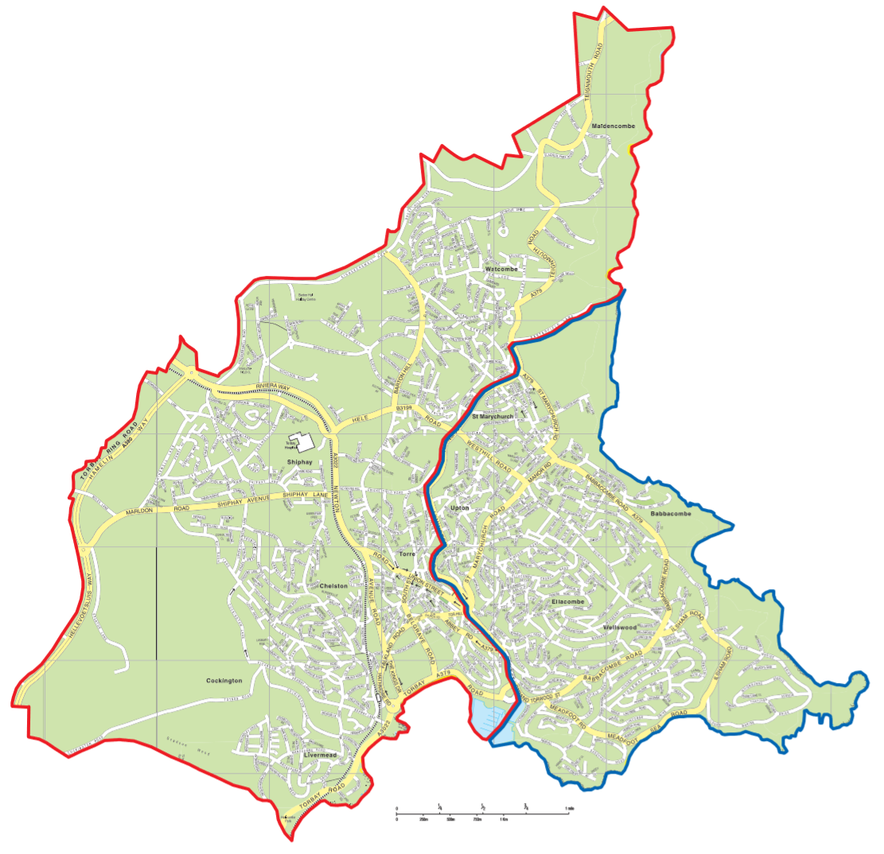

This map has been taken from Torbay Council’s TIPS Booklet on their website.
The designated area for Torquay Academy is outlined in red.

