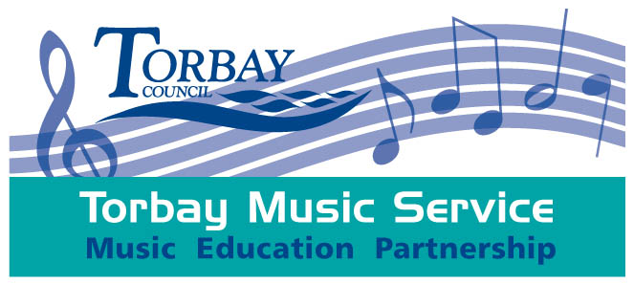

Associate Application Form

Please try to be as succinct as possible – bullet points are fine in questions 2-7 – please try to keep the version you send in to us to no more than 4 sides!

- Key information
Your name
Your email address
Your organisation’s name
Full current postal address inc postcode.
Please tick the boxes that apply to you and your application
What type(s) of Associate Status do you want? |  |  | What types of work are you doing – you can tick more than one.
□ | Associate Provider (individual)  (A music teacher within and external to a school setting) |  | □ | Peripatetic Tutor
 |  |  | □ | Music Leader / Community Musician
 |  |  | □ | Projects
□ | Associate Provider – Whole Class Ensemble Tuition  (A music teacher who also delivers whole class ensemble teaching (inside and external to a school setting)) |  | □ | Events /Performances

Do you teach from home? | □Yes □No | Other – including any particular specialisms
Do you teach in Schools within Torbay? | □Yes □No | Do you run external musical activities? | □Yes □No

How did you hear about The Torbay Associates Network?
Have you a valid DBS check? Or do you have registration with the update service, if so, what is your number?
Are there any reasons why you would not be considered suitable to work with children, young people or vulnerable adults – including anything that may not register on a current DBS check such as ongoing investigations, bans or allegations? Yes / No - If YES, please provide brief details which we will follow up with you
Do you consider yourself to have a disability?
Please provide your home address if different to above (or business address for organisations) below

Age ranges with which you work
4 and under | □Yes □No | 11-13 | □Yes □No
5-6 | □Yes □No | 14-15 | □Yes □No
7-10 | □Yes □No | 16+ | □Yes □No
 |  | Adults (e.g. for CPD) | □Yes □No

- What instruments / technologies and musical genres/styles are you working in? CPD providers please indicate what professional development areas you specialise in
 | - Please tell us why Associate status is important to you / your organisation.
 | - Please outline the skills / qualities, experience, knowledge and qualifications (if any) etc. that you / your organisation (and the people it employs / hires) bring to your work.
 | - Please tell us about you/ your organisation’s attitude to progressing young musicians (within and beyond your own ‘offer’) and how the work you do/ provide can link into a wider Hub offer.
 | - If you want to be recognised as Inclusive Music Aware, please type YES in this box and ‘pledge’ your development (this is an area in which we are looking to offer more training)
 |  | - Tell us about your attitude to / interest in accessing Torbay instruments and other resources (if applicable)
 |  | - Tell us how you engage with Professional Development and training opportunities. If you are applying as an organisation please outline your CPD strategy or plan for employees and other professionals you hire to deliver on your behalf.
- Please provide us with the names of 2 referees that we can contact for a reference covering your professional experience, suitability for tuition / participatory work and suitability to work with children & young people. Please be clear who they are and in what capacity they know you. Ideally both will be a recent employer or someone who has hired your services as a music tutor / music leader recently.
- These referees should also be people to whom you could direct your clients if they requested a reference (we may recommend they do this).
- They do not need to be the same people who provide you with any endorsements that you show in your online listing.
- Referees will need to have provided us with their references on our template before we can interview you.
 |  |  | In submitting this application, I declare its contents to be true and accurate. | □Yes □No

Once you’ve finished this application form email it to us.
Send it to: TMHassociates@torbay.gov.uk
with the subject heading “Associate application – YOUR NAME”
Please don’t forget that you also need to have arranged you Public Liability Insurance and done appropriate Child Protection Training
If you are in need of updating insurances and training please detail below.

