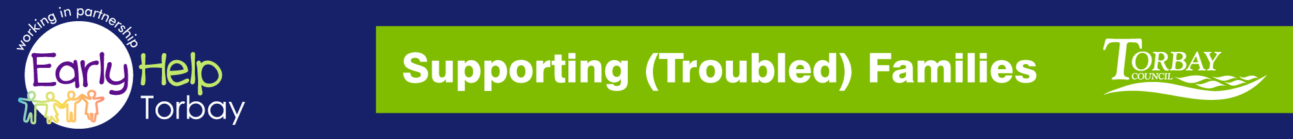
Supporting Families
NETWORK MEETING

THURSDAY 27th September 2018 9.30-12.00hrs
At ‘The Beehive’ Bishops Place, Paignton, TQ3 3DZ

A GENUINE NETWORKING OPPORTUNITY TO MEET AND SHARE YOUR EXPERIENCES WITH YOUR PARTNERS

AGENDA
- Minutes from last meeting
- Steve Leech - Terms of Reference Review
- Amanda Paterson – Head of Service
- Vikki McGeough – Outcome Framework
- Steve Leech – Supporting Troubled Families update
- Guest Speaker: Angie Manning: - ‘What’s your
Problem’
- Refreshment Break
- Guest Speaker: Gina Wilson – Perinatal Mental
Health
- Date, Venue & Time for next meeting tbc
Reply to: nadia.cooper@torbay.gov.uk

steve.l eech@torbay.gov.uk - Interim Supporting (Troubled) Families Coordinator

ALL MINUTES, INFORMATION LEAFLETS AND FORMS ARE AVAILABLE TO VIEW ONLINE (follow the Link below:-

WEBSITE: http://www.torbay.gov.uk/children-and-families/services-and-support/supporting-troubled-families/

