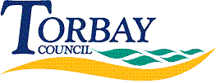
Request Reference: 18190425
Date received: 13 June 2018
Date response sent: 12 July 2018

1. The total amount of land (in acres) currently owned by your Council.

4340

2. The total amount of land (in acres) currently owned by your Council that has been identified as surplus to requirements.

24

3. The total amount of land (in acres) currently owned by your Council that is scheduled to be sold.

0

4. The total amount of land (in acres) currently owned by your Council scheduled for joint venture housing development or where such development is already taking place.

0

