St. Marychurch Church of England
Primary and Nursery School
Faith Supplementary Information Form 2019-20

To be completed only where a parent is seeking admissions priority on faith criteria.
Where there are more applications than there are places, we will prioritise applications where a faith criterion has been met. Please complete and return this form to the school by 15 January 2019 or as soon as possible thereafter for admissions at the start of the Reception year.
You must also complete a Local Authority Common Application Form.

Please complete and return this form to the school as soon as possible for in-year admissions.
You must also complete a Torbay Common Application Form.

Please read the admissions policy, including definitions, before completing this form.

PART A – to be completed by the parent
Full name of child
Date of Birth

Please tick box if it describes your child’s circumstances.
 | Criterion 3 | Children who live in our designated area and are (or whose parents are) regular attenders at St Marychurch Parish Church.
 | Criterion 4 | Children who live in our designated area and are (or whose parents are) regular attenders at another Christian Church.
 | Criterion 5 | Children who live in our designated area and are (or whose parents are) regular attenders at a place of worship recognised by another faith.
 | Criterion 8 | Children who live outside our designated area and are (or whose parents are) regular attenders at St Marychurch Parish Church.
 | Criterion 9 | Children who live outside our designated area and are (or whose parents are) regular attenders at another Christian Church.
 | Criterion 10 | Children who live outside our designated area and are (or whose parents are) regular attenders at a place of worship recognised by another faith.
I confirm that I have submitted a Common Application Form.
Parent’s name |  |  | Date
Please sign here

Once you have completed Part A, please pass the form to your priest, minister, faith leader or church official who should complete Part B and return it to the school. Only where both parts are completed and the form is returned can your application prioritised accordingly. If you don’t return this form, your application will be considered under the “non-faith” criteria.

PART B – to be completed by a Church Priest or Minister
Full name of child
Church

Priest or minister

Address

Telephone

From your knowledge, please tick box if it describes the child’s circumstances, with reference to the text in bold:
 | Criterion 3 | Children who live in our designated area and are (or whose parents are) regular attenders at St Marychurch Parish Church.
 | Criterion 4 | Children who live in our designated area and are (or whose parents are) regular attenders at another Christian Church.
 | Criterion 5 | Children who live in our designated area and are (or whose parents are) regular attenders at a place of worship recognised by another faith.
 | Criterion 8 | Children who live outside our designated area and are (or whose parents are) regular attenders at St Marychurch Parish Church.
 | Criterion 9 | Children who live outside our designated area and are (or whose parents are) regular attenders at another Christian Church.
 | Criterion 10 | Children who live outside our designated area and are (or whose parents are) regular attenders at a place of worship recognised by another faith.
I confirm that the information provided above is accurate.
Please sign here |  |  | Date

Thank you for your assistance in completing this Supplementary Information Form. Please note that if a family is refused a place at the school and appeals against the decision, this form may be used as evidence at the appeal.

Please return this form to:
St Marychurch C of E Primary & Nursery School, Hartop Road, St Marychurch, Torquay TQ1 4QH

Data Protection
The information collected on this form will be processed and may be stored electronically by the school in compliance with the Data Protection Act. The data may be shared with Torbay Council or other agent of the school, but only for administrative or other service provision purposes and with Government Departments where there is a legal requirement to do so. In accordance with the School Admissions Code, should information given be found to be fraudulent then the offer of a school place can be withdrawn. If you would like further information about Data Protection, please contact the school. By signing or submitting this form. You acknowledge that you have read, understood and agreed to this data processing.

Designated Area
Our designated area is in the middle of the map, bordered by a purple line. You can view it in more detail online at devon.cc/schoolareamaps. This will confirm whether addresses close to the boundary are inside or outside our area. We welcome admissions applications for children living inside and outside our designated area.

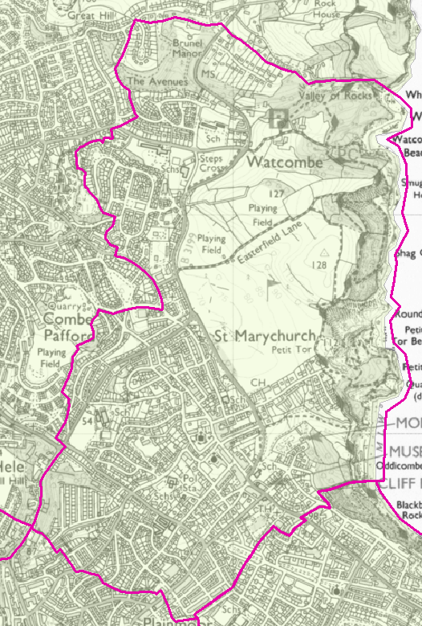

© Crown Copyright. All rights reserved. Devon County Council 100019783 2016

Either the child or a parent attends a church service at least a once a month for at least one year, immediately prior to the point of application.
All Churches affiliated to Churches Together In England.
By this we mean Islam, Judaism, Sikhism, Unitarianism, Baha’I, Mormonism, Buddhism, Hinduism and Taoism.
Either the child or a parent attends a church service at least a once a month for at least one year, immediately prior to the point of application.
All Churches affiliated to Churches Together In England.
By this we mean Islam, Judaism, Sikhism, Unitarianism, Baha’I, Mormonism, Buddhism, Hinduism and Taoism.

