

**ELECTIVE HOME EDUCATION PROGRAMME**

* In completing this programme you are informing the Local Authority of arrangements you are making for your child’s education at home.
* You will know that the Local Authority must be satisfied that appropriate education is being provided.
* This gives us a really useful background for our first home visit. Please feel free to fill in as much as you feel you can and do not worry if you cannot complete it all.
* There is a section for your child(ren) to complete too, it’s important that they have their say.

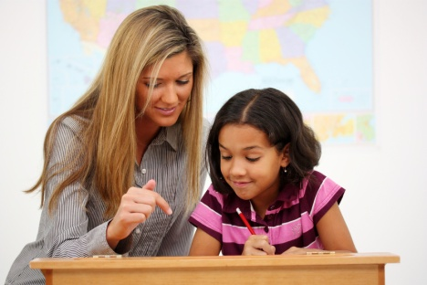

Thank you for your assistance in this matter.

**PART ONE: YOUR DETAILS**

**Name of child(ren): __________________________**

Date of Birth: __________________________

Home address: __________________________

_________________________

_________________________

Telephone No: __________________________

Last school: __________________________

Any information which you would like to offer as to your choice to electively home educate:

|  |
| --- |
|  |

**PART TWO: PATTERN OF EDUCATION**

* If you have a regular timetable please complete the weekly planner below.

|  |  |  |  |  |  |
| --- | --- | --- | --- | --- | --- |
|  | MON | TUES | WED | THUR | FRI |
| AM |  |  |  |  |  |
| PM |  |  |  |  |  |

OR

* If you do not have a fairly regular pattern, approximately how many hours are spent involved in educational activities each week? ……………….. hours

What kinds of activity do you do?:

|  |
| --- |
|  |

**PART THREE: PLANNING AND RESOURCES**

* Please place a tick in the second column if that subject is included in your child’s education programme and, where appropriate, the main textbook, course or other resources used.

|  |  |  |
| --- | --- | --- |
| Subject | MC900434713[1] | Main textbook, course or resources used |
| English |  |  |
| Mathematics |  |  |
| Science |  |  |
| Geography |  |  |
| History |  |  |
| RE |  |  |
| French |  |  |
| Technology |  |  |
| Art |  |  |
| Music |  |  |
| PE |  |  |

* Please place a tick in the second column if you use any of the following resources? If ‘yes’, please give further information.

|  |  |  |
| --- | --- | --- |
| Resource | MC900434713[1] | Further information if appropriate |
| Computer |  |  |
| Local library |  |  |
| TV and radio programmes |  |  |
| Visits and outings |  |  |
| Practical equipment |  |  |

* Please give a brief outline of what you expect your child to learn in the next 12 months.

|  |
| --- |
|  |

* Please list the people who are regularly involved in the education of your child and the areas of your planned programme which they teach.

|  |  |
| --- | --- |
| Name | Areas involved in |
|  |  |

* What arrangements are made to make sure that your child(ren) has social contact with other children and adults? Please give examples:

**PART FOUR; KEEPING RECORDS**

1. Do you keep your child’s work? YES/NO
2. Do you clearly indicates the date YES/NO

when it was completed?

1. Do you keep a diary or record of YES/NO

the work completed by your child?

**PART FIVE: WORKING TOWARDS QUALIFICATIONS**

**(14-16 year old children only)**

* Is your child being prepared YES/NO

for a national qualification?

* If YES please give details of the subject and the qualification s/he is working towards,

e.g. GCSE etc.

|  |  |
| --- | --- |
| Subject | Qualification/exam board |
|  |  |

**PART SIX : YOUNG PERSON’S VIEW**

Your views are really important, this is a chance for you to tell us how you feel about your home education.

* What is going well in your home education? What do you enjoy?
* What tasks/activities have you done recently that you have been proud of?
* What clubs or activities do you do outside of your home education?
* Is there anything you would change about your home education?

Thank you very much for completing this outline of your child(ren)’s education at home programme.

* If you or your child(ren) would like to give any additional information please attach it to this form.

The address for return by post is:

EHE Coordinator

Room SF332, Electric House

c/o Town Hall, Castle Circus

Torquay TQ1 3DR

* The home education visitor will contact you with a home visit appointment to talk about your provision and to meet you and your child(ren).
* In the mean time, please do not hesitate to telephone on the EHE mobile 07824 529627 should you require further clarification, discussion or information.

