- A calculation that shows how work will affect your current benefits and how much better off in work you could be.
- Information on local voluntary work opportunities.
- Help to find the right work experience opportunity for you, giving you a valuable work reference
- Help and support to compile a CV, mock interview skills and preparation.
- Information on local training opportunities, jobs and apprenticeships.
- Information on additional financial help available to you to help overcome barriers to work
- Help to improve confidence and motivation and much more

If you are interested in any of the above please complete the referral form overleaf and I will contact you.

I look forward to meeting you!
From Paul
Contact me on 07825833258
Email: paul.blake2@dwp.gsi.gov.uk

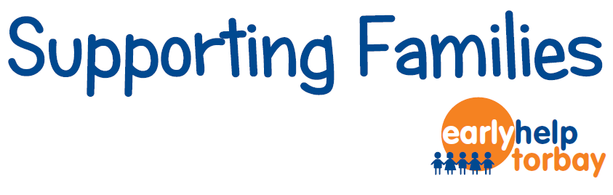

Employment Support and Advice
My name is Paul and I am an Employment Support Adviser part of the Supporting Families Programme

I am available to provide more intensive and flexible help and support to get you take those all important steps into finding employment.

I can meet you informally for a chat at a time, date and location convenient for you.

I offer a range of services that can be tailored to your needs including:

Parent / Carer Name: | D.O.B:
Address: | Contact No:
Child’s Name: | D.O.B:
- Are you unemployed? Yes/ No (please circle)

2) What benefits are you receiving?
Benefit | Yes / No | Benefit | Yes /No
Jobseekers Allowance |  | Carers Allowance
Income Support |  | Employment Support Allowance
Incapacity Benefit |  | Severe Disability Allowance
Notes

3) What support would you like?
Support Type | Yes / No | Support Type | Yes/No
An in work benefits calculation to give an estimate of how better off you could be in work? |  | Local education or training opportunities?
Careers Advice/ Help completing a CV? |  | Work experience, Work Trials & Apprenticeship opportunities?
Help looking for work? |  | Local Volunteering Opportunities?
Is there anything else you’d like help with?

4) Support Worker Details:
Name: | Agency:
Telephone No. | E-mail:

5) Consent:
I have been involved in the completion of this form: |  | Yes No
I consent to the Supporting Families Employment Advisor to contact me in relation to the information on this form: |  | Yes No
Sign: | Print: | Date:

Please send completed form to Paul Blake (Supporting Families Employment Advisor) 2nd Floor North, Tor Hill House, Castle Circus, Torquay TQ1 3DR.Telephone: 07825833258

